**VISHAY SUCHI**

|  |  |  |
| --- | --- | --- |
| **KRAM SANKHYA** | **VISHAY** | **PAGE NO** |
| 1. | 5.56mm INSAS Rifle | **1-77** |
| 2. | 5.56mm INSAS LMG | **78-180** |
| 3. | 84mm Rocket Launcher MK-II | **181-234** |
| 4. | 84mm Rocket Launcher MK-III | **235-251** |
| 5. | 51mm Mortar | **252-275** |
| 6. | 40mm Multi Shot Grenade Launcher (MGL) | **276-300** |
| 7. | 40mm Under Barrel Grenade Launcher (UBGL) | **301-325** |
| 8. | 40mm Under Barrel Grenade Launcher (INSAS) | **326-330** |
| 9. | Rifle 7.62mm AK-47 | **331-334** |
| 10. | 9mm Pistol | **335-347** |
| 11. | Grenade aur Trip Flare | **348-361** |
| 12. | RPO-A- Flame Thrower | **362-368** |
| 13. | Improvised Explosive Devise (IED) | **369-371** |
| 14. | Integrated Weapon Training | **372-416** |

O

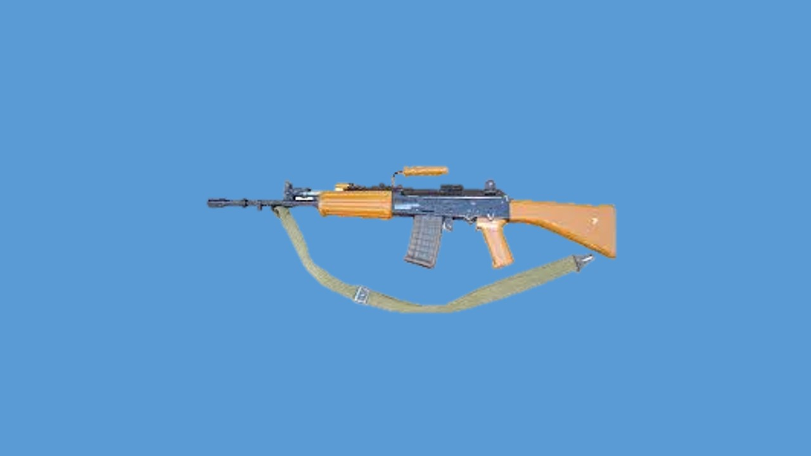

**5.56MM INSAS RIFLE**

**LESSON-1**

**5.56 MM INSAS RIFLE**

**CHHOTE KUTAR KA VIKAS AUR INSAS SE PARICHAY**

**Parichay.**

1. Sena ko majbut aur tandrust rakhne ke liye duniya mein ho rahi tabdiliyon ke sath kadam se kadam milakar chalne ki zarurat parti hai. Pichhle chand ek varshon se adhiktar desh ke small arms mein chhote kutar (calibre) ko apna rahe hain. Yeh jang mein hue anubhav aur vivekshil soch vichar ka natija hai. Hamare desh ne bhi 5.56mm calibre ke chhote kutar ke hathiyaron ko apnane ka faisla kiya hai.

**Uddesh.**

2. Duniya ke chhote hathiyaron ke kutar mein badli aur INSAS ke bare mein jankari dena hai.

**Bhag.**

3. Yeh sabaq do bhagon mein banta gaya hai:-

(a) Duniya ke chhote hathiyaron ke kutar mein badli.

(b) 7.62 mm ke hathiyaron mein kamiyan aur INSAS project.

**Bhag-1 : Duniya ke Chhote Hathiyar ke Kutar Mein Badli**

4.Unnisawin sadi (19th Century) ke baad 11mm se 12mm kutar ke hathiyar istemal hote the. Uske baad 7mm se 8mm kutar kaafi der tak istemal hue lekin dwitiya vishwa yudh (2nd World War) ke baad yeh yakin ho gaya ki chhote hathiyaron ka larai mein effective range zyada se zyada 400 mtr tak hi hai jahan ki target ki pahchan ki ja sakti hai. Is liye yeh saaf ho gaya hai ki 7.62mm kutar ke hathiyar, zarurat se zyada takatwar ammunition fire karte hain aur zyada wazandar aur zyada recoil force dete hain.

5. **Rifle Fire Ke Vishleshan.** Dwitiya Vishwa Yudh, Korea ki larai, Vietnam ki larai ke Rifle fire ki visheshtaein is prakar hain:-

|  |  |  |  |  |
| --- | --- | --- | --- | --- |
| (a) | 30% Engagement | - | 100 Mtr se kam rg Par. |  |
| (b) | 70% Engagement | - | 200 Mtr se kam rg Par. |  |
| (c) | 90% Engagement | - | 300 Mtr se kam rg Par. |  |
| (d) | 95% Engagement | - | 400 Mtr se kam rg Par. |  |

6. Dwitiya vishwa yudh ke baad, Russia ne 7.62mm x 39mm ke AK-47 hathiyar apnaye. Yeh hathiyar 7.62mm x 54mm ke hathiyaron ke banishpat halke aur kam recoil wale the. Vietnam ki larai mein America ke   
7.62mm x 51mm wale M-14 hathiyar, AK-47 ke sammunitione achha pradarshan nahin kar paye. AK-47 ke halke wazan, kam recoil energy hone ke karan, zyada rapid fire karne se percentage hit (PH) kafi achha tha.

7. Larai ke baad America aur baki desh milkar badi research karne ke baad FN Belgium SS 109 ko apna ammunition mana. Is ammunition ka kutar 5.56mm hai.

8. Is tarah se yeh yakin ho gaya hai ki chhote kutar ke ammunition ki muzzle velocity (MV) zyada aur ballistics achha hone ke karan tgt hit hone ka chance bare kutar ke ammunition ke banishpat zyada hai.

9. Chhote kutar ke ammunition ke kuch faide:-

(a) **Halka Hathiyar**. Hathiyar ki handling asan hoti hai aur carry karne main asan.

(b) **Halka Ammunition**. Kam load hota hai ya usi load mein jiada ammunition ata hai.

(c) **Zyada Muzzle Velocity**. Trajectory Chapta hota hai aur is karan hit chances barh jata hai.

(d) **Recoil Energy Kam**. Firer ko dhakka kam lagta hai jis ke karan accuracy zaida hai.

(e) **Ziada Lethality**. Ballistic Stability achha hone ke karan lethality ziada hota hai.

**Bhag-II : 7.62mm Hathiyaron Mein Kamiyan Aur INSAS Project**.

10. Abhi Infantry section mein teen prakar ke hathiyar hain joki do prakar ke ammunition ka istemal karte hain. Iske karan hamari trg, logistics, maint mein bahut asuvidhayen hoti hain. Iski kamiyan is prakar hain :-

* + 1. Infantry section ke hathiyaron mein farak aur chal ke sidhant mein farak.
    2. Hathiyar ke banane mein kathinayi aur zyada samay lagna.
    3. Instructor aur student ke trg mein kathinayi.
    4. Maint mein kathinayi.
    5. Wazandar hathiyar.

11. Inhi kamiyon ko dur karne ke liye **ARDE** mein Nov 1979 mein ek conference hua. Is conference mein niche likhe points ke upar naya weapon system banane ka prastav rakha gaya:-

* + 1. Bharatiya hathiyaron ka vikas.
    2. Adhiktam hisse purzon ka ek jaise hona.
    3. LMG ki bipod par range 800 Mtr aur Tripod par 1000 Mtr.
    4. Rate of fire mein badhawa.
    5. Ammunition aur hathiyar ke wazan mein kami.

12. **INSAS Project.** Hamari sena ki zaruraton ko dhyan mein rakhte hue aise hathiyaron ko banane ki zarurat thi jo zarurat sudha rg par manzur sudha prabhav hasil kar sake. Isliye INSAS ammunition ko pahle banakar INSAS hathiyaron ko phir banaya gaya.

13. **INSAS Ammunition**. INSAS Ammunition ki ek hi sarv pratham zarurat rakhi gayi thi. Yeh zarurat thi ki LMG 800 Mtr par prabhav shali fire dal sake. Is ke liye avashyak tha ki aisa ammunition banaya jae jismein kam se kam 488 joules ka terminal energy ho. Kyon ki kisi bhi unprotected tgt ko na kabil banane ke liye 81 joules ka energy hona zaruri hai. Agar target protected hai to protective item mein ghusav hasil karne ke liye 407 joules energy ki zarurat hai.

14. **Design.** Ammunition aur hathiyar ka design tafsil mein agle lesson mein diya gaya hai.

15. **Sankshep**. INSAS Parivar ke hathiyar aur ammunition hamare hi desh mein banaye ja rahe hain. Yeh hamare liye garv ki baat hai. Is project mein kafi mehnat aur anusandhan kiya gaya hai. Is liye chand ek kranthkari aur adhunik tabdiliyan karke INSAS felta ka rup pradan kiya gaya hai.

**LESSON-1**

**CHHOTE KUTAR KA VIKAS AUR INSAS SE PARICHAY**

Q1. Hathiyar ke kutar mein kya kya badli hui hai aur iski zarurat kya hai?

Q 2. Chhote hathiyaron ka larai mein zyada se zyada engagement kis range tak hota hai?

Q 3. AK 47 ke ammunitionn ka naap ----------------x----------- hai jabki M 14 hathiyar ki naap-------x---------- hai.

Q 4. Chhote kutar ki muzzle velocity bare kutar se -------------- hoti hai.

Q 5. Chhote kutar ke ammunition ke faide likho?

Q 6. Infantry section mein teen prakar ke hathiyar hain is se kya asuvidhaen hoti hain likho?

Q 7. Naye hathiyar banane ke prastav mein kya baaten shamil hain likho?

Q 8. Suraksha kavach aur bina kavach ke target ko marne ke liye kitni energy (takat) zaruri hai?

**LESSON-2**

**5.56MM INSAS RIFLE AUR ACCESSORIES SE WAQFIAT**

Ref - (Infantry Training Volume 1, Infantry Platoon Weapons Pamphlet No 3B Basic Marksmanship (The 5.56mm Insas Rifle) 2007)

**Pahunch.**

1. Assault Rifle ya Rifle 5.56mm INSAS IA, INSAS parivar ka mul hathiyar hai. Maujuda 7.62mm Rifle ki tulna mein yeh hathiyar halka, zyada compact aur ismen kam recoil hone ke karan ise chalana aur fire karna zyada aramdeh ho gaya hai. Is Rifle ke foldable butt rupantar ko viksit kar, iski lambai ghata di gayi hai taki chhatadhari sainik bhi ise asani se istemal kar saken.

**Uddesh.**

1. 5.56mm INSAS Rifle aur iski accessories ke bare mein sikhana hai.

**Saman.**

1. 5.56mm INSAS Rifle, Sling, Magazine, Bayonet, safai ka saman aur ground sheet.

**Bhagon Mein Baant.**

1. Yeh sabak teen bhagon mein banta gaya hai.
   * 1. **Bhag-I** - 5.56mm INSAS Rifle ka zaruri tech data.
     2. **Bhag-II** - INSAS Rifle ke hisse purzon ke naam aur kam.
     3. **Bhag-III** - INSAS Rifle ki accessories.

**Bhag-I - INSAS Rifle Ka Zaruri Tech Data**

1. **Tech Data**

|  |  |  |
| --- | --- | --- |
| (a) Bina magazine kewal Rifle | - | 4.018 Kg |
| (b) Khali Magazine ka wazan | - | 90 gms |
| (c) Khali magazine ke sath | - | 4.108 Kg |
| (d) Bhari magazine ka wazan | - | 347 gm |
| (e) Folded butt ke sath | - | 3.2 Kg |
| (f) Bhari magazine ke sath Rifle | - | 4.365 Kg |
| (g) Bayonet ka wazan | - | 305 gm |
| (h) Bhari mag aur Bayonet ke sath | - | 4.670kg |
| (j) Fix butt ke sath lambai | - | 960mm |
| (k) Bayonet ki lambai | - | 285mm |
| (l) Bayonet ke sath lambai | - | 1110mm |
| (m) Barrel ki lambai | - | 464mm |
| (n) Sight radius | - | 470mm |
| (o) Folded butt ke sath lambai | - | 750mm |
| (p) Folded butt ki lambai | - | 200mm |
| (q) MV | - | 915m/sec |
| (r) Grooves | - | 06 (RH) 200mm |
| (s) Penetration | - | 3.5mm at 400m MSP  (Mild Steel Plate) |
| (t) Muzzle energy | - | 1685 joule |
| (u) Recoil energy | - | 4.43 joule |
| (v) Type of Gas regulator | - | Exhaust Type |
| (w) Barrel aur Chamber | - | Chromium Plated |
| (x) Type of chamber | - | Tapered |
| (y) Type of Gren Sight | - | Collapsible |
| (z) Trigger Pull | - | 2.1 Kg |
| (aa) Bayonet ke kaam | - | Multi Purpose |
| (ab) Chalne ka siddhant | - | Gas Operated |
| (ac) Mechanical safety | - | Lock, Unlock, Safety Sear aur Stem |
| (ad) Rate of fire :-  (i) Normal  (ii) Control Burst  (iii) Intense  (iv) Cyclic | -  -  -  - | 60 RPM  90 RPM  150 RPM  600-650 RPM |
| (ae) Fire kiye jane wala ammunition:-  (i) Ball Rounds  (ii) Tracer Rounds  (iii) Blank Rounds  (iv) HD Cart | -  -  -  - | 5.56mm x 45mm  -do-  -do-  -do- |

**Bhag-II - INSAS Rifle ke hisse purzon ke naam aur kaam**

1. INSAS Rifle ki banawat mein chand ek adhunik tabdilian ki gayi hain. Is Rifle se ham teen round ka burst bhi fire kar sakte hain. Ek jawan Insas Rifle ko assani se khol aur jor sakta hain. Iske purje INSAS parivaar ke hathiyar se badly kar sakte hain.

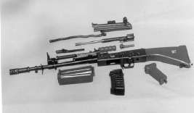

Hand Guard

Trigger Mech

Piston Grip

Mag

Cover

Handle Cocking

Body Housing

Rotating Bolt

Gas Tube

Barrel

Butt

Recoil Spring

Piston Extension

**INSAS RIFLE KE HISSE PURZE**

1. Yeh Rifle mote taur par 12 Assembly ki bani hui hai. Yeh assembly is prakar se hain:-

(a) Body Housing Assembly.

(b) Barrel Assembly.

(c) Handle Cocking Assembly.

(d) Piston Extension Assembly.

(e) Rotating Bolt Assembly.

(f) Recoil Spring Assembly.

(g) Trigger Mechanism.

(h) Cover Assembly.

(j) Butt Assembly.

(k) Pistol Grip.

(l) Hand Guard Assembly.

(m) Magazine Assembly.

1. 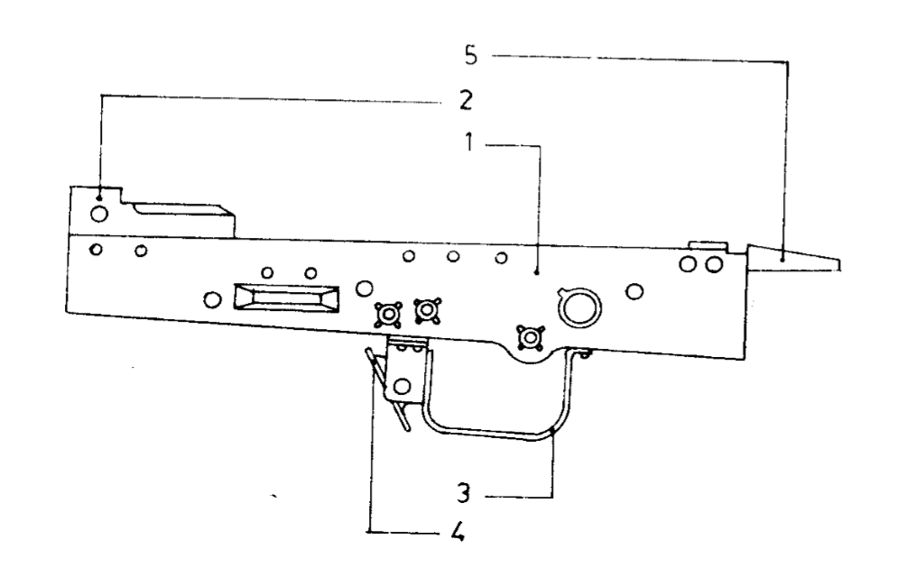**Body Housing Assembly.** Yeh sheet metal ki bani hui hai. Ismen ek piece guide hai jo ki rotating bolt ki rotation ko arambh karata hai. Iske hisse purze ke naam nimnlikhit hai:-
   1. Body Housing
   2. Barrel extension
   3. Guard Trigger & Catch Mag
   4. Spacer
   5. Block Rear

**Body Housing Assembly**

1. **Body Housing.** Yeh 1mm mota sheet metal ka bana hua hai. Iske niche magazine, trigger aur pistol grip fit kiye gaye hain.

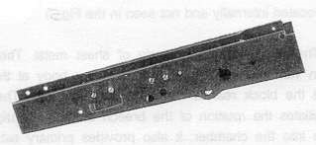

**Body Housing**

1. **Barrel Extension**. Yeh body mein rivet fitted hoti hai. Piece guide bhi ismein hi fit kiya gaya hai. Iske pichhle hisse mein do locking surfaces diye gaye hain jahan breech block lock hota hai.

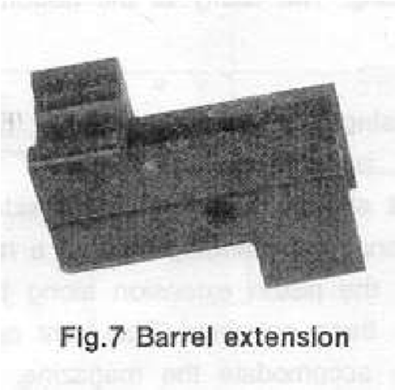

**Barrel Extension**

1. **Guard Trigger and Catch Magazine**. Trigger guard body housing ke niche rivet fit hai.Iske sammunitione ek spring loaded catch Magazine fitted hai.
2. **Block Rear**. Yeh body housing par rivetted hai aur yeh piston extension ki peechhe ki harkat ko rokta hai.

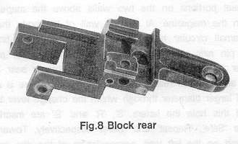

**Block Rear**

1. **Channel right and Channel left**. Channel right safety sear aur channel left ejector ko accomodate karta hai.

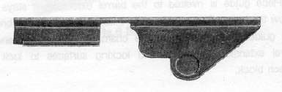

**Right Channel**

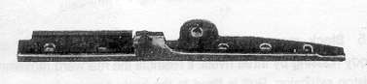

**Left Channel**

1. **Spacer**. Yeh ek cylinderical akar ka hota hai aur yeh body ko bulge hone se rokta hai.
2. **Barrel Assembly**. Ismen nimnlikhit hisse purze shamil hain:-
   1. 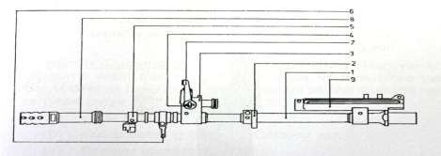Barrel
   2. Hand Guard
   3. Gas Regulator
   4. Lug Bayonet
   5. Loop Slip Front
   6. Fore Sight
   7. Flash Elimnator

**Barrel Assembly**

* + 1. **Barrel**. Goli ko sahi disha mein jane mein madad deta hai. Iske ander bane grooves aur land Goli ko spin deta hai jisse use stability milti hai.

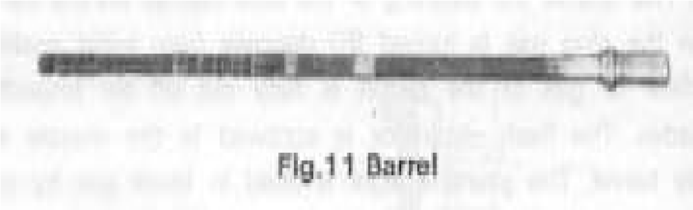

**Barrel**

* + 1. **Guard Hand wa Cup Hand Guard**. Rifle ko age se pakarne mein madad deta hai aur uske sir par ek Cup laga hua hai.

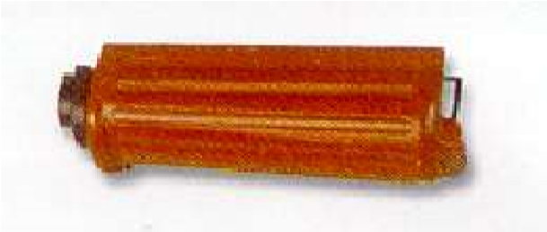

**Guard Hand wa Cup Hand Guard**

* + 1. **Block Gas wa Plug Gas**. Gas vent ke upar lagi puri assembly ko block gas kahte hain. Gas Block ke ander gas plug ko fit kiya gaya hai. Gas plug ke ander gas passage hole hota hai jisse gas cylinderinder mein dakhil hoti hai.

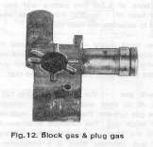

**Block Gas wa Plug Gas**

* + 1. **Gas Regulator wa Gas Escape hole**. Ismein exhaust type ka gas regulator hota hai. Gas regulator gas ki matra ko control karta hai iski do position hoti hai (Low & High). Isko low par karne se gas escape hole khul jata hai aur high par karne se escape hole band ho jata hai jisse piston head par gas ka dabav badh jata hai.
    2. **Lug Bayonet**. Bayonet fit karne ke kam ata hai.
    3. **Loop Sling Front.**  Sling lagane ke liye hota hai.
    4. **Fore Sight**. Gas Block ke upar fit hota hai. Yeh pole type ki hoti hai.
    5. **Flash Eliminator.** Paida hone wale shole ki tivrata ko kam karta hai wa Gren Projector ka kam bhi karta hai.

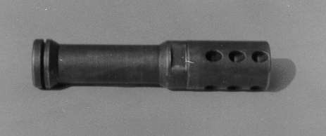

**Flash Eliminator**

(j)  **Gas Plug Operating Handle (Gren Sight)**. Gas plug ke hole wa gas vent ko saaf karne ke liye istemal kiya jata hai.

1. **Handle Cocking Assembly** . Cocking Handle Hathiyar ko cock karne mein madad deta hai. Slide ke agle hisse par ander ki taraf ek lug hota hai. Jo piston ko pichhe dhakelta hai. Iske hisse purze is parkar se hain:-

(a) Slide cocking handle.

* + 1. Catch cocking handle/Cocking lug.
    2. Plunger cocking handle.
    3. Pin cocking handle.
    4. Cocking handle/Piece.

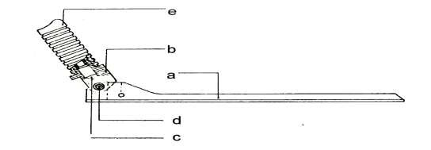

**Handle Cocking Assembly**

1. **Piston Extension Assembly**. Chal Wale purjon ko gas ke dabav se unlock wa pichhe ki harkat mein madad deta hai.Iske hisse purzon ke nam is prakar hain:-
   1. Piston.
   2. Piston Extension.
   3. Rivet Piston Extension.

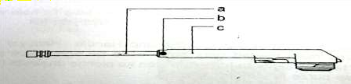

**Piston Extension Assembly**

1. **Rotating Bolt Assembly**. Yeh Assembly nimn hisse purzon se milkar bani hai.

(a) Rotating bolt.

* + 1. Extractor.
    2. Spring Extractor.
    3. Pin Extractor.
    4. Pin firing.
    5. Pin locking pin firing.
    6. Cam.
    7. Locking lug.

(j) Feed Piece

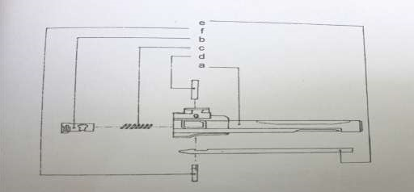

**Breech Block Assembly**

13. **Recoil Spring Assembly**. Recoil spring ke do guide hote hain. Dono  
 siron par stopper laga hota hai, guide piece ka agla sira stopper front se aur pichla sira stopper rear se laga hota hai.Is Assembly mein nimnlikhit hisse purze hote hain:-

(a) Spring recoil.

* + 1. Guide recoil spring.
    2. Retainer.
    3. Stopper.

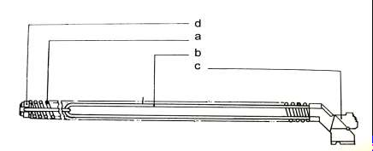

**Recoil Spring Assembly**

14. **Trigger Mechanism**. Trigger mech ko niminlikhat hisson mein banta  
 gaya hai:-

(a) Safety Sear.

* + 1. Spring safety sear.

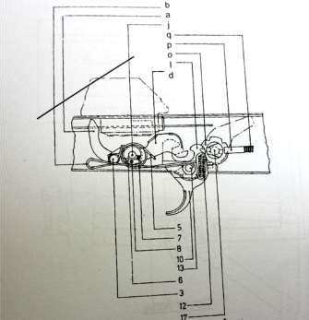

* + 1. Pin safety sear.
    2. Hammer.
    3. Spring hammer.
    4. Pawl hammer.
    5. Spring pawl hammer.
    6. Pin pawl hammer.
    7. Pin axis hammer.
    8. Trigger.
    9. Sear auxiliary.
    10. Spring sear auxiliary.
    11. Pin trigger sear.
    12. Wheel.
    13. Plunger.
    14. Spring plunger**.**
    15. Stud lever change.  **Trigger Mechanism**

1. **Cover Assembly**. Yeh nimnlikhit hisse purzon ki bani hui hai:-

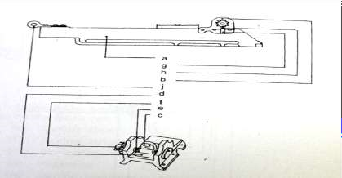(a) Cover.

* + 1. Housing rear sight.
    2. Rear sight.
    3. Leaf sping.
    4. Screw axis rear sight.
    5. Wheel.
    6. Plunger.
    7. Spring Plunger.

(j) Hinge.

**Cover Assembly**.

1. **Butt Assembly**. Butt Assembly ke parts is prakar hain:-

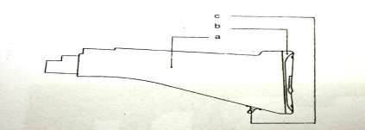

* 1. Butt.
  2. Butt Plate.
  3. Loop Sling Rear.
  4. Butt Trap.

**Fixed butt assembly**

1. INSAS mein folding butt bhi ata hai. Uske hisse purze is prakar hain:-
   1. 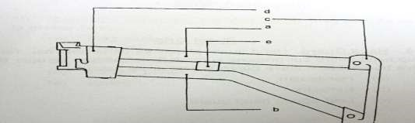Tube Upper.
   2. Tube Lower.
   3. Plate end Butt.
   4. Piece Hinge.
   5. Piece Strengthening.

**Foldable Butt Assembly**

1. **Pistol Grip wa Block Firing Pistol Grip**. Yeh plastic ka bana hota hai aur ek screw aur block ki madad se body housing ke sath butt aur trigger guard ke beech laga hota hai.

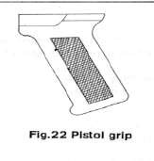

**Pistol Grip**

1. **Hand Guard**. Hand guard plastic ka bana hota hai. Yeh cup hand guard aur grooves ki madad se hathiyar ke upar fit kiya hua hai. Iske hisse purze is prakar se hain:-
   * 1. Handguard.
     2. Reflector.
     3. Leaf Spring hand guard.

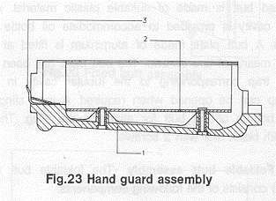

**Hand guard assemly**

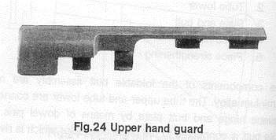

**Upper hand**

**guard**

1. **Magazine Assembly wa Magazine Catch** Magazine Assembly ke parts is prakar hain :-
   * 1. Magazine casing
     2. Plate form
     3. Retainer plate
     4. Bottom plate
     5. Spring

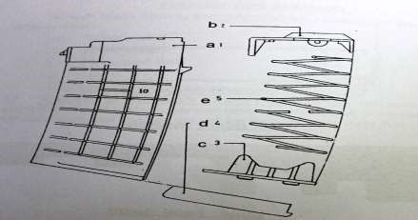

**Magazine Assembly**

**Bhag-III - Accessories**

1. Is hathiyar ke sath nimnlikhit accessories di gai hain:-

(a) Sling Carrying.

* + 1. BFA (Blank Firing Attachment).
    2. Muzzle Cover.
    3. Bayonet.
    4. Passive Night Sight (PNS) (Optional).
    5. Day Light Telescope (TDLS) (Optional).

1. **Sling Carrying**. Is Rifle ke sath nylon sling diya gaya hai.

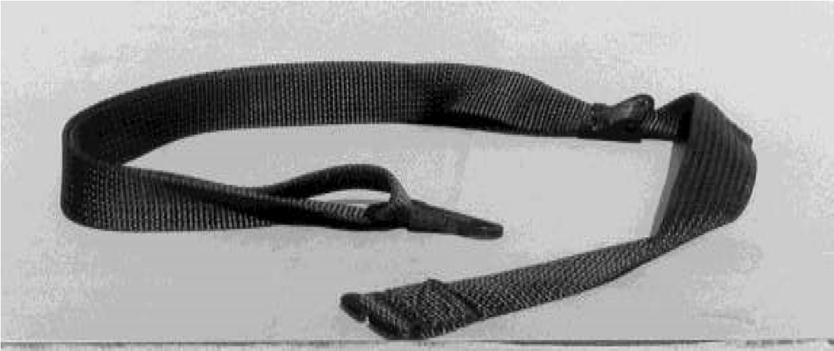

**Sling Carrying**

1. **Blank Firing Attachment**. Is ki madad se hum blank round automatic fire kar sakte hain.

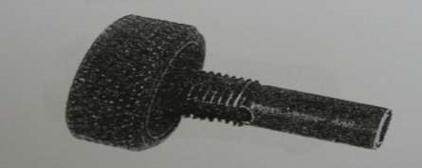

**Blank Firing Attachment**

1. **Muzzle Cover**. Ek sadharan plastic muzzle cover is Rifle ke sath diya hai. Yeh muzzle par slide fit ho jata hai. Yeh barrel mein dhool wa pani jane se rokta hai.

1. **Bayonet**. Isse nimn kamon mein istemal mein laya jata hai:-

(a) Dagger.

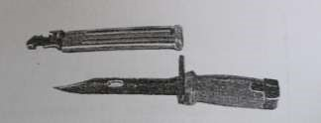

**Bayonet and**

**Scabbard**

* + 1. Wire cutter.
    2. Screw driver.
    3. Hammer.
    4. Saw.
    5. Bottle Opener.

1. **Passive Night Sight (Optional)**. Iska vivaran Appendix 'A' mein diya hai.

1. **Day Light Telescope (Optional)**. Iska vivaran Appendix 'B' mein diya hai.

1. **Tulanatmak Data**. 7.62 mm SLR aur 5.56 mm INSAS Rifle ka tulanatmak data Appendix 'C' mein diya hai.

**LESSON- 2 : EK NAZAR**

1. **Zaruri technical data: -**
   1. Wazan - 4.018 Kg.
   2. M/V - 900 m/s
   3. Penetration - 3mm 700 mtr par (MSP)
   4. 4 Prakar ka Ammunition fire hota hai.
   5. Bayonet multi purpose.

1. Yeh Rifle mote taur par 12 Assembly ki bani hui hai. Yeh is prakar se hain:-

(a) Body Housing Assembly.

* 1. Barrel Assembly.
  2. Handle Cocking Assembly.
  3. Piston Extension Assembly.
  4. Breech BlockRotating Bolt Assembly.
  5. Recoil Spring Assembly.
  6. Trigger Mechanism.
  7. Cover Assembly.
  8. Butt Assembly.
  9. Pistol Grip.
  10. Hand Guard Assembly.
  11. Magazine Assembly.

1. Is hathiyar ke saath niminalikhit accessories di gai hain:-

(a) Sling Carrying.

* 1. Blank Firing attachment.
  2. Muzzle Cover.
  3. Bayonet.
  4. Passive Night Sight (Optional).
  5. Day Light Telescope (Optional).

**LESSON 2**

**INSAS RIFLE AUR ACCESSORIES SE PARICHAY**

Q 1. 7.62 mm SLR aur 5.56 mm INSAS ke mukhya Farq likho?

Q 2. INSAS Rifle ke vibhinn assemblies aur hisse likho ?

Q 3. Nimnlikhit assemblies ke hisse aur unke kaam lilcho ?

1. Body housing Assembly.
2. Barrel Assembly.
3. Handle cocking Assembly.
4. Piston aur piston extension Assembly.
5. Rotating Bolt Assembly.
6. Recoil spring Assembly.
7. Trigger Mech.
8. Cover Assembly.

(j) Butt Assembly.

(k) Piston grip/Block firing piston grip.

(l) Hand Guard.

(m) Magazine Assembly.

Q 4. INSAS Rifle ke saath mein kya accessories aate hain?

Q 5. INSAS Rifle ke multi purpose bayonet ke kaam likho?

Q 6. Passive night sight ki vishestaen likho?

Q 7. Day light telescopic sight ki vishestaen likho?

Q 8. Under trial INSAS tracer arnn ka ek chitra banao?

Q 9. 5.56 mm INSAS cartridge ka kul wazan likho?

**LESSON - 3**

**5.56MM INSAS RIFLE KE AMMUNITION SE WAQFIAT**

**Ref - (Infantry Training Volume-I, Infantry Platoon Weapons Pamphlet No 6A)**

**Aam Bayan**

1. 5.56mm INSAS Rifle, LMG aur Carbine se ek hi kism ka ammunition fire hota hai. INSAS Rifle se 4 kism ka ammunition fire hote hai. INSAS mein Ball, Tracer, Blank, Ballistic/ HD Carts (High Density Carts) fire kar sakte hain.

**Uddesh**

1. 5.56mm ammunition ke bare mein jankari dena.

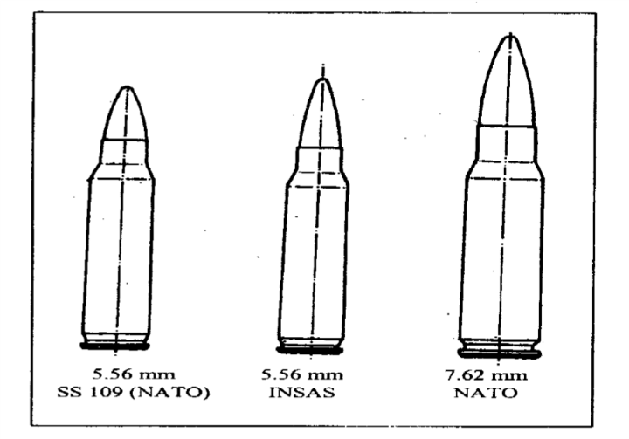

1. **Ball Ammunition**. Iska istemal tgt ko barbad karne ke liye kiya jata hai. 5.56mm INSAS ke liye ball ammunition ka mudda hai ki Rifle se fire karne par 400mtr tak kargar fire dalen. Yeh mudda hasil karne ke liye ball ammunition mein NATO ammunition ke banishpat yeh sudhar kiya hai:-

(a) Bullet ka ballistic shape zyada achha hai.

(b) Bullet ka mass zyada hai.

(c) Bullet inert steel ka banaya gaya hai taki zyada ghusav hasil ho sake.

1. Ball ammunition ka technical data :-

|  |  |  |  |  |
| --- | --- | --- | --- | --- |
| **Round** |  | **5.56 x 45 MM** |  | **5.56 x 45MM** |
|  |  | **INSAS MK I** |  | **FNSS109 NATO** |
| (a) Calibre |  | 5.56 x 45mm |  | 5.56 x 45mm |
| (b) Cartridge ki Lambai |  | 60mm |  | 57.3mm |
| (c) Cartridge ka wazan |  | 12.85g |  | 12.42g |

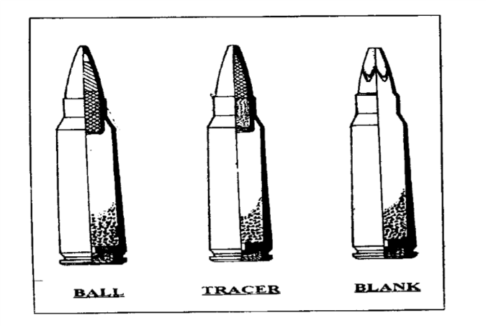

**Case 5.56 x 45 MM 5.56 x 45MM**

**INSAS MK I FNSS109 NATO**

* 1. Type Rimless bottle necked Rimless bottlenecked
  2. Lambai 45mm 45mm

**Bullet**

|  |  |  |  |  |
| --- | --- | --- | --- | --- |
|  | (a) Type | Boat Tailed | | Boat Talied |
|  | (b) Wazan | 4.16gm | | 4.00gm |
|  | (c) Lambai | 24.50mm | | 23.50mm |
|  | (d) Envelope | Gilding Metal | | Gilding Metal |
|  | (e) Core | Lead With Steel tip | | Lead With Steel tip |
|  |  |  |  |  |
|  | **Cap** |  |  |  |
|  | (a) Type | Boxer |  | Beroundan |
|  | (b) Composition | FA 956 |  | FA 956 |
|  | **Propellent** |  |  |  |
|  | (a) Type | Ball Powder |  | Ball powder |
|  | (b) Charge ka wt | 1.61gm |  | 1.65gm |
|  | **Ballistic Data** |  |  |  |
|  | (a) MV | 915 m/s |  | 945 m/s |
|  | (b) Mean Pressure | 335MPa |  | 330 MPa |
|  | (c) Max Rg | 3500m |  | 3500m |
|  | (d) Max Kargar rg | 1000m |  | 500m |

**Blank Cartridge**

1. Blank round trg ke dauran firing ki awaz ko darshane ke liye banaya gaya hai. Iska technical data is prakar hain:-

|  |  |  |  |
| --- | --- | --- | --- |
| (a) | **Cartridge** |  |  |
|  | (i) Wazan  (ii) Lambai | -  - | 8.1gm  57.5mm |
| (b) | **Case** |  |  |
|  | (i) Wazan  (ii) Lambai | -  - | 7.53gm 57.5mm |
| (c) | **Bullet** | - | Case ke sath shamil hai |
| (d) | **Propellant** |  |  |
|  | (i) Type  (ii) Wazan | -  - | SPA-II 0.480gm |
| (e) | **Primer** |  |  |
|  | (i) Type  (ii) Composition | -  - | Boxer Lead Styphnate FA 956 |
| (f) | **Sound Level** | - | 95db |
| (g) | **Safety Distance** | - | 3m |
| (h) | **Auto Firing** | - | Blank Firing attachment muzzle ke age fit |

1. **HD/Ballistics Carts.**. Istemal Rifle gren ko fire karne ke liye kiya jata hai. Iski banawat Blank round ki tarah hoti hai, lekin ismen propellant adhik hota hai.

1. **Tracer Round.** Tracer Round mar trajectory ko darshane aur firer ki accuracy ko dekhne ke liye banaya gaya hai.

**Gen Purpose Anti Personnel Grenade.**

1. INSAS 5.56 mm Rifle se gen purpose anti personnel gren bhi fire kiya jata hai. Yeh gren offensive aur defensive type ka hai. Offensive gren mein splinters nahi hote, jabki defensive gren mein splinters ek fragmentation sleeve mein hote hain. Yeh gren Rifle ya hath se launch kar sakte hain.

1. Technical data is prakar hai:-

(a) **Modes**. Offensive, Defensive aur Rifle modes, ek hi kism ka fuze aur HD carts se launch hota hai.

(b) **Wazan.**

|  |  |  |
| --- | --- | --- |
| (i) | Offensive Gren - | 270 g |
| (ii) | Defensive Gren - | 500 g |
| (iii) | Rifle Gren - | 675 g |

(c) **Size.**

|  |  |  |
| --- | --- | --- |
| (i) | Lambai - | 235mm with Tube Launching |
| (ii) | Max Diameter - | 60mm |

(d) **Fuze.** Percussion aur delay fuze arming delay 05 sec.

(e) **Lethality.** 4500 fragments hote hai. Ek fragment ka wazan   
 32-40 mg aur 8mtr tak maar sakta hai.

(f) **Safety.** 20 m se dur koi khatra nahin hain. Prime karne se pahle   
 para dropping ke liye istemal kar sakte hain.

(g) **Explosive.** 100 gm RDX/TNT (60:40).

1. **Offensive Gren**. Offensive gren tab fire kiya jata hai jab Kam ilake mein nuksan karna chahte hain. e.g. Def mein dushman ke upar assault karte samay.
2. **Defensive Gren**. Defensive gren ka istemal tab kiya jata hai jab dushman ka phailav jiada ho aur hum nuksan jiada ilake ke upar karna chahte hain.

1. **Safety**
   1. Para drop karna munasif hai.
   2. Fuze ko kitni bar bhi laga kar nikal sakte hain.
   3. Unprimed condition mein 100 pratishat safe hai.
   4. - 50 degree se 75 degree Celsius tak istemal kar sakte hain.
   5. Humidity ka koi asar nahin hota hai.
   6. 15 saal tak life hai.

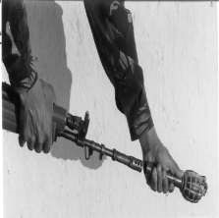

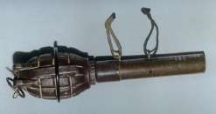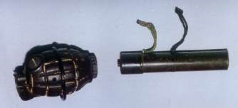

**Grenade Rifle No 36 & Tube Launcher 1A**

**Grenade Firing Position**

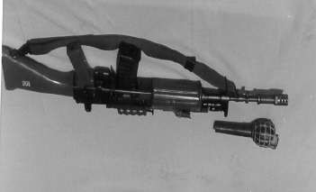

**Grenade Rifle No 36 Assembled on Rifle**



**Rifle 5.56mm (INSAS) & Rifle Grenade No 36**

**LESSON 3 : EK NAZAR**

**Ball Ammunition.**

1. 5.56mm INSAS ke liye ball ammunition ka mudda hai ki Rifle se fire karne par 400m tak kargar fire dalen. Yeh mudda hasil karne ke liye ball ammunition mein NATO ammunition ke banishpat yeh sudhar kiya hai:-

(a) Bullet ka ballistic shape zyada achha hai.

(b) Bullet ka mass zyada hai.

(c) Bullet inert steel ka banaya gaya hai taki zyada ghusav hasil ho sake.

**Gen Purpose Anti Personnel Grenade.**

2. INSAS 5.56mm Rifle se gen purpose anti personnel gren bhi fire kiya jata hai. Yeh Gren offensive aur defensive type ka hai. Offensive gren mein splinters nahi hote, jabki defensive gren main splinters ek fragmentation sleeve mein hote hain. Yeh gren Rifle ya hath se launch kar sakte hain.

3. **Offensive Gren.** Offensive gren tab fire kiya jata hai jab hum kam ilaqe mein nuksan karna chahte hon. e.g Def mein dusham apne ammunition ke upar assault karte samay.

4. **Defensive Gren.** Defensive gren ka istemal tab kiya jata hai jab dushman ka phailav ziada ho aur hum nuksan ziada ilake mein karna chahte hain.

5. **Safety.**

* 1. Para drop karna munasif hai.
  2. Fuze ko kitni bar bhi laga kar nikal sakte hain.
  3. Unprimed condition mein 100 pratishat safe hai.
  4. -50 Degree se 75 degree C tak istemal kar sakte hain.
  5. Humidity ka koi asar nahin hota hai.
  6. 15 sal tak life hai.

**LESSON 3**

**INSAS KA AMMUNITION**

|  |  |
| --- | --- |
|  |  |
| Q1. | INSAS Ammunition ki kismein likho? |
| Q2. | INSAS ammunition ka peak pressure kya hai? |
| Q3. | INSAS ammunition ka figure of merit kya hai aur kaise nikala jata hai? |
| Q4. | INSAS ammunition charge ki banawat likho? |
| Q5. | INSAS ammunition ke tracer Round ka chitra banao? |
| Q6. | INSAS am ki 7.62mm ammunition se tulna karen? |
| Q7. | INSAS ammunition ke cartridge ka kul wazan likho? |
| Q8. | INSAS ballistics Cart ka data likho? |

Q9. Blank cart ka technical data likho?

**LESSON - 4**

**5.56MM INSAS RIFLE KA KHOLNA, JORNA AUR SAFAI**

Ref - (Infantry Training Volume 1, Infantry Platoon Weapons Pamphlet No 3B Basic Marksmanship (The 5.56mm Insas Rifle) 2007)

**Pahunch.**

1. Assault Rifle ya Rifle 5.56mm INSAS, ek jawan ka jaati hathiyar hai. Iski dekhbhal karna jawan ki apni jawabdari hai. Iski maint kaafi aasan hai. Isko asani se khola aur joda ja sakta hai. Islie takih yeh hathiyar samay parne par kaam aa sake aur dhokha na de, iski safai karana bahut hi jaruri hai.

**Uddesh.**

1. 5.56mm INSAS Rifle ko kholna, safai aur jorne ka tarika sikhana hai.

**Saman.**

1. 5.56mm INSAS Rifle, Magazine, safai ka saman aur ground sheet.

**Bhagon Mein Baant.**

1. Yeh sabak teen bhagon mein banta gaya hai:-
   1. **Bhag I** - 5.56mm INSAS Rifle ko kholna.
   2. **Bhag II** - INSAS Rifle ka jorna.
   3. **Bhag III** - INSAS Rifle ka safai.

**Bhag-I - INSAS Rifle Ka Kholna.**

1. Rifle ko Kholne ka tarika is prakar se hai:-
   1. **Magazine kholna.** Magazine ko bayen hath se pakre aur magazine catch ko anguthe se age ki aur dabate hue nikalen.
   2. **Assembly cover kholna.** Rifle ko cock karen. Change lever ki position “S” par karen. Lever locking retainer ko bayen hath ki madad se dabayen aur dahine hath ke anguthe se retainer ko age ki aur dabayen. Jab retainer age aa jaye to locking retainer se dabav hata len, taki pichhe ka opening cover retainer se ajad ho jaye, Ab assembly cover ko upar ki taraf uthae aur age ki taraf kar len.
   3. **Recoil Spring Assembly ko Nikalna**. Retainer ko dabate hue recoil spring assembly ko bahar nikale aur spring aur guide ko alag karen.
   4. **Piston Extension Assembly ko Nikalna**. Piston extension ke pichhle hisse ko pakren aur upar ki taraf uthate hue bahar nikalen.

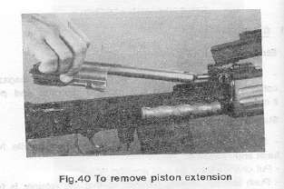

**Piston Extension ko nikaalna**

* 1. **Rotating Bolt ko Nikalna**. Is ke liye piston extension ko bayen hath se ulta pakren. Dahine hath se rotating bolt ko is ke recess se juda karen.
  2. **Firing pin ko kholna**. Locking pin ko drift ki madad se nikalen. Aise karne se firing pin bahar aa jaega.
  3. **Gas plug aur Gren Sight ko Nikalna**. Drift ki madad se pin fixing gas plug ko nikale aur gas plug ko dabate hue gas block ko bahar nikalen. Ab gren sight bhi alag karen.
  4. **Hand Guard kholna**. Hand guard ka agla kinara gas block ke pass cup hota hai. Pin locking ko sidha khara karen aur drift ki madad se isse bahar nikalen. Cup ko gas block ki taraf khiskate hue hand guard ko bahar nikalen.

(j) **Magazine Kholna**. Retainer dimple ko dabate hue bottom plate ko nikalen. Retainer spring aur plate form ko bhi bahar nikalen.

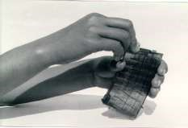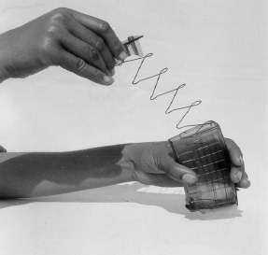

**Magazine Assembly**

**Bhag-II : Jorna.**

1. Rifle ke hisse purje jis tarah khole jate hain thik uske vipreet jore jate hain. Iske liye karwai is prakar karen:-
2. Magazine ko jorna (Agar khola gaya hai to).
3. Extractor aur firing pin ko jorna (Agar khola gaya hai to).
4. Hand Guard ko jorna.
5. Gas tube catch ko 900 main khada karen aur gas tube ko lagaye.
6. Piston extension aur rotating bolt ko jorna.
7. Piston extension assembly ko gas cylinder mein dakhil karen.
8. Recoil spring assembly ko housing way mein dakhil karen.
9. Cover Assembly ko band karna aur retainer ko lock karna.

(j) Magazine ko lagana.

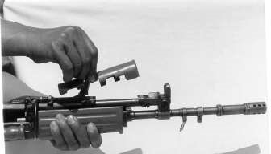

**Assembly Cover Kholna (Ref Para 5(b))**

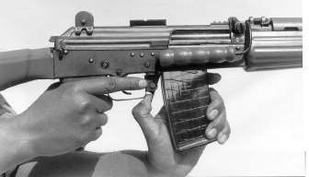

**Magazine**

**Kholna (Ref Para**

**5(**

**a**

**))**

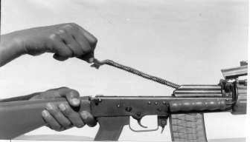

**Recoil Spring Assembly Kholna (Ref Para 5 (c))**

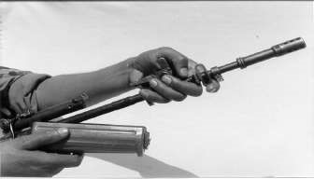

**Breech Block Assembly Kholna (Ref Para 5(e))**

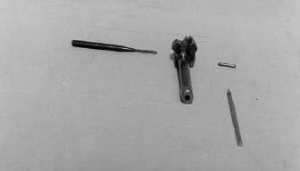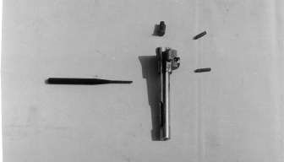

**Firing Pin Kholna (Ref Para 5 (f))**

**Extractor Nikalna (Ref Para**

**5(**

**g**

**))**

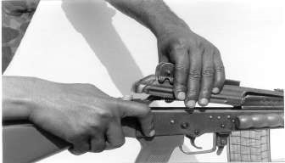

**Cover Assembly Kholna (Ref Para 5 (h)**

1. Rifle ke hisse purjon ko jorne ke baad Rifle ki janch is prakar karo.
   1. Magazine ko nikalen.
   2. Change lever ko “R” par karen.
   3. Rifle ko cock karen.
   4. Yakin karen ki piston extension puri tarah age gaya hai ya nahi.
   5. Change lever ko “S” par karen.
   6. Trigger ko dabane ki koshish karen woh nahi dabega.

**Bhag-III - Safai.**

1. Yeh jaruri hai ki Rifle ki thik tarah se saaf safai ki jaye aur usmein thik se tel lagaya jaye taki woh bina rukawat ke asani se chalai ja sake. Iski safai ke liye nimin likhit chijon ki jarurat paregi:-
   1. Oil “A” with oil bottle
   2. Brush cleaning bore
   3. Brush cleaning chamber
   4. Pull through
   5. Rod cleaning barrel
   6. Tool adjusting fore sight/rear sight
   7. Tool removing ruptured case
   8. Chindi

(j) Drift

**Note**. Rifle ki safai wa rakh rakhao mein kisi ghisne ya ragarne wali samagri ka istemal nahi karna chahiye.

1. **Safai ke parkar** 
   1. Aam Safai
   2. Firing ke lihaz se
   3. Mausam ke lihaj se

(a) Aam Safai

(i) Rojana ki safai

(ii) Weekly safai

(iii) Monthly safai

(b) Firing ke lihaj se

(i) Firing se pahle

(ii) Firing ke dauran

(iii) firing ke baad

(c) Mausam ke lihaj se

(i) High altitude

(ii) Desert

1. **Aam Safai**:-

**Firing se pahle ki safai**. Rifle ko field strip karke sabhi purjon ki safai karne ke sath sath unki tut fut ki janch karni hogi. Yeh Armourer ka kaam hai ki woh tut fut wale purjon ko badli kar den. Magazine aur ammunition ko bhi saaf karna chahiye aur uski tut fut ki janch karna. Niminlikhit ke anusar kuchh purjon mein tel diya jayega aur kuchh mein nahi diya jayega.

|  |  |
| --- | --- |
| **Purjon ko Tel Lagana** | **Purjon ko Tel Nahi Lagana** |
| Breach block face ko chor kar pure breech block. | Barrel |
| Magazine catch. | Cylinder Gas |
| Trigger Mech | Plug Gas |
| Recoil spring Assembly. | Piston extension Assembly. |
| Rifle ke bahar. |  |
| Magazine plate form Sight. |  |

1. **Firing ke baad**. Rifle ko field strip kar uski safai karen aur   
   pull through aur chindi ki madad se bore ko is prakar saaf karen ki usmen gilapan na rahe. Ab bore mein tel laga den. Brush cleaning cylinder mein tel lagakar usse cylinder gas ko saaf karen. Chindi aur pull through ki madad se cylinder ko is prakar saaf karen ki is mein gilapan na rahe. Jab safai ka kaam samapat ho jaye to Rifle ke andurni bhagon mein tel laga den. Gas se prabhavit purje jaise rotating bolt, gas plug, piston, piston extension aur firing pin ko savdhani se saaf kare taki unmein se gas fouling dur ki ja sake. Purjon ko saaf karne ke bad us mein tel lagana chahiye. Is ke alawa Rifle ke dusre hisse purjon ko kapra ya sutar ki madad se saaf karna chahiye. Rifle ki bahri satah ko tel wale kapre dwara jor se nahi ragarna chahiye. In jaghon se dhool jharne ke liye kapre ka istemal karna chahiye. Yadi Rifle nami ya dhul wale mausam mein pari rahi ho to uski magazine ko khol kar saaf karna chahiye. Agar magazine saaf dikhai deti hai to use bar bar kholne ki jarurat nahi hai.

1. **Asamanya Mausami Avastha**. Jyada thande mausam mein istemal karne ke liye Rifle ko karger banane ke liye uske sabhi purjon ko K/Oil aur OX 13 ke misran ko istemal karna chahiye. Iske atrikat Rifle se fire karne se pahle ek do bar cock kar lena chahiye.
2. **Lubrication**. Niminlikhit Tapman mein prayog karne wale lubricant ki suchi is prakar hai:-

|  |  |  |
| --- | --- | --- |
| **Istemal** | **Tapman** | **Lubricant** |
| Body aur trigger mech ke sabhi purje | 4 degree C se adhik tapmaan  4 degree C se -18 degree C  -18 degree C se -40 degree C  -40 degree C se -50 degree C | Oil OX 52  Oil OX 13  Oil OX 13 + Superior quality K/Oil 1:1(ASC/9140-000008)  Oil OX 13 + Superior quality K/Oil 2:3 |

**Chindi ka size.**

* 1. Safai ke lie - 4" x 1.5"
  2. Oil - 4" x 1"

1. **Instructor Note.**
   1. Sabak ke dauran Rifle ke jis hisse purje ka aap istemal karen usi hisse purje ka naam aur kaam sath-sath batate jao.
   2. Jawan ko batao ki Rifle ko cock karne ke liye cocking handle ko pura pichhe khinche aur pure taur par chhor den. Kabi bhi cocking handle ko pakre pakre purjon ko age na jane den.

**LESSON-4 : EK NAZAR**

**Rifle ko kholne ka tarika**

Magazine

¦

Assembly Cover

¦

Recoil Spring

¦

Piston Extension

¦

Rotating Bolt

¦

Firing Pin

¦

Gas Cylinder tube

¦

Hand Guard

¦

Magazine

**Rifle ko Jorna**

Rifle ko jis kram mein khola gaya hai uske ulte kram mein jora jae.

**Safai**

** Firing se pahle ki safai

** Firing ke bad ki safai

** Bhin bhin mausam ki safai

**LESSON-5**

**5.56MM INSAS RIFLE KE MAGAZINE KA BHARNA,**

**KHALI KARNA, RIFLE KA BHARNA, SIGHT LAGANA,**

**MAKE SAFE AUR KHALI KARNA**

Ref - (Infantry Training Volume 1, Infantry Platoon Weapons Pamphlet No 3B Basic Marksmanship (The 5.56mm Insas Rifle) 2007)

**Pahunch.**

1. Ek jawan ko 5.56mm INSAS Rifle ko kholna, jorna aur safai karne ka tariqa seekh lena hi kafi nahin hai. Balki tezi aur durusti se dushman par kargar kamyabi pane ke liye magazine bharna, sight lagana ana chahiye, taki Sighton ka sahi istemal karte hue fire kar sake. Sath hi trg ke dauran ya test fire ke dauran samne koi jandar bastu nikal aye to unko bachane ke liye make safe ka tariqa bhi ana chahiye. Is Rifle se bagair rim wala ammunition fire kiya jata hai. Ek carton mein 20 round ate hai. Kyonki yeh ammunition carton mein ata hai is liye is ammunition ko filler se nahi bhara jata hai.

**Uddesh.**

1. 5.56mm INSAS Rifle ke magazine ka bharna, INSAS Rifle ka bharna, khali karna, sight lagana aur make safe karne ka tarika sikhana hai.

**Samaan.**

1. INSAS Rifle, Magazine, drill carts, 1'x1' target, small pointer aur ground sheet.

**Bhagon Mein Baant.**

1. (a) **Bhag-I** - INSAS magazine ko bharna aur khali karna

(b) **Bhag-II** - Sight lagana aur uspar range hasil Karna (c) **Bhag-III** - Rifle ko bharna, ready, make safe aur khali karna.

**Bhag I - INSAS Rifle ki magazine ka bharna aur khali karna.**

1. **Ammunition ki Safai.** Round ko le aur samay hai to kisi saf kapare se ek-ek karke saf karen. Agar jaldi hai to kai roundon ki ek saath safai ki ja sakti hai lekin dhyan rahe ki ek dusare round mein gharshan nahi hona chahiye. Ammunition ko Saf karke ground sheet ya kisi saaf jagah par rakhe.
2. **Magazine ka Bharna*.*** INSAS Rifle ke magazine ka bharna aur khali karna huba-hu 7.62mm LMG ke tarah hai farq sirf itna hai ki 7.62mm LMG ka Magazine lohe ka bana hua hai aur yeh fiber glass ka bana hone ke karan round bahar se dikhai deta hai. Iske round carton ke andar hone ke karan filler ka istemal nahi kiya jata hai (Namuna bayan ke sath aur class sath sath naqal karega). Magazine ko len aur check karen. Magazine kahin se tuta hua to nahi hai, uske platform sahi aur spring thik kaam kar raha hai, agar in sabhi bataye gaye baton mein koi nuks hai to us magazine ka istemal na kiya jae. Agar sahi hai to use kisi saaf jagah par rakhen. Magazine ko len aur magazine ka chhotta mehrov apne taraf aur bara mehrov bahar ki taraf rakhte hue ground sheet, Raan ya boot ke toe ke upar rakhte hue donon hathon ke anguli aur angutha ke sahare se ek-ek kar ke round bharen. Bharte samay agar koi round gir jae to use bad mein saf kar ke magazine mein bharen. Yeh yakin karen ki round ka pichhla hissa magazine ke diwar ke andar wale bhag se laga hua hai. Is prakar ek magazine mein 20 rounds bhare ja sakte hai.
3. **Magazine ka khali karna.** (Namuna Bayan se) Magazine ko len bayen hath ki charo unguli bahar se angutha andar se grip karte hue chhote mehrov ko zamin ke taraf rakh kar ek round ke barkhilaf kisi nukili chiz se madhya mein dabayen round ko nikale. Khali karane ke liye agar round ka istemal kar rahe ho to ek do round ke baad badli kiya jae. Rounds ka girao saaf jagah par hona chahiye.

**Bhag-II Sight Lagana**

1. 5.56mm INSAS Rifle ke upar teen prakar ki sight system ki suvidha di gai hai.
   * 1. Open Sight
     2. Telescopic Day Light Sight
     3. Passive Night Sight
2. **Open Sight** (Class close karo aur sight sambandhi hisse purjon ke naam batao).
   1. **Front open sight**

(i) Fore sight tip

(ii) Locking nut

(iii) Fore sight protector

* 1. **Rear open sight**

(i) Housing rear sight

(ii) Rear sight

(iii) Leaf spring

(iv) Screw axis rear sight

(v) Plunger

(vi) Rivet

1. **Rear open sight** Rear open sight par do lips bane hue hain, pahle par 2 likha hua hai jo 200m ke range ko zahir karta hai. Dusra jismen 4 likha hua hai woh 400m ke range ko zahir karta hai. Agar 300m Range aur 100 mtr rg hasil karna ho to POA mein Tabdili karna parta hai. Yah agle lesson mein cover kia gaya hai.
2. **Telescope Day Light Sight (TDLS)**. Iske saath din ke samay durust, asan aur prabharshali tariqe se din ke samay fire kiya ja sakta hai. visheshtaen is prakar hain:-

|  |  |  |
| --- | --- | --- |
| (a) | Size - | 255mm lamba aur 65mm dia |
| (b) | Weight - | 485gm |
| (c) | Magnification - | 4x |
| (d) | Field of View - | 15 degree |
| (e) | Engagement - | Adj in Zeroing graticul provided |
| (f) | Engagement Range - | 400mtr |
| (g) | Principle - | Line of Sight |
| (h) | Exit Pupil Dia - | 6mm |
| (j) | Eye Clearance - | 40mm |
| (k) | Objective glass - | Refractive |
| (l) | Eye Piece - | Fixed focus Monocular Pattern |
| (m) | Temp:-  (i) Operating - (ii) Storage - | -40 degree C se +55 degree C  -40 degree C se + 70 degree C |

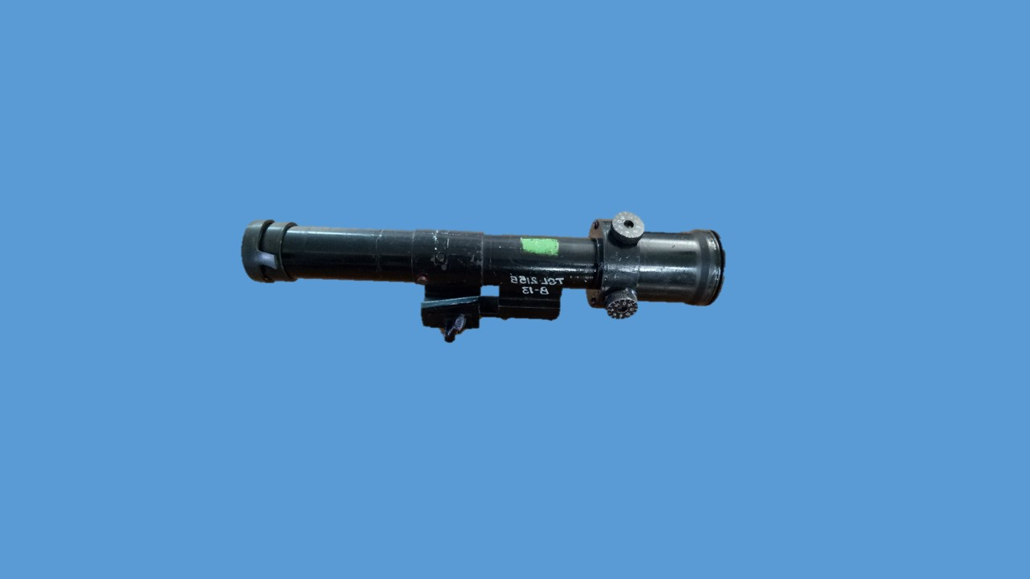

1. **Passive Night Sight**  (Optional). Iski visheshtaen yeh hain:-

|  |  |  |  |
| --- | --- | --- | --- |
| (a) | Weight - | 1.65kg | |
| (b) | Size - | 281mm long & 70mm dia | |
| (c) | Principle - | Image Intensification | |
| (d) | Field of view - | 10 degree | |
| (e) | Magnification - | 4x | |
| (f) | Range recognition - | 200mtr | |
| (g) | Detection - | 300mtr | |
| (h) | Bore sighting/zeroing - | Adjustment of the graticule for bore sighting/zeroing provided | |
| (j) | Exit pupil dia - | 6mm | |
| (k) | Eye Clearance - | 22mm | |
| (l) | Eye Piece - | Monocular variable focus | |
| (l) | Temp:-  (i) Operating - (ii) Storage - | -30 degree C se +45 degree C  -30 degree C se + 65 degree C |

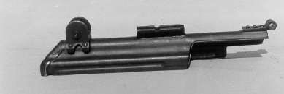

**MALE DOVETAIL**

**DOVETAIL ON COVER**

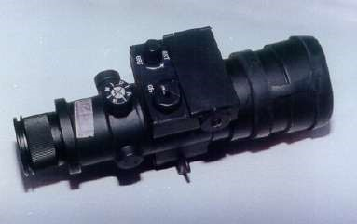

**AZUMATH KNOB**

**ELEVATION KNOB**

**BTY COMPARTMENT**

**OBJECTIVE GLASS & RUBBER COVER**

**EYE PIECE**

**ON/OFF SWITCH**

**PASSIVE NIGHT SIGHT**

**MOUNTING BRACKET**

**POTENTIAL METER**

1. **Night Beta Sight.** Raat mein tgt par roshni ho to open sight ki tarah istemal karke tgt ko engage kar sakte hain.

1. **Abhyaas.** Sabhi prakar ke sight ke dwara range hasil karne par abhyas liya jaega.

**Bhag-III - Rifle Bharna, Ready, Make Safe aur Khali Karna.**

1. Jab Rifle par bhari magazine ho aur change lever “S” par ho to Rifle bhari mani jati hai. Jab Rifle cock ho aur chamber ke ander round ho aur change lever “R” ya “B” par ho kalme wali unguli trigger per ho toh Rifle ready mani jati hai. Jab chamber mein round na ho, magazine khali ho aur change lever ki position “S” par ho to Rifle khali mani jati hai.

1. **Bhar ke hukam par karwai.** Jab Firer ko tgt dikhai de ya trg ke dauran adesh mile bhar to karwai is prakar karen (Namuna Bayan se) change lever ke position ko “S” par karen, Magazine catch dabate hue khali magazine ko utaren, pouch mein rakhen. Pouch se bhari magazine le mulazia karte hue magazine way mein dakhil karen. Yekin karen magazine thik baith gaya hai, pouch ka button band karen aur bayan hath fore hand guard par.

1. **Ready.** Ready us waqt kiya jata hai, jab firer fire karne ka irada rakhta ho, tgt dikhai de ya adesh mile ready toh ready ki karwai ki jati hai. (namuna bayan se) Ready ke adesh par change lever ka position ko ‘R’ ya ‘B’ par karen, Rifle ko cock karen, butt kandhe ka milap karen, kalme wali ungli trigger par aur agle hukum ka intzaar karen.

1. **Make safe.**
   * 1. Kalme wali ungli ko trigger se alag karen, butt kandhe ka milap tode, mag catch ko dabate hue bhari mag ko utare aur pouch main band karen.
     2. Rifle ko dahine turn karte hue do baar cock karen aur chal wale purjo ko aage jane den aur butt kandhe ka milap Karen aur trigger press karen.
     3. Change lever ka position “S” par karen.
     4. Bhari hui magazine ka mulahija karte hue Rifle par charha den.
     5. Zamin par gire hue rounds ko uthaen, saaf karen aur dusre magazine mein bhar den, magazine ko pouch mein band karen.

1. **Khali karna.** Khali kar ke hukam par make safe ki karwai karen par akhir mein bhari magazine ki jagah khali magazine charha den aur yeh karwai sawal-aur-jawab se karen.

1. (a) Class se swal-aur-jawab se.

(b) Class ko khas taur par yeh baten batai jayen:-

(i) Ammunition ki safai.

(ii) Teji aur durusti se Rifle ka bharna aur khali karna. Teji ke bajae durusti par jyada jor diya jae.

**LESSON 5 : EK NAZAR**

**SIGHTS INSAS RIFLE**

Open Sight Telescopic Sight PNS

***INSAS Rifle ki magazine Filler se nahin bhari jati hai***

**Make safe ki karwai ke ant mein bhari magazine charhai jati hai**

**Khali kar ki karwai ke ant mein magazine charhai jati hai**

**INSAS RIFLE KE MAGAZINE KA BHARNA, KHALI KARNA, RIFLE KA**

**BHARNA, KHALI KARNA, SIGHT LAGANA, READY MAKE SAFE AUR KHALI KARNA**

* 1. INSAS Rifle aur SLR ki magazine mein vibhinntaen likho ?

* 1. INSAS Rifle ke upar kitne prakar ke sight lagayi ja sakti hai ?

* 1. Open sigt ke hisse purjon ke naam likho ?

* 1. Bhar ke adesh par kya karwai ki jati hai ?

* 1. Ready ke adesh par kya karwai ki jati hai ?

* 1. Make safe ki karwai kab aur kaise ki jati hai ?

* 1. Make safe aur khali kar mein kya antar hai ?

* 1. Beta light sight kyon istemal ki jati hai ?

**LESSON-6**

**BHIN-BHIN POSITIONS SE 5.56 MM INSAS RIFLE**

**KI DURUST PAKAR HASIL KARNA**

Ref - (Infantry Training Volume 1, Infantry Platoon Weapons Pamphlet No 3B Basic Marksmanship (The 5.56mm Insas Rifle) 2007)

**Pahunch.**

1. Rifle ko kai position se fire kiya jata hai lekin position aisa hona chahiye kih asani se ikhtiyar kiya ja sake aur hathiyar par majbut pakar hasil kar sake. Larai ke maidan mein kis position ka istemal kiya jae woh banawati aur kudrati arh par nirbhar karega. Isliye har ek jawan ko arh ka istemal karte hue durust position lena aur har ek position mein hathiyar par durust pakar hasil karna ana chahiye.

**Uddesh.**

1. Bhinn bhinn positions se 5.56mm INSAS Rifle ki durust pakar hasil karne ka tarika sikhana hai.

**Saaman.**

1. Rifle 5.56mm INSAS, Magazine, Sling, Sand Bags, 1’x 1' tgts, fig 11 Tgts, trenches, sheet ground.

**Bhagon Mein Baant**.

1. **Bhag-I** : Lying Position.

**Bhag-II** : Kneeling Aur Sitting Position.

**Bhag-III** : Standing Position Aur Trench Ka Istemal.

1. **Lying Position**. (Namuna bayan se aur naqal) Kisi bhi position ke teen buniyadi usul hai :-

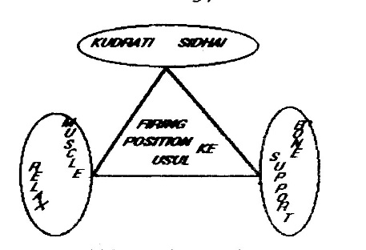

* 1. Bone Support
  2. Relaxed Muscles
  3. Kudrati Sidhai

Lying Position asani se ikhtiyar kiya jane wala aramdeh aur buniyadi position hai. Is position mein badan ka khaka chhota aur kafi niche banta hai jisse larai ke maidan mein nichi se nichi arh ke piche position lekar bhi dushman ke nazar aur goli se bachte hue apne hathiyar se dushman par kargar fire kar sakte hain.

1. **Position Lene ka Tarika**. Sabse pahle target ke sidh mein tgt ko dhyan mein rakhte hue khare ho jayen. Chalti halat mein bayen paon ko thora age aur bayen len sath hi Rifle ko bayen hath se badan ke samne is prakar uchhalen ki barrel takriban 45 degree ke angle par ho aur bayen hath se hand guard par pakren. Iske baad dahine hath se zamin ka sahara lete hue let jaen. Is position mein dekhne wali baaten is prakar hain:-
   1. Flash Eliminator zamin se upar ho.
   2. Badan tgt se tirchha ho.
   3. Badan ke niche koi chubhne wali chiz na ho.
   4. Paon kad ke mutabiq khule hon.

(e) Aur ho sake to eriyan zamin par baithi hui ho.

1. **Kudrati Sidhai**. Rifle ko dahine rakhen aur bayen hath ki kohni ko tab tak harkat den jab tak ki tgt bayen khoni aur dahina kandha aur tang ek line mein na aa jayen. Abhi dahini kohni ko lag bhag us jagah par rakhen jahan par ki khoni thora dahine aur dahina kanda ke niche rahe. Donon hathon ki hatheli ko thudi ke niche lagakar ankhen band karen aur badan ke tanav ko mehsoos karen yadi badan mein tanav hai to kohni usi jagah par rakhte hue badan aage ya piche ki harkat dekar tanav ko dur kiya jaye aur kohniyon ki jagah ko mark kar diya jae.

1. **Durust Pakar**. Rifle par pakar hasil karne ke liye Rifle ko kandhe mein jamayen aur bayen hath ki kalme wali ungli aur anguthe ke bich jo V banta hai wahan par use rakhe ki hand guard hatheli ke niche wali haddi par aa jae charon ungliyan bahar se aur angutha ander se sath hi magazine kalai se laga hona chahiye.
   1. **Bayen hath.** Bayan hath Rifle ko niche jaane se rokta hai aur hand guard ke niche support ka kaam karta hai.
   2. **Dayen Hath**. Dayen hath se pistol grip par is prakar pakare ki teenon unguliyan bahar se aur angutha andar se ho aur kalme wali unguli trigger guard kea aar par ho. Dayen hath ki unguliyan aur angutha ke beech ka hissa Rifle ke pistol grip par laga hona chahiye. Dahine hath se Rifle ko kandhe ki taraf khinch kar rakha jayen aur saath hi Rifle ko mazbuti se pakra jae.
   3. **Shir**. Shir ko butt par is prakar rakhen ki gal ka naram bhag butt par tik jaye. Sir se butt ko na dabaya jaye balki kewal sahara dene ke liye butt par rakha jaye. Yeh position butt par hamesha ek jaisa aur ek hi jagah hona chahiye.
   4. **Kandha**. Kandha butt ko tikane ke liye jagah deta hai aur Rifle ko pichhe jane se rokta hai. Kandhe mein jo gada banta hai wahan par butt ko rakha jaye nakih haddi (bone) ke uper.
   5. **Dahini kohni** Dahini kohni badan se dahine aur thora age ki taraf ho. Is prakar se donon kandhe taqriban barabari par honge aur firer ki position balanced rahti hai.
   6. **Saans.** Agar ham firing ke dauran am tariqe se sans lete rahen to chhati ke upar niche hone ki wajah se Rifle hilegi. Is lie fire karne se pahle ek lambi sans lo, thora sans chhoro aur phir sans ko rok do. Is ke bad shist lo aur fire karo. Lekin dhyan rahe ki sans ko zyada na roka jae aur isi dauran goli fire ho jani chahiye.
   7. **Puri Pakar ko Majboot karna**. Puri pakar mazboot karne ke liye bayen kohni ka loose maans ko kabu karne ke liye kohni ko zamin par jamate hue thora aage push karen. Dahine kohni ke loose maans ko kabu karne ke liye kohni ko apni taraf ya pichhe khinche abhi, agar Rifle upar ki taraf point karti to bayen hath ke kohni ko piche laye agar niche point kar rahi ho aage karen. Agar rifle dahine point kar rahi ho to dahine paon ko thora dahine karen aur bayen point kar rahi hai to bayen paon ko bayen karen. Khara hone ke liye bayen hath se Rifle ko dahine bagal mein layen sath hi bayen paon ko close karen. Dahine hath se zamin ko push karte hue khare ho jaen.

1. **Lying Supported Position**. Range par fire karte samay jawan ko pahle unsupported position lena chahiye uske baad hi badan ki unchai ke anusar arh lagaya jae. Support lagate samay dhyan rahe ki kudrati sidhai na bigre, sath hi agar support naram mitti ka hai to bayen hath ki kalai ko support ke sath lagaya jae aur agar support sakhat mitti ka hai to support par hand guard ko rakha jaye. Dhyan rahe ki support ke saath magazine na lage.

1. **Kewal Kohni Ka Support Dena** . Yadi Rifle ko unsupport position se zero kar liya jata hai aur uske baad usi Rifle se arh ka istemal karte hue fire kiya jae to goli POA ki jagah se upar lagti hai. Agar arh ke sath zero kiya jaye to unsupported fire karne se goli nishane ki jagah se niche lagti hai is liye Rifle ko elbow support se zero karna chahiye taki kisi bhi position par fire karne se goli POA ki jagah par hi lage. Kohni ko support dene ke lie karwai is prakar karen, pahle unsupport position ikthiyar karen uske baad bayan kohni ke aage ek char inch mottai tak ret ya mitti se bhare bag laga den jisse firer ko fg ke dauran kafi sthirta milegi lekin is position mein magazine support se nahi laga hona chahiye.

1. **Instructor Note**
   1. Agar jawan ka bayen hath “master hand” aur baen ankh “master eye” ho to jawan ko bayen kandhe se fire karne diya jaye.
   2. Abhyas ke dauran shist lene aur fire karne ki koshish na ki jaye.
   3. Agar jawan ki erhian zamin par puri tarah na jamen ya jamne mein taklif ho to woh apni position mein badli kar sakta hai

**Bhag-II : Kneeling aur Sitting Position.**

1. Samtal aur apne samne upar uthi hui zamin ki satah par nikalne wale tgt par fire karne ke liye, kneeling position sabse achhi position hai. Is position se hathiyar ke line of fire ki unchai ko badla ja sakta hai. Is position mein ilake mein darkhton, makanon ke kinaron aur motor gariyon ki madad se, hathiyar ko tham kar asani se fire kiya ja sakta hai.

1. **Kneeling unsupported position.** (Namuna bayan se aur naqal) Kneeling position ikhtiar karne ke liye tgt ki taraf face karo, bayen paon ko tgt ki sidhai mein karo, sath hi Rifle ko age uchhalte hue bayen hath main tol wali jagah se pakro, muzzle age aur uper ki taraf ho, ab dahine ghutne ko kafi dahine rakhte hue dahine ghutne par baith jao. Agar mumkin ho to badan ka bojh erhi par tikao. Bayen kohni ko bayen ghutne par is prakar tikao ki kohni ki haddi ghutne ki haddi se alag ho. Dahine hath se pistol grip ko pakro aur butt ko dahine kandhe ke gadde mein jamaon. Dahini kohini ko upar aur zamin ke samanantar rakho. Aisa karne se butt ko kandhe mein jamane ke liye kafi jagah milegi. Is position mein firer apni suvidha anusar dahine paon ki erhi ya pure paon par baith sakta hai.

1. **Kneeling supported position**. (Namuna bayan se aur naqal) Kneeling supported position ikhtiar karne ke liye sabse pahle kneeling position ikhtiar karo. Ab itna age harkat karo ki bayan hath aur baen tang support ke sath mil jaye. Rifle ka koi bhi hissa support ke sath nahi lagna chahiye, nahi to firer ko jaldi jaldi POA badli karne mein dikkat hogi.

1. **Sitting Position**. (Namuna bayan se aur naqal) Jab ki arh kneeling position se chhota ho aur dhalwandar zamin par position lena ho to aise mein sitting position ka asaani se istemal kar sakte hain. Dhalwandar zamin par position lete samay donon eriyon ko zamin par jama diya jae jisse badan ko sthirta mile. Position is prakar len, tgt ko dekhen, Baen paon ko tgt ke seedh mein karen, dahine paon ko dahine aur age se bayen hath se Rifle pakaren aur dahine hath se zamin par sahara lete hue baith jaen, bayen hath ki pakar ko durust karen aur uske baad dahine ghutne ko dahine kohni ke niche lagayen.

**Bhag-III : Standing position aur fire trench ka istemal**.

1. Standing position se ham tgt par us waqt fire karte hai, jab kisi dusri position se fire karna munasib na ho ya harkat ke dauran jab achanak tgt samne aye tabhi is standing position ka istemal kiya jata hai.

1. **Standing Position**. (Namuna bayan se aur naqal) Standing position ikhtiar karne ke liye tgt ki taraf face karo, adha dahine muro, sath hi Rifle ko uchhalte hue bayen hath se is prakar pakro ki muzzle asman ki taraf aur butt Kandhe ke samne ho. Paon qad ke mutabik khule hon. Ab dahine hath se pistol grip ko pakrte hue, butt ko dahine kandhe ke gadde mein tikao. Dahini kohni ko zamin ke sammantar upar uthao, taki kandhe mein butt ke liye achhi jagah bane aur Rifle ko majbuti se pakra ja sake. Is prakar Rifle ka jyada se jyada wajan dahine hath par hoga, bayen hath se Rifle ko baki positions ki tulna mein age se pakro. Aisa karne se Rifle ko sahara milega aur Rifle jyada nahi hilegi. Position ko akhri taur par thik karne ke liye, paon ko us waqat tak harkat do jab tak ki kudrati taur par nisana na le saken. Badan ka boj donon tangon par barabar hona chahiye.

1. **Standing in Fire Trench.** Morche main khara hokar apni kadh ke anusar morche ko set karen, iske bad badan ke bayen hisse ko morche ki agli diwar se lagayen. Dahine paon ko thora pichhe lete hue badan ko thora age dhakelen. Dono kohniyan trench se bahar zamin par jamaya hua aur chest ke wajan se kohnion ko daba kar rakhen. Is position mein hathiar ki pakar aur support lying position ki tarah hi hai.

**Instructor Note.**

1. **Wobble area.** Shist lete waqt, Rifle ki taraf ki harkat ki haad ke bich jo ilaqa banta hai, use wobble area kahte hain. Yeh harkat kudrati hai jis ko puri tarah dur nahin kiya ja sakta. Jitna zyada Rifle ko sahara milega, utna hi wobble area kam banega. Agar unsupported position se fire kiya jae, toh wobble area zyada banega, khas taur par us waqt jab standing position se fire kiya jae. Firer ka trigger ke dabane par pura cont hona chahiye, taki woh unhi chand sec mein fire kare, jab ki Rifle sabse kam harkat kare. Agar Rifle zyada harkat kare toh firer ko trigger ke dabao ko hataen, dobara shist len aur Rifle par kabu rakhte hue trigger par dabao dalen.Yeh banta hathiyar per hai aur mahsus tgt per hota hai.

**EK NAZAR : LESSON - 6**

**Lying Position**

** Aram deh aur bunyadi

** Kudrati sidhai

** Durust pakar

** Sans lene ka tarika

** Muscle relax

**EK GOLI : EK DUSHMAN**

** Kneeling supported position

** Standing in Fire Trench

### LESSON-7

**5.56MM INSAS RIFLE SE SHIST LENA AUR FIRE KARNA**

Ref - (Infantry Training Volume 1, Infantry Platoon Weapons Pamphlet No 3B Basic Marksmanship (The 5.56mm Insas Rifle) 2007)

**Pahunch**

1. Achook nishane baji ka dusra usul hai durust shist. Agar ek firer, durust position aur pakar hasil karne ke bad durust shist lekar fire karta hai to woh, ek goli ek dushman, ka mudha hasil kar sakta hai. Agar ek jawan squad post par durust shist lene ki sikhlai achhi tarah paya huwa hai to woh yeh mudda asani se hasil kar sakta hai.

**Uddesh**

1. 5.56mm INSAS Rifle se shist lena aur fire karne ka tarika sikhana hai.

**Saman**

1. Rifle, Magazine, Aiming Rest, Aiming Box, Aiming disc, Aiming corrector, Sight picture ka board, Shist ki galti ka board, sahi shist ka board, Pencil, Rubber, Easal, Black board, Chalk, Duster, Pointer, 1’x1' Target, Sheet ground.

**Bhagon mein bant**

|  |  |  |
| --- | --- | --- |
| 4. | (a) **Bhag-I** | - Durust Shist Lena. |
|  | (b) **Bhag-II** | - Shist lete samay hone wali galtiyan aur sudharak exercise. |
|  | (c) **Bhag-III** | - Fire karne ka tariqa. |

**Bhag-I : Shist lena**

1. Firer apne ankh aur dimag ka sahi talmel karke, Rifle ki sighton ka sahi istemal karte hue shist ko POA par milane ki karwai ko shist lena kahte hai.

1. **Durust Shist ka Qaida**. Muqarar shudha position ikhtiyar karen, Rifle ko mazboot wa sidha pakaren, Aperture ke madhya se tgt ko dekhen aur tgt ka khaka apne dimag mein bithayen. Fore sight tip ko aperture ke madhya mein rakhkar, tip ko POA par milayen, wapis nigah fore sight tip par jamayen. Jab firer shist leta hai to do karwai ko amal mein lata hai:-

(a) **Sight Alignment**. Jab ek firer back sight aperture ke Madhya mein fore sight tip ko milata hai, yani ki firer ki ankh, back sight aperture ka madhya aur fore sight tip ko ek line mein milane ki karwahi ko **sight alignment** kahte hain. (Sight alignment and sight picture model par).

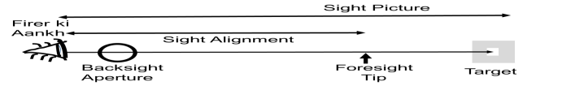

* 1. **Sight Picture**. Durust align ki gai sight ko POA par milane ke karwahi ko sight picture kahte hain, yani ki firer ki aankh, back sight aperture ka Madhya, fore sight tip aur POA tak jo farziya line banti hai use **sight picture** kahte hain (Sight alignment aur sight picture model par).

**Bhag-II : Shist lete Samay Hone Wali Galtiyan aur sudharak exercises**.

1. Jab ek firer sahi shist lekar fire karta hai, kabhi kabhi uski goli uske POA se hatkar lagti hai. Iska karan anya takniki karanon ke sath sath firer ki ankh ki khasusiyat par nirbhar hai. Har ek insan ki ankh mein yeh kamzori hai ki, ankh ek hi samay mein do nishanon ko joki alag alag fasle par ho, focus nahin kar sakta hai. Isi ko mahsus karne ke liye aap apne bayen hath ke anguthe ko khara rakhte hue tgt par POA par dekhen to aapko anguthe ka nakhun dhundla dikhai dega aur jab aap anguthe ko dhyan se dekhte hue POA ko dekhenge to POA dhundla dikhai dega.

1. Isi prakar jab jawan POA ko dhyan se dekhta hai to use fore sight tip dhundla nazar ata hai, jisse woh tip ko aperture ke madhya mein na rakh pane ki galti kar deta hai, ise sight alignment ki galti kahte hai. Lekin jawan jab fore sight tip ko aperture ke madhya mein rakhne par jor deta hai to use POA dhundla dikhai deta hai. Is halat mein jawan POA ke chunao ki galti kar deta hai. Ise sight picture ki galti kahte hai.

1. Dono galtion se goli POA se hatkar lagti hai, ab yeh jan lena zaruri hai ki achhe fire ke liye kis ki ahmiyat jiada di jaye.

1. Larai ke maidan mein agar ek jawan sight picture ki galti karta hai toh bhi goli target par hit hogi kyonki yeh galti har range par ek jaisi hi hoti hai. Lekin sight alignment ki galti karne se goli target bhi chhor sakti hai. Kyonki yeh galti badhte range ke sath sath badhti chali jati hai, is liye sight picture ke banispat sight alignment ki ahmiyat jiada hai.

**Sudharak Exercises**

1. (a) **Aiming Box Exercise.** Sight alignment ki galti karne wale firer ko aiming box ex diya jata hai. Is ex mein firer short aiming rest ke pichhe position leta hai aur rifle short aiming per fit hoti hai, muzzle end se 10 mtr ki duri per aiming box rakha jata hai aur box per lage safed kagaz ka size 6” x 6” hota hai. Firer ke ishare ke mutabik coach aiming disc ko white kagaz per harkat deta hai. Jab aiming disc ka POA firer ki align ki gai sight ke mutabak aa jata hai to firer stop kahta hai aur coach aiming disc ki surakh se nishan laga deta hai. Yeh karwai teen bar ki jati hai. Aisa karne par agar firer ka gp ka size 6mm ka banta hai to sight alignment ki karwai sahi hai.

(b) **Aiming Corrector Exercise.** Sight picture ki galti karne wale firer ko aiming corrector ex diya jata hai. Is ex mein Rifle ki back sight ke pichhe aiming corrector lagaya jata hai. Iske bad coach firer dwara li gai shist ko check karta hai aur zarurat sudha correction dekar durust karwata hai.

**Bhag-III : Fire karne ka tariqa**

1. **Trigger Operation**. Yeh Rifle SLR ke banispat chota hone ke karan trigger dabate samay zyada control ki zarurat padti hai. Is rifle se single shot aur teen rds control burst fire kiya jata hai. Trigger ke do khinchav hain pahla halka aur dusra sakhat khichav. Jyon hi firer ko tgt dikhai deta hai to pahle khinchav ko hasil kar leta hai. Jyon hi shist tgt ke madhya main mil jati hai to dusre khinchav ko hasil karta hai (dekhen is parkar). Trigger dabate samay barrel harkat nahin karni chahiye. Is prakar trigger par 2.1 kg ka dabav aane par trigger press ho jata hai. Jis prakar se trigger ko dabaya gaya hai usi prakar aram se trigger ko release bhi kiya jaye (dekhen is parkar) is karwai ko **short release** ki karwai kahte hain. Galat trigger operation ki karwai karne wale firer ko Tin disk ex di jati hai. Firer lying posn ikhtiyar karne ke baad bhar aur ready ki karwai karta hai. Coach barrel ke upar tin disc rakhta hai aur firer se trigger press karne ko kahta hai. Firer dwara trigger press karne par agar tin disc nahi girta hai toh firer ke trigger operation ki karwai sahi mani jati hai. Yeh karwai bhi teen baar karai jati hai. Agar do baar tin disc nahi girta hai to trigger operation ki karwai sahi mani jati hai. Tin disc ka dia 10mm aur wt 2.5gm hota hai.

**Fire Karna**

1. Alag alag halaton mein nikalne wale target par kargar fire dalne ki kabiliyat ke lihaj se is Rifle ko banaya gaya hai. Is Rifle se do kisam ka fire kiya jata hai:-

(a) Single shot.

(b) Three Rds Control Burst.

1. **Single Shot Fire** (Namuna bayan se sath).
   1. Sahi position ikhtiyar karen.
   2. Natural alignment check karen.
   3. Hathiyar ko bhar aur ready, sahi sight alignment aur sight picture hasil karen.
   4. Dimagi taur par sharir ke un angon ko check karen jo Rifle ko pakrne mein madad karte hain. Jaise bayen hath, dayen hath, kandha, aur sir.
   5. Ab sans ko normal halat mein chalne do taki yeh pata chal jaye ki position thik hai. Back sight aperture ke madhya se fore sight tip ko POA par milao. Abhi fore sight tip back sight apreture ke madhya mein dikhai dena chahiye aur normal sans ke chalte hue fore sight tip POA ke 12 baje aur 6 baje harkat karni chahiye.
   6. Trigger ka pahla khichav hasil karen aur kuch samay ke liye sans roken aur trigger ke dusre khinchav ko bhi hasil Karen. Goli fire hone ke baad, usi position, pakar aur shist ko kayam rakhte hue foresight tip ki movement ko check karen. Foresight tip jaha point kar raha hai goli takriban usi jagah par lagi hogi. Ab sans ko chhor den aur maar ko pukaren. Goli fire hone se maar pukarane tak ki karwai ko follow through kahte hain. Is parkar se single shot mein 1 min mein 60 rds ke hisab se fire kiya ja sake.

1. **Stop**. Fire ke dauran tgt wale ilake mein achanak koi jandar vastu nikal aye ya trg ke dauran aadesh mile stop to karwai is parkar Karen:-
   1. Kalme wali ungli ko trigger se bahar nikale.
   2. Rifle ko kandhe se niche laen aur change lever ki position ko “S” par karen.
   3. Iska magazine ardh pardarshi hone ke karan mag ka yakin karne ki zarurat nahi padti. Agar mag khali hone wala hai toh mag ki badly karen aur agle hukam ka intezar karen.

1. **Go On**. Agar tgt ilake se jandar vastu hat jae ya trg ke dauran aadesh mile ‘GO ON’ to change lever ki posn ko pahle wali posn mein karen aur butt kandh ka milap karen aur Rif ko fire mein shamil karen.

1. **Three Round Control Burst**. Control burst fire mein ek baar trigger dabane se teen rds fire hote hain aur agla agla burst fire karne ke liye trigger ko release karne parta hai. Burst fire mein ‘Stop’ aur ‘Go on’ ki karwai single shot ki tarah hi hoti hai, ismen har ek rd ka follow through nahin kiya ja sakta hai. Cont burst fire mein ek minute mein 90 rounds fire kiya ja sakta hai.

1. Stop aur go on ki karwai hu-ba-hu single shot fire ke tarah hi hai, sath hi har ek round ko follow through nahi kiya ja sakta hai. Point 3 sling support position se le jana bahut hi behtar hai, is position mein Rifle chhota ho jata hai aur donon hath free hote hain, saath hi zarurat parne par teji se fire kar sakta hai.

**LESSON-7 : EK NAZAR**

**Durust Shist**

SIGHT ALIGNMENT

SIGHT PICTURE

SHIST KA QAIDA

|  |
| --- |
| **SUDHARAK EXERCISE** |
| SATS |
| AIMING BOX EXERCISES |
| AIMING CORRECTOR EXERCISES |
| TIN DISC |
| **FIRE KE PARKAR** |
| SINGLE SHOT |
| THREE ROUND CONTROL BURST |

**LESSON - 7**

**INSAS RIFLE SE SHISHT LENA AUR FIRE KARNA**

|  |
| --- |
| Q1. Shist ka quaida likho? |
| Q2. Nimnlikhit ki paribhasha likho:-  (a) Sight Alignment  (b) Sight Picture |
| Q3. Manav ankh ki critical focus aur finge of vision se aap kya samajhte hain? |
| Q4. Ek firer firing ke dauran kya galtian kar sakta hai? |
| Q5. Sight alignment aur sight picture ki galti ki sudharak ex kya hain? |
| Q6. INSAS Rifle ke trigger operation ka tariqa likho? |
| Q7. INSAS Rifle se kitne prakar ka fire kiya jata hai? |
| Q8. Rifle se single shot aur TRB fire karne ki tartib likho? |

.

**LESSON 8**

**5.56MM INSAS RIFLE KI CHAL AUR ROKEN**

Ref - (Infantry Training Volume 1, Infantry Platoon Weapons Pamphlet No 3B Basic Marksmanship (The 5.56mm Insas Rifle) 2007)

**Pahunch**

1. 5.56mm INSAS Rifle gas ke dabav aur recoil spring ki taqat se chalne wala hathiyar hai. Larai ke maidan mein is hathiyar se bhari tadad mein single shot aur burst fire karke dushman ko barbad kiya ja sakta hai. Lekin hathiyar ek machine hai isliye is mein firing ke dauran chand ek roken pad sakti hain. Isliye zaruri hai ke is hathiyar ka pura faida uthane ke liye jawan ko is hathiyar ke bare mein puri jankari ho, taaki rokon ko asani se dur kar saken.

**Uddesh**

1. 5.56mm INSAS Rifle ki chal, padne wali roken aur unhen dur karne ka tariqa sikhana hai.

**Saman**

1. 5.56mm INSAS Rifle service, 5.56mm INSAS Rifle sectionised, Mag, Drill Carts, Accessories pouch, 1'x1’ Target, Board, Chalk, Duster aur   
   Ground sheets.

**Bhag mein bant**

1. Yeh sabak char bhagon mein banta gaya hai:-

(a) **Bhag-I.** INSAS Rifle ki chal.

(b) **Bhag-II**. Fouri ilaj ki karwai aur sakhat khichav ki rok.

(c) **Bhag III.** Gas ki kami ki rok.

(d) **Bhag IV.** Anya roken.

**Bhag-I : 5.56mm INSAS Rifle ki Chal.**

1. 5.56mm INSAS Rifle ki Chal 8 action mein puri hoti hai. (Ustad ke dwara board ki madad se bataya jaye).

**FIRE**

**UNLOCK**

**EXTRACT**

**EJECT**

**FEED**

**LOAD**

**LOCK**

**COCK**

**CHAL**

1. Rifle ki chal mein kaam karne wale hisse purzon ke naam. Change lever, Trigger, Ejector, Gas vent, Gas Plug, Gas cylinder, Hammer, Hammer vent, Safety sear, Sefety sear ki notch, Rotating bolt, Extractor, Feed piece, Firing pin, Cam, Locking lug, Piston extension, Piston head, Cam way, Stem, Bottom surface, housing way, Piston Extension ka dahina, pichla aur nichla wala pehlu, Recoil spring, Barrel extension locking surface, Chamber, Magazine aur Magazine ke upar wala round.

(a) **Fire.** Jab firer change lever ki position ko ‘S’ se 'R' ya 'B' par karke trigger ko press karta hai toh hammer azad ho jata hai. Hammer azad hokar firing pin ke pichhe wale bhag par thokar marta hai, jisse firing pin apne hole se nikalkar chamber wale round ke primer par thokar marta hai aur round fire ho jata hai. Is karwai ko **fire** ki karwai kahte hain.

(b) **Unlock.**  Fire huye round se gas paida hoti hai, joki bullet ko barrel mein aage dhakelti hai. Jab bullet gas vent ke pass se gujarta hai to kuch gas, gas vent, gas plug se hokar gas cylinder mein dakhil hoti hai. Kuch gas bullet ko target tak pahuchane mein madad karta hai. Gas cylinder mein dakhil hui gas piston head par dabav dalti hai jisse piston extension piche ki harkat karta hai. Jab piston extension piche ki

harkat karta hai to rotating bolt ka cam, cam way ki madad se dayen se bayen ko itna ghumta hai ki rotating bolt ka locking lug barrel extension locking surface se alag ho jata hai. Is karwai ko **unlock** ki karwai kahte hain.

(c) **Extract.** Unlock hone ke baad rotating bolt aur piston extension ek saath piche ki harkat karte hain, isji dauran extractor fired case ko piche lata hai, is karwai ko **extract** ki karwai kahte hain.

(d) **Cock.** Chal wale purzon ke pichhe ki harkat jari rahti hai. Is harkat ke dauran piston extension ka stem shuru shuru mein hammer ko thora niche dabata hai baad mein piston extension ka bottom surface hammer ko pura niche daba deta hai, jisse safety sear ki notch ka milap hammer ke vent se ho jata hai. Is karwai ko **cock** ki karwai kehte hain.

(e) **Eject.**  Chal wale purje ki isi harkat ke dauran fired case ejector se takrakar ejection slot ke raste dahine aur niche gir jata hai, is karwai ko **eject** ki karwai kehte hain.

(f) **Feed.**  Recoil spring apne hoUusing mein sikur jata hai aur recoil spring guide over lap ho jate hain. Jab recoil spring apne tanav ko pura karta hai to chal wale purzon ko aage ki taraf dhakelta hai, aage ki harkat ke dauran Rotating bolt ka feed piece magazine ke upar wale round ko chamber mein dakhil kar dete hai. Is karwai ko **feed** ki karwai kahte hain.

(g) **Load.** Extractor chamber wale round ke pende par sawar ho jata hai, Is karwai ko **load** ki karwai kahte hain. Yahan par Rotating bolt ki aage ki harkat samapt ho jati hai lekin Piston extension ki aage ki harkat baki rahti hai.

(h) **Lock.**  Piston extension ki aage ki harkat ke dauran rotating bolt ka cam, cam way ki madad se bayen se dayen itna ghumata hai ki rotating bolt ka locking lug, barrel extension locking surface ke sath lock ho jata hai. Is karwai ko **lock** ki karwai kahte halin. Lock hone ke baad bhi piston extension ka kuch harkat baki rahta hai. Is akhiri harkat ke dauran piston extension ka dahina, pichla aur nichla wala pehlu safety sear par dabav dalta hai, jisse safety sear ka notch, hammer ke vent se alag ho jata hai aur rifle dubara fire ke liye taiyar ho jata hai.

1. Abhyas puri class ko den.

**Bhag-II : Fouri ilaj ki karwai aur sakhat khichav ki rok**.

1. 5.56mm Insas rif ki samay samay par saaf safai ki jaye aur amn ko saaf karke bhara jaye to bahut hi kam roken parti hain lagatar firing ke duran agar chand ek roken par bhi jayen to ek firer rokon ko kis parkar se door karta hai issi karwai ka namuna hathiyar par bayan ke saath doonga aap dekhen thatha samjhen, lying posn, bhar, sight rg 200, ready, samne 1’ x 1’ tgt, fire.
2. Sune trigger press karne par rifle fire na kare ya fire karte-karte ruk jaye to fouri ilaj ki karwai ki jayegi.

**Karne ka tarika**. Sabse pahle kalme wali anguli ko trigger se bahar karen. Butt aur kandhe ka milap toden. Rifle ko dahine turn karte hue cock karen aur holding opening device ko lagayen. Magazine catch ko dabate hue magazine ko utaren aur pouch mein band karen. Pouch se bhara hua magazine len, mulaiza karte huye magazine way mein fit karen, yakin karen magazine lag gaya hai. Chal wale purjon ko aage jane den. Butt aur kandhe ka milap karen. Rifle ko fire mein shamil karen. Rifle thik fire karega. Is prakar rifle ko ek bar cock karke, holding opening device lagakar, khali magazine ki badli karne se teen prakar ki roken dur ki jati hain:-

* + 1. Magazine ki rok.
    2. Misfire.
    3. Body mein atka hua round ya fired case.

**Sakhat khichav ki rok**. Fouri ilaj ki karwai karne ke baad bhi Rifle thik fire na kare ya fire karte karte chal wale purje aage hi ruk jayen to rok ko pehchane. Pehchane ka tariqa, sabse pahle kalme wali anguli ko trigger se alag karen. Butt aur kandhe ka milap toden. Rifle ko dahine turn karte hue cock karen, Rifle asani se cock nahi toh sakhat khichav ki rok samajkar dur karen.

**Karne ka tarika**. Rifle ko niche rakhen. Kneeling position ikhtayar karen. Rifle ko bayen hath se uthayen. Is position mein dekhne wali baten. Rifle takriban 45 degree ke angle par barrel aasman ko point karta huwa. Bayen hath ki pakar fore hand guard par charon anguli niche se angutha upar se barrel ko point karta huwa. Ejection slot zamin ke taraf point karnta hua. Rifle ka butt dahine ghutne ke sath laga hua. Dahina ghutna butt ko pichhe jane se rokta hai. Dahine hath ki madad se cocking handle ko upar uthayen. Charon angulion ka hook banate huye rifle ko ek hi jhatke mein cock karen. Yakin karen ki sakhat khichav ki rok dur ho gaya hai. Chal wale purjon ko aage jane den. Rifle ko niche rakhen. Pahle wala firing position ikhtiyar karen. Butt aur kandhe ka milap karen. Rifle ko fire mein shamil karen rifle thik fire karega. Sakhat khichav ki rok padne ke karan:-

* 1. Ganda chamber.
  2. Maila Ammunition.

Yeh tha fouri ilaz aur sakhat khinchav ki rok ko dur karne ka tariqa yahan tak kiye gaye bayan aur karwai main kisi bhi student ka koi sawal, sawal nahi toh yeh tha namuna abhi hoga isi ka abhyas, Abhyas ke liye aadesh is prakar honge. Rifle thik fire karta rukta ke aadesh par fouri ilaj mein rifle ko cock karke holding opening device lagane tak ka karwai kiya jayega. Ustad ke dwara rok ka naam diya jayega aur students ke dawara rok ko dur kiya jayega. Jaise

* + 1. Magazine ki rok ke adesh par magazine ko badli kiya jayega.
    2. Eject hua round ke adesh par round ke primer ko check kiya jayega.
    3. Body mein atka hua round ya fired case ke adesh par body ko clear kiya jayega.
    4. Cock nahin ke adesh par sakhht khichav ki rok samajkar dur kiya jayega.

**Bhag-III : Gas Ki kami ki rok.**

1. **Gas ki kami ki rok**. Fouri ilaj ki karwai aur sakhht khinchav ki rok ko dur karne ke baad bhi rifle thik fire na kare ya fire karte-karte ek do round ke baad ruk jaye to gas ki kami ki rok samajkar dur karen.

**Karne ka tarika**. Sabse pahle kalme wali anguli ko trigger se alag karen butt aur kandhe ka milap toden, Rifle ko dahine turn karte hue cock karen. Change lever ki position ko 'S' par karen. Rifle ko dahen bagal mein pichhe layen. Gas regulator ki position ko check karen, agar gas regulator ki position low par ho to chindi ya saaf kapre ki madad se low se high par karen dhyan rahe gas regulator ki posn ki badly karte samay hath ka koi bhi hissa barrel ke sath touch nahi hona chaiya. Low se high per kiya agar gas regulator ki position pehle se high par ho toh kisi chindi ya saaf kapre ki madad se grenade sight ko 60 degree ke angle par khara karen. Drift ki madad se gas vent ki safai karen, wapis grenade sight ko niche baitha den. Gas regulator ki position ko chindi ya kapre ki madad se high se low par karen. Change lever ki position ko fire par karen butt aur kandhe ka milap karen aur rifle ko fire mein shamil karen. Rifle thik fire karega. Gas ki kami ki rok padne ka karan gas ka adhik matra mein fouling hone se gas vent ka band ho jana hai. Gas ki kami ki rok main kisi student ka koi sawal, sawal nahi toh yeh tha namuna abhi hoga isi ka abhyas. Abhyas ke liye adesh is prakar honge. Rifle thik fire karta ek do round ke baad rukta ke adesh par aap gas ki kami ki rok samajh kar dur kiya jayega. (Ustad ke dwara rok ka naam diya jayega aur students ke dwara rok ko dur kiya jayega).

**Bhag-IV :Anya Roken.**

1. **Anya Roken**. Fouri ilaj, sakhat khinchav aur gas ki kami ki rok dur karne ke baad bhi rifle fire na kare ya fire karte karte body se alag si awaj aaye to anya rok samaj kar dur karen.

**Karne ka tariqa.** Sabse pahle kalme wali anguli ko trigger se bahar nikalen butt aur kandhe ka milap toden magazine catch ko dabate huye magazine ko utaren. Rifle ko dahine turn karte hue cock karen aur sikhe hue tarike se rifle ko khol den. Firing pin aur extractor ka mulaiza karen yadi koi purja tuta ho to badli karen. Agar firing pin extractor thik ho toh, ho sakta hai body aur chamber ki rok. Donon haathon se rifle ko pistol grip se pakden aur butt ko upar uthyen. Body aur chamber ka mulaiza karen. Yadi body clear aur chamber mein kata hua case nazar aaye to sikhe huye tarike se rifle ko jod den. Dhyan rahe body aur chamber ko check karte samay rifle ka barrel zamin par nahi lagna chahiye. Rifle ko cock karen. Holding opening device ko lagayen. Assy pouch se clearing plug ko len. Iske teen bhag Base, centre pin aur sleeve. Base aur centre pin ko tight karen. Chamber mein dakhil karen. Chal wale purjon ko aage jane den. Rifle ko cock karen aur holding opening device ko lagayen.Yakin karen clearing plug ke sath kata hua case bahar aa gaya hai. Yadi samay ho to unscrew ki karwai karen nahin to mauka milte hi unscrew ki karwai kiya jaye. Pouch se bhara hua magazine bahar nikalen aur mulaija karte huye magazine way mein fit karen yakin karen ki magazine lag gaya hai. Chal wale purjon ko aage jane den. Butt aur kandhe ka milap karen. Rifle ko fire mein shamil karen. Rifle thik fire karega. Chamber mein case katne ke karan:-

(a) Chamber ka jyada garm ho jana.

(b) Cartridge case ke metal ka kamjor hona.

Anya rok ko dur karne main kisi student ka koi sawal, sawal nahi toh rif thik fire karta khali kar. Kabhi kabhi clearing plug ke sath kata hua case bahar nahi aata hai, iske chand ek karan:-

* + 1. Base aur centre pin ka tight na hona.
    2. Sleeve ke head ka ghis jana.
    3. Sleeve ka ulta jud jana .
    4. Clearing plug ke kisi hisse purje ka tut jana.

Abhyas ke liye adesh is prakar honge. Rifle thik fire karta, fire nahi ke adesh par anya rok samajh kar dur kiya jayega. Ustad ke dwara rok ka naam diya jayega aur students ke dwara rok ko dur kiya jayega.

**LESSON-8 : EK NAZAR**

1. INSAS Rifle ki chal 8 action mein puri hoti hai. Fire, Unlock, Extract, Cock, Eject, Feed, Load aur Lock. INSAS Rifle mein kam hi roken padti hain. Phir bhi niminlikhit par dhyan den.
   * 1. Fouri ilaj ki karwai se dur hone wali roken.
     2. Sakhht khichav ki rok.
     3. Gas ki kami ki rok.
     4. Anya roken.

**LESSON NO 8**

**5.56 INSAS RIFLE KI CHAL AUR ROKEN**

Q1. INSAS Rifle ki chal mein kaam karne wale hisson purjon ke naam likho?

Q2. INSAS Rifle ki chal likho?

Q3. INSAS Rifle mein kaun kaun si rok padti hain?

Q4. Rokon ko dur karne ke liye fouri ilaj ki karwai likho?

Q5. Chamber mein case katne ke kya karan hain?

Q6. Sakhht khichav aur gas ki kami ki rok ko kis prakar dur kiya jata hai?

Q7. INSAS Rifle ki mechanical safety kya hai?

Q8. TRB mode mein rifle 3 rounds kaise fire karti hai?

Q9. Trigger mechanism ke hisse purje likho?

Q10. Three Round Burst mechanism ke faide likho?

**LESSON-9**

**5.56MM INSAS RIFLE KA TRIGGER MECHANISM**

Ref - (Infantry Training Volume 1, Infantry Platoon Weapons Pamphlet No 3B Basic Marksmanship (The 5.56mm Insas Rifle) 2007)

**Parichay**

1. 5.56mm INSAS Rifle INSAS parivar ka mul hathiyar hai. Yeh hathiyar,   
7.62 mm SLR Ke banishbat halka, jiada compact aur ismein kam recoil hone ke karan isse hum asani aur jaida durusti se istemal mein la sakte hain. Is hathiyar ki banawat mein chand ek adhunik tabdiliyan ki gayi hain, jaise ki chrome plated barrel, plastic furniture, teen prakar ke sighting system, transparent magazine aur rotating bolt type of locking mechanism. INSAS Rifle se hum teen round ka burst bhi fire kar sakte hain. Isse iski goliyon ka tgt mein lagne ka andesha badh gaya hai. Yeh nihayat zaruri hai ki aap sabhi is trigger mechanism se bakhubi jankari rakhte hon taki zarurat parne par ise asani se istemal mein laya ja sake.

**Uddesh**

1. 5.56mm INSAS Rifle ke trigger mechanism ke bare mein jankari dena hai.

**Bhag mein bant**

1. Yeh sabak teen bhagon mein banta gaya hai:-
   1. **Bhag-I**. Trigger ki chal mein istemal hone wale hisse purze.
   2. **Bhag-II**. TRB Assembly se waqfiat.
   3. **Bhag-III**. TRB Mechanism.

**Bhag-I :Trigger ki Chal Mein Istemal Hone Wale Hisse Purze**

1. Trigger ki chal mein kaam ane wale hisse purze is prakar se hain:-

(a) **Change lever**

(i) Stem.

(ii) Rib.

(iii) Lug.

* 1. **Trigger.**
  2. **Trigger Sear**

(i) Claw.

(ii) Tail.

* 1. **Auxillary Sear**

(i) Sear claw.

(ii) Neck.

(iii) Arm.

* 1. **Hammer Assembly**

(i) Hammer

(ii) Recess for safety Sear.

(iii) Platform.

(iv) Hammer return Spring.

(v) Pawl and pawl return spring.

* 1. **Safety Sear**. Alag Axis Pin Par.

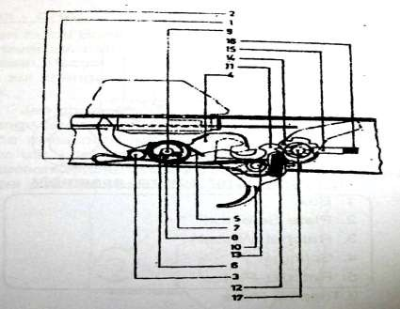 **TRIGGER MECHANISM (REF PARA 4)**

1. Safety sear 10. Trigger
2. Spring safety sear 11. Sear
3. Pin safety sear 12. Spring sear
4. Hammer 13. Pin trigger
5. Spring hammer 14. Wheel
6. Pawl hammer 15. Plunger
7. Spring pawl hammer 16. Spring plunger
8. Pin pawl hammer 17. Stud lever change
9. Pin axis hammer

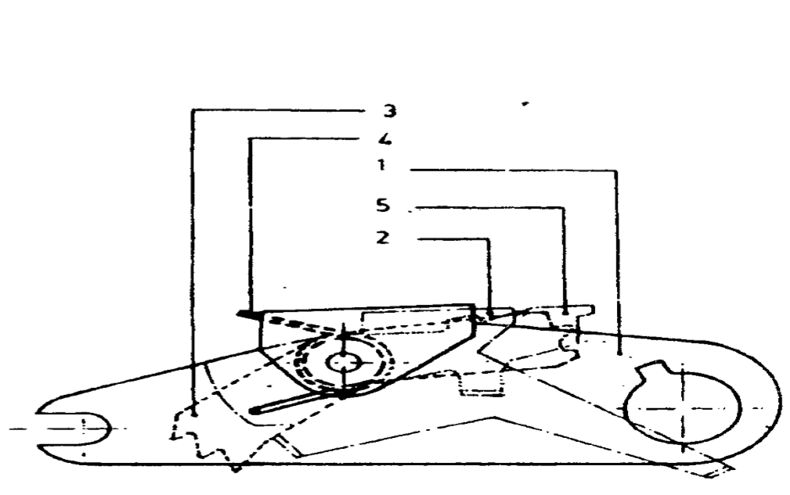

1. Box

2. Plate Selector

3. Ratchet Wheel

4. Spring

5. Ratchet Plate

(Tripping Plate)

**UNIT BURST CONTROL ASSEMBLY**

**Bhag- II - TRB Assembly Se Waqfiat**

1. TRB Assembly ka matlab hai Three Round Burst Assembly. TRB Assembly ke Hisse Purze is prakar hain :-
   1. Box.
   2. Axis pin.
   3. Plate Selector.
   4. Ratchet wheel.
   5. Ratchet Plate. (Tripping Plate)
   6. Spring.

**Bhag-III - TRB Mechanism**

1. Teen round burst control karne ke liye jo bhi purza hai yeh change lever aur hammer ke beech mein fit kiya gaya hai. Yeh aapas mein nazdik nazdik sthit kiye gaye hain. Yeh purze hammer aur change lever ke beech trigger mechanism se jude hue hain.
   1. Jab change lever ko B position mein lagate hain to uska lug plate selector ko niche daba deta hai jisse ratchet wheel pawl ke radial path mein aa jata hai.

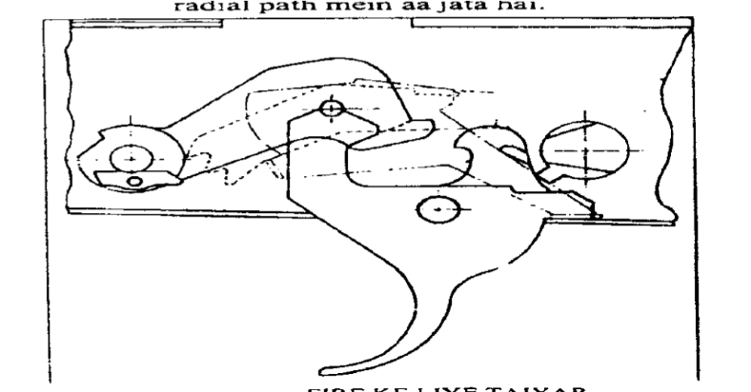

**Fire Ke Liye Taiyar**

* 1. Jab trigger ko dabaya jata hai to hammer trigger sear se azad ho jata hai aur firing pin ke pichhe wale hisse par thokar marta hai. Jisse round fire ho jata hai. Is dauran pawl ratchet wheel ki upar wale daant mein phas jata hai aur wheel ko spring ke barkhilaf ghuma deta hai. Is samay ratchet wheel ka pichla aur nichla katao safety sear ko piche ki aur apne spring ke tension ke barkhilaf daba deta hai.

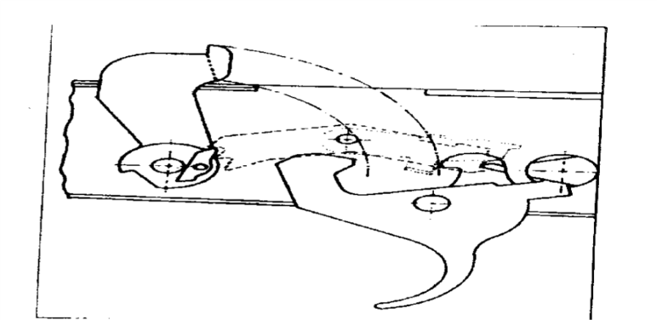

**Pahla Round Fire Hone ke Bad**

* 1. Jab rotating bolt aur piston extension pichhe ki harkat karte hain to ratchet wheel apani hi jagah par barkarar rahta hai, pawl apne spring ki tension ke barkhilaf press ho jata hai aur hammer pichhe dab jata hai. Is samay trigger pressed hone ke karan hammer ko trigger sear nahin rok pata hai. Aur dusra round bhi fire ho jata hai.

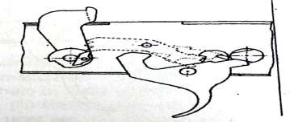

**Teesra Round Fired**

* 1. Is samay ratchet wheel ka dusra dant pawl ke sath phans jata hai aur ratchet wheel ka pichhla aur upar wala dant auxillary sear ko pihche dabata hai. Jab Chalwale purje pichhe ki harkat karte hain to hammer ko na trigger sear rokta hai aur na hi auxillary sear rok pata hai. Karwai usi prakar se hoti hai jaise pahle round ke fire hone ke bad hui thi. Is prakar teesra round bhi fire ho jata hai.
  2. Jab teesra round fire hota hai to pawl ratchet ke sabse niche aur teesre dant mein phans jata hai. Aisa hone se ratchet wheel pura upar uth jata hai aur tripping plate ke niche bani projection ko niche daba deta hai. Isse tripping plate ka pichla hisa niche ki harkat karta hai. Is samay tripping plate ke pichhe bani projectve auxillary sear ko pichhe dhakel deti hai. Yeh halat us samay ka hai jab chal wale purje age hote hain aur teesra round fire ho chuka hota hai.

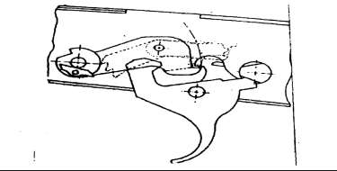

**Teesra Round Fire Hone Ke Bad**

* 1. Jab chal wale purje pichhe ate hain to pawl bhi hammer ke sath pura pichhe ghum jata hai. Is samay pawl aur ratchet wheel aur pawl ka milap tut jata hai. Aisa hone se ratchet wheel apani jagha par wapis aa jata hai yani ratchet wheel niche ki harkat karta hai. Isse tripping plate ke upar se bhi ratchet wheel ka dabav hat jata hai aur trapping plate upar uth jati hai. Ab Auxillary Sear Azad ho jata hai. Jab hammer par auxillary sear sawaar ho jata hai aur purze pura pichhe ruk jate hain. Aisa us samay hoga jab Trigger pressed hi raha gaya ho, verna trigger sear hammer platform par swaar hojata hai aur use pichhe rok leta hai. Is prakar teen round fire hone ke baad agla round tab tak fire nahin hoga jab tak trigger ko release na kar diya jai.

1. TRB mechanism is hathiyar ki visheshta hai. Change lever ki position R par hone se INSAS Rifle Single Shot fire karti hai aur agar change lever ki position S par ho to Rifle fire nahin karegi.

**TRB MECHANISM**

**(Flow Diagram)**

|  |
| --- |
| Change lever B par Selector niche Rachet wheel pawl ke radial path mein aur wheel ka pichla dant sear par sawaar |
| **First Round Fire (**Jab trigger press**)** |
| Pawl rachet wheel ke pahle dant par sawar, rachet wheel ka pichhe aur dusre dant auxillary sear par sawar. |
| Weapon cock Trigger pahle se hi pressed hai Safety sear pressed |
| **Dusra Round Fired** |
| Pawl rachet wheel ke dusre dant par sawar, rechat plate ka pichla aur upar wala dant sear per sawar |
| Weapon cock Trigger pahle se hi pressed hai Safety sear pressed |
| **Teesra Round Fired** |
| Pawl rachet wheel se azad, sear ya trigger sear hammer par sawar |

**LESSON - 9 : EK NAZAR**

Trigger ki chal mein kam ane wale hisse purje is prakar hain:-

1. **Change Lever**
   * 1. Stem
     2. Rib
     3. Lug
2. **Trigger**
3. **Trigger Sear**
   * 1. Claw
     2. Tail > Ek hi Axis pin par sawaar
     3. Searclaw
     4. Neck
     5. Arm
4. **Hammer Assly**
   * 1. Hammer
     2. Recess for safety sear
     3. Plateform
     4. Hammer return spring
     5. Pawl and pawl return spring
5. **Safety sear.** Alag axis pin par
6. **TRB Assly ke hisse purze**
   * 1. Box
     2. Axis pin
     3. Plate selector
     4. Ratchet wheel
     5. Ratchet plate
     6. Spring

**LESSON -9**

**5.56 MM INSAS RIFLE KA TRIGGER MECHANISM**

Q1. Rifle ko cock karne par breech block ki aage ki harkat ke dauran trigger sear ka kya kaam hai ?

Q2. TRB se fire karte waqt kaun se hisse kaam mein aate hain ?

Q3. TRB ke faide likho ?

Q4. TRB mode mein ek baar trigger press karne par dusra round fire hone ke liye kis prakar taiyar ho jata hai ?

Q5. Dusre round fire karne ke bad wheel, pawl aur trigger sear ki kya position hoti hai ?

Q6. Teesra round fire karne ke baad pawl aur trigger sear ki kya position hoti hai ?

Q7. INSAS Rifle ki R aur B position mein kya antar hai ?

Q8. TRB ki tulna mein auto fire ke kya faide aur nuksan hain ?

Q9. TRB assly ka chitra banayen ?

Q10. Change lever ki position S par hone par insas Rifle ko cock kiya ya nahin kiya ja sakta hai ?

**LESSON-10**

**5.56MM INSAS RIFLE KA ZEROING KA TARIKA**

Ref - (Infantry Training Volume 1, Infantry Platoon Weapons Pamphlet No 3B Basic Marksmanship (The 5.56mm Insas Rifle) 2007)

**Parichay**

1. Zeroing, Rifle ki sighton mein elevation yah deflection ki galti ko dur kar, group ke MPI ko chune hue sthan par lane ke liye kiya jata hai. Is se Rifle se aam halaton mein bhi fire kiya jaye to uski goliyan usi jagah lagengi, jis jagah par hamne shist liya tha. Is Rifle ka zeroing kisi vayu rahit prakash din mein kiya jana chahiye. Zeroing ki karwai sight ko 200m par sthir kar, zamin par 30.5m ki range par karna hi uchit hoga. Aisa karte samay lying supported position hona zaruri hai.

**Paribhasha**

1. MPI ko POA par ya pahle se diye gaye sthan par lane ke liye hathiyar ki sighton par, upar nichhe aur dahine bayen ki galti ko dur karne ke liye jo tabdiliyan ki jati hain, is karwai ko zeroing kahte hain. Zeroing se line of sight aur trajectory ke beech ka farak samapat ya manjur sudha kiya jata hai.

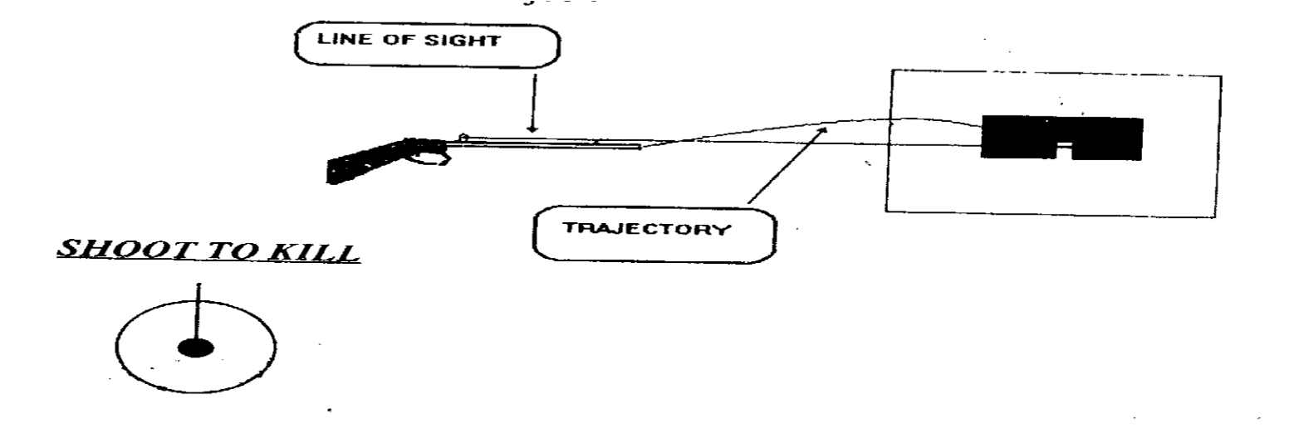

**Faide**

1. Zeroing ke chand ek faide is prakar hain:-
   1. Rifle aur apne aap par bharosa.
   2. Shoot to kill ka mudha hasil hona.
   3. Clasification fire ke natije achhe.

**Mauqe**

1. Zeroing ke mauqe is prakar hain :-

(a) Accuracy par shak hone par.

(b) Jab Rifle naya issue ho.

(c) Ek jawan se dusre jawan ko di jaye ya liyajaye.

(d) Classification fire karne se pahle/competition mein jane se pahle.

(e) Larai mein jane se pahle.

(f) High altitude mein jane se pahle aur aane ke baad.

(g) Bari repair ke baad.

**Zeroing ke Waqt Zaruri Baten**

1. **Tuning Up.** Rifle ko rojana istemal karne se aur kote mein rakha rakhne se bhi out of tune ho jati hai. Is liye zaruri hai ki zero karne se pahle Rifle ko armr se tuning up karwa lena chahiye. Bina tuning up hue, Rifle ka, fire par bahut bura asar parta hai.

1. **Mausam**. Zeriong par kharab mausum ka asar parta hai. Is liye zaruri hai ki liye saaf din aur kam hawa wala waqt hi chuna jaye.
2. Bayonet na laga ho.
3. Magazine zamin par na tika ho.
4. Barrel support ke sath na laga ho.

**Zeroing**

1. Durust rg lagakar hi zero kiya jaye. Sight par 200m rg laga hona chahiye aur ground rg 30.5m ho toh MPI, POA se 1.25 cms upar aur 1.25 cms ke diameter mein banega.

1. Agar sight rg 200m ho aur ground rg 100m ho, MPI POA se 4" ke diameter mein 2" upar banega.

**Correction**

1. Rifle factory se hi zero hokar ata hai. Phir bhi thode adjustment ki zarurat hoti hai. Isko qualified personnel hi karen.

1. **Elevation.** Upar/niche ki galti ko dur karne ke liye fore sight ko rotate karen. Fore sight ko upar karne se MPI niche shift hoga. Aur agar MPI ko upar shift karna hai to fore sight ko niche kare. 100m range par foresight ko pura chakkar dene se 100m par MPI 4" shift hoga. Tool adjusting foresight se pahle lock nut ko dhila kar lena zaruri hai. Phir isi tool se foresight ko ghumaya jae. Zaruri correction dene ke bad lock nut ko kas dena chahiye.

1. **Lateral Correction**. Dahine/bayen ki galti ko dur karne ke liye rear sight par correction di jati hai. Agar back sight ko bayen le jaye toh MPI bayen shift hota hai. Back sight mein correction dene ke liye screw ko ghumana parta hai. Screw ko clock wise ghumane se sight right ko harkat karti hai. Agar MPI ko bayen le jana hai to sight ko ghari ke ulte rukh ghumana parega. Iske liye tool combination ka istemal karte hain. 100m back par sight screw ko ek pura chakkar diya jae to MPI POA se 4" shift hota hai. Correction kar lene ke bad yeh zaruri hai ki screws ko dobara kas diya jae.

**Accuracy Specifications**

1. Yeh Rifle factory mein nimnlikhit accuracy specifications par test hokar aati hai:-

|  |  |  |  |  |  |
| --- | --- | --- | --- | --- | --- |
| Ser No | Range (m) MPI | Sight (M) | No of Rds | Accuracy (HxV)mm | MPI (mm) |
| 1. | 30.5 | 200 | 4 out of 5 (SS) | 25.5 x 38 | 12.5 up 12.5 L or R |
| 2. | 200  64 L or R | 200 | 6 out of 7 (SS) | 168x168 | 0 to 250 up |
| 3. | 400 | 400 | 6 out of 7 | 336x336  1681  L or R | 0 to 500 |

16. Dhyan mein rakhen ki :-

* 1. Rifle ko zero karte samay sight hamesha 200 Mtr par hona chahiye.
  2. Bayonet lagakar zero nahi karna chahiye.
  3. 4' x 4' tgt ke beech 1' chauri kali patti, Khare rukh lagakar do hisson mein bant do. Donon hisson ke beech 9” x 9” ka kale kagaz ka tukara lagao. Inke niche aur beech wali point par 3”x 4.5” ka ek safed aiming mark lagao.
  4. Yeh zaruri hai ki zero ke liye thik position ikhtiyar kar li jae, yani ki baju ko sand bag par tikaya jae. Yeh Rifle ko sthir rakhta hai. Iske ilawa Rifle ko niche diye hue tarikon se zero karne se MPI mein farak parega:-

(i) Arh par barrel tikakar.

(ii) Rifle ko arh par tika kar.

(iii) Magazine ko zamin par tika kar.

(iv) Bayonet laga kar.

(v) Khule mein bina kisi kisam Ki arh se.

**LESSON - 10**

**EK NAZAR**

Sight Range Ground Range

200M 30.5M

MPI

1.25CM UPAR

AUR 1.25CM DIAMETER

Sight Range Ground Range

200M 100M

**ONE CHAKKAR = 4" (100M)**

**5.56 MM INSAS Rifle KA ZEROING KA TARIKA PARICHAY**

Q1. Zeroing ki paribhasha likhen.

Q2. Zeroing ke mauqe likhen.

Q3. Stocking up aur tuning up se aap kya samajhte hain.

Q4. Zeroing se pahle aur dauran zaruri baaten kya hain Likhen.

Q5. Zeroing ke liye kaun sa target hathiyar par taiyari aur range.

Q6. Ammuman zeroing kaun si range par ki jati hai. Zeroing ke liye foresight aur backsight par ek chakkar ghumane se target par kitna asar parta hai. Ek table dwara samjhaen.

**LESSON - 11**

**5.56 MM INSAS RIFLE SE HATKAR SHIST LENE KA TARIKA**

Ref - (Infantry Training Volume 1, Infantry Platoon Weapons Pamphlet No 3B Basic Marksmanship (The 5.56mm Insas Rifle) 2007)

**Pahunch**

1. Larai ke maidan mein shayad hi jawan ko itna mauqa mile ya na mile ki woh hathiyar par dushman ka sahi rg lagakar fire kar sake. Ho sakta hai us samay tgt chal raha ho ya kudrati halat mein ho aur us samay hawa bhi asar dal sakti hai. Tamam halat mein dushman par hatkar shist lene ka tarika ana chahiye. INSAS Rifle mein 200m aur 400m ke range ki hi suvidha hai. Is liye bahut zaruri hai ki shist main tabdili karne ka tarika ek jawan ko achhi tarah ana chahiye.

**Uddesh**

1. Shist mein tabdili karna, shist ki jagah chunna, hawa ka hak rakhte hue POA chunne ka tarika sikhana hai.

**Saman**

1. 5.56mm INSAS Rifle, long easal, short easel, black bd, chalk, duster, diagram, fig 11 tgt aur ground sheet.

**Bhag**

1. Is lesson ko char bhagon mein banta gaya hai:-

|  |  |  |  |
| --- | --- | --- | --- |
| (a) | Bhag-I | - | Shist mein tabdili karna. |
| (b) | Bhag-II | - | Shist ki jagah chunna. |
| (c) | Bhag-III | - | Harkati tgt par POA lena. |
| (d) | Bhag-IV | - | Hawa ka fire par asar. |

**Bhag-I : Shist Mein Tabdili Karna.**

1. Jab hathiyar par tgt ka sahi rg lagakar fire karte hain toh goli nishan ki jagah par lagti hai, lekin agar sight par tgt ke rg se kam rg laga ho to goli POA ki jagah se nichhe lagegi. Agar rg sight par jiada laga ho to goli POA ki jagah se upar lagegi. Goli POA ki jagah se kitna upar ya niche lagegi yeh tgt ke fasle par nirbhar karta hai. Sight rg kam ya jaida hone se goli POA ki jagah se kitna upar ya niche lagegi yeh Appx 'D' mein diya gaya hai. Alag alag range per goli kitna upar ya niche lagti hai yeh aap trajectory board ki madad se samajhen.

|  |  |  |
| --- | --- | --- |
| **Ground Range** | **Sight Range** | |
| **200mtr per MPI ki Jagah** | **400mtr par MPI ki jagah** |
| 100 Mtr | 7.12 CM (U) | 24.41 CM (U) |
| 200 Mtr | 00.13 CM (N) | 34.43 CM (U) |
| 300 Mtr | 24.55 CM (N) | 27.30 CM (U) |
| 400 Mtr | 69.55 CM (N) | 00.43 CM (N) |

Isse yeh saf jahir hota hai ki agar tgt 300m par hai aur sight par 200m rg laga hai to firer ko thora upar shist lena parega aur agar sight rg 400m hai aur tgt 300m par hai to shist thora niche lena parega taki goli tgt ke POA mein lage.

**Bhag-II : Shist ki Jagah Chunna.**

1. INSAS Rifle ko is prakar zero kiya jata hai ki 200m par goli POA ki jagah par lagti hai. Is tarah 100m se zero ki gai Rifle se jab ham 30.5m rg par fire karte hain toh goli 12.5mm shist ki jagah se upar lagti hai. Is lie 200m se kam rg ke tgt ko engage karne ke liye shist tgt ke madhya se thora niche aur 200m se jiada ke liye shist madhya se thora upar lena chahiye. Is prakar shist lekar 200m se kam rg par nikalte tgt ko engage karne ke liye do bare faide hain:-

(a) Agar goli zamin par takra kar ricochet hota hai to tgt hit ho sakta hai. (b) Firer mar ko dekh kar dusri goli se correction dekar tgt barbad kar sakta hai.

**Bhag-III : Harakati Tgt par POA Lena.**

1. Harkati tgt ko hit karne ke liye zaruri hai ki shist age liya jae. Kitna age shist lena hai yani kitna lead lena hai tgt ke rg aur tgt ki raftar par nirbhar karta hai. Firing ke lihaz se tgt ki teen raftar mani gai hain:-

(a) Chalta tgt.

(b) Daurta tgt.

(c) Tej daurta tgt.

1. Teenon kism ke tgt par badalti rg mein lead bhi badalti hai. Kitne rg par kis kisam ke tgt par kitna lead liya jayega yeh tgt ki speed aur bullet ke time of flight par nirbhar karta hai. Is ko madhaya nazar rakhte hue sikhlai ko asan karne ke liye mote taur par lead table Appx "E" mein diya gaya hai.

**NOTE:-** (a) Ek insane tgt mein do lead hote hai.

(b) 01 Lead = 24 cm aur 02 Lead = 48cm

**Tgt ka Lead Table**

|  |  |  |  |
| --- | --- | --- | --- |
| **Range** | **Tgt ki stage** | | |
| **Chalta** | **Daurta Tgt** | **Tej Daurta Tgt** |
| 100 M | 01 | 02 | 03 |
| 200 M | 02 | 04 | 06 |
| 300 M | 03 | 06 | 09 |
| 400 M | 04 | 08 | 12 |

Lead = Range x Stage

100

**Bhag-IV : Hawa ka Fire par Asar.**

1. Firing ki lihaj se hawa ki teen raftaar hoti hai.
   1. **Halki Hawa**. Jis hawa ke chalne se chhoti jharion ki Pattiyan aur firing point par lega flag 22 degree ke angle par lehrata hai us ko halki hawa kahte hain.
   2. **Tej Hawa**. Jis hawa ke chalne se pattiyan hilti hain, chehre per mahsus kar sakte hain, firing point par laga hua flag 45 degree ke angle par lahrata hai us ko firing tej hawa kahte hain.
   3. **Bahut Tej Hawa**. Jis hawa ke chalne se bari bari tahniya hilti hain, dhul, garda urta hai aur firing point par laga flag 90 degree par lahrata hai usko bahut tej hawa kahte hain.

* 1. **Cross Wind**. Jo hawa 3 se 9 baje ki line mein chalti hai use cross wind kahte hain.
  2. **Tirchhi Hawa.** Jo hawa 11 se 5 aur 1 se 7 baje ki line mein chalti hai usko tirchhi hawa kahte hain. Sikhlai ko asan karne ke liye mote taur par alag alag rg par alag alag hawa ke liye lead table appx "F" mein diya gaya hai. Tirchi hawa ke liye ek POA kam kar diya jata hai. POA lene ka tarika:-

**Hawa ka Lead Table**

|  |  |  |  |
| --- | --- | --- | --- |
| **Range** | **Hawa ki stage** | | |
| **Halki** | **Tej Hawa** | **Bahut Tez Hawa** |
| 100 M | - | - | - |
| 200 M | - | 01 | 01 |
| 300 M | 01 | 02 | 03 |
| 400 M | 02 | 03 | 04 |

POA = Range x Stage + Hawa

100

11. Agar tgt aur hawa donon ek taraf ki ho to tgt ki speed ke POA se hawa ek POA kam kar diya jae, agar donon vipreet disha mein ho to tgt ke POA mein hawa ka POA jor diya jae.

#### LESSON – 11 : EK NAZAR

Target ki Kism

Chalta Daurta Tej Daurta

Lead = Range x Tgt ki Speed

Hawa ki kism

Halki Tej Bahut Tej

POA = Range x Speed + Hawa

100

**LESSON NO 11**

**SHIST MEIN TABDILI POA CHUNNA AUR HAT KAR SHIST LENA PARICHAY**

|  |  |
| --- | --- |
| Q1. | INSAS ki open rear sight par kya nishan bane hain? |
| Q2. | Alag alag range ke lie shist mein tabdili karna kyon zaruri hai? |
| Q3. | Elevation table ki madad se alag alag rg par elevation mein antar dikhao? |
| Q4. | Zeroing Ke Lie 100 mtr rg kyon chuna gaya hai? |
| Q5. | Kisi tgt ko 200 mtr ke andar engage karne ke kya faida hain? |
| Q6. | Harkati tgt ke lie POA ka table banao? |

Q7. Alag alag rg par haw aka prabhav batao?

**LESSON-12**

**BETA LIGHT SIGHT KE ISTEMAL MEIN SAVDHANIYA**

1. Beta rays, tritium gas se nikalti hai aur phosphorous coating aur glass capsule mein sokh li jati hai.

1. Agar glass capsule tuta hai toh uske nazdik hone wale jawanon ko khatra paida ho jata hai. Isliye jawanon ko kam se kam adhe ghante ke liye 10m tak hat jana chahiye. Durghatna ki detail Head, DRP, BARC, Bombay ko bhej dena chahiye.

1. Sans ke jariye tritium gas ke sharir mein pravesh karne ke karan swasthya par antrik rup se khatra paida hota hai, aur yeh khatra radio dharni (radio active) Tritium Gel se antarik dushman ka hota hai. Aise dushman se prabhavit sabhi logon ke sharir ko subse pahle bahari taur par dushman se muqt kar lena chahiye aur aisa karne ke liye sampuran sharir ko sabun paani se dho lena chahiye.

1. Durghtna ke 15 ghante pashchat polythene ki shishi mein peshab ke namune(Lagbhag 30ml) lekar evam us mein upyukt parirakshak milakar Division of Radiological Protection, BARC, Trombay, Bombay, 400085 ke pradhan ko bhej dena chahiye.

1. Jo yantr Tritium gas se dushit ho gaya hai use puri tarah sabun paani se dho lena chahiye. Tute hue kanch ke tukron ko do feet gehrai gaddhe mein gar dena chahiye. In tukron ko hath se nahin chhuwa jae.

1. Jis component se Tritium strot ko badalna hai use us upkaran se khol liya jae jismein woh laga hai. Aab jis padarth dwara capsule laga hai uspar acedic acid ki kuchh bunden dalkar use kamjor bana lein. Aab us jagah ki safai kar wahan par dusra capsule laga den.

**LESSON NO 12**

**BETA LIGHT SIGHT KE ISTEMAL MEIN SAVDHANIYAN**

Q1. Beta rays kahan se paida hoti hai, aur isse bachao ke liye kya coating aur cover hota hai? Likhen.

Q2. Agar glass capsule tut jae to kya khatra paida hota hai aur iske liye kya karyawahi honi chahiye? Likhen.

Q3. Tritium gas se yadi koi prabhavit ho jae to kya kya karyawahi honi   
chahiye? Likhen.

**LESSON 13**

**SHURU KI SIKHLAI KI PARIKSHA (TsOET)**

Ref - (Infantry Training Volume 1, Infantry Platoon Weapons Pamphlet No 3B Basic Marksmanship (The 5.56mm Insas Rifle) 2007)

**Uddesh**

1. Shuru ki sikhlai ke test isliye karae jate hain taki pata chal jaye ki jawan hathiyar chalane mein kitna yogya hai.

**Grading**

1. Jawan ka darja bandi is tarah kar sakte hai :-

|  |  |  |
| --- | --- | --- |
| (a) | Sabse achha | - 80 se 90 Number lene wala |
| (b) | Ausat darje se upar | - 70 se 79 -do- |
| (c) | Ausat darje | - 60 se 69 -do- |
| (d) | Ausat darje | - 50 se 59 -do- |
| (e) | Fail | - 50 se kam -do- |

**Star Hasil Karna**

1. Recruit ko aisi sikhlai di jae ki akhir mein woh ausat darje hasil karen. Sikhlai paya hua jawan jo ausat se achha kaam nahin kar sakta unhen aur abhyas diya jae.

**Sancha lan**

1. PWT lesson ke dauran mukable ke jariya yeh test karwaye ja sakte hain. Test se pahle jawano ko iski sharten achhi tarah samjhana zaruri hai. Test shuru hone ke bad jawan ko kuch batana nahin chahiye.

**Record Rakhna**

1. TsOET ke natije result form par likhkar use jawan ke pragati folder mein rakha jata hai. Is form ko dekhkar jawan ki sikhlai ka sthar malum ho sakta hai. Is form ka namuna Appx "G" mein diya gaya hai.

1. **TsOET No-1** Hath se magazine bharna.
   1. **Saman**. 20 Rounds drill carts, magazine, watch progress folder. (b) **Sharten**. "Magazine bhar" ke aadesh par jawan hath se 20 goliyan magazine mein bhare. Galat bharne par number na diya jae.

(c) **Number Dena.**

(i) 30 ya kam sec - 10 Number

(ii) 31 se 34 sec - 08 -do-

(iii) 35 se 38 sec - 06 -do-

(iv) 39 se jaida sec - 04 -do-

**TsOET No- 2** Standing Position Se Rifle Bharna:-

* 1. **Saman**: Khali magazine lagi Rifle. Ek bhari magazine, watch, progress folder
  2. Sharten Bhar ka adesh do, jawan ke bharne tak ruko.
  3. **Number Dena**
     1. 12 sec se kam - 10
     2. 13 sec se 16 sec - 08
     3. 17 sec se 20 sec - 06
     4. 21 sec se jyada - 04

1. **TsOET No-3** Standing Position se khali karna
   1. Saman Test No 2 ki tarah
   2. Sharten Khali kar ka adesh do, Jawan ke khali karne tak ruko.
   3. **Number Dena :-**

(i) 15 ya kam sec - 10

(ii) 16 se 19 sec - 08

(iii) 20 se 23 sec - 06

(iv) 24 se jyada - 04

1. **TsOET No-4**: Kholna aur jorna

(a) **Saman Rifle.**

* 1. **Sharten** Jawan ko aadesh do ki woh Rifle saaf karne ke liye khole aur jorden. Jawan ko batao ki kholne aur jorne mein samay ki pabandi hai lekin woh teji se aur sahi kam kare.
  2. **Number Dena**  Har galti ke liye half number kato, agar galti security ke barkhilaf ho to 5 No kato. Subse zyada 15 number do.

1. **TsOET No-5 Roken**
   1. **Saman.** Rifle, Tgt, drill cart, Progressive folder.
   2. **Sharten.** Aadesh do "bhar", "Letkar position", "Fire". Jawan ko trigger dabate hi aadesh do Rifle thik fire karta rukhta. Is tarah pure rokon ko dur karne ka test liye jae.
   3. **Number Dena**

(i) Bilkul sahi karwai par - 20 Number.

(ii) Agar galti security ke barkhilaf hai to 5 No kato.

(iii) Chhoti galti ke liye 1 Number kata jai.

1. **TsOET No-6** - Aiming Box Ex
   1. **Saman Rifle.** Short Aiming Rest, Box, Rubber, Pencil aur Progressive Folder.
   2. **Sharten.**Aiming box ex 5 bar karo. Har bar gp 8 mm ka hona chahiye.
   3. **Number Dena**

(i) Bilkul Sahi - 15 Number

(ii) 4 bar sahi - 12 Number

(iii) 3 bar sahi - 9 Number

(iv) 2 bar sahi - 6 Number

(v) 1 bar sahi - 3 Number

1. **TsOET No-7** Hat kar shist lena.
   1. **Saman -** Fig 11 tgt.
   2. **Sharten.** Lead kis prakar se liya jata hai is ke bare mein jawan se 4 sawal puchho.
   3. **Number Dena**

(i) har sahi jawab ke liye 2.5 Number.

(ii) Zyada se zyada 10 Number.

**LESSON NO 13**

**SHURU KI SIKHLAI KI PARIKSHA**

Q1. TsOET ki zarurat kya hai ?

Q2. TsOET Ke dauron anken ke mutabik darjabandi kis prakar ki jati hai? Table banaen.

Q3. Jo jawan sikhlai ke baad ausat se accha kam nahin kar pate unke liye kya karyawahi ki jati hai?

Q4. TsOET ke parinam ke record rakhne ki zarurat kyon hai?

Q5. TsOET No 1 test ka saman sarten aur ank dene ki tartib likhen.

**TRAJECTORY HEIGHTS WHEN WEAPONS IS ZEROED FOR 200 M**

|  |  |  |  |  |  |  |  |  |  |
| --- | --- | --- | --- | --- | --- | --- | --- | --- | --- |
| **RANGE** |  | **TIME OF TRAJECTORY** | | | | **ENERGY** | | **WIND** | |
|  |  | **FLIGHT** |  | **HT** |  | | **OFFSET** | |
| **(m)** |  | **(s)** |  | **(m)** | **(j)** | | **(M/mph)** | |
| 50.00 |  | 0.0568 |  | 0.0521 | 1550.19 | | 0.0005 | |
| 75.00 |  | 0.0860 |  | 0.0660 | 1486.10 | | 0.0012 | |
| 100.00 |  | 0.568 |  | 0.0712 | 1423.79 | | 0.0021 | |
| 125.00 |  | 0.1465 |  | 0.0675 | 1363.33 | | 0.0033 | |
| 150.00 |  | 0.1777 |  | 0.0545 | 1304.93 | | 0.0048 | |
| 175.00 |  | 0.2096 |  | 0.0317 | 1238.41 | | 0.0067 | |
| 200.00 |  | 0.2422 |  | -0.0013 | 1193.97 | | 0.0088 | |
| 225.00 |  | 0.2756 |  | -0.0450 | 1140.92 | | 0.0113 | |
| 250.00 |  | 0.3098 |  | -0.1000 | 1089.85 | | 0.0141 | |
| 275.00 |  | 0.3447 |  | -01666 | 1040.71 | | 0.0172 | |
| 300.00 |  | 0.3805 |  | -0.2455 | 993.25 | | 0.0207 | |
| 325.00 |  | 0.4171 |  | -0.3372 | 947.61 | | 0.0207 | |
| 350.00 |  | 0.4545 |  | -0.4422 | 903.78 | | 0.0289 | |
| 375.00 |  | 0.4929 |  | -0.5615 | 861.54 | | 0.0335 | |
| 400.00 |  | 0.5322 |  | -0.6955 | 821.00 | | 0.0386 | |
| 425.00 |  | 0.5725 |  | -0.8452 | 782.08 | | 0.0441 | |
| 450.00 |  | 0.6138 |  | -1.0113 | 744.77 | | 0.0501 | |
| 475.00 |  | 0.6561 |  | -1.1943 | 709.07 | | 0.0564 | |
| 500.00 |  | 0.6994 |  | -1.3952 | 674.96 | | 0.0633 | |
|  |  |  |  |  |  | |  | |
|  |  |  |  |  |  | |  | |

**Appendix ‘A’**

(Ref Para 25, lesson 2)

**Passive Night Sight (Optional)**. Iski visheshtaen is prakar se hain:-

|  |  |  |  |
| --- | --- | --- | --- |
| (a) | Size |  | 281mm long & 70mm dia. |
| (b) | Principle of Op |  | Imagazinee Intensification. |
| (c) | Field of View |  | 10 degree. |
| (d) | Magazine |  | 4 guna. |
| (e) | Range recognition |  | 200m. |
| (f) | Detection |  | 300m. |
| (g) | Bore sighting/Zeroing |  | Adjustment of the graticule |
|  |  |  | for boresighting/ zeroing provided. |
| (h) | Weight |  | 1.06 Kg. |
|  |  |  | **Appendix ‘B’** |
|  |  |  | (Ref Para 26, lesson 2) |
|  |  |  |  |

**Telescope Day Light.** Is ke sath din ke samay durust, asan aur Prabhavshali tarique se din ke samay fire kiya ja sakta hai. Is ki visheshtaen is prakar hain:-

|  |  |  |  |
| --- | --- | --- | --- |
| (a) | Size |  | 255mm lamba aur 65mm dia |
| (b) | Weight |  | 485gm. |
| (c) | Magazinenification |  | 4 guna. |
| (d) | Field of View |  | 15 degree. |
| (e) | Engagement Range |  | 400M. |
| (f) | Boresighting/Zeroing | | Adjustment in graticule provided. |
|  |  | |  |

|  |  |  |  |  |  |
| --- | --- | --- | --- | --- | --- |
|  |  |  |  | | **Appendix ‘C’** |
|  |  |  | **TULANATMAK DATA** | | (Ref Para 27, lesson 2) |
| **Work** |  |  | **7.62mm SLR** |  | **5.56mm Rifle** |
| Eff Rg |  |  | 285 Mtr |  | 400 Mtr |
| MV |  |  | 815 M/S |  | 900 M/S |
| Lambai |  |  | S/B - 1125 mm |  | Fixed butt 960 mm |
|  |  |  | N/B - 1140 mm |  | Folded Butt 750 mm |
|  |  |  | L/B - 1150 mm |  | Long Butt nahi hai |
| Wajan |  |  | 5.1 Kg |  | 4.018 Kg |
| Barrel |  |  | 535 mm |  | 464 mm |
| Riflling |  |  | 6 |  | 6 |
| Sight |  |  | Iron (200 to 600) |  | 200 m aur 400m |
| Rate Of Fire | |  | 60 Rounds/M |  | 650 Rounds/M |
| Cart | |  | 7.62 x 51 mm |  | 5.56 x 45 mm |
| Furniture ka Prakar | |  | Plastic, Lakdi |  | Plastic |
| Gren Sight | |  | Wpn par nahi hota | | Collapsable gren |

sight wpn par hotahai(gas plug ke saath att hota hai).

**Appx "D"**

(Ref para 5 of Lesson No 11)

**TRAJECTORY HEIGHT WHEN WEAPON IS ZEROED FOR 400 M**

|  |  |  |  |  |  |  |
| --- | --- | --- | --- | --- | --- | --- |
| **RANGE** |  | **TIME OF** | **TRAJECTORY HT** | | **ENERGY** | **WIND** |
|  |  | **FLIGHT** |  |  |  | **OFFSET** |
| **(M)** |  | **(S)** |  | **(M)** | **(J)** | **(M/mph)** |
| 50.00 |  | 0.0568 |  | 0.1386 | 1550.19 | 0.0005 |
| 100.00 |  | 0.1159 |  | 0.2441 | 1423.79 | 0.0021 |
| 150.00 |  | 0.1777 |  | 0.3138 | 1304.92 | 0.0048 |
| 200.00 |  | 0.2422 |  | 0.3443 | 1193.78 | 0.0088 |
| 250.00 |  | 0.3098 |  | 0.3321 | 1089.83 | 0.0141 |
| 300.00 |  | 0.3805 |  | 0.2730 | 993.24 | 0.0207 |
| 350.00 |  | 0.4545 |  | 0.1626 | 903.76 | 0.0289 |
| 400.00 |  | 0.5322 |  | -0.0043 | 820.99 | 0.0386 |
| 450.00 |  | 0.6138 |  | -0.2336 | 744.75 | 0.0501 |
| 500.00 |  | 0.6994 |  | -0.5311 | 674.94 | 0.0633 |

**Appx “B”** (Ref para 5 of Lesson No 11)

**TARGET KE LIYE LEAD**

|  |  |  |  |
| --- | --- | --- | --- |
| **Range** | **Chalta Tgt** | **Daurta Tgt** | **Tez Daurta Tgt** |
| 100M | 1 POA | 2 POA | 3 POA |
| 200M | 2 POA | 4 POA | 6 POA |
| 300M | 3 POA | 6 POA | 9 POA |
| 400M | 4 POA | 8 POA | 12 POA |

**Appx "F"**

(Ref Para 11 of Lesson 11)

**TARGET KE LIYE LEAD**

|  |  |  |  |
| --- | --- | --- | --- |
| **Range** | **Halki Hawa** | **Tej Hawa** | **Bahut Tez Hawa** |
| 100M | - | - | - |
| 200M | - | 1 | 2 |
| 300M | 1 | 2 | 3 |
| 400M | 2 | 3 | 4 |

|  |  |  |
| --- | --- | --- |
|  |  | **Appx "G"**  (Refer Para 5 of Lesson 13) |
|  |  | **TsOET KA RECORD** |

**No Rank Name Pl**

____________________________________________________________

**TsOET No Highest No Date No Date No Date No**

____________________________________________________________

1. **(b) (c) (d) (e) (f) (g) (h)**

____________________________________________________________

1. 10 1-3-70 6 10-3-70 8

2.

3.

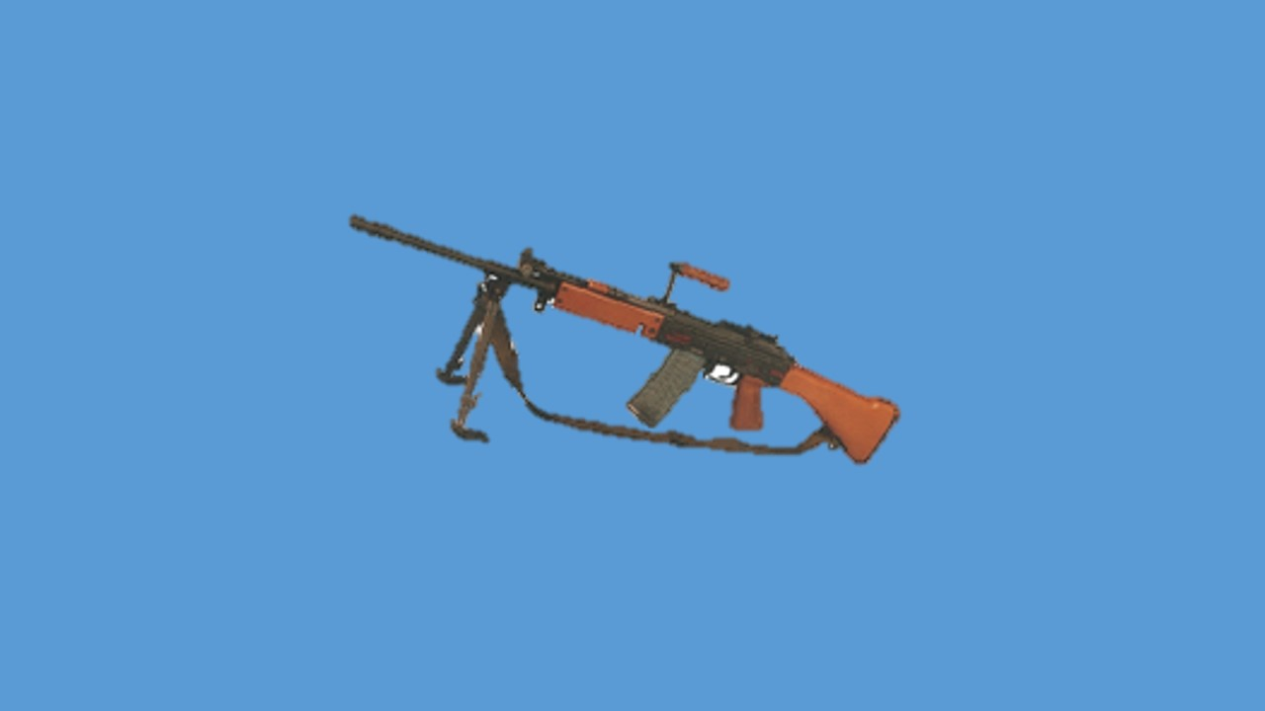

**5.56MM INSAS LMG**

**LESSON-1**

**INDIAN SMALL ARMS SYSTEM- INSAS AUR**

**5.56MM LMG KA VIKAS**

**Parichay**

1. Sansar ke anya deshon ki sena ke chotte hathiyaron mein ho rahi **tabdiliyon** ke karan humari sena mein chhotte kutar ke hathiyaron ki jarurat mahsus ki gai. Is karanvash **INSAS project ke tahat 5.56mm kutar hathiyaron ka vikas** shuru kiya gaya. 5.56mm INSAS LMG Indian Small Arms System parivar ka ek mahatvapurn hathiyar hai.

1. 5.56mm INSAS LMG ek **halka, accurate aur bhari** tadad mein fire dalne wala automatic hathiyar hai. Zamini targets ke alawa ise kam raftar mein nichai par urne wale dushman ke hawai jahaj ke khilaf bhi istemal kiya jata hai .

**Uddesh**

1. Chotte kutar ke hathiyaron ka vikas, INSAS ka vikas aur 5.56 mm INSAS LMG ke bare mein jankari deina hai.

**Bhag**

1. Yeh sabak teen bhagon mein banta gaya hai:-

* + 1. **Bhag-I.** Chotte kutar ke hathiyaron ka itihas.

* + 1. **Bhag-II.** INSAS parivar ka vikas aur khubian.

* + 1. **Bhag-III.** 5.56 mm INSAS LMG ki visheshtaen.

**Bhag-I : Chotte Kutar ke Hathiyaron ka Itihas**

1. Duniya ki senaon ke itihas mein small arms ek mahatavpurn hissa raha hai. Anek desh jaise Korea, Vietnam/Indo China, South Asia, Middle East, Africa, Latin America aur anya chetriya (regional) larai aur Low Intensity conflicts ke dauran Infantry ne apne chhote hathiyaron ka mahatav sidh kar dikhaya hai. **Effective, robust aur bharosemand** small arms jawan ka hosla badhate hain, Infantry ke alawa small arms sena ke anya angon, Air force aur Navy dwara bhi istemal mein laye jate hain.

1. Varsh 1945 Dwitiya Vishwayudh ke parinam ke vishleshan ke dauran paya gaya ki larai ke maidan mein 95% dushman ka engagement 400m ki range tak kiya gaya. Yeh bhi paya gaya ki 7.62mm NATO round ka target par asar ‘Overkill’ (Zarurat se zyada) hone ke karan hathiyar aur amn bhari the. Isliye NATO desh jaise America, England aur France dwara 5.56x45mm NATO round (FNSS-109) apnaya gaya . Bhutpurv Soviet Union dwara bhi 7.62mm kutar wale AK-47, Kalashnikov parivar ki tulna mein 5.56mm kutar apnaya gaya.

1. Nai peedhhi ke 5.56mm kutar ke hathiyaron ki chand ek khasusiat hain:-

* + 1. **Halka Amn.** Amn halka hone ke karan isko le jane mein sahuliat hai aur zyada amn carry kiya ja sakta hai.

* + 1. **Halka Hathiyar.** Hathiyar halka hone ke karan iski handling asan hai aur troops ko kam thakawat hoti hai.

* + 1. **Kam Recoil.** Recoil energy kam hone ke karan firer ko kam dhaka lagta hai jisse ki accuracy badhti hai.

* + 1. **Zyada Lethality.** Acchi ballistics hone ke karan bullet ko zyada sthirtha milti hai jisse ki lethality badhti hai.

**Bhag-II : INSAS Parivar ke Hathiyaron ka Vikas aur Khubian**

1. Is chhotte hathiyar ke kutar mein ho rahi badalti parampara ke saath rahne ki awashyakta ko Bharatiya sena dwara bhi mahsus kiya gaya. Chhotte hathiyaron ka vikas Infantry ke mukhya hathiyar hone ke karan nazar andaz nahin kiya ja sakta tha. Isliye Bharatiya sena dwara ARDE **(Armament Research and Development Establishment)** Pune ko GSQR dwara chhote hathiyaron ke vikas ke liye nirdesh diya gaya, ARDE Pune dwara chhotte hathiyaron ka vikas Nov 1979 mein INSAS (Indian Small Arms System) project ke tahat shuru kiya gaya.

1. **DRDO** **(Defence Research and Development Organisation)** ke samne yeh ek chunauti bhari baat thi ki aise chhotte hathiyaron ke parivar ka vikas kiya jae jo ki vishwa ke adhunik hathiyaron ka muqabla kar sake. Shuru se hi is baat par jor diya gaya ki behtar amn wale assault rif aur LMG ka vikas kiya jae jo ki NATO 5.56mm (SS 109) ki 600m ke baad beasar range ki kami ko dur kar sake.

1. **INSAS parivar mein nimn likhit hathiyar shamil hain:-**

(a) **Assualt Rif (AR**). Iske do prakar hain:-

* + - 1. Fixed Butt version.

* + - 1. Foldable Butt version.

(b) **Light Machine Gun (LMG**) Iske do prakar hain:-

* + - 1. Fixed Butt version.

* + - 1. Foldable Butt Version.

**5.56mm INSAS Hathiyaron ki Khubian**

1. 5.56mm INSAS hathiyaron mein chandek khubian hain, jo ki is prakar se hain :-

* + 1. **Purn Swadeshi.** Yeh hathiyar 100% swadeshi saman se bana hai.
    2. **Ek Prakar ka Amn.** INSAS parivar ke teenon hathiyaron ke liye ek hi kism ka amn istemal mein laya jata hai.

* + 1. **Hisse Purjon mein Samanta (commonality / Interchange-ablity**). Teenon hathiyaron ke kafi had tak hisse purje aapas mein badle ja sakte hain.

* + 1. **Training, Maintenance aur Logistics Asan**. Hathiyaron mein samanta hone ke karan inke traning maintenance aur logistics ek saath kiya ja sakta hai.

* + 1. **Economical.** Ek kism ka amn aur hathiyaron mein samanta hone ke karan inke utpadan (production) mein bachat hai. Dusra ismen plastic ka istemal kiya gaya hai joki dubara istemal recycle kiya ja sakta hai aur kimti lakdi ki bachat hoti hai.

* + 1. **Halke Amn aur Hathiyar.** INSAS parivar ke hathiyar kafi halke hain.

* + 1. **Behtar Hit Probability.** Kam recoil, zyada muzzle velocity aur rifle mein three round burst ki suvidha ke karan tgt hit probability zyada hai.

* + 1. **Flexibility.** 5.56mm INSAS hathiyaron mein single shot, three round burst aur automatic burst fire karne ki suvidha hai. Yeh hathiyar NATO 5.56 mm SS 109 amn bhi fire kar sakte hain.

**Bhag-III: 5.56mm INSAS LMG ki Visheshtaen**

1. 5.56mm INSAS LMG ek mahatvpurn hathiyar hai, jiske fixed butt version Infantry aur foldable version mechanised Infantry aur special forces dwara istemal mein laya jata hai . Is hathiyar ki chand ek khasusiat hain.

* + 1. **Halka Hathiyar.** 5.56mm INSAS LMG 7.62mm LMG se takriban

45% halki hai .

* + 1. **Kam Recoil.** Kam recoil hone ki wazah se firer ko kam dhakka lagta hai aur accuracy badhti hai.

* + 1. **Zyada Muzzle Velocity.** Is hathiyar ki muzzle velocity zyada hone ke karan trajectory chapti banti hai isliye tgt hit probability bhi zyada hai.

* + 1. **Lamba Range.**Zyada muzzle velocity hone ke karan hathiyaron ki range bhi zyada hai.

* + 1. **Automatic Fire.** Yeh hathiyar automatic mode per bhi bhari tadad mein fire karta hai .

* + 1. **Accurate.** Acchi ballistics kam recoil aur sighting system (telescopic sight, PNVS aur beta light sight) hone ke karan kafi accurate hai.

* + 1. **Lethality.** Acchi ballistic hone ke karan bullet ko zyada stability milti hai aur lethality zyada hai.

**Sankshep**

1. 5.56mm INSAS hathiyar hamari sena ke zarurat ke mutabik banaya gaya adhunik hathiyar hai. Ane wale samay mein yeh hathiyar kafi bharosemand aur kamyab sidh honge.Yeh zaruri hai ki hum nirantar chhotte hathiyaron ki technology mein unnatti ki ore agrasar hote rahen, taki hamari Infantry hamesha ucch koti ki bani rahe.

**LESSON-2**

**5.56MM INSAS LMG AUR ACCESSORIES SE WAQFIAT**

Ref- (Infantry Training Volume-I, Infantry Platoon Weapons Pamphlet No 6A 5.56mm Insas Light Machine Gun 2006)

**Parichay**

1. 5.56mm INSAS LMG Indian Small Arms System ke parivar ka lambi range ka automatic hathiyar hai. Is hathiyar se defence ke dauran ek Infantry sec ko bhari tadad mein fire power milti hai. Yeh hathiyar sec dwara hamle ke dauran support role mein istemal mein laya jata hai. Yeh hathiyar maujuda 7.62mm LMG se 30% halka aur 70% kam recoil hone ke karan chalane aur fire karne mein jiada aramdeh hai.

**Uddesh**

1. 5.56mm INSAS LMG aur accessories ke bare mein jankari dena hai.

**Saman**

1. 5.56mm INSAS LMG, mag, sling, Blank Firing Attachment (BFA), muzzle cover, safai ka saman aur ground sheet.

**Bhag**

1. Yeh sabak teen bhagon mein banta gaya hai:-

(a) **Bhag-I** - 5.56mm INSAS LMG ke zaruri data.

(b) **Bhag-II** - 5.56mm INSAS LMG ko kholna, hisse, purje ke naam aur kaam aur jorne ka tariqa.

(c) **Bhag-III** -5.56 mm INSAS LMG ki accessories se jankari.

**Bhag-I : 5.56mm INSAS LMG Ka zaruri Tech Data**

1. **Tech Data**

|  |  |  |  |
| --- | --- | --- | --- |
|  | **Wazan** |  |  |
|  | Fixed butt LMG | - | 6.23kg |
|  | Folded butt LMG | - | 5.87kg |
|  | Khali Mag | - | 0.11kg |
|  | Bhari Mag | - | 0.50kg |
|  | Bipod | - | 0.75kg |
|  | Bhari LMG | - | 6.73kg |
|  | **Lambai** |  |  |
|  | Fixed Butt | - | 1050mm |
|  | Barrel (Fixed Butt) | - | 535mm |
| (j) | Folded Butt Extended | - | 1015mm |
| (k) | Butt Folded | - | 750mm |
| (l) | Barrel (Folded Butt) | - | 500mm |
| (m) | Sight Radius | - | 475mm |
|  | **Chaurai** |  |  |
| (n) | Bipod Extended (Low Posn) | - | 241mm |
| (o) | Bipod Extended (High Posn) | - | 318mm |
| (p) | Grooves | - | 06 RH |
|  | **MV** |  |  |
| (q) | Fixed Butt LMG | - | 925m/sec |
| (r) | Folded Butt LMG | - | 915m/sec |
| (s) | Pentration | - | 3.5mm on 700m MSP  (Mild Steel Plate) |
|  | **Rate of Fire** |  |  |
| (t) | Single Shot | - | 60 rds/min |
| (u) | Automatic | - | 150 rds/min |
| (v) | Cyclic | - | 600-650 rds.min |
| (w) | Karger Range | - | 700mtr |
| (y) | Recoil Energy | - | 4.4 joule |
| (z) | Muzzle Energy | - | 1685 joule |
| (aa) | Terminal Energy | - | 488 joule |
| (ab) | Protected Tgt | - | 407 joule |
| (ac) | Unprotected Tgt | - | 81 joule |
| (ad) | Trigger Pull | - | 2.1kg |
| (ae) | Eye relief | - | 3 se 4 Inch |

**Bhag-II** : 5**.56mm INSAS LMG ko kholna, hissa purjon ke naam, kaam aur jorne ka tariqa**:-

Sabse pahle mag ko utaren, cock Karen, cover assy ko kholen, piston extension assy ko nikalen, rotating bolt ko alag karen, gas tube ko kholen, firing pin, extractor, mag ke plate form ko bhi khol sakte hai.

6. **Hisse Purjon ke Naam**:- INSAS LMG 13 assy ka bana hua hai.

1. Barrel Assy
2. Hand Guard Assy
3. Bipod Assy
4. Cocking Handle Assy
5. Cover Assy
6. Body Housing Assy
7. Trigger Mech Assy
8. Piston Extension Assy
9. Rotating Bolt Assy
10. Recoil Spring Assy
11. Butt Assy
12. Piston Grip Assy
13. Mag Assy

(a) **Barrel Assy**.

(i) **Flash eliminator.** Paida hone wale shole ki teevrta ko kam karta hai. Isse flash kafi kaam ho jata hai.

(ii) **Barrel.** Goli ko sahi disha mein jaane mein madad karta hai. Ismein grooves aur land goli ko spin deta hai jisse goli ko sthirta milti hai.

(iii) **Block Gas and Gas Plug.** Gas vent ke upar lagi puri assy ko control karta hain gas block ke ander kati hui jhari ko gas plug kahte hai jisse gas cylinder mein dakhil hoti hai.

(iv) **Gas Regulator wa Gas Escape Hole.** Gas regulator ki matra ko cont karta hai. Iski do posn hain. Low aur High.

(v) **Loop Front Sling.** Sling lagane ke kaam ata hai.

(vi) **Fore Sight.** Gas block ke upar fit hoti hai. Yeh pole type ki hoti hai.

(b) **Hand Guard Assy**. Hand Guard plastic ka bana hota hai. Jo ki LMG ko aage se pakdne ke kaam aata hai.

(c) **Bipod Assy.** Yeh LMG ko sthirtha deta hai. Iske hisse purje ke naam:-

(i) Shoes.

(ii) Catch.

(iii) Legs.

(d) **Cocking Handle Assy.** Cocking handle hathiyar ko cock karne mein madad deta hai. Slide ke pichhle hisse laga hota hai. Iske purjon ke naam is prakar hain:-

(i) Slide cocking handle

(ii) Catch locking handle

(iii) Pin Cocking Handle

(iv) Plunger Cocking Handle

(v) Cocking Handle

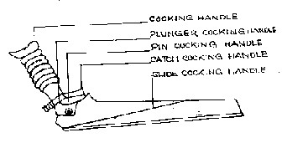

(e) **Cover Assy**. nimnlikhit hisse purjon ki bani hui hai:-

(i) Cover

(ii) Housing Rear Sight

(iii) Leaf Spring

(iv) Screw axis rear sight

(v) Wheel

(vi) Plunger

(vii) Spring Plunger

(viii) Hinge

(f) **Body Housing Assy.**  Yeh sheet metal ki bani hui hai. Ismein ek piece guide hai jo ki breech block ki rotation ko shuru karta hai. Iske hisse purjen nimnlikhit hai :-

(i) **Body Housing.** Yeh 1.8mm sheet metal ki bani hui hai. Iske niche mag, trigger aur pistol grip fit kiye gaye hain.

(ii) **Barrel Extension.** Yeh body mein rivet fitted hota hai.Piece guide bhi ismein hi fit kiya gaya hai. Iske pichle hisse mein do locking surfaces diye gaye hai. Yahan breech block lock hota hai.

(iii) **Guard trigger aur Catch Mag.** Trigger guard body housing ke niche rivet fit hai. Iske samne ek spring loaded catch mag fit hai.

(iv) **Block Rear.** Yeh body housing par rivet fit hai aur piston extension ke piche ki harkat ko rokta hai.

(v) **Channel Right aur Channel left**. Yeh safety sear ko accomodate karne ke liye banaya gaya hai. Chanel Right mein ek projection hai. Ismein se khali khoke eject hote hai.

(vi) **Spacer**. Yeh ek cylindrical akar ka hota hai aur iski body ko buldge hone se bachata hai.

7. **Trigger Mechanism.** Isko detail mein trigger mechanism ke lesson mein cover kiya gaya hai. Iske hisse purjen nimnlikhit hai:-

1. Safety sear assy.
2. Hammer Assy.
3. Trigger Assy
4. Wheel Assy
5. Change Lever Assy
6. Automatic Control Unit

8. **Piston Extension Assy.** Chal wale purjon ko gas ke dabav se unlock wa picche harkat mein madad deta hai. Yeh piston extension ke saath juda hota hai. Iske hisse purjon ke naam is prakar se hai:-

1. Piston.
2. Piston extension.
3. Rivet piston extension.
4. **Rotating Bolt Assy.** Yeh assy nimnlikhit hisse purjon ki bani hui hai.

(a) Breech block.

(b) Extractor.

(c) Hollical Spring inner & outer.

1. Pin extractor.
2. Pin firing.
3. Pin locking pin firing.

10. **Recoil Spring Assy.** Recoil spring ke do guide hote hai. Dono siron par stopper laga hota hai guidepiece ka agla sira stopper front se aur dusra sira stopper rear se laga hota hai. Is assy mein nimnlikhit hisse purje ate hain:-

(a) Spring recoil.

(b) Guide recoil spring.

(c) Retainer.

(d) Stopper.

11. **Butt assy (Fixed Butt Version).** Butt assy ke hisse is prakar hain:-

1. Butt.
2. Butt plate.
3. Swivel pin.
4. Butt trap.

* + 1. Pivot Butt Shoulder.

12. **Butt Assy (Foldable Butt Version).** INSAS LMG mein foldable butt bhi ata hai jo ki Mech Inf aur Special forces dwara istemal mein laya jata hai. Uske hisse purje is prakar hai:-

1. Tube upper.
2. Tube lower.
3. Plate end butt.
4. Piece hinge.
5. Piece strengthening

13. **Pistol Grip wa Block Firing Pistol Grip.** Yeh plastic ka bana hota hai aur ek screw aur block ki madad se body housing ke saath butt aur trigger ke beech laga hota hai. Ismein nimnlikhit saman ata hai:-

1. Oil bottle.
2. Brush cleaning.
3. Pull through.

14. **Mag Assy wa Mag catch.** Mag assy ke hisse purje is prakar hai:-

1. Mag casing.
2. Plate form.
3. Retainer plate.
4. Bottom plate.
5. Spring.

**Bhag-III : 5.56 mm INSAS LMG ki Accessories.**

1. 5.56mm LMG ke saath nimnlikhit accessories aati hain:-

(a) Sling.

(b) BFA (Blank firing attachment).

(c) Muzzle cap.

(d) Monopod.

(e) Passive Night Sight (optional).

(f) Telescopic Day Light Sight (optional).

(g) Beta light sight (optional).

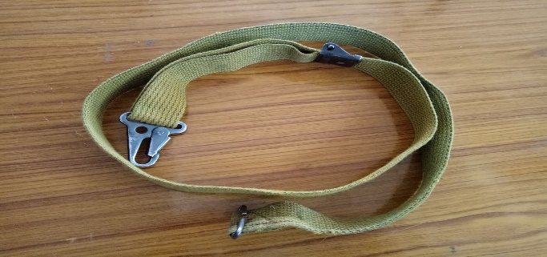 (a) **Sling.** Yeh LMG ko carry karne mein madad deti hai.

(b) **BFA (Blank Firing attachment).** Yeh muzzle par lagaya jata hai aur blank rounds fire karne mein madad deta hai.

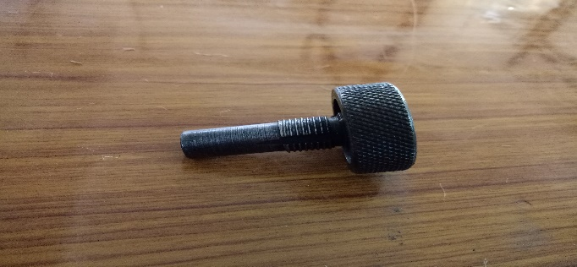

(c) **Muzzle Cap.** Yeh muzzle mein mitti dhul jane se rokta hai.

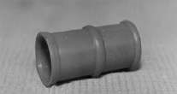

(d) **Monopod.** Yeh age lesson mein vistar meincover kiya gaya hai.

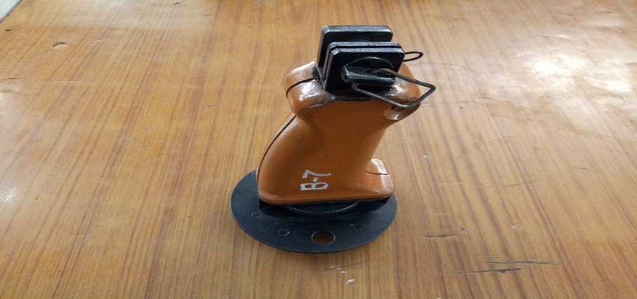

(e) **TDLS (Telescopic Day Light Sight)**. Is sight ka istemal din ke samay lambe range per dushman ko barbad kar sakte hai.

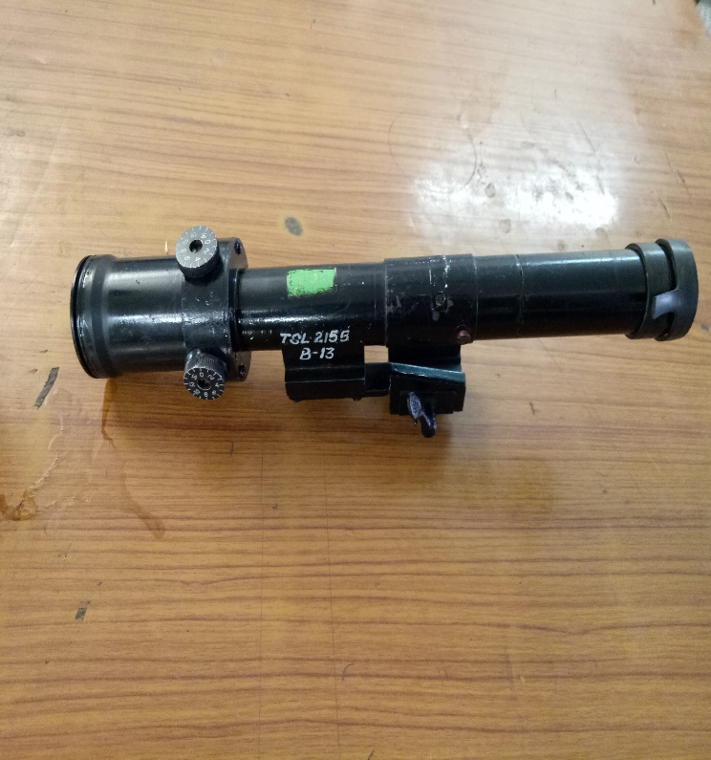

1. **PNS (Passive Night Sight)**. Is sight ka istemal raat ke samay ya kam roshini main bhi kiya ja sakta hai.

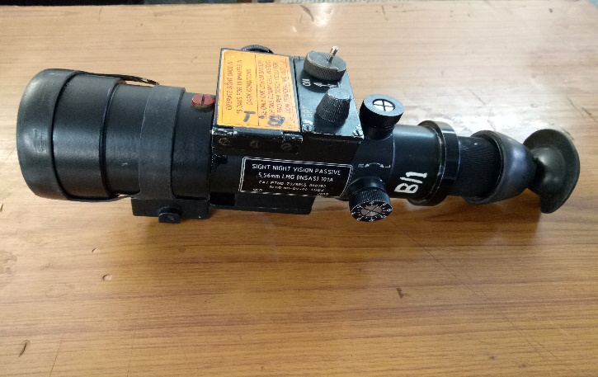

(g) **Beta Light Sight.** Is sight ka istemal raat ke samay kiya jata hai lakin target per roshini hona zaruri hai.

1. **Sankshep.** 5.56mm INSAS LMG 13 assy mein kholi jati hai jiske bare mein jankari awashyak hai taki samay padne par inko kholna jorna asan ho. Yadi hame inki assys ke bare mein jankari ho to iski sikhlai ke liye sahuliat ho jati hai.

**LESSON 2 : EK NAZAR**

5.56mm INSAS LMG, 7.62mm LMG se 30% halka aur 70% kam recoil wala hathiyar hai.

**ZARURI TECHNICAL DATA**

**FIXED BUTT FOLDABLE BUTT**

|  |  |
| --- | --- |
| 1. WAZAN 6.23 KG | 5.87 KG |
| 2. LAMBAI 1050 mm  (Butt Folded) | 1015 mm 790mm |
| 3. BARREL KI LAMBAI 535 mm | 500 mm |
| 4. SIGHT RADIUS 475 mm | 475 mm |
| 5. GROOVES 6 RH | 6 RH |
| 6. MV 925 m/sec  **RATE OF FIRE** | 915 m/sec |
| 7. SINGLE SHOT | 60 rds/min |
| 8. AUTOMATIC | 100 rds/min |
| 9. CYCLIC | 600-650 rds/min |

**LESSON-3**

**5.56MM INSAS LMG KE AMMUNITION SE WAQFIAT**

**Ref- (Infantry Training Volume-I, Infantry Platoon Weapons Pamphlet No 6A 5.56mm Insas Light Machine Gun 2006)**

**Aam Bayan**

1. 5.56 mm amn banane ke baad INSAS hathiyar ka vikas kiya gaya.   
   5.56mm INSAS Rif, LMG aur Carbine se ek hi kism ke amn fire hota hai. INSAS Rif se 3 kism ka amn fire hota hai. Yeh hai Ball, Tracer, Blank amn. NATO ke 5.56mm INSAS Ball FNSS 109 amn se 5.56mm INSAS ball amn kafi acha hai.

**Uddesh**

1. 5.56mm amn ke bare mein jankari deina hai.

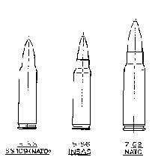

**5.56**

**5.56**

**7.62**

**SS 109 (NATO)**

**INSAS**

**NATO**

**Ball Amn**

1. 5.56mm INSAS ke liye ball amn ka mudda hai ki LMG (Fixed Butt) se fire karne par 700m tak kargar fire dalen. Yeh mudda hasil karne ke liye ball amn mein NATO amn ke banishpat yeh sudhar kiya hai.

* + 1. Bullet ka ballistic shape zyada acha hai.
    2. Bullet ka mass zyada hai.

(c) Bullet inert steel ka banaya gaya hai taki zyada ghusav hasil ho sake.

4. **Ball Amn Ka Technical Data**:-

|  |  |  |  |
| --- | --- | --- | --- |
| **Round** | | **5.56 x 45mm**  **AS MK-I** | **5.56 x 45MM FNSS 109 NATO** |
| **Ball** | | | |
| (a) | Calibre | 5.56 x 45 | 5.56 x 45 |
| (b) | Cartridge ki lambai | 60mm | 57.3mm |
| (c) | Cartridge ka wazan | 12.85gm | 12.42gm |
| **Case** | | | |
| (a) | Type | Rimless bottle Necked | Rimless bottle necked |
| (b) | Lambai | 45mm | 45mm |
| **Bullet** | | | |
| (a) | Type | Baot Tailed | Boat Tailed |
| (b) | Wazan | 4.16gm | 4.00gm |
| (c) | Lambai | 24.50mm | 24.50mm |
| (d) | Envelope | Gilding Metal | Gilding Metal |
| (e) | Core | Lead with Steel tip | Lead with steel tip |
| **Cap** | | | |
| (a) | Type | Boxer | Berdan |
| (b) | Composition | FA-956 | - |
| **Propellant** | | | |
| (a) | Type | Ball Powder | Ball Powder |
| (b) | Charge ka wazan | 1.61gm | 1.61gm |

5. **Blank Cartridge**:- Blank round trg ke liye firing ki awaz ko darshane ke liye banaya gaya hai. Iska technical data is parkar hai:-

|  |  |  |
| --- | --- | --- |
| (a) | **Cartridge** |  |
|  | 1. Wazan | 8.1gm |
|  | (ii) Lambai | 57.5mm |
| (b) | **Case** |  |
|  | (i) Wazan | 7.53gm |
|  | (ii) Lambai | 57.5mm |
| (c) | **Bullet** : Case ke sath shamil hai | |
| (d) | **Propellant** |  |
|  | (i) Type | SPA-II |
|  | (ii) Wazan | 0.480gms |
| (e) | **Primer** |  |
|  | (i) Type | Boxer |
|  | (ii) Composition | Lead Styphnate FA 956 |
| (f) | Sound level | 95db |
| (g) | Safety Distance | 3m |

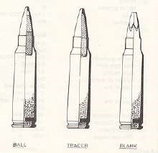

**BALL TRACER BLANK**

6. **Tracer Round.** Tracer round trajectory ko darshane aur firer ki accuracy ko dekhne ke liye banaya gaya hai.

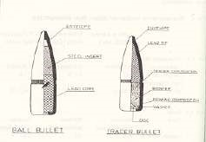

**Sankshep**

7. 5.56mm INSAS amn ek behtar kism ka amn hai jiski ballastics achhi hai. Is amn ki range lambi hai aur lethality bhi jiada hai. Yadi ek jawan ko is amn ke bare mein jankari ho to woh hathiyar ke kaam karne ke bare mein achhi jankari hasil kar sakta hai.

**LESSON 3 : EK NAZAR**

**5.56 MM AMN EK BEHTAR AMN**

1. Halka Amn.
2. Zyada Muzzle Velocity.
3. Acchi Ballastics.
4. Zyada Lethality.
5. Lambi Range.

**INSAS LMG Se Teen Kism Ke Round Fire Kiye Jate Hain**

|  |
| --- |
| 1. Ball 2. Tracer 3. Blank 4. 5.56mm INSAS LMG ke liye ball amn ka mudha hai ki LMG (Fixed Butt) se fire karne per 700m tak karger fire dalen. Yeh mudha hasil karne ke liye ball amn mein NATO amn ke banishpat yeh sudhar kiya hai:- 5. Bullet ka ballistic shape zyada acha hai. 6. Bullet ka mass zyada hai. 7. Bullet inert steel ka banaya hai taki zyada ghusav hasil ho sake. |

**LESSON-4**

**5.56MM INSAS LMG KO KHOLNA, JORNA AUR SAFAI**

**KARNE KA TARIQA**

**Ref- (Infantry Training Volume-I, Infantry Platoon Weapons Pamphlet No 6A 5.56mm Insas Light Machine Gun 2006)**

**Pahunch**

1. 5.56mm INSAS LMG lambi duri tak dushman ko engage karne ke liye Sec ka ek matra auto hathiyar hai. Iska pura pura faida uthane aur iski zindagi ko badhane ke liye safai ki jarurat parti hai, sath hi iske hisse purjon ki tut fut ki badli karne ke liye LMG ko kholne aur jorne ki zarurat parti hai, isliye Sec ke har ek jawan ko chahiye ki woh LMG ko kholna, jorna aur safai karne ka tarika achi tarah janta ho .

**Uddesh**

1. 5.56mm INSAS LMG ko kholna, jorna aur safai karne ka tarika sikhana hai .

**Saman**

1. 5.56mm INSAS LMG, mag, sling, muzzle cap, accessory bag, safai ka saman, sheet ground, oil bottle.

**Bhag**

1. Yeh sabak teen bhagon mein banta gaya hai .

* + 1. **Bhag- I.** 5.56 mm INSAS LMG ka kholna.

* + 1. **Bhag- II.** 5.56 mm INSAS LMG ka jorna.

* + 1. **Bhag- III**. 5.56 mm INSAS LMG ka safai karna.

**Bhag-I : 5.56 mm INSAS LMG Ka Kholna**

1. LMG ko kholne ka tarika is prakar hai:-

* 1. **Mag Kholna.** Mag ko bayen hath se pakren aur mag catch ko anguthe se age ki aur dabate hue mag ko nikalen, muzzle cap aur sling ko nikalen.

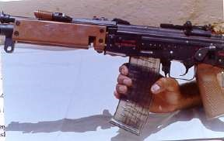

* 1. **Assy Cover Kholna.** Change lever ki posn ‘R’ ya ‘A’ par karen. aur LMG ko cock karen. Change lever ki posn ‘S’ par karen. Retainer   
     catch ko bayen hath ki madad se dabayen aur dayen hath ke anguthe se retainer ko age taraf dabayen jab retainer age aa jata hai to locking retainer se dabao hata len takih peeche ka opening cover retainer se azad ho jae ab assy cover ko upar ki taraf uthaen aur age ki taraf lein.

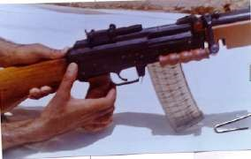

* 1. 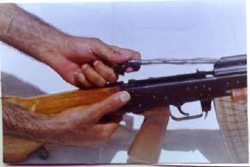**Recoil Spring Assy Ko Nikalna** . Retainer ko dabate hue recoil spring assy ko guide se juda karen aur recoil spring assy ko bahar nikalen.
  2. **Piston Extension Assy Ko Nikalna**. Piston extension ke pichle hisse ko pakren aur upar ki taraf uthathe hue bahar ki taraf nikalen.

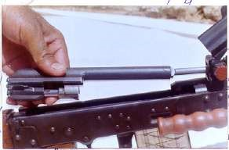

* 1. **Rotating Bolt Ko Nikalna.**  Iske liye piston extension ko bayen hath se ulta pakren. Dahine hath se Rotating Boltko iske races se judha

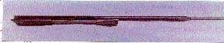

karen.

(

f

)

**Gas Tube Ko Nikalna.**

Iske

liye

gas

tube

locking

lever

ko

90

degree per khara karen aur gas tube ko bahar nikalen.

1. **Chotte Purjon Ko Kholna.**
   1. **Firing Pin Ko Kholna.** Locking pin ko drift ki madad se nikalen aisa karne se firing pin bahar aa jayega.

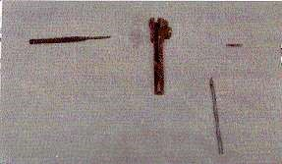

(ii) **Extractor ko kholna.** Iske liye bhi drift ki jarurat parti hai bayen hath ke anguthe se extractor ko dabao drift ke nokile bhag se axis pin ko press karen axis pinbahar nikal jayega ab extractor aur spring ko iske bane races se judaa Karen.

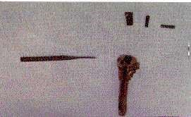

* 1. **Gas Plug Ko Nikalna.** Drift ki madad se pin firing gas plug ko nikalen aur gas plug ko dabate hue gas block ko bahar nikalen.

* 1. **Mag Ko Kholna.** Retainer ko dabate hue bottom plate ko nikalen. Retainer spring aur platform ko bhi bahar nikalen.

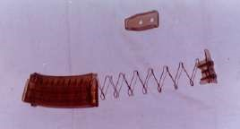

1. **Hand Guard Ko Kholna.** Screw ko kholen aur hand guard ko bahar nikalen.

**Bhag-II : LMG ko Jorna**

1. LMG ko jis tartib se khola jata hai thik uske vipreet jora jata hai. Dhyan rakhen ke agar do ya do se adhik LMG kholi ho to jorne se pahle hisson purjon ke Regd No check kar liye jayen:-
   1. Mag ke plateform ko mag mein joren.
   2. Extractor aur Firing Pin ko joren.
   3. Gas Plug ko joren.
   4. Gas Cylinder tube ko joren aur locking catch ko niche dabaen.
   5. Hand Guard ko joren.
   6. Piston Extension aur Rotating Bolt ko joren.
   7. Piston Extension Assembly ko Gas tube mein dakhil karen.
   8. Body Housing mein Piston Extension Assy Recoil Spring ko dalen.
   9. Cover Assy ko band karen aur retainer ko lock karen.
   10. Mag ko lagaen, Sling aur Muzzle Cover ko lagaen.

1. LMG ke hisse purjon ko jorne ke bad LMG ki janch is prakar karen:- (a) Mag ko nikalen.

(b) Change lever ko “R” par karen.

(c) LMG ko cock karen.

(d) Piston Extension ko aage jane de.

(e) Trigger ko press Karen.

**Bhag-III : LMG Ki Safai**

1. Yeh zaruri hai ki LMG ki thik tarah se samay samay par saaf safai karte rahna chahiye taki LMG ko bina rukawat ke fire mein shamil kar saken. Iski safai ke liye nimnlikht chizon ki zarurat parti hai :-
   1. Oil ‘A’ with oil bottle.
   2. Brush cleaning bore.
   3. Brush cleaning chamber.
   4. Pullthrough.
   5. Rod cleaning barrel.
   6. Tool adjusting fore sight /rear sight.
   7. Tool Removing ruptured case.
   8. Drift.

(j) Chindi.

**Note.** LMG ki saaf safai wa rakh rakhav mein ghishe ya ragarne wale saman ka istemal nahin karna chahiye.

9. **Safai ke parkar**

1. Aam Safai
2. Firing ke lihaz se
3. Mausam ke lihaj se

(a) Aam Safai

(i) Rojana ki safai

(ii) Weekly safai

(iii) Monthly safai

(b) Firing ke lihaj se

(i) Firing se pahle

(ii) Firing ke dauran

(iii) firing ke baad

(c) Mausam ke lihaj se

(i) High altitude

(ii) Desert

(a) **Aam Safai**:-

(i) **Rojana ki Safai**. Hathiyar kisi trg ke liye nikala gaya ho to us samay hathiyar ke bahar wale hisse ko saaf kapre se acchi tarah saaf kiya jaye.

(ii) **Weekly Safai.** Hathiyar ke ander wale purjon ki safai aur tel ki badli ki jai.

(iii) **Monthly Safai.** Tel ki badli se pahle garam pani daal kar hi safai kiya jai

(b) **Firing ke lihaz**

(i) **Firing se pahle ki safai**. LMG ko khol kar iske sabhi purjon ki safai karne ke sath sath unki tut fut ki janch leni  
 chahiya. Yeh Armr ka kaam hai ki woh tut fut wale purjon ko  
 badli kar den. Magazine aur ammunition ko bhi saaf karke mag main bharna chahiya aur mag ki tut fut check kar leni chahiya. Niminlikhit ke anusar kuchh purjon mein tel diya jayega aur kuch mein nahi diya jayega.

|  |  |
| --- | --- |
| **Purjon ko Tel Lagana** | **Purjon ko Tel Nahi Lagana** |
| Rotating Bolt face ko chor kar pure Rotating Bolt. | Barrel |
| Magazine catch. | Cylinder Gas |
| Trigger Mech | Plug Gas |
| Recoil spring Assembly. | Piston extension Assembly. |
| LMG ke bahar. |  |
| Magazine plate |  |

(ii) **Firing ke dauran safai.** LMG ko firing ke sauran bhi pull through se saaf karte rahna chahiya. Iske faids yeh hai ki LMG ki barrel garam hoti hai gas jaldi saaf ho jati hai.

(iii) **Firing ke baad**. LMG ko field strip kar uski safai karen aur pull through aur chindi ki madad se bore ko is prakar saaf karen ki usmen gilapan na rahe. Ab bore mein tel laga den. Brush cleaning cylinder mein tel lagakar usse cylinder gas ko saaf karen. Jab safai ka kaam samapat ho jaye to LMG ke andurni bhagon mein tel laga den. Gas se prabhavit purje jaise rotating bolt, gas plug, piston, piston extension aur firing pin ko savdhani se saaf kare taki unmein se gas fouling dur ki ja sake. Purjon ko saaf karne ke bad us mein tel lagana chahiye. Is ke alawa LMG ke dusre hisse purjon ko kapra ya sutar ki madad se saaf karna chahiye. LMG ki bahri satah ko tel wale kapre dwara jor se nahi ragarna chahiye. In jaghon se dhool jharne ke liye kapre ka istemal karna chahiye. Yadi LMG nami ya dhul wale mausam mein pari rahi ho to uski magazine ko khol kar saaf karna chahiye. Agar magazine saaf dikhai deti hai to use bar bar kholne ki jarurat nahi hai.

(c) **Asamanya Mausami Avastha**. Jyada thande mausam mein istemal karne ke liye LMG ko karger banane ke liye uske sabhi purjon ko K/Oil aur OX 13 ke misran ko istemal karna chahiye. Iske atrikat LMG se fire karne se pahle ek do bar cock kar lena chahiye.

10. **Lubrication**. Niminlikhit Tapman mein prayog karne wale lubricant ki suchi is prakar hai:-

|  |  |  |
| --- | --- | --- |
| **Istemal** | **Tapman** | **Lubricant** |
| Body aur trigger mech ke sabhi purje | 4 degree C se adhik tapmaan  4 degree C se -18 degree C  -18 degree C se -40 degree C  -40 degree C se -50 degree C | Oil OX 52  Oil OX 13  Oil OX 13 + Superior quality K/Oil 1:1  (ASC/9140-000008)  Oil OX 13 + Superior quality K/Oil 2:3 |

**Chindi ka size.**

* 1. Safai ke lie - 4" x 1.5"
  2. Oil - 4" x 1"

1. **Dhyan Deine Wali Baten:-**

* + 1. Sabak ke duran LMG ke jis hisse purje ko aap kholen uske naam aur kaam sath sath bataen.

* + 1. Studeint ko batayen ki LMG ko cock karne ke liye cocking handle ko pura pichein khinche aur purre taur par chodein. Kabhi bhi cocking handle ko pakre pakre purjon ko age na jane dein.

**Sankshep**

1. LMG ek bharosemand hathiyar tabhi ban sakta hai jab ki uski thik tarah se rakh rakhav, saaf safai aur dekhbhal ki jai. Ek hathiyar ki aayu uski maintenance par nirbhar karti hai. LMG ki safai tabhi sambhav hai jabki jawan ko iske kholne jorne ki tartib malum ho.

# LESSON 4 : EK NAZAR

**INSAS LMG 7 Bare aur 4 chote hisson mein kholi jati hai**

**Bare Hisse Chote Hisse**

1. Magazine 1. Firing Pin
2. Cover Assy 2. Extractor
3. Recoil Spring 3. Gas Tube
4. Piston extension 4. Mag
5. Rotating Bolt
6. Gas Tube
7. Hand Guard

**NOTE:-**

1. Extractor ki badli karne ke liye pahle firing pin axis pin ko kholna parta hai.

1. Firing pin ki badli karne ke liye extractor axis pin ko kholne ki jarurat nahin padti.

**LMG ko jorna**

1. Jorne ki tartib kholne ki tartib ke vipreet hai.

1. Jo hissa purja baad mein khola gaya hai use pahle jora jae.

**SAFAI**

1. Aam Safai

(i) Rojana ki safai.

(ii) Weekly safai

(iii) Monthly safai

1. Firing ke lihaz se safai

(i) Firing se pahle.

(ii) Firing ke dauran

(iii) Firing ke baad

1. Mausam ke lihaz se safai

(i) High altitude.

(ii) Desert

**LESSON-5**

**5.56MM INSAS LMG KI MAG KO BHARNA, KHALI KARNA, LMG KO BHARNA, SIGHT LAGANA , READY, MAKESAFE AUR KHALI KARNE**

**Ref- (Infantry Training Volume-I, Infantry Platoon Weapons Pamphlet No 6A 5.56mm Insas Light Machine Gun 2006)**

**Pahunch**

1. Ek jawan ko 5.56mm INSAS LMG ko kholna, jorna aur safai karne ka tarika sikh lena hi kafi nahin hai balki teji aur durusti se dushman par kamyabi pane ke liye mag bharna, sight lagana aana chahiye taki sighton ka sahi istemal karte hue fire kar sake. Sath hi larai ke maidan mein bhari LMG ko ek jagah se dusri jagah le jane hot oh makesafe ka tariqa bhi aana chaiya.

**Uddesh**

1. INSAS LMG ke mag ko bharna, khali karna, sight lagana, LMG ko bharna, ready, make safe aur khali karne ki karwai sikhana hai.

**Saman**

1. INSAS LMG, Mag, Drill Cart, 1’ x 1’ tgt, Small pointer aur grnd sheet.

**Bhag**

1. Yeh sabak aapko theen bhagon mein sikhaya jaega.

* 1. **Bhag-I** . INSAS LMG ki mag ko bharna aur khali karna.

* 1. **Bhag-I** . Sight lagana aur range hasil karna.

* 1. **Bhag-III.** LMG bharna, ready, make safe aur khali karna.

**Bhag I : INSAS LMG ki Mag ka Bharna aur Khali Karna**

1. **Amn ki Safai.** Round ko len aur samay hai to kisi saaf kapre se ek-ek karke saaf karen. Agar jaldi hai to kai roundon ko ek sath saaf karen. Lekin dhyan rahe ki round ek dusre se ragad na lage. Amn ko saaf kar kisi saaf jagah par ya ground sheet ke upar rakhen.

1. **Mag ko Bharna.** 5.56mm INSAS LMG ke mag ko bharne ka tarika aur khali karna hu-ba-hu Rif ki mag ki tarah hi hai. Mag ko len aur check karen, Mag kahin se tuta hua to nahin hona chahiye. Platform aur spring ka nirikshan karen. Mag ko len aur uska chhotta mehraav apne taraf aur bara mehraav bahar ki taraf rakhte hue grnd sheet, boot ke toe par rakhte hue, dono hathon ke anguthe ke sahare se ek ek karke round bharen. Bharte samay agar koi round gir jata hai to use saaf kar ke mag mein bharen. Yeh yakin karen ki round ka pichla hissa mag ke diwar ke sath laga hua ho. Is prakar ek mag mein 30 rds bhare jate hai. Registaan ke ilake mein bhi mag mein 30 rds hi bhare jati hai.

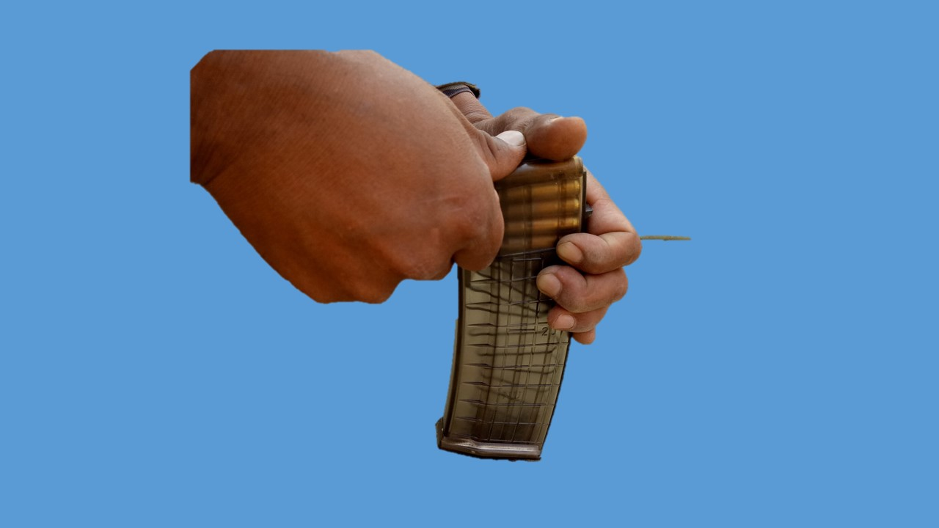

1. **Mag ka Khali Karna.** Bhari mag len, bayan hath ki char ungli upar se, angutha ander se pakarte hue chhote mehraav ko zamin ki taraf rukh kar ek round ki nok se ya kisi nukili chiz se Madhya se dabate hue eke k karke mag ko khali Karen. Mag ko khali karne ke liye agar round ka istemal kar rahen hain to har ek ya do round ke baad round ki badli kar li jae. Round ka girna saaf sthan par hona chahiye.

**Bhag-II : Sight Lagana**

1. **Rear Sight ke Hisse-Purjey**. Iske hisse purje is prakar hain:-

* 1. Slide, Ramp par harkat karti hai.
  2. Plunger Slide ko harkat deine mein madad karta hai.
  3. Ramp par 200m se 1000m tak ank khude hain.

1. **Lagane ko Tarika.** Plunger ko dabate hue slide ko harkat dete hue range ko ramp ke kate hue nishan ke niche kinare se milaye.

**Bhag-III : LMG Bharna, Ready, Make Safe aur Khali Karna**

1. Jab LMG par bhari mag ho aur change lever ‘S’ par ho to LMG bhari mani jati hai. Jab LMG per bhari mag chada ho, chamber ke ander round ho aur change lever ‘R’ ya ‘B’ par ho kalme wali ungi trigger per ho toh LMG ready mani jati hai. Jab chamber khali ho, mag khali ho aur change lever ki posn ‘S’ par ho to LMG khali mani jati hai.

1. **Bhar ki Hukum par Karwai.** Jab firer ko tgt dikhai de ya trg ke dauran hukum mile Bhar to karwai is prakar kare. Change lever ki posn S par karen, mag catch ko dabate hue mag ko utare pouch mein rakhe. Pouch se bhari mag len nirikshan karte hue mag way mein dakhil karen. Yakin kare ki mag thik baith gaya hai. Pouch ka buttton bandh karen aur dahine hath ko pistol grip par le jaye.

1. **Ready.** Ready us waqt kiya jata hai jab firer fire karne ka irada rakhta ho, tgt dikhai de ya trg ke dauran aadesh mile ready toh change lever ko 'R' ya 'B' par karen. LMG ko kandhe par le jayen cock karen aur kalme wali ungli trigger par le jayen aur agle hukum ka intezar karen.

1. **Make Safe.** Jab bhari hui LMG ko ek jagah se dusri jagah le jana ho to make safe ki karwai is prakar ki jati hain.

(a) Kalme wali ungli ko trigger se alag kare change lever ki posn ko 'S' par karen, pouch ke button khole, bhari mag ko utare aur pouch mein band karen.

(b) Change lever ki posn ko 'R' par kare, LMG ko do baar cock karen aur trigger dabayen.

* + 1. Change lever ki posn 'S' par karen.
    2. Bhari hue mag ko le mulahihza karte hue LMG mein chadhayen.
    3. Zamin par gire round ko uthayen, saaf karen aur dusri mag mein bhardein. Mag ko pouch mein band karen.

1. **Khali Karna.** Khali kar ke hukum par make safe ki karwai karne par aakhri mein bhari mag ki jagah khali mag chadha do.

**Sankshep**

1. Yadi ek jawan ko mag bharna aur LMG ko kholna durust ata ho woh larai ke maidan mein bina samay barbad kiye jaldi se fire kar sakta hai. Yeh jaruri hai ki jawan ko ismein sikhlai dekar use durust karna chahiye.

**LESSON No 5 : EK NAZAR**

1. INSAS LMG ki mag capacity - 30 rds hai.
2. INSAS LMG mag mein - 30 rds hi bhare jate hain.
3. Retile /gardile ilake mein bhi - 30 rds hi bhara jaten hain
4. Mag, filler se nahin bhari jati hai.
5. Mag ko kisi nukile chij ya rd ki nok se khali kiya jata hai.
6. Make safe ki karwai mein ant mein bhari mag chadhai jati hai.
7. Khali kar ki karwai mein ant mein khali mag chadhai jati hai.

# LESSON-6

**5.56 MM INSAS LMG SE SHIST LENA,**

**PAKAR KAYAM KARNA AUR FIRE KARNA**

**Ref-(Infantry Training Volume-I, Infantry Platoon Weapons Pamphlet No 6A 5.56mm Insas Light Machine Gun 2006)**

**Parichay**

1. Ek firer agar, durust posn aur pakar hasil karne ke baad durust shist lekar fire karta hai to woh, ek goli ek dushman ka mudha hasil kar sakta hai. 5.56mm INSAS LMG humari sena mein naya hathiyar aaya hai. Iske shist, pakar aur fire ka tarika 7.62 mm LMG ki tarah hi hai. Agar ek jawan sqd post par achhi sikhlai paya hua hai to woh 5.56mm INSAS LMG se fire karke ek goli ek dushman ka muda hasil kar sakta hai.

**Uddesh**

1. 5.56 mm INSAS LMG se shist, pakar aur fire karne ka tariqa sikhana hai.

**Saman**

1. LMG, mag, drill cart, 5.56mm INSAS Rif, field of view board, 1’ x 1’ tgt, black board, chalk, duster, pointer aur grnd sheet.

**Bhag**

1. Is sabak ko teen bhagon mein baanta gaya hai:-

* 1. **Bhag-I** : Durust Pakar
  2. **Bhag-II** : Durust shist lene ka tarika
  3. **Bhag-III** : Fire karna

**Bhag-I : Durust pakar**

1. Kisi bhi firer ke fire ka star kafi had tak uske durust pakar par nirdharit hai. (5.56mm INSAS Rif aur LMG ki pakar mein antar hai do jawanon ki posn dikhakar sajhayen). LMG mein Bipod laga hai lekin Rif mein sahara dene ke liye bayen hath ko aage karte hue fore hand guard ke niche se pakara jata hai. Iske karan Rif mein badan tirchha rakha jata hai, 5.56mm INSAS LMG mein bayan hath small of the butt ke upar hone ke karan LMG par badan sidha rakhte hain.
2. **Durust pakar hasil karne ka tariqa.**

* 1. Tgt ko dekhkar bipod ko tgt ki sidh mein align karo, tgt bipod ke beech mein hona chahiye.

* 1. Durust pakar hasil karne ki karwai (namuna wa bayan). Hukam mile lying posn to posn ikhtiiyar karen, range milne par sight par diya hua range lagayen, LMG ko kandhe par le jaen, khande par le jate samay shoulder rest ko khara kare aur kandhe par rakhen, LMG ko cock karen aur kohniyon ko harkat dekar posn durust karen. Yadi shist Point of Aim se niche ya upar ho to zarurat ke mutabik bipod shoes ko niche ya upar karen.

1. **Durust pakar ke liye sharir ke alag alag hisse ke kam is prakar hai:-**

* 1. **Kandha**. Kandha butt ko tikane ke liye jagah deta hai aur LMG ko pichhe jane se rokata hai. Kandhe mein jo gadda banta hai wahan par butt ko rakha jae na ki haddi ke upar. Butt aur kandhe ke milap ko kayam karne ke liye sabse pahle LMG ke shoulder rest ko khole aur kandhe par rakhe. Yadi kandhe aur butt ka milap thik se nahin ho raha ho to sharir ko aage ya piche ki harkat dekar posn set karen na ki LMG ko aage ya piche kinch kar.

* 1. **Bayen Hath**. Bayen hath se LMG ke small of the butt ko pakara jata hai, charon unguliyan upar se aur ungutha niche se. Bayan hath butt ko pichhe aur niche ki taraf khinch kar rakhta hai.
  2. **Dahine Hath.** Dahine hath ki pakar pistol grip par teenon ungliyon bahar se aur angutha ander se kalmi wali anguli trigger guardd ke upar, angutha ander ki taraf. Dahina hath LMG ko pichhe khinch kar rakhta hai aur LMG ko samanatar rakhne mein madad deta hai.

* 1. **Sir**. Sir ko butt ke upar is prakar rakho ki gaal ka naram wala bhag butt ke upar tik jae. Gaal bayen hath ki kalme wali ungli ke pass is prakar rakho ki ankh rear sight se takriban 3'' se 4'' ke bich ho.

* 1. 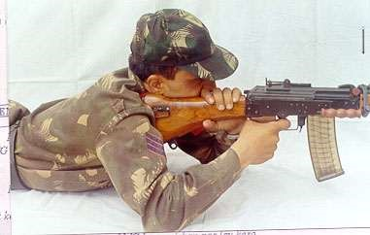**Puri pakar ko majboot Karna**. Puri pakar ko majboot karne ke liye gaal se bayen hath ko butt ke sath dabate hue donon kalaion ko andar ki taraf karo is karwai ko clamping ki karwai kahte hai.

1. Agar jawan ka bayan hath “MASTER HAND“ aur bayen ankh   
   “MASTER EYE“ ho to jawan ko bayen kandhe se fire karne diya jae kyon ki 5.56mm INSAS LMG ka back sight aperture, sight ke bichon bich hai.
2. **Abhyas.** Sabhi students ko hathiyar ke saath handling karwa kar abhyas karaya jae.

**Bhag-II : Durust Shist Lene ka Tarika**

1. Firer apne dimag aur ankh ka talmel karke LMG ki sighton ka sahi istemal karte hue shist ko POA par milane ki karwai ko durust shist lena kahte hai. 5.56mm INSAS LMG ke back sight upar hone ke karan firer koi bhi ek ankh band kar sakta hai. INSAS Rif aur LMG mein pakar wa posn mein antar hone ke karan INSAS LMG mein eye relief zyada hai jisse field of view kam banta hai.

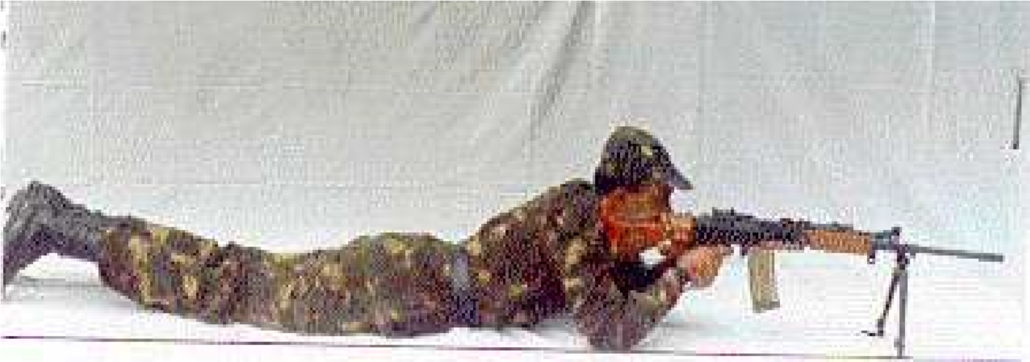

1. **Shist ka kaida** LMG mein shist ka kaida hu-ba-hu Rifle ki tarah hai. LMG mein automatic fire karne ke kabliyat hone ke karan ismein tharatharahat zyada hoti hai. Thartharhat ke karan ek firer ko fore sight ko aperture ke madhya mein rakhne mein zyada dhyan dena parega wa majboot pakar ko barkarar rakhne ki jarurat paregi.

**(Sight Alignment ki Ahmiyat Sight Picture se Adhik)**

1. **Hatkar Shist Lena.** LMG se bhi hatkar shist lene ka tarika Rif ki hi tarah hai, lekin tgt ko engage karne ke liye LMG mein farak hai, LMG se hum tracking wa trapping ke tarike se target engage kar sakte hai.

* 1. **Trapping**. Is tarike se target ko engage karne ka tarika is prakar hai:-
     1. Target ke rukh aur range ko malum karo aur sight par sahi rg lagao.
     2. Tgt ke age ek nishan chuno aur LMG ko us nishan par fix karo.
     3. Tgt ki raftar ko madhya nazar rakhte hue tgt ka POA nikalen.
     4. Tgt aur nishan ke bich nikale gaye lead ko mashoor nishan se tgt ki taraf lein aur akhiri wale lead ek upar madad ka nishan chune.
     5. Jab tgt madad ke nishan ke pass pahunch jae to 6 se 8 round ka burst fire pahale mashoor nishan par karen, tgt apne hi lead ke upar barbad ho jaega.
  2. **Tracking.** Is tarike se tgt ka pichha karte hue tgt ko barbad kiya jata hai. Bipod fold karke, sand bag par rakh kar bhi tracking ke tarike ka istemal kiya jata hai.

Note: **trapping ka tarika tracking ke tarike se zyada acha hai.**

1. **Abhyas**. Is puri karwai par class se abhyas lein. Tracking aur trapping ke tarike ka farak achi tarah samjhayen.

**Bhag-III : Fire Karna**

1. Alag alag halaton mein nikalne wale tgt par kargar fire dalne ki kabliyat ke lihaj se INSAS LMG ko banaya gaya hai. INSAS LMG se hum nimnlikhit prakar ke fire kar sakte hain:-
   1. Single shot.
   2. **Automatic Fire**

(i) Burst fire.

(ii) Rapid Fire.

1. **Single Shot Fire.** (Namuna bayan ke saath)

(a) Sahi posn ikhtiyar karo.

* 1. Natural alignment ko check karo.
  2. LMG ko bhar aur ready, sahi sight lagao aur sight alignment aur sight picture ko hasil karo.
  3. Dimagi taur par sharir ke un angon ko check karen jo LMG ko pakarne mein madad karte hain jaise bayan hath, dahina hath, kandha, aur shir.
  4. Durust sight alignment aur sight picture hasil hone ke baad   
     foresight par nazar jamaye, yakin karen ki foresight tip aperture ke madhya mein hai.
  5. Change lever ki posn ‘R’ par karen trigger par pahle dabav hasil karen. Kuch der sans roken aur trigger ko press karen. Is prakar se 1 min mein 60 round ke hissab se single shot fire kiya ja sakta hai.

1. **Stop.** Fire ke dauran yadi target chup jaye ya trg ke dauran aadesh mile ‘STOP’ to karwai is prakar karen (Namuna bayan se).

(a) Kalme wali ungli trigger se bahar nikalo.

* 1. LMG ko kandhe se niche lao aur change lever ki posn ko ‘S’ par karo, agle hukam ka intzaar karen.
  2. Iska mag ardhpardarshi hai, is liye khali mag ka yakin nahi kiya jata hai, zarurat ho to mag ki badli kiya jae.

1. **Go On ya Jari Kar.** Go On ya Jari kar ke hukam par butt aur kandhe ka milap karen aur change lever ki position pahle wali position per karen aur LMG ko fire mein shamil karen.
2. **Rapid Fire** Rapid fire mein lagatar fire kiya jata hai. Ismein “STOP” aur “GO ON” ya “ JARI KAR” ki karwai single shot ki tarah hi hai. Rapid fire ke dauran 1 min mein 150 rds (5 mag) ke hissab se fire kiya jata hai. “STOP” ka hukam milne par LMG ko cock karen, holding opening device lagayen taki barrel thandi ho jae.
3. **Burst Fire (Bayan).** Burst fire mein change lever ko ‘A’ par karen aur trigger dabata hai aur 2 ya 2 se adhik rounds fire ho isse burst fire kahte hai.

Burst kitna lamba hoy eh tgt ke range, kism aur firer ki kabhiliyat par nirbhar hai.

* 1. 2 se 3 round ka burst achha mana jata hai.
  2. 4 se 5 round ka tgt par phail kar lagta hai. Isse tgt par mar asani se dekhi ja sakti hai.
  3. 6 se 8 round ke burst harkati target ko barbad karne ke liye kiya jata hai.

1. **Limber Up.** Firing se pahle limber up ki karwai karna zaruri hai. Khas kar burst fire ke dauran limber up ki karwai, firing ke dauran mauka milne par bhi karna chahiye. Firer ko tgt ke upar shist lena chahiye phir fore sight ke upar nigah jamate hue LMG ko aage pichhe ki harkat deina chahiye. Yadi fore sight upar niche ki harkat karti hai to firer ka posn sahi hai.

**Sankshep**

1. Ek firer agar durust pakar aur shist hasil karte hue fire karta hai to woh 5.56 mm INSAS LMG se asani se dushman ko barbad karte hue ek goli ek dushman ka mudda hasil kar sakta hai.

**LESSON 6 : EK NAZAR**

DURUST DURUST

PAKAR SHIST

**DURUST FIRE**

EK GOLI

**DURUST FIRE KA MUDDA**

EK DUSHMAN

SIGHT ALIGNMENT KI AHMIYAT SIGHT PICTURE SE ADHIK

**TRAPPING KA TARIKA TRACKING KA TARIKE SE JYADA ACCHA HAI**

TRAPPING SE 6-8 RDS KA BURST ACCHA MANA GAYA HAI

TRACKING SE TGT KA PICHHA KIYA JATA HAI

**LESSON - 7**

**5.56MM INSAS LMG KI CHAL AUR ROKEN**

**Ref- (Infantry Training Volume-I, Infantry Platoon Weapons Pamphlet No 6A 5.56mm Insas Light Machine Gun 2006)**

**Pahunch**

1. 5.56 mm INSAS LMG kafi dur tak dushman ko engage aur bhari tadad mein fire karne wala automatic hathiyar hai. Lagatar fire ki dauran ismein chand ek roken par sakti hai. Sec ka har ek jawan is kabil hona chahiye ki woh LMG ki chal aur parne wali rokon ko bhi asani se dur kar sake.

**Uddesh**

1. 5.56mm INSAS LMG ki chal parne wali roken aur unhen dur karne ka tarika sikhana hai.

**Saman**

1. 5.56mm INSAS LMG, drill carts, mag, Assy pouch, 1’ x 1’ tgt, sheet ground, small pointer.

**Bhag**

1. Yeh sabak aapko do bhagon mein sikhaya jayega.
   1. **Bhag-I**  : 5.56mm INSAS LMG ki chal
   2. **Bhag-II** : Fouri ilaj se rokon ko dur karne ka tarika.
   3. **Bhag-III** : Gas ki kami ki rok ko dur karne ka tariqa.
   4. **Bhag-IV** : Anya roken.

**Bhag-I : 5.56mm INSAS LMG ki chal**

1. LMG ki chal 8 action main pura hota hain yeh action kis parkar se hai inhe samjaen aap board per bane chal ke diagram ki madad se:-

Fire

Unlock

Cock

Extract

Eject

Feed

Load

Lock

1. **LMG ke chal mein kam ane wale hisse purjon ke nam is prakar hai**:-

Trigger, Hammer, firing pin, gas vent, gas plug, gas tube, piston extension, rotating bolt, barrel extension locking surface, ejector, extractor, recoil spring, feed piece, round, piston extention ka pichla, nichla aur daye wala pahlu aur safety sear.

(a) **Fire.** Jab firer change lever ki position ko ‘S’ se 'R' ya 'A' par karke trigger ko press karta hai toh hammer azad ho jata hai. Hammer azad hokar firing pin ke pichhe wale bhag par thokar marta hai, jisse firing pin apne hole se nikalkar chamber wale round ke primer par thokar marta hai aur round fire ho jata hai. Is karwai ko **fire** ki karwai kahte hain.

(b) **Unlock.**  Fire huye round se gas paida hoti hai, joki bullet ko barrel mein aage dhakelti hai. Jab bullet gas vent ke pass se gujarta hai to kuch gas, gas vent, gas plug se hokar gas cylinder mein dakhil hoti hai. Kuch gas bullet ko target tak pahuchane mein madad karta hai. Gas cylinder mein dakhil hui gas piston head par dabav dalti hai jisse piston extension piche ki harkat karta hai. Jab piston extension piche ki harkat karta hai to rotating bolt ka cam, cam way ki madad se dayen se bayen ko itna ghumta hai ki rotating bolt ka locking lug barrel extension locking surface se alag ho jata hai. Is karwai ko **unlock** ki karwai kahte hain.

(c) **Extract.** Unlock hone ke baad rotating bolt aur piston extension ek saath piche ki harkat karte hain, isi dauran extractor fired case ko piche lata hai, is karwai ko **extract** ki karwai kahte hain.

(d) **Cock.** Chal wale purzon ke pichhe ki harkat jari rahti hai. Is harkat ke dauran piston extension ka stem shuru shuru mein hammer ko thora niche dabata hai baad mein piston extension ka bottom surface hammer ko pura niche daba deta hai, jisse safety sear ki notch ka milap hammer ke vent se ho jata hai. Is karwai ko **cock** ki karwai kehte hain.

(e) **Eject.**  Chal wale purje ki isi harkat ke dauran fired case ejector se takrakar ejection slot ke raste dahine aur niche gir jata hai, is karwai ko **eject** ki karwai kehte hain.

(f) **Feed.**  Recoil spring apne housing mein sikur jata hai aur recoil spring guide over lap ho jate hain. Jab recoil spring apne tanav ko pura karta hai to chal wale purzon ko aage ki taraf dhakelta hai, aage ki harkat ke dauran Rotating bolt ka feed piece magazine ke upar wale round ko chamber mein dakhil kar dete hai. Is karwai ko **feed** ki karwai kahte hain.

(g) **Load.** Extractor chamber wale round ke pende par sawar ho jata hai, Is karwai ko **load** ki karwai kahte hain. Yahan par Rotating bolt ki aage ki harkat samapt ho jati hai lekin Piston extension ki aage ki harkat baki rahti hai.

(h) **Lock.**  Piston extension ki aage ki harkat ke dauran rotating bolt ka cam, cam way ki madad se bayen se dayen itna ghumata hai ki rotating bolt ka locking lug, barrel extension locking surface ke sath lock ho jata hai. Is karwai ko **lock** ki karwai kahte hain. Lock hone ke baad bhi piston extension ka kuch harkat baki rahta hai. Is akhiri harkat ke dauran piston extension ka dahina, pichla aur nichla wala pehlu safety sear par dabav dalta hai, jisse safety sear ka notch, hammer ke vent se alag ho jata hai aur LMG dubara fire ke liye taiyar ho jata hai.

**Bhag-II : Fouri ilaj ki karwai aur sakhat khichav ki rok**.

1. 5.56mm Insas LMG ki samay samay par saaf safai ki jaye aur amn ko saaf karke bhara jaye to bahut hi kam roken parti hain lagatar firing ke duran agar chand ek roken par bhi jayen to ek firer rokon ko kis parkar se door karta hai issi karwai ka namuna hathiyar par bayan ke saath doonga aap dekhen thatha samjhen, lying posn, bhar, sight rg 200, ready, samne 1’ x 1’ tgt, fire.
2. Sune trigger press karne par LMG fire na kare ya fire karte-karte ruk jaye to fouri ilaj ki karwai ki jayegi.

**Karne ka tarika**. Sabse pahle kalme wali anguli ko trigger se bahar karen. LMG ko cock karen aur holding opening device ko lagayen. Magazine catch ko dabate hue magazine ko utaren aur pouch mein band karen. Pouch se bhara hua magazine len, mulaiza karte huye magazine way mein fit karen, yakin karen magazine lag gaya hai. Chal wale purjon ko aage jane den. LMG ko fire mein shamil karen. LMG thik fire karega. Is prakar LMG ko ek bar cock karke, holding opening device lagakar aur khali magazine ki badli karne se teen prakar ki roken dur ki jati hain:-

* + 1. Magazine ki rok.
    2. Misfire.
    3. Body mein atka hua round ya fired case.

**Sakhat khichav ki rok**. Fouri ilaj ki karwai karne ke baad bhi LMG thik fire na kare ya fire karte karte chal wale purje aage hi ruk jayen to rok ko pehchane. Pehchane ka tariqa, sabse pahle kalme wali anguli ko trigger se alag karen. LMG ko cock karen, LMG asani se cock nahi toh sakhat khichav ki rok samajkar dur karen.

**Karne ka tarika**. Butt kandhe ka milap tode, LMG ko niche rakhen. Kneeling position ikhtayar karen. LMG ko bayen hath se uthayen. Is position mein dekhne wali baten. LMG takriban 45 degree ke angle par barrel aasman ko point karta huwa. Bayen hath ki pakar fore hand guard par charon anguli niche se angutha upar se barrel ko point karta huwa. Ejection slot zamin ke taraf point karnta hua. LMG ka butt dahine ghutne ke sath laga hua. Dahina ghutna butt ko pichhe jane se rokta hai. Dahine hath ki madad se cocking handle ko upar uthayen. Charon angulion ka hook banate huye LMG ko ek hi jhatke mein cock karen. Yakin karen ki sakhat khichav ki rok dur ho gaya hai. Chal wale purjon ko aage jane den. LMG ko niche rakhen. Pahle wala firing position ikhtiyar karen. Butt aur kandhe ka milap karen. LMG ko fire mein shamil karen LMG thik fire karega. Sakhat khichav ki rok padne ke karan:-

* 1. Ganda chamber.
  2. Maila Ammunition.

Yeh tha fouri ilaz aur sakhat khinchav ki rok ko dur karne ka tariqa yahan tak kiye gaye bayan aur karwai main kisi bhi student ka koi sawal, sawal nahi toh yeh tha namuna abhi hoga isi ka abhyas, Abhyas ke liye aadesh is prakar honge. LMG thik fire karta rukta ke aadesh par fouri ilaj mein LMG ko cock karke holding opening device lagane tak ka karwai kiya jayega. Ustad ke dwara rok ka naam diya jayega aur students ke dawara rok ko dur kiya jayega. Jaise

* + 1. Magazine ki rok ke adesh par magazine ko badli kiya jayega.
    2. Eject hua round ke adesh par round ke primer ko check kiya jayega.
    3. Body mein atka hua round ya fired case ke adesh par body ko clear kiya jayega.
    4. Cock nahin ke adesh par sakhht khichav ki rok samajkar dur kiya jayega.

**Bhag-III : Gas Ki kami ki rok.**

1. **Gas ki kami ki rok**. Fouri ilaj ki karwai aur sakhht khinchav ki rok ko dur karne ke baad bhi LMG thik fire na kare ya fire karte-karte ek do round ke baad ruk jaye to gas ki kami ki rok samajkar dur karen.

**Karne ka tarika**. Sabse pahle kalme wali anguli ko trigger se alag karen. LMG ko cock karen aur chal purjon ko aage jane den. Change lever ki posn ‘S’ karen. Butt aur kandhe ka milap toden. LMG ko bayen pahlu aage jaye aur gas regulator ki position ko check karen, agar gas regulator ki position low par ho to chindi ya saaf kapre ki madad se low se high par karen dhyan rahe gas regulator ki posn ki badly karte samay hath ka koi bhi hissa barrel ke sath touch nahi hona chaiya. Low se high per kiya agar gas regulator ki position pehle se high par ho toh kisi chindi ya saaf kapre ki madad gas plug ko kholen aur gas plug ki safai karen. Gas plug ko jor den aur gas regulator ki position ko chindi ya kapre ki madad se high se low par karen. High se low per kiya. Change lever ki position ko fire par karen butt aur kandhe ka milap karen aur LMG ko fire mein shamil karen. LMG thik fire karega. Gas ki kami ki rok padne ka karan gas ka adhik matra mein fouling hone se gas vent ka band ho jana hai. Gas ki kami ki rok main kisi student ka koi sawal, sawal nahi toh yeh tha namuna abhi hoga isi ka abhyas. Abhyas ke liye adesh is prakar honge. LMG thik fire karta ek do round ke baad rukta ke adesh par aap gas ki kami ki rok samajh kar dur kiya jayega. (Ustad ke dwara rok ka naam diya jayega aur students ke dwara rok ko dur kiya jayega).

**Bhag-IV :Anya Roken.**

1. **Anya Roken**. Fouri ilaj, sakhat khinchav aur gas ki kami ki rok dur karne ke baad bhi LMG fire na kare ya fire karte karte body se alag si awaj aaye to anya rok samaj kar dur karen.

**Karne ka tariqa.** Sabse pahle kalme wali anguli ko trigger se bahar nikalen mag catch ko dabate hue mag ko kholen aur LMG ko cock Karen chal wale purjon ko aage jane de, LMG ko khol den. Firing pin aur extractor ka mulaiza karen yadi koi purja tuta ho to badli karen. Agar firing pin extractor thik ho toh, ho sakta hai body aur chamber ki rok. Donon haathon se LMG ko pistol grip se pakden aur LMG ko badan ke samne le jayen. Body aur chamber ka mulaiza karen. Yadi body clear aur chamber mein kata hua case nazar aaye to sikhe huye tarike se LMG ko jod den. Dhyan rahe body aur chamber ko check karte samay barrel zamin par nahi lagna chahiye. LMG ko cock karen. holding opening device ko lagayen. Assy pouch se clearing plug ko len. Iske teen bhag Base, centre pin aur sleeve. Base aur centre pin ko tight karen. Chamber mein dakhil karen. Chal wale purjon ko aage jane den. LMG ko cock karen aur holding opening device ko lagayen.Yakin karen clearing plug ke sath kata hua case bahar aa gaya hai. Yadi samay ho to unscrew ki karwai karen nahin to mauka milte hi unscrew ki karwai kiya jaye. Butt kandhe ka milap karen, pouch se bhara hua magazine len aur mulaija karte huye magazine way mein fit karen yakin karen ki magazine lag gaya hai. Chal wale purjon ko aage jane den. LMG ko fire mein shamil karen. LMG thik fire karega. Chamber mein case katne ke karan:-

(a) Chamber ka jyada garm ho jana.

(b) Cartridge case ke metal ka kamjor hona.

Anya rok ko dur karne main kisi student ka koi sawal, sawal nahi toh LMG thik fire karta khali kar. Kabhi kabhi clearing plug ke sath kata hua case bahar nahi aata hai, iske chand ek karan:-

* + 1. Base aur centre pin ka tight na hona.
    2. Sleeve ke head ka ghis jana.
    3. Sleeve ka ulta jud jana .
    4. Clearing plug ke kisi hisse purje ka tut jana.

Yeh tha namuna abhi hoga isi ka abhyas, abhyas ke liye adesh is prakar honge. LMG thik fire karta, fire nahi ke adesh par anya rok samajh kar dur kiya jayega. Ustad ke dwara rok ka naam diya jayega aur students ke dwara rok ko dur kiya jayega.

**Sankshep**

1. Ek firer ko LMG ki chal ke bare mein malum hona chahiye taki is mein parne wali roken ko samajhne mein asani hoti hai. Yadi rok parti hai to samaj se ek firer ko is kabil hone chaihye ki woh rokon ko dur karke LMG ko fire mein shamil kar sake.

**LESSON 7 : EK NAZAR**

**INSAS LMG KI CHAL 8 ACTION MEIN PURI HOTI HAI**

|  |  |  |  |  |
| --- | --- | --- | --- | --- |
|  | FIRE |  |  | EJECT |
|  | UNLOCK |  |  | FEED |
|  | EXTRACT |  |  | LOAD |
|  | COCK |  |  | LOCK |

**ROKEN**

1. Fauri ilaj se dur hone wali roken
2. Sakhat khinchao
3. Gas ki kami ki rok
4. Anya roken

**FAURI ILAJ SE DUR HO**

**NE WALI ROKEN**

Khali Mag

Misfire

Body mein atka hua rd

**LESSON-8**

**5.56MM INSAS LMG KA TRIGGER MECHANISM**

**Ref- (Infantry Training Volume-I, Infantry Platoon Weapons Pamphlet No 6A 5.56mm Insas Light Machine Gun 2006)**

**Parichay**

1. 5.56mm INSAS LMG single shot aur automatic mode mein bhari tadad mein fire girane wala hathiyar hai. Is hathiyar mein applied aur mechanical safety di gayi hai. Yeh ek bharosemand aur kargar hathiyar hai aur ismen bahut kam roken padti hain. Iski mechanical safety iske trigger mechanism se hasil hoti hai. Ismen automatic fire iska trigger mechanism mein auto control unit se hasil hota hai. Isliye yeh jaruri hai ki iske trigger mechanism se waqfiat ho taki jarurat padne par ise asani se istemal mein laya ja sake.

**Uddesh**

1. 5.56 mm INSAS LMG ke trigger mechanism ke bare mein jankari deina hai.

**Bhag**

1. Yeh sabak teen bhagon mein banta gaya hai.
   1. **Bhag-I.** Trigger ki chal mein istemal hone wale hisse purje.
   2. **Bhag-II**. Single shot mechanism (SSM) se waqfiat.
   3. **Bhag-III.** Full automatic mechanism (FAM) se waqfiat.

**Bhag-I : Trigger ki chal mein istemal hone wale hisse purje**

1. Trigger ki chal mein kaam ane wale hisse purje is prakar se hain.
   1. **Change Lever.**

(i) Stem

(ii) Rib

(iii) Lug Left

(iv) Lug right

(b) Trigger.

(c) **Trigger Sear.**

(i) Claw

(ii) Tail

(d) **Auxillary Sear.**

(i) Sear claw

(ii) Neck

(iii) Arm

* 1. **Hammer Assy.**

(i) Hammer.

(ii) Recess for safety sear.

(iii) Plateform.

(iv) Hammer return spring.

* 1. **Safety Sear.** Alag axis pin par.
  2. Spring plunger wheel lock.
  3. Stud lever change.
  4. Plunger wheel lock.
  5. Wheel lock.

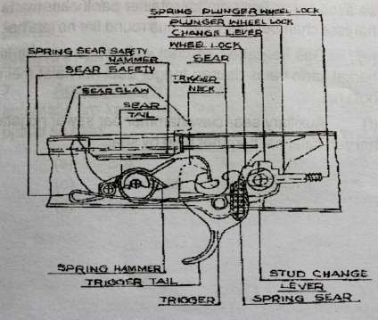

**Bhag-II : Single Shot Mechanism (SSM) se waqfiat**

1. **Change Lever ki Posn S Par (safe mode).** Jab change lever ki posn S par hoti hai to change lever ka right lug trigger par sawar rahta hai aur trigger ki harkat ko rokta hai is dauran yadi trigger dabaya jae to nahi dabega aur trigger mechanism kaam nahin karega yeh LMG mein applied safety hai aur is posn mein LMG safe mani jayegi.
2. **Change Lever ki Posn R par (Single shot Fire).** Jab change lever ki posn S se R par karte hai to:-
   1. Change lever ghari ke sulte rukh ghumta hai.
   2. Change lever ka right lug trigger se hat jata hai aur trigger se applied safety hat jati hai.
   3. Jab LMG cock karte hai to chal wale purje hammer ko pichhe aur niche daba dete hai jisse trigger ki neck hammer par sawar ho jata hai aur hammer ki harkat ruk jati hai.
   4. Jab trigger dabate hai to hammer trigger neck se azad hokar firing pin ke retainer par thokar marta hai jisse chamber mein load hua round fire ho jata hai.
   5. Gas ke dabav se chal wale purje peeche ki harkat karte hai is dauran trigger dabi hui halat mein hota hai.
   6. Auxillary sear claw hammer par sawar ho jata hai yeh halat hai hammer held by sear.
   7. Jab trigger ko release kiya jata hai to auxillary sear claw hammer se alag ho jata hai aur trigger mech hammer par sawar ho jata hai. Yeh halat hai, **Hammer held by trigger aur ready to fire.**

**FUNCTIONING OF SINGLE SHOT**

**Hammer Held by Sear**

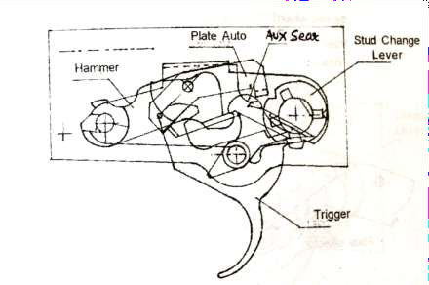

**Bhag-III : Full Automatic Mechanism (FAM) se Waqfiat**

1. **Automatic Control Unit.** Auto control unit LMG ko automatic fire karne mein madad deti hai iske hisse purje is prakar se hain.
   1. Box.
   2. Plate selector.
   3. Plate auto.
   4. Spring wheel.
   5. Bush.

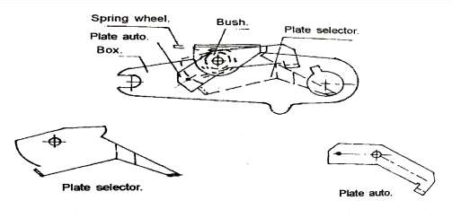

**PARTS OF AUTO MECHAN**

**ISM**

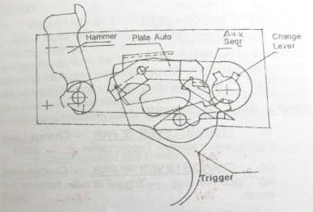

1. **Change lever ki Posn A par (FAM).** Jab change lever ko S se A ya R se A par karte hain.
   1. Change lever ghari ke sulte rukh ghumta hai.
   2. Change lever ka right lug trigger se alag ho jata hai.
   3. Change lever ko aur zyada ghumata hai ya R se A par karte hain to change lever ka left lug plate selector ko niche dabata hai.
   4. Plate selector niche ki harkat karta hai aur plate selector ka dusre kinara fulcrum action se plate auto ko harkat deti hai.
   5. Plate auto auxillary sear ko niche dabata hai jisse sear niche ki harkat karta hai aur dabi hui halat mein rahta hai.
   6. Is halat mein auxillary sear hammer ke harkat ke raste se alag ho jata hai hammer ka milap kewal trigger neck se rahta hai.
   7. Trigger yadi is dauran dabi hui halat mein ho to trigger neck ka bhi milap tut jata hai.
   8. Is prakar change lever ki posn A par aur trigger pressed hone par auxillary sear trigger aur hammer ka milap tut jata hai jisse LMG automatic fire karti hai.

**FUNCTIONING OF SINGLE SHOT**

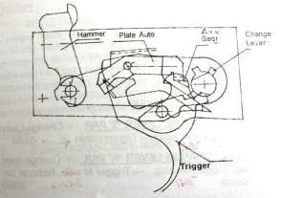

**Sankshep**

1. 5.56mm INSAS LMG ke trigger Mechanism ke bare mein jankari hona bahut jaruri hai taki iski chal aur ismen padne wali roken aur applied wa mechanical safety ko samjhane mein sahuliat ho. Yadi trigger mechanism ke bare mein jankari ho to LM G ko kholna jorna bhi asan ho jata hai.

**LESSON NO 8 : EK NAZAR**

**TRIGGER MECHANISM KE HISSE PURJE**

1. Change lever
2. Trigger
3. Trigger sear
4. Auxillary sear
5. Hammer assy
6. Safety sear
7. Auto control unit

**SINGLE SHOT MECHANISM**

1. **CHANGE LEVER ‘S’ PAR** Change Lever lug trigger tail par sawar - Trigger nahin dabta.
2. **CHANGE LEVER ‘R’ PAR** Change lever lug Trigger tail se alag -Trigger ki sear hammer par sawar .
3. **TRIGGER KA DABANA** Hammer Trigger nook se azad.
4. **CHAL WALE PURJON KI PICHE KI HARKAT** Trigger dabi hui halat mein - Auxillary sear claw Hammer par sawar.

**FULL AUTOMATIC MECHANISM**

1. **CHANGE LEVER ‘A’ PAR**Change lever lug Trigger se alag - change lever left lug plate selector ko nichey dabata hai - Plate auto ki harkat - Auxillary sear nichey ki harkat aur hammer ke raste se alag.
2. **TRIGGER KA DABAV** Hammer trigger sear se azad - Sear dabi hui halat mein rahta hai.

# LESSON-9

**5.56MM INSAS LMG KI SURAKSHA SAMBANDHI JANKARI**

**Ref- (Infantry Training Volume-I, Infantry Platoon Weapons Pamphlet No 6A 5.56mm Insas Light Machine Gun 2006)**

**Parichay**

1. INSAS LMG ek lambe range par fire dalne wala bahut hi kargar hathiyar hai. Yeh ek bahut hi bharosemand aur surakshit hathiyar hai. Agar Nos ko LMG ke suraksha sambandhit tarikon ke bare mein jankari ho to woh pure vishwash ke saath hathiyar ka istemal karke dushman ko barbad kar sakte hain. Saath hi ek hathiyar ko fire se pahle aur uske bare mein suraksha sambandhi puri jankari ka pata hone se hathiyar ki handling aur firing mein sudhar kiya ja sakta hai.

**Uddesh**

1. 5.56mm INSAS LMG ki suraksha ke bare mein jankari deina hai.

**Bhag**

1. Yeh sabak do bhagon mein banta gaya hai :-

* 1. **Bhag-I.** Applied safety
  2. **Bhag-II.** Mechanical safety

**Bhag-I : Applied Safety**

1. Change lever ki posn badli karne se hamen applied safety milti hai. Change lever ki teen posn hoti hain ‘S’, ‘R’ aur ‘A ‘.
   1. Jab change lever ki posn S par hoti hai stem ka rib upar uth jata hai jisse auxillary sear rib ke upar sawar ho jata hai jisse auxillary sear niche jane se ruk jata hai. Is samay LMG cock nahi hoti aur trigger bhi nahi dabta hai to LMG ‘S’ par bhi cock ho jati hai.

* 1. Jab change lever ki posn ‘R’ par hoti hai to stem ka rib pichhe ki taraf aa jata hai jisse sear tail ko niche jane ki jagah mil jati hai aur auxillary sear hammer plateform par sawar ho jata hai. Jab trigger ko dabate hain to trigger sear aur auxillary sear ek hi axis par juda hone ke karan trigger sear ka tail upper uth jata hai aur auxillary sear hammer se pichhe hat jata hai. Jab goli fire ho jati hai chal wale purje hammer ko dobara cock kar dete hain, hammer niche dab jata hai aur auxillery sear hammer par sawar ho jata hai jab tak trigger ko nahi dabate goli fire nahin hogi.

* 1. Jab change lever ki posn ‘A’ par karte hain to us samay stem ka rivet puri tarah pichhe aa jata hai jisse auxillary sear aur hammer ka apas men milap nahin hota. Is posn mein trigger sear hammer ka milap apas men rahta hai.

**Bhag-II : Mechanical safety**

1. INSAS LMG mein chaar prakar ki mechanical safety hain:-

(a) Lock.

* 1. Unlock.
  2. Safety sear.
  3. Stem.

1. **Lock aur unlock.** Lock aur unlock hathiyar mein safety rakhi hai jab tak hathiyar mein’Lock’ ki karwai nahi hoti tab tak fire nahi hoga, aur jab tak gas safe pressure mein nahi ati tab tak Unlock ki karwai nahi hogi. INSAS LMG mein lock aur unlock is prakar se hasil hota hai:-
   1. Piston extension Rotating bolt ko age ki harkat deta hai. Jab Rotating bolt barrel face ke najdik pahunchta hai to barrel extension mein piece guide Rotating bolt ko dahine ki taraf initial rotation deta hai. jaise hi Rotating bolt aur age jata hai to ismein final rotation paida hoti hai jisse Rotating bolt barrel extention ke saath lock ho jata hai. Is dauran round chamber mein puri tarah se dakhil ho jata hai aur hathiyar fire ki halat mein hota hai.
   2. Piston extention peeche ki harkat ke dauran Rotating bolt ko piece guide groove mein bayen ki ore ghumata hai jisse Rotating bolt unlock ho jata hai.

1. **Safety sear.** Safety sear bhi hathiyar ka ek safety hai. Jab chal wale purje age jate hain to piston extension ka nichla aur dahine wala bhag safety sear par dabav dalta hai jisse safety sear aur hammer ka milap tut jata hai. Yeh karwai safety sear ka niche wala hissa aur hammer ke bich mein hoti hai.

1. **Stem**. Agar gas vent pichhe hota to bhi hathiyar mein safety nahi hoti . Jab tak bullet barrel se bahar nahi nikal jati hai aur gas ka pressure kam nahi ho jata tab tak hathiyar mein unlock ki karrawai nahi hoti. Isliye yeh bhi ek mechanical safety hai.

**Sankshep**

1. Kisi bhi hathiyar ke istemal se pahle uski suraksha sambandhi upayon ke bare mein jankari hona nihayat hi zaruri hai. Yeh isliye zaruri hai taki ek firer ko hathiyar ke upar pura bharosa ho sake aur woh hathiyar ka istemal kar ke tgt ko barbaad kar sake.

**LESSON 9 : EK NAZAR**

**INSAS LMG MEIN SAFETY**

**APPLIED SAFETY MECHANICAL SAFETY**

* + - CHANGE LEVER - LOCK AUR UNLOCK

- SAFETY SEAR

- STEM

* HATHIYAR MEIN APPLIED AUR MECHANICAL SAFETY HADSON AUR TUT FUT SE BACHATE HAIN.

**LESSON-10**

**5.56MM INSAS LMG KI ACTION MEIN HANDLING**

**Ref-(Infantry Training Volume-I, Infantry Platoon Weapons Pamphlet No 6A 5.56mm Insas Light Machine Gun 2006)**

**Pahunch**

1. Infantry section mein LMG hi ek aisa hathiyar hai jis se bhari tadad mein lagatar fire dalkar lambe range par dushman ko barbad kiya ja sakta hai. Is hathiyar ki khubiyon ka pura faida uthane ke liye larai mein is par do jawan No 1 aur No 2 ki hasiat se ek team ke taur par kaam karte hain.   
   No 2 ko hamesha No1 ke bayen aur nazdik rahna chahiye takih woh lagatar fire karne mein fire ke dauran agar koi rok pare to use dur karne mein No 1 ki madad kar sake, No 1 ko amn ki supply kar sake aur agar No 1 casualty ho jae to uski jagha le kar lagatar fire kar sake.

**Uddesh**

1. Action ke dauran 5.56mm INSAS LMG ko handling karne ka tariqa sikhana hai.

**Saman**

1. 5.56mm INSAS LMG, 9mm CMG, Mag, Drill Cart, Assy Pouch.

**Bhag**

1. Yeh sabak do bhagon mein banta gaya hai:-

(a)  **Bhag-I .** Fire position ka chunao.

(b) **Bhag-II.** Action mein LMG ki handling.

**Bhag-I - Fire Position Ka Chunao:-**

1. Jab adh nimin parkar ki hon :-
   1. **1' ya Nichi ki Adh.** Is prakar ki adh ko lying position se asani ke sath istemal kiya ja sakta hai. Yahan tak ho saken LMG ko on bipod hi istemal karna chaiya isse kafi sthirta milti hai agar aad izzajat na den toh bipod ko fold karke bhi istemal kar sakte hai lakin dhyan rahen ki mag aad ke sath nahi lge isse feeding ki karwai main badha aa sakti.

* 1. **2’ se 2.5’ tak Ki Adh**. Is prakar ki adh ko sitting, kneeling posn ya high kneeling se istemal main kiya ja sakta hai. Yahan tak ho saken LMG ko on bipod hi istemal karna chaiya isse kafi sthirta milti hai agar aad izzajat na den toh bipod ko fold karke bhi istemal kar sakte hai lakin dhyan rahen ki mag aad ke sath nahi lge isse feeding ki karwai main badha aa sakti hai.
  2. **Gol Adh**. Is prakar ki adh ko apne bayen chorte hue yani dahine se istemal kiya ja sakta hai. Gol adh ka matlab sirf gol hona hi nahin hai yeh adh koi diwar, burji ya koi bara darakht ho sakta hai. Jise se hum ek kinara istemal karten hain is adh ko istemal karne se No 1 taqriban aur No 2 puri tarha se adh ke piche aa jata hai.
  3. **Dhalwandar Adh**. Dhalwandar adh ka istemal karte samay agar aad izazat de to dhalwan ke baprit disha wale bipod shoes ke niche ki mitti khod kar LMG ko zamin ke samantar karen. Aisa karne se zyada sthirta milti hai agar zamin izazat na de to jis taraf dhalwan ho to us taraf ke bipod leg ko khol kar LMG ko zamin ke samantar karen, sath hi jis taraf dhalwan hai us taraf ke paon ko fold karen, aisa karne se badan ko sthirta milti hai.
  4. **4 se 4.5’ ki Adh ya Fire trench ka istemal**. Is kism ki adh ka istemal standing posn se kiya jata hai. Yahan tak ho saken LMG ko on bipod hi istemal karna chaiya isse kafi sthirta milti hai agar aad izzajat na den toh bipod ko fold karke bhi istemal kar sakte hai lakin dhyan rahen ki mag aad ke sath nahi lge isse feeding ki karwai main badha aa sakti. Agar fire trench ka istemal kiya ja raha toh LMG ko on bipod hi isteml kare aur kohini donon fire trench ki diwar ke upar ho.

**Bhag-II - Action Mein LMG ki Handling**

1. Action mein LMG ki handing ki karawai is prakar karte hain:-

* 1. **LMG ko action ke liye tayar karne ka tariqa** Yakin kare ki change lever ki posn S per hai mag catch ko dabate hue mag catch ko utare aur LMG ko cock Karen is parkar LMG ‘S’ per cock nahi, change lever ki posn ko ‘R’ per Karen aur LMG ko cock Karen chal wale purjon ko aage jane de, change lever ki posn ko ‘S’ per kare aur trigger press kare is parkar trigger press nah o toh LMG ‘S’ per thik. Change lever ki posn ko ‘R’ per Karen aur trigger ko press Karen aur sath hi trigger per dabab ko rekhte hue LMG ko cock karen aur chal wale purjon ko aistya aage jane den is parkar hammer ki awaz na aaye aur trigger ko release karte samay click ki awaz aaye toh LMG ‘R’ per thik, change lever ki posn ko ‘A’ per Karen aur trigger ko press Karen trigger per dabab ko rakhte hue LMG ko cock kare aur chal wale purjon ko kabu main rakhte hue aage jane den is parkar hammer ki awaz aaye aur trigger ko release karte samay click ki awaz na aaye toh LMG ‘Á’ per thik. LMG ko makesafe mein Karen aur apne hisse ki mag ko apne pouch mein band karta hai. Assy pouch ko apni bayen taraf belt ke sath lagata hai aur LMG ko carry handle se pakrate hue piche lata hai aur no 2 ki report mil jane per sec cdr ko report deta hai ki No 1 LMG gp handling ke liye tayar, trg ke dauran yeh karawai sthan lo ya take post ke aadesh par ki jati hai. Yeh tha LMG ko action ke liye tayar karna ka tariqa. No 2 9mm CMG ka nirikshan karta hai aur makesafe ki karwai karta hai aur apne hisse ki mag ko pouch main band karta hai aur No 1 ko report deta hai ki No 2 ka hathiyar saman thik. Trg ke dauran yeh karwai take post ya sthan lo ke aadesh per ki jati hai.

* 1. **No 1 aur No 2 LMG gp take post ke addesh par**. Ustad take post ki karwai check karen aur agar studeint galti karta hai to use dur karen. Action ke liye taiyar hai ka report mil jane ke baad ustad LMG Gp ke piche khara hokar line of advance de kar advance karwaye, Sakht fire ke aadesh par ustad sikhaye hue tariqe se arh pakarwaye aur target par fire karwaye, is ke baad ustad No 2 ko line tod karwaye aur khud No 2 ki duty bayen ke saath namuna de.

* 1. **Class ko close karke dikhayen**:-

* + 1. **Mag ki Rok.**  LMG thik fire karta rukta mag ki rok ke addesh per No 1 mag ko utharta hai aur No 2 ko deta hai No 2 apne bayen hath se bhari hui mag No 1 ko deta hai aur No 1 mag ko fit karta hai aur LMG ko fire main shamil karta hai.

* + 1. **Gas ki kami ki rok**. LMG thik fire karta rukta ek ya do round ke bad rukta ke aadesh par No 1 LMG ko cock karta aur   
       No 2 ko gas regulator ki posn ko badly karne ka aadesh deta hai. No 2 chindi ya saaf kapre ki madad se gas regulator ki posn ko low se high per karta hai. No 1 tab tak anguli ko bahar rakhta hai jab tak No 2 apni posn main nahi aa jata.

* + 1. **Body chamber ki Rok**. LMG thik fire karta rukta fire nahi ke adesh per No 1 mag ko utarta hai aur LMG ko cock karta hai chal wale purjon ko aage jane deta hai aur LMG ko kholta hai firing pin extractor ka muliza karta hai agar koi hissa tuta ho toh donon No mil kar badly karte hai agar thik ho toh body chamber ka muliza karta hai body clear chamber main kata hua case No 1 LMG ko jorta hai aur cock karke HOD lagata hai aur No 2 assy pouch se clearing plug ko bahar nikalata hai base centre pin ko tight karta hai aur No 1 ko deta hai aur rok ko clear karta hai aur LMG ko fire main shamil karta hai. No 2 unscrew ki karawai karta hai.
    2. Agar No 1 casuality ho jaye toh No 2 LMG se alag karta hai No 1 ko belt se pakrate hue khinchta hai aur No 1 ka sthan leta hai. Yeh karwai trg ke dauran badly kar ke upar ki jati hai. Task pura ho jane per LMG ko makesafe kare aur jis parkar aad ko pakda tha usi parkar aad ko shoda jaye.

* 1. **Adv jari kar**. Is adesh par dubara adv ke liye tayar ho jaye.

**SANKSHEP**

1. Yadi ek jawan LMG ko durust tariqe se fire position le kar dushman par kargar fire dalta hai to bahut kamyabi hasil hogi. Is liye ek jawan ke liye zaruri hai ki wah LMG ke firing position ke bare mein janta ho. Sath hi ek jawan ko larai mein mukhtalif kism ke zamin ke halat ke anusar LMG ki handling mein mahir hona chahiye.

**LESSON NO 10 : EK NAZAR**

**LMG KI FIRING POSITION**

1’ ya nicchi adh - Lying position

2 se 2.5’ ki adh - Sitting, Kneeling aur High kneeling position

Gol Adh - Lying position

Dhaladar Adh - Lying Position

4 se 4.5’ ki Adh - Standing position

**ACTION MEIN LMG KI HANDLING**

MAG KI ROK GAS Ki KAMI BODY AUR CHAMBER KI ROK

**LESSON-11**

**ANTI AIR CRAFT ROLE MEIN 5.56MM INSAS**

**LMG KA ISTEMAL**

**Ref- (Infantry Training Volume-I, Infantry Platoon Weapons Pamphlet No 6A 5.56mm Insas Light Machine Gun 2006)**

**Pahunch**

1. 5.56mm INSAS LMG ko “ZAMINI” dushman ke alawa, dushman ke hawai jahajon ke khilaf bhi istemal mein laya ja sakta hai. Aam taur par LMG ka fire jahajon ke khilaf us samay kiya jata hai jab hawai jahaj LMG ke range mein bahut hi dhire ud rahe ho ya phir hamle ke liye dhire kar rahe ho. Yadi ek jawan ko 5.56 mm INSAS LMG ka AA role mein istemal achhi tarah aata hai to woh dushman ke hamlawar jahajon ko mar girane mein saafal hoga.

**Uddesh**

1. Anti Aircraft Role mein 5.56mm INSAS LMG ko istemal karne ka tariqa sikhana hai.

**Saman**

1. 5.56mm INSAS LMG, Mount, Mag, Drill Cart, Assy pouch.

**Bhag**

1. Yeh sabak teen bhagon mein chalaya jaega:-

(a) **Bhag-I.** AA Role ke liye LMG ko taiyyar karna.

* + 1. **Bhag-II.** Firing posn aur fire karna.
    2. **Bhag-III.** LMG No 1 aur 2 ki dutiyan.

**Bhag-I : AA Role Ke liye 5.56mm INSAS LMG ko Taiyar Karna**

1. 5.56mm INSAS LMG ko anti aircraft role mein istemal karne se pahle ise AA role ke liye taiyar kar lena chahiye. Nimn likhit baton par visesh dhyan diya jae.

* + 1. **Gas Regulator** Anti aircraft role mein istemal karne wali LMG ke gas regulator ko High (H) position mein rakha jae.

* + 1. **AA Magazine**. Ek LMG par panch magazine AA role ke liye mukarar kiya jate hain, In par safed rang se AA likha hota hai. 5.56mm INSAS LMG ke AA mag bhi thik usi parkar se bhare jate hai jaise ki 7.62mm LMG mein pahle panch ball round phir ek tracer ek ball ke hisab se pura magazine bharen. Is prakar ek mag mein 30 round yani ki 17 ball aur 13 tracer round bhare jate hai. Pahle bhare 5 ball round akhir mein fire hokar tracer round ke fouling ko saaf karne mein madad deta hai. Jab 5.56mm INSAS LMG ke amn mein aag lagane wale amn ka ijad ho jae to AA Mag mein kuch round aag lagane wale bhi bhar deine chahiye. Dhyan rahe ki AA mag ko zamini dushman ke liye us samay tak istemal na kiya jae jab tak bahut hi zaruri na ho.
    2. **AA Mount.** 5.56mm INSAS LMG ko AA role mein istemal karne ke liye AA mount abhi ordance se nahi aaya hail akin improvise tariqe se mount bna kar istemal main la sakte hain. Front mounting pin ki madad se LMG ko AA mount ke upar fix kiya jata hai. Is ke madad se standing / Kneeling position mein charon taraf fire dala ja sakta hai.

**Bhag-II : Firing Position Aur Fire Karna**

1. 5.56mm INSAS LMG se mount ke sath ya bina mount ke do position se fire kiya jaata hai, kneeling position aur standing position. Iske alawa improvised tariqe se mount karke bhi LMG ko AA role mein fire kar sakte hain. LMG ko AA role mein kis prakar istemal karna chahiye yeh har ek firer ko achi tarah se ana chahiye.

1. **Kneeling Posn.** Yeh anti aircraft role ke liye bina mount ke sabse achi position hai. Normal kneeling position iktiyar karen. LMG ke butt ko dahine tang ke rang par rakhe. Bayen hath se LMG ke bipod ko pakare tatha dahine hath se pistol grip ko pakare.

1. **Standing Position.** Is posn ko us waqt iktiyar karte hai jab kneeling position iktiyar karne ke liye samay na ho ya phir slit trench se fire karna pade. Is posn ko iktiyar karte waqt bayen pair ko age karen, sharir ka pura wajan aage wale pair par rakhen, donon hathon ki position hu bahu kneeling position ki tarah honi chahiye. LMG ke butt ko dayen bagal mein ya kohni par rakh kar bhi fire kar sakte hai.

1. **Fire Karna.** Hawai jahaj par fire karne ke liye, firing ka hose pipe tarika sabse achha tarika hai. Is tarike mein puri mag ek burst mein fire kar di jati hai. Agar tracer jahaj ke pichhe jate dikhai parte hai to golion jahaj ke upar se ja rahi hain. LMG ki max kargar range 700m hai. Agar hawai jahaj sidha firer ki taraf drive kar raha hai ya drive kar ke ja raha hai to LMG ko jahaj ke aage ki taraf fire karna chahiye.

1. Yeh puri karwai class ko namuna de kar samjhaya jae.

**Bhag- III : LMG No 1 Aur 2 Ki Dutiyan**

1. Hawai jahaj ke khilaf LMG ko istemal karte waqt LMG No 1 aur No 2 ek team ke taur par kam karte hai. Hukam milne par ya jab No 1 fire karne ka nishchay karta hai to donon ki dutiyan is prakar se hongi:-

* + 1. **No 1 Ki Duty.** No 1 LMG ko cock karta hai, jahaj ki taraf rukh karta hai. Yadi No 1 ko harkat karne ki zarurat parti hai to No 2 ki suraksha ka pura khayal rakha jaega.

* + 1. **No 2 ki Duty.** No 2 AA mag carry karta hai. Yeh No 1 ke thoda pichhe aur dahine khada/Kneeling position mein rahta hai. No 2 ki dutiyan hai:-

* + - * 1. Yakin karna ki apne fire se apne troops ya hawai jahaj ko to khatra nahin hai, yadi hai to woh LMG No 1 ko STOP kare aur LMG par se mag ko utare.
        2. Yadi fire ke dauran LMG main koi rok pad jaye toh wah No 1 ke sath mil kar rok ko dur karne main madad kare.

1. Is puri karwai ka namuna class mein se studeints ko bhula kar karaya jae.

**Sankshep**

1. 5.56mm INSAS LMG ek bahut hi achha hathiyar hai jisse zamini dushman ke elawa hawai jahaj ke khilaf bhi istemal kiya ja sakta hai. Isse hawai hamle ke khilaf mount ke saath ya bina mount ke istemal kiya jata hai. Isliye zaruri hai ki LMG Nos ko na sirf isse zamini rukh mein balki hawai rukh mein bhi istemal karna ana chahiye.

**LESSON-11 : EK NAZAR**

**1. AA ROLE KE LIYE LMG KI TAIYARI**

* + - * 1. Gas regulator high par.
        2. Mag mein pahle 5 ball rounds.
        3. Mag mein 5 ball rounds ke baad ke tracer or ek ball rd.
        4. LMG ko aa mount par lagana.

**FIRING POSITIONS**

**KNEELING POSITION STANDING POSITION**

**NOTE. MAG MEIN 17 BALL AUR 13 TRACER ROUNDS ATE HAIN**

###### LESSON 12

**5.56MM INSAS LMG KE ZEROING KA TARIQA**

**Ref-(Infantry Training Volume-I, Infantry Platoon Weapons Pamphlet No 6A 5.56mm Insas Light Machine Gun 2006)**

**Pahunch**

1. 5.56mm INSAS LMG ek bahut hi accurate aur kargar hathiyar hai jo ek sec ko bhari matra mein fire girane ki kabliat deta hai. Kisi bhi hathiyar ka accurate fire girane ki kabliyat uske durust zeroing par nirbhar karta hai. LMG diye hue range par durust fire kare iske liye zaruri hai ki uska durust zeroing kiya gaya ho.

1. Zeroing kisi saaf mausam wale din mein kiya jana chahiye. Zeroing ki karwai sight par 200m par sthir karen, zamin par ya 100m ki range par karna uchit rahti hai. Aisa karte waqt posn lying supported aur LMG bipod par honi zaruri hai.

**Uddesh**

1. 5.56mm INSAS LMG ko zero karne ka tariqa sikhana hai.

**Saman**

1. 5.56mm INSAS LMG, Tool adjusting Fore sight and back sight.

**Bhag**

1. Yeh sabak do bhagon mein banta jayega.
   * 1. **Bhag-I** : Zeroing ki paribhasha, Faide, nuksan aur zaruri baten.
     2. **Bhag-II** : Zeroing ka tariqa

**Bhag-I : Zeroing ki paribhasha, faide, mauke aur zaruri baten**

1. **Paribhasha.** Hathiyar perlagi sighton ko upar, niche, dayen, bayen ka correction dekar MPI ko sahi jagah mein lane ki karwai ko zeroing kahte hain.

1. **Faide.**  Zeroing ke chand ek faide is parkar se hain:-

(a) Hathiyar aur apne aap par bharosa.

* + 1. Shoot to kill (Ek goli Ek dushman ka mudda hasil hona).
    2. Classification fire ka natija accha.
    3. Amn ki bachat.

1. **Mauqe**. Zeroing ke mauqe is parkar hai:-

(a) Accuracy par shak hone par.

* + 1. Jab LMG nai issue ho.
    2. Ek jawan se dusre jawan ko di jae ya li jae.
    3. Classification fire se pahle.
    4. Larai mein jane se pahle.
    5. High altitute mein jane ke baad aur ane ke baad.
    6. Badi repair ke baad.

1. **Zeroing Ke Waqt Zaruri Baten**:- Zeroing ke waqt chand ek baton ka dhyan rakha jata hai taki thik aur durust zeroing ho sake :-

(a) **Firer.** Har ek jawan apni apni Rifle ko khud hi zero karta hai lekin LMG ek sec ka hathiyar hai. LMG No 1 aur No 2 milkar handle karte hain aur isko zero karne ki zimmewari bhi No1 aur No2 ki hai. Aise halat mein dono acche firer hone chahiye:-

* + - * 1. No 1 LMG ko zero karta hai aur sec ke baki jawan isse check group fire karten hain aur apni shist mein tabdili ka andaja laga lete hai.

* + - * 1. Jahan tak ho sake firer 30.5 m range per group ki kabliyat 4 cm (3.8cm) aur 100m range par 12cm (11.4cm) rakhta ho.

* + - * 1. Agar Rect ko fire karna ho to ustad khud LMG ko zero kare aisa karne se amn aur samay ki bachat hoti hai.

(b) **Hathiyar.** Aam taur per LMG ko bipod se hi fire kiya jata hai is liye chahiye ke :-

Hathiyar acchi tarah se tuning up aur stocking up ho.

LMG bipod par ho aur lying posn se pivot shoulder supported ho.

Zero karne se pahle 10 rds ka burst (Auto fire) barrel garam karne ke liye stop butt par fire kar lena chahiye.

* + - 1. **Target.** Yadi aap 30.5m se zero kar rahen hain to target 1'x1' aur 100m se target 4'x4' hota hai. Is per aining mark ka size 8''x12'' aur aiming point ka size 4''x3'' hoga. 1'x1' target per aiming mark ka size 2''x3'' aur aiming point ka size 1”x 0.75” hota hai.

* + - 1. **Range**. LMG ki back sight par hamesha 200m hi range lagi honi chahiye aur ground per 30.5m ya 100m hi range honi chahiye.

* + - 1. **Mausam** . Saaf, Hawa ke asar kam aur prakash wala din hona chahiye.

* + - 1. **Zeroing Tools**. Tool adjusting foresight aur backsight ka hona zaruri hai.

**Bhag-II : Zeroing Ka Tariqa**

1. LMG ko zero karne ke liye aisa din anukool hai jab ke roshni acchi ho aur hawa na chal rahi ho. Zero karne ke liye firer ko lying posn ikhtiyar karna chahiye aur sirf upari baju ko sahara dekar fire karna chahiye. Is position mein yakin kiya jaye ki :-

* + - 1. Bipod zamin par samantar ho.
      2. Mag zamin ke sath nahi laga ho.

1. **MPI ki Durust Jagah:-** 
   * 1. POA se MPI 30.5m range per 1.25cm upar aur 2.5cm ke circle mian banega.
     2. MPI 100m range par POA se 5cm upar aur 10cm ke circle mein banega. (Ref Accuracy specifications given at appx).

1. **Upar Ya Niche ka Correction**. Yeh correction foresight ko harkat dekar MPI ki upar ya niche ki galti ko dur karne ke liye diya jata hai :-

* + 1. Agar foresight ko upar karenge to MPI niche aaegi aur forsight ko niche karenge to MPI upar aayegi.

* + 1. Aisa karne ke liye foresight adjusting tool ki madad se locking nut ko unlock karen.

* + 1. Foresight ko zarurat suda upar ya niche ki harkat dein aur foresight ko tool ki madad se usi position mein rakhte hue locking nut ko tight karen.

* + 1. Foresight ka ek pura chakkar se MPI 100m range par 10mm (4”) upar ya niche harkat karta hai.

* + 1. Foresight par 16 chakkar dein shakten hain aur upar niche 64” ki galti ko dur kar sakten hain.

1. **Daen Ya Baen ka Correction:**- Yeh correction backsight ko harkat de kar MPI ki dayen ya bayen ki galti ko dur kiya jata hai:-

* + 1. Agar backsight dayen karenge to MPI bhi dayen jayegi yadi backsight ko bayen karenge to MPI bhi bayen jayegi.

* + 1. Tool adjusting ki madad se wheel ke upar lagate hue chakkar de.

* + 1. Ek chakkar se 100mtr par MPI 10mm (4”) dayen/bayen jati hai.

* + 1. Is parkar dayen/bayen 12 chakkar de kar dayen/bayen ki 48” ki galti ko dur kiya ja sakta hai.

* + 1. Akhir mein check group fire karke MPI ko check kar lena chahiye.

1. **Sankshep**:- Firing ke dauran aur larai ke maidan mein accha natija hasil karne ke liye zaruri hai ke sabhi firer LMG thik zero honi chahiye. Hathiyar ki thik zero hone se amn aur samay ki bachat hoti hai. Sath hi ek firer ko apne hathiyar par bharosa badhta hai aur firing ke dauran acha natija hasil kar sakta hai.

**LESSON 12 : EK NAZAR**

**GROUP SIZE**

4CM AT 30.5 M 12CM AT 100 M

SIGHT RANGE 200 M GROUND RANGE 30.5 M

**MPI**

1.25 CM UPAR AUR 2.5 cm DIAMETER MEIN BANEGI

SIGHT RANGE200 M GROUND RANGE 100 M

**MPI**

5CM UPAR AUR 10CM DIAMETER MEIN BANEGI

**LESSON 13**

**5.56MM INSAS LMG KI SIGHTON SE JANKARI**

**Ref-(Infantry Training Volume-I, Infantry Platoon Weapons Pamphlet No 6A 5.56mm Insas Light Machine Gun 2006)**

**Parichay**

1. 5.56mm INSAS LMG lambi range tak fire karne wala bahut hi kargar automatic hathiyar hai. LMG se dushman ko adhik se adhik barbad kiya ja sakta hai jabki firers ko iski sights ka sahi istemal karna ata ho. Iski anya accessory sights ke istemal karne se LMG ki accuracy badh jati hai. Iski open iron sights ke alawa iske saath telescopic day light sight (TDLS), aur passive night sight (PNS) ka bhi istemal kiya jata hai.

**Uddesh**

1. 5.56mm INSAS LMG ki sighton ke bare mein jankari deina hai.

**Saman**

1. 5.56mm INSAS LMG, telescopic day light sight, passive night sight.

**Bhag**

1. Yeh sabak char bhagon mein chalaya jaega:-

(a) **Bhag-I**. Foresight aur rear sight ki jankari (Iron Sights)

(b) **Bhag-II**. Telescopic day light sight ki jankari.

(c) **Bhag-III.** Passive night sight ki jankarii (d) **Bhag-IV.** Beta light sight ki jankarii

**Bhag-I. Foresight aur Rear Sight ki Jankari**

1. **Fore sight.** Yeh pole type hoti hai. Is pole ke dono taraf foresight protectors lage hote hain joki isko tutne se bachate hain. Yeh gas block ke upar mein screwed hai aur lock nut ki madad se tight kiya jata hai. Isko jiada se jiada 18 chakkar ghuma sakte hain lekin 16 chakkar hi ghumakar 100mtr par 64” ki upar aur niche ki galti dur kar sakte hain.

1. **Rear Sight**. Rear sight slide type hai aur iske ramp par 200 se 1000m tak range diya gaya hai bayen taraf sam aur dahine taraf visham ank khude hue hain. Iske hisse purje is prakar hain:-
   * 1. Slide.
     2. Bed.
     3. Plunger.
     4. Leaf.
     5. Aperture.
     6. Adjusting wheel
2. Isko ham jiada se jiada 14 Chakar de sakte hain isko kewal 12 chakar hi dete hain aur 100mtr par 48” ki dayen ya bayen ki galti ko dur kar sakte hain.

**Bhag-II : Telescopic Day Light Sight ki Jankari**

1. Larai ki halat aur kam roshni ke dauran jawan mansik aur sharirik thakawat ke karan open iron sights ko kargar tarike se istemal karne ke kabil nahi rahta. Jawan ki firing kabliyat aur accuracy badhane ke liye telescopic sights ka istemal kiya jata hai jo ki 5.56mm INSAS LMG ke upar special mounting bracket (Male dovetail) ki madad se fit kiya jata hai.
2. Telescopic day light sight halka, compact aur fixed focus telescopic sight hai.
3. **Hisse Purjeon ke Naam.**
   * 1. Objective Glass Housing Assy Module (OG).
     2. Erector Assy.
     3. Mounting Bracket (Female Dovetail).
     4. Eye Piece (EP).
     5. **Graticule Assy.**
        1. Graticule Adjustors 8 divisions hain, har ek division 200m rg par 100mm ka farak dalta hai.

(aa) Graticule pattern mein ek vertical aur do horizontol equispaced, bore sighting lines hai. Vertical bore sighting line ke niche 6 dots hain jo ki 200, 400, 500, 600, 700 aur 800m range ko jahir karte hain (Refer diagram)

200M

400M

500M

600M

700M

800M

**GRATICULE PATTERN**

(ab) Graticule safed rang ka hai jo ki tritium ki madad se chamakta hai.

1. **Technical Data**. Iska technical data is prakar se hai:-

|  |  |  |  |
| --- | --- | --- | --- |
| (a) | Weight | - | 610gm |
| (b) | Length | - | 288mm |
| (c) | FOV | - | 9 degree |
| (d) | Magnification | - | 4x |
| (e) | Engagement Range | - | 700m |
| (f) | Objective Glass | - | Refractive |
| (g) | Eye Piece | - | Fixed Focus Monocular Pattern |
| (h) | Eye clearance | - | 40mm |
| (j) | Diameter | - | 73mm |
| (k) | Operating Temp | - | -400 C se 550 C |
| (l) | Storage Temp | - | -400 C se 700 C |



**TELESCOPIC DAY LIGHT SIGHT**

1. **Istemal karne ka Tariqa.**

(a) **Mounting.** TDLS ko LMG par chadhane ke liye karwai is prakar ki jati hai:-

* + - 1. TDLS ko FRP storage case se bahar nikalo aur sarsari taur par check karo. Sath hi mounting bracket ko locking aur unlocking thimble ko bhi check karen.
      2. Telescope mounting bracket ke female dovetail ko LMG ke male dovetail mein slide karen.
      3. Telescope ko thimble ki madad se male dovetail mein diye gaye slot mein tight fit karen.

(b) **Dismounting.** Jab telescopic sight ko istemal mein na laya ja raha ho to karwai is prakar se karen:-

* + - 1. OG aur EP Lagao.
      2. Thimble ki madad se telescopic sight ko age ki aur slide karte hue nikalo.
      3. Telescopic sight ko pouch/FRP case mein rakhen.

**Boresighting**. LMG ko initial boresighting factory mein kiye jata hai. Joki prakar se kiya jata hai:-

* + 1. LMG ko aiming rest par fire kar level ground par rakhe.
    2. Barrel ke samne 10-15m ki duri par bore sighting chart lagao.
    3. Iron sights se line of sight ko niche wale POA par milao.
    4. TDLS mount karo aur screw driver dwara graticule adjusters ko harkat dekar reticle pattern ka madhya upar wale POA par milao.

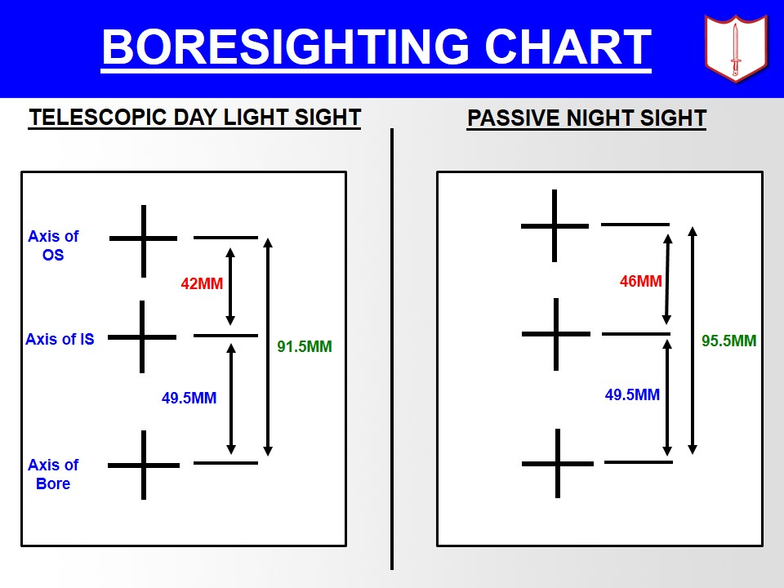 **BORESIGHTING CHART**

1. **Zeroing.** Initial Boresighting kar lene ke baad zeroing kiya jata hai.

(a) Zeroing ke liye 200m dot ka istemal kiya jata hai.

(b) 200m range se 3 ya 5 rds ka gp fire kar MPI nikalo.

(c) Screw driver ki madad elevation aur azimuth knobs ko harkat dekar MPI ko POA par milao.

(d) Graticule adjuster cap mein 8 divisions hain. Har ek division 200m range par 100mm ka fark dalta hai.

* + 1. TDLS mein graticule pattern upar-niche aur dahine bayen ki 50 minute ki harkat ho sakti hai.

1. **Precautions.**

(a) Lense ko hath na lagae.

(b) Lever ko jor se istemal na kare.

1. **Accessories.**

(a) FRP carrying case.

(b) Convas myton psuch.

* + 1. Cleaning Brush and Lint cloth.
    2. User’s Hand Book.

**Bhag-III: Passive Night Sight (PNS) ki Jankari**

1. Passive Night sight 5.56mm INSAS LMG ya rifle ke sath istemal ki jati hai. Yeh ek compact, halki aur micro channel image intensification ke sidhant per kaam karti hai. Yeh raat ke waqt sitaro aur chand ki roshni ke dauran survellance wah firing ke liye istemal mein layi jati hai.

1. **Hisse Purjon ke Naam**. PNS ki teen sub assemblies hain:-

* + 1. Objective Glass Module (OG).

* + 1. **Tube housing module.** (Iske nimn hisse hain):-

(i) Image intensification tube.

(ii) Reticle assembly.

(iii) Power Supply unit.

(aa) On/Off Switch

(ab) Potentiometer

(ac) Battery Housing

(c) Eye piece module (EP)

1. **Technical Data**. Iska technical data is prakar se hai.

|  |  |
| --- | --- |
| (a) Wazan | - 1.065 Kg |
| (b) Height | - 281mm |
| (c) Diameter | - 70mm. |
| (d) Field of view | - 10 degree. |
| (e) Magnification | - 4x |
| (f) Objective | - Refractive, F/1.5. |
| (g) Eye piece | - Variable focus 5D to +5D |
| (h) Sensor | - 18mm proximity focussed micro  chanel tube with FO twister. |
| (j) Power supply | - Two 1.5 volt cell, size AA/3.5 V  lithium cell with a dummy for   use of low temp. |
| (k) Range recognition | - 200m (engagement) |
| (l) Detection | - 300m for human tgt  under star lit and average   contrast condition |
| (m) Operating tempature | - -30 degree to 45 degree C |
| (n) Storage tempature | - -30 degree to 65 degree C |

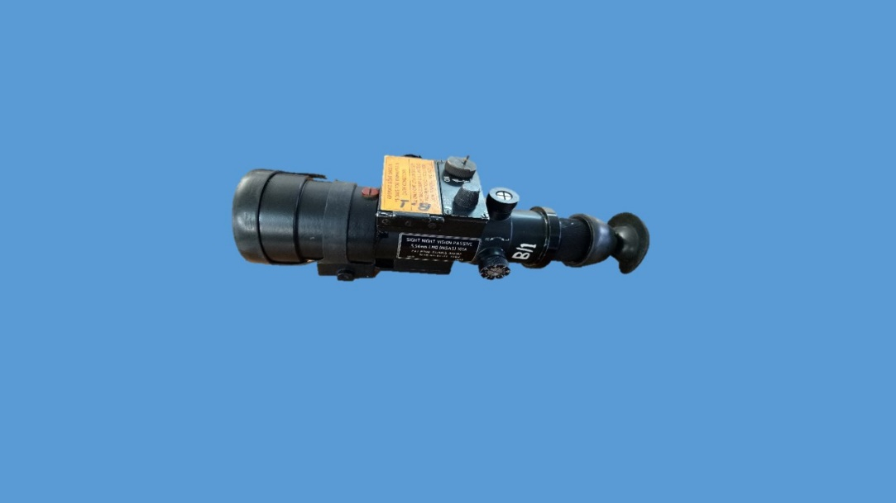

**PASSIVE NIGHT SIGHT**

1. **Istemal karne ka Tariqa.** PNS ko nimn likhit tarike se istemal mein laye jata hai.

(a) **Mounting**. Sight ko case se bahar nikale aur sarsari taur par mulaiza karen.

(i) Battery agaen aur PNS ke female dovetail ko LMG ke dovetail par slide kar lever ki madad se lock karen.

(ii) Thimble ki madad se unlock karen aur sight ko age ko slide kar ke nikalen.

(iii) Sight ko wapas case mein rakh dein.

1. Atyadhik sard ilake mein lithium battery ke istemal karen.

1. **Boresighting aur Zeroing**. PNS ke reticle pattern mein Range Dot diye gaye hai joki radium dwara chamakta hai. Reticle pattern mein boresighting aur zeroing dot diye gaye hain, reticle upar niche aur dayen-bayen ki 500  tak ki harkat kar sakte hai. PNS ko boresighting aur zeroing karne ka tariqa TDLS jaisa hai aur 200m range par din ke waqt karte hain.

   
  
  
  
  
  
  
  
  
  
  
  
  
  
  
  
  
  
  
  
  
  
  
  
  
  
  
 **BORESIGHTING CHART**  
  
**Precautions**

* + 1. Tej roshni ya dhoop ke waqt OG aur EP cap na nikale.
    2. Lens ko hath na lagaen.
    3. ON/OFF switch ko istemal karte waqt off position mein rakhen.
    4. Batteries ko +ve aur -ve marking dekh kar fit kiya jae.
    5. Knobs aur thimble par jor na lagaen.

**Bhag-IV : Beta Light Iron Sight ki Jankari**

1. **Aam Jankari**. Beta light iron sight dwara raat ke samay shist lekar LMG ko fire kar sakte hain. Roshni dene ke liye glass tube mein bhare tritium gas ka istemal kiya gaya hai, jo ek radio active padarth hai. Front beta light iron sight, gas block par, foresight ke piche lagai jati hai. Ismen ek tritum filled gas tube (TFGT) laga hai. Rear beta light iron sight leaf hai. Rear beta iron sight ke donon TFGT ke beech ka ilaka rear sight aperture ke line mein hota hai. Donon front aur rear beta light iron sight flip type hai aur jab inka istemal nahin ho raha ho to inhen niche gira diya jata hai.

1. **Istemal** Raat ke samay istemal mein lane ke liye donon beta light iron sight ko khara karo, rear beta light iron sight ke do binduon ke bichon beech front beta light iron sight ko milakar sahi sight alignment hasil karo. Tgt par shist lo aur fire karen.

1. **Glass Tube Tutne Par Savdhaniyan**. BLS ki glass tube tutne par nimn savdhaniyan honi chahiye.
   * 1. Tritum hanikarak radiation (Kirane) kam matra mein paida karta hai, islie firer ki aankh ko koi khatra nahin hai. Agar firing ke dauran TFGT tut bhi jae to firer ko nuksan nahin hoga.

* + 1. Agar khule ilaqe mein TFGT tuta hai to iske hanikarak padarth kirne vatavaran mein ghul jati hai aur iska asar kam ho jata hai.

* + 1. Agar TFGT kamre ke andar tuta ho to us kamre ke sabhi vyaktion ko bahar nikal diya jae. Kamre ke sabhi khirki/darwaje khol diye jaen kamre ke andar ek ghante tak kisi ko na ane diye jae.

1. **Sankshep.** Agar sahi sight ka istemal range ke mutabiq kiya jae to LMG ek bahut hi kargar hathiyar hai. Sighton ka istemal karna ek bahut hi asan kaam hai, Goli ko tgt tak pahunchne ke liye aur tgt ko barbad karne ke liye zaruri hai ki firers sighton se wakif hon aur uska istemal karne ke bare mein jante hon, yadi ek firer sighton ka sahi istemal karna janta ho to larai ke maidan mein achha natiza hasil kar sakta hai. Sights ke istemal ke saath firer ko hathiyar par bharosa badta hai aur kamyabi hasil hoti hai.

**LESSON 13 : EK NAZAR**

**INSAS LMG KI SIGHTS**

**IRON SIGHTS**

**TELESCOPIC DAYLIGHT SIGHT**

**PASSIVE NIGHTSIGHT**

**BETA LIGHTSIGHT**

|  |  |
| --- | --- |
|  |  |
| **TDLS MAGNIFICATION** | **- 2.5 X** |
| **ENGAGEMENT RG** | **- 700m** |
| **PNS MAGNIFICATION** | **- 4 X** |
| **RANGE** | **- 300 m** |

**BETA LIGHT SIGHT KO SAVDHANI SE ISTEMAL KARNA CHAHIYE**

**LESSON 14**

**5.56MM INSAS LMG FIRER KO COACH KARNA**

**Ref- (Infantry Training Volume-I, Infantry Platoon Weapons Pamphlet No 6A 5.56mm Insas Light Machine Gun 2006)**

**Parichay**

1. 5.56mm INSAS Rif aur INSAS LMG firer ko coach karne mein zyada antar nahin hai. LMG ek section ka hathiyar hai aur iski banawat aur fire bhi Rif se bhinn hai, isliye yeh zaruri hai ki coach ko hathiyar aur firer ke tal-mel ke bare mein malum ho. Is sabak mein un khas baton ka zikar hai jo ek LMG coach ko malum honi chahiye.

**Uddesh**

1. 5.56mm INSAS LMG firer ko coach karne ka tariqa sikhana.

**Saman**

1. INSAS LMG, mag, drill cart, sling, 1' x 1' tgt, black board, easel, chalk, duster, grnd sheet, gp vishleshan chart, firing data card.

**Bhag**

1. Sabak teen bhagon mein sikhaya jaega:-

(a) **Bhag-**I - INSAS LMG aur Rif mein antar.

(b) **Bhag-II** - Grouping firing ke dauran coaching.

(c) **Bhag-III** - Application fire ke dauran coaching.

**Bhag-I : INSAS LMG aur Rif Mein Antar.**

1. INSAS LMG aur Rif mein kafi samantaen hain. Lekin kuch khas baten hain jo ek LMG coach ko malum honi chahiye.

* + - 1. **Zeroing.** LMG ek sub unit hathiyar hai na ki Rif ki tarah personal hathiyar. Is liye sec ka LMG No 1 (sabse achha LMG firer) hi ise zero karta hai aur sec ke sabhi jawan check group fire karte hain. Group ki MPI ki madad se har firer jarurat parne par apne point of aim ko correction dekar durust fire karta hai.

* + - 1. **Position aur Pakar.** LMG ka position aur pakar bhi Rif se alag hai. Aur aap iske bare mein pahle seekh chuke hain. LMG mein bipod hathiyar ko sthirta pradan karta hai. Saath hi uske bhari wajan aur shoulder rest ke karan firer majbut pakar hasil nahin karta yeh galat hai. Coach ko yeh dhyan rakhna chahiye ki firer ne majbut pakar hasil ki hai.

* + - 1. **Sharirik Kamiyan.** LMG firer ke sharirik kamion ka position aur fire par asar par sakta hai. Inko thik karne ka tarika is prakar hai

* + - * 1. **Halka Wajan.** Yadi firer ka wajan kam ho to use apni taang faila lena chahiye. Taki sharir ka zamin ke saath milap bar jaye aur jiada sthirta mile.

* + - * 1. **Panje Garna.** Recoil ko jajab karne ke liye firer apne panje garh sakte hain, jisse golian niche lagengi. Aise mein panjon ke niche sand bag lagana chahiye.

* + - * 1. **Under Hand Grip.** Yadi firer ko apna sir pichle hath ke upar rakhne mein pareshani hoti hai to use pichle haath ki pakar niche se karni chahiye. Is posn se un firer ko bhi faida hota hai jo pichle haath se LMG ko fire ke dauran bayen / dahine khinchte hain.

(d) **Trigger Operation, Shot Release aur Follow Through.**

* + - * 1. **Trigger Operation.** Burst fire ke dauran trigger ko chorne ki karwai khas ahmiyat rakhti hai, trigger ko jhatke se chorne ka fire par asar hota hain, kyon ki us samay gun fire kar rahi hoti hai. Is liye coach ko iska dhyan rakhna chahiye ki jis tarah trigger ko dabaya jata hai usi tarah use chorna bhi chahiye.

* + - * 1. **Shot Release aur Follow Through.** Burst fire ke dauran LMG mein kafi thartharahat paida hoti hai, jisko pure burst ke dauran majbut pakar se kabu mein rakhna hota hai. Saath hi pure burst ke dauran aur trigger chorne ke bad tak ek hi pakar aur shist banaye rakhna zaruri hai.

**Bhag-II : Grouping Fire ke Dauran Coaching**

1. Grouping fire chahe short range ya long range par karwaya jae, coaching ki tartib ek hi hai. Grouping fire ke dauran coach dwara check karne wali baten is prakar se hai.

* 1. **Firing se Pahle.**

(i) Firing record check karen.

(ii) Hathiyar ka nirikshan.

(iii) Target No check karna.

(iv) Firer ki posn aur pakar check karen.

(v) Sight Picture aur Sight Alignment check karen.

(vi) Firer ke dahine posn len (dahine hath master hand hai).

(b) **Firing ke Dauran.**

* + - * 1. Firer ki galti note karen aur firing data card bharen.
        2. Firer ka dhyan na todein.
        3. Moti galti karne par fire ko stop karen.

(iv) Call tgt aur Hit tgt bharen.

(c) **Firing ke Baad.**

* + - * 1. Group ka size napen.
        2. MPI ki posn note karen.
        3. Call tgt aur hit tgt milaen.
        4. Gp ka nirikshan karen.
        5. Fire ko discuss karen, galti bataen.
        6. Galti dur karne ka tarika samjhaen.
        7. Firer ko badhava dein.

1. **Group ka Nirikshan** Firer ke gp ka nirikshan kar ke uski chand ek galtion ke bare mein pata chal sakta hai.

* + - 1. **Single Shot Group** Burston ki pahli goli ka group single shot group kahlata hai. Burst ki pahli goli kaun si hai pata lagana mushkil hai. Burst fire karte samay agar firer durust pakar, shist , aur trigger operation karta hai to uski pahli goli Point of Aim (POA) ke nazdik lagti hai aur thartharahat ke karan baki golion POA se dur lagegi. Is baat ko dhyaan mein rakhte hue POA se sabse nazdik goli ko burst ki pahli goli mana jata hai. Is prakar har burst ki pahli goli ko mark karke single shot group ka nirikshan kiya jana chahiye. Single shot group ke khake ko dekh kar galtion ka usi prakar se pata chalega jis prakar INSAS Rif ke single shot fire mein pata chalta hai.

* + - 1. **Burst Group** Fire kiye har burst ke bikhrav ko dekh kar nimn galtion pata chal sakti hai.

* + - * 1. **LMG Piche Khinchna.** Yadi firer LMG ko fire ke dauran piche khinchta hai to golion ka bhikrav aiming point se lekar upar ki taraf hoga.

* + - * 1. **LMG ko age dhakelna.** Yadi firer LMG ko fire ke dauran age ko dhaka deta hai to har goli pichle goli se niche lagegi. Yani pahli goli se niche lagegi. Yani pahli goli POA ke nazdik aur baki golion niche lagegi.

* + - * 1. **Bikhra hua Group.**Pakar kamjor hone par bikhra hua group banega.

* + - * 1. **Baya Hath Master Grip.**Yadi golion bayen se dahine aur upar ko lagi ho to iska matlab firer ka bayen hath master grip hai. Under hand grip dwara is galti ko dur kiya ja sakta hai.

* + - * 1. **Dahina Hath Master Grip.** Golion dahine se bayen aur niche ko dahine hath master grip hone par lagti hai.

* + - * 1. **Ek-a-Ek Majboot Pakar.** Firer pahli goli fire hone ke bad pakar ko majbut karta hai aisa karne se pahli goli thik lagti hai aur bhaki group kahin aur banta hai.

1. **Burst Group Fire Mein Coach Ka Janne Wali Baten**

(a) Burst group single shot group se bata hota hai.

(b) 30.5 gaz mein LMG bipod par 4 cm ka group sahi mana gaya hai. (c) Burston ka failao burst ki pahli goli ko ikattha rakhne ki kabliyat par nirbhar karta hai.

(d) Coach ko burst group ka ausat group size malum ho.

(e) Burst ko chota ya bara group fire ke dauran LMG par control yani sahi trigger operation, shot release aur followthrough par nirbhar karega.

(f) Chand burston ki pahli goli kitna hatkar lagegi yeh single shot gp ki kabliyat par nirbhar karega.

(g) Burst ki pahli goli fire karte samay nishanebhaji ke sidhanton ko dhyan mein rakha jae.

(h) Firer ki galtion kafi had tak fire karte samay observe karne se pata lagaya ja sakta hai.

**Bhag-III : Application Fire ke Dauran Coaching**

1. Prarambhik nishanebaji (Squad post aur grouping fire 25 mtr) ke baad basic nishanebaji ke star par firer ko le jaya jata hai. Ismein grouping 100 mtr, zeroing, application fire aur classification fire hota hai.

1. **Application Fire**  Yeh coaching ka akhri hissa hai. Application fire ke dauran larai mein istemal ki jane wali position aur combat tgt istemal kiya jata hai. Firer se kam range se jyada range mein lejakar fire karwai jati hai, aur uski golion ki maar dikhai jati hai. Firer apni goli ki maar ko dekh kar shist mein tabdili karta hai. Coach ki yeh koshish rahni chahiye ki woh lagatar firer ko badhawa de aur uski golion ko note karen. Application fire ke dauran coaching ki tartib is prakar hai.
2. **Firing se Pahle.**

(i) Firing ki practice yakin karen aur ESA, scoring system bataen.

(ii) Yakin karo durust range laga hai.

1. **Firing ki Dauran.**

(i) Galtion ko note karo.

(ii) Yakin karo MPI ESA ke andar hai.

(iii) Record card bharo.

1. **Firing ke Baad.**

(i) Galtian Samjhao.

(ii) Natija note karo.

(iii) Firer ko badhawa do.

**Sankshep**

1. Sabhi firer ko coach karna malum hona chaihye taki jarurat padne par wah dusre firer ko coach karke use uski galtion ka ahsaas dila sake tatha uski galtion ko sudharne mein madad kar sake. Yadi ek firer ko coach karna malum ho to woh acchi sikhlai de sakta hai.

**LESSON 14 : EK NAZAR**

**INSAS LMG FIRER KE LIYE KHAS BATEN**

* + 1. ZEROING
    2. POSITION AUR PAKAR
    3. SHARIRIK KAMIYAN
    4. TRIGGER OPERATION, SHOT RELEASE AUR FOLLOW THROUGH

**LMG FIRER KI AAM GALTIYAN**

* + 1. LMG PICHE KHINCHNA - GOLION POA SE UPPAR
    2. LMG AGE DHAKELNA - GOLIAN POA SE NICHE
    3. KAMJOR PAKAR - BIKHRA HUA GROUP
    4. BAYAN HATH MASTER - GOLIAN BAYEN SE DAYEN AUR GRIP NICHE
    5. DAYEN HATH MASTER - GOLIAN DAYEN SE BAYEN AUR GRIP NICHE

**LESSON-15**

**5.56MM INSAS LMG KO MONOPOD KA ISTEMAL**

**KARTE HUE FIXED LINE PAR LAGANA**

**Ref- (Infantry Training Volume-I, Infantry Platoon Weapons Pamphlet No 6A 5.56mm Insas Light Machine Gun 2006)**

**Parichay**

1. Raat ke samay andhere ya kharab mausam aur dhuan ya dhund ka parda hone par LMG ko fixed line par laga kar fire kiya ja sakta hai. Iske lie pahle se tazwiz kiye hue targeton par LMG lagakar rakha jata hai, jidhar se dushman ke ane ka zyada andesha ho. Fixed line par fire karne ke liye INSAS LMG ke saath ek monopod diya gaya hai.

**Uddesh**

1. Monopod dwara LMG ko fixed line par site karne ka tarika sikhana.

**Saman**

1. LMG, Mag, Drill cart, Sling, Assy pouch, Monopod, Ground sheet, black board, chalk duster, easel aur small pointer.

**Bhag**

1. Sabak do bhagon mein chalaya jaega.

(a) **Bhag-I**.Monopod ka istemal.

(b) **Bhag-II**. Defence mein fixed line.

**Bhag-I : Monopod ka Istemal**

1. Fixed line par fire karne ke liye monopod LMG ke sath accessory ke taur par diya gaya hai. Monopod ko LMG ke butt par rear lug se jora jata hai.
2. **Monopod ke hisse Purzon ke Naam.**

(a) **Elevation Drum (Nut aur Screw)**. Yeh ek housing ke andar pae jate hai. Nut ki madad se disha aur unchai ki correction di jati hai.

(b) **Leaf Spring**. Yeh nut ko apni jagah par rakhta hai aur nut ghumane par click ki awaz deta hai.

(c) **Sleeve aur Pin**. Iski madad se monopod ko LMG ke rear lug ke

sath joda jata hai.

1. **Shoe**. Yeh zamin ke saath lagakar LMG ko sthirtha pradan karta hai.
2. **Plastic Grip.** Monopod pakarne ke liye Istemal mein ata hai.
3. **Monopod Lagana.** LMG No 1 monopod lagata hai. Iske lie sabse pahle LMG ko fixed line ki disha mein karo. Monopod ke sleeve se pin ko nikalo. Sleeve ko rear lug mein fix karo aur pin ko laga do. Bipod ki wajah se LMG sthir rahegi Bipod ke legs aur monopod ko nut/screw ki madad se LMG ko upar niche aur dahine bayen ki harkat di ja sakti hai. Kewal monopod se LMG ko 80mm ki uppar niche ki harkat di ja sakti hai. Pin ko nikal kar monopod utara jaa sakta hai.

1. **Fixed Line par Lay Karna.** LMG No 1 fixed line ke POA ka sahi range rear sight par lagata hai. Bipod ke legs aur monopod ke screw /nut ki madad se LMG ko harkat deta hai aur sahi shist milata hai.

1. **Fire Karna** Fixed line par fire karte samay 6 se 8 rounds ka burst achha mana gaya hai. Fixed line par fire karte samay butt ka kandhe par hona jaruri nahin hai, sivai shist check karne ke liye.

**Bhag-II : Defence mein Fixed Line**

1. **Fixed Line** Ek hathiyar ko fixed line par sited mana jata hai jab woh raat, kam roshini, dhuen ya dhund mein, ek pahle se nirdharit disha (line) mein fire karne ki kabliyat rakhta ho. Aam taur par LMG ko defence ke dauran hi fixed line mein lagane ki jarurat padti hai.

1. **Fixed Line ka chunav.** Defence mein LMG ka primary task padosi section defended post ki suraksha hota hai, taki donon section mutual support mein ho aur hamlawar dushman ko kam se kam do LMG ke fire se guzarna pade. Fixed line ka fire padosi section se jitna nazdik se guzarega utna hi kargar hoga. Lekin ismein kam se kam 5 degree ka safety angle rakhna jaruri hai. Fire ki line mein koi rukawat na ho aur jahan tak ho sake plunging fire na ho.

1. **Fire Karna** Fixed line par fire karte samay 6 se 8 rounds ka burst acha mana gaya hai. Fixed line par fire karte samay butt ka kandhe par hona jaruri nahin hai, sivai shist check karne ke liye rakhna jaruri hai. Fire ki line mein koi rukawat na ho aur jahan tak ho sake plunging fire na ho.

1. **Range.** 700m se jiada duri ke tgt par LMG ko fixed line par lay nahin karna chahiye, kyonki 700m tak golion ki trajectory zamin se 4½’ se upar nahin uthti, jiske wajah se LMG se lekar tgt tak pura ilaka khatarnak ilaka ban jata hai.

1. Alag alag ranges par trajectory ki zamin se unchai appx 'C' mein di gai hain.

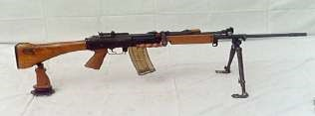

**MONOPOD PAR FIXED LINE**

1. **Fire Kholne ka Ishara.** Fire kholne ka ishara pahle se mukrar kar lena jaruri hai. Ishara milte hi ek sentry ko jald fire kholna chahiye aur dusra sentry bache hue section ko alert karta hai. Ammunition ka scale aur rate of fire bhi pehle se bataya hua ho.

1. **Improvised Tarike Se Fixed Line Lagana.** Monopod na hone par LMG ko improvised tarike se bhi fixed line par lagaya ja sakta hai. Jaise niche die chitron mein dikhaya gaya hai.

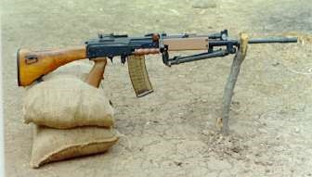

**IMPROVISED METHOD TO LAY LMG ON FIXED LINE**

**Sankshep**

1. LMG ke monopod ka istemal aur fixed line par lay karne ke bare mein jankari hona bahut jaruri hai taki defence ke dauran LMG ko fixed line par lay karne ka tariqa malum ho aur iski handling mein sahuliat ho. Saath hi LMG ko improvised tariqe se fixed line par lagana ana chahiye.

**LESSON 15 : EK NAZAR**

**MONOPOD KE HISSE PURJEN**

* + 1. ELEVATION DRUM (NUT AND SCREW).
    2. LEAF SPRING.
    3. SLEEVE AUR PIN.
    4. SHOE
    5. PLASTIC GRIP.

MONOPOD KI MAX UPPAR-NICHE HARKAT - 80MM

INSAS LMG KI FIXED LINE PAR RANGE - 700M

LMG KO FIXED LINE PAR LAGATE SAMAY SAFETY ANGLE - 50

**LESSON 16**

**5.56 MM INSAS LMG KA MUTHBHER**

**KI LARAI MEIN ISTEMAL**

**Ref-(Infantry Training Volume-I, Infantry Platoon Weapons Pamphlet No 6A 5.56mm Insas Light Machine Gun 2006)**

1. **Pahunch.** Hamla Jungle ya gali kuche ki larai mein hamara dushman ke sath kam fasle par lagav ho sakta hai. Is halat mein samay iske liye izajat nahin dega ki jawan dushman par shist le kar fire kar sake aise halat mein apne aap ko bachate hue dushman par teji se fire karne ki zarurat paregi aise samay mein dushman par kargar fire dalne ke liye jaldi se jaldi kudrati sidhai hasil karne ki jarurat hogi.

1. **Uddesh.**  Muthbher ki larai mein 5.56mm INSAS LMG ka istemal karne ka tarika sikhana hai.

1. **Saman**. 5.56mm INSAS LMG, Sling, Magazine, Assy Pouch, Wallets, Drill catridge aur Figure 11 Target.

1. **Bhagon Mein Bant:-**

* 1. **Bhag-I .** Le jane ke tariqe
  2. **Bhag-II.** Firing position.

(c) **Bhag-III.** Fire karna.

**Bhag-I : Le Jane Ke Tariqe:-**

1. LMG ko jaldi istemal karne ki zarurat ho to isko le jane ke do tarike hain:-

* 1. Sling bayen kande mein dalkar.
  2. Sling dahine kandhe mein dalkar.

Yeh faisla firer par chhor diye jae ki kaon si position akhthiyar kiya jae kionki yah us ilaqe par nirbhar karta. Jis ilaqe mein wah gugar raha hai. Yeh baat zarur yaad rahe ki jab LMG ka sling baen kandhe par rakha ho aur firer use niche la kar bipod par mount karke fire karna ho to kuchh zaida waqt lagega.

1. **Bhag-II : Firing Position -** Iske liye do basic position hai :-

(a) **Hip Position**:- Is position ko taiyar karne ke liye:-

(i) LMG ke sling ko dahine ya baen kandhe mein dalen.

(ii) Baen hath se fold kiye hue bipod ko is tarah se pakro ki bayan baju kohni se thora mura hua ho aur yakin karo ke hath ka koi bhag barrel ko na chhua hua ho.

(iii) Aam tariqe se dahine hath se pistol grip ko pakro aur Butt ko badan ke sath kohni se ander ki taraf dabao.

(iv) Baen paon ko target ki sidh mein rakhte hue ek kadam age lo aur baen ghutne mein khamb dalte hue battle crouch position ikhtiar karo.

(b) **Bagal Position**. Yeh position hip position ki hi tarah hai siwae is ke:-

(i) Butt dahine bagal mein dabaya jata hai.

(ii) Badan ka jhukao thora kam hai.

(iii) Sir sidha rakha jata hai Ankh samne aur target ke beech hoti hai.

1. **Bhag -III - Firing Ka Tariqa**

(a) LMG ko harkat ke liye taiyar karo.

(b) Zarurat shuda position ikhtiyar karo.

(c) Harkat ke dauran LMG ko cock rakho aur change lever ko ‘S’ par rakho aur kisi rukawat ko par kar rahe ho to kalmen wali ungli trigger se bahar ho.

(d) Tgt milne par zarurat shuda position ikhtiyar karo aur kudrati sidhai hasil karte hue 4 se 5 Rds ka burst fire karo.

(e) Firing ke waqt pakar achhi aur tgt ko teji aur drusti se hit karne ka firer ka pakka irada hona chahiye.

(f) Jab No 2 kabhi mumkin ho to pahle se sikhe hue tarike ke mutabiq firer ki madad karni chahiye.

**Sankshep**

8. INSAS LMG ko larai ke halat ko madhya nazar rakhte hue do tarikon se carry kiya jata hai. Yadi jawan in tarikon men mahirta hasil kar le to kam samay men dushman ko barbad kar sakta hai. Sath hi firer ko firing position se bhi jankari honi chahiye.

**LESSON NO-16 : EK NAZAR**

**LMG LE JANE KE TARIKE**

SLING BAYEN KANDHE SLING DAHINE KANDHE

MEIN DALKAR MEIN DALKAR

**FIRING POSITION**

HIP POSITION BAGAL POSITION

LMG Firing ka 3 - 4 rounds ka burst accha mana gaya hai.

**LESSON-17**

**5.56MM INSAS LMG KI BUNIYADI BATEN**

**Ref-(Infantry Training Volume-I, Infantry Platoon Weapons Pamphlet No 6A 5.56mm Insas Light Machine Gun 2006)**

**Parichay**

1. 5.56mm INSAS LMG ek kargar aur bhrosemand auto hathiyar hai. Isko haal ke dino mein fauj mein shamil kiya gaya hai. Yeh Inf Bn mein 7.62mm LMG ki jagah lega.

1. Is hathiyar ki kabilyat ka bharpoor faida uthane ke liye hamen chandek buniyadi baton se waqfiat hona chahiye.

**Chalne ki vidhi**

1. LMG ek gas ke dhakke se chalne wala aur hawa se thanda hone wala hathiyar hai jo ke mag ke dwara feed kiya jata hai.

**Beaten Zone**

1. Iska auto fire karne se is ki goliyan hawa mein andakar shakal banati hain jo ki zamin par cover hone wale ilake mein beaten zone kahlati hain. 700 mtr ke range par beaten zone 175m x 2m hota hai aur 1000m par beaten zone 115m x 4m hota hai.

1. Beaten zone ka pura faida uthane ke liye do LMG ko apas mein mutual support mein lagana chahiye taki hamlawar dushman par enfilade fire karke jiada se jiada nuqsan pahunchaya ja sake.

**Fixed Line**

1. Def ke dauran raat ke samay andhere ya kharab mausam jaise ke dhund adi LMG ko fixed line par laga kar fire karna chahiye, jisse ki bina dekhbhal kiye bhi dushman ke aane ke mumkin raston par kargar fire dala ja sake. Iske liye LMG ko din ke samay pahle se chune hue mumkin target par laga kar rakha jata hai.

**Safety Angle**

1. LMG ko fixed line laga kar fire karne se apne padosi ke morchon ke frontage ko cover karte samay yeh zaruri hai ki apni fauj ki suraksha ka dhayan rakha jae. LMG se fire karte samay line of fire apne morchon se kam se kam 5 degree dur hona chahiye.

**Golion Ki Uran**

1. Is hathiyar se fire ki gai goliyan 700m tak line of fire ki satah se 41/2 feet se jiada nahin uthti hai. (Refer Appx 'D')

**Firing Positions**

1. LMG ko kai posns se fire kiya ja sakta hai. Kaun si posn ikhtiyar ki jae yah adh ki shakal aur size par nirbhar karta hai. Kisi bhi posn mein nimn likhit baten dhyan mein rakhni chahiye:-

(a) LMG bipod se fire karte samay jiada accurate hota hai. Phir bhi ho sakta hai ke adh ka istemal karte samay bipod ko fold karna pare.

(b) Yadi dhalwandar zamin par posn lena pare to LMG ke bipod leg ko lamba ya chhota kar ke position ko hamwar kar lena chahiye.

**Siting**

1. **Enfilade Fire**. Def mein LMG ko is prakar lagaya jana chahiye ki woh dushman par enfilade fire dal sake. Isse beaten zone ka lamba wala bhag jiada se jiada dushman ko cover karega.

1. **Mutual Support**. LMG ko hamesha mutual support mein lagana chahiye. Iske faide is parkar hai:-

(a) Do position ke beech ka gap cover hota hai.

(b) Ek hathiyar ke liye jo dead ground hai woh dusre hathiyar se cover hota hai.

(c) Ek post par assualt karta hua dushman dusre post ki LMG ke enfilade fire mein aa jata hai.

1. **Local Protection**. LMG ko site karte samay local potection ka dhyan rakha jaye.

1. **Defiladed position.** Jahan tak ho sake position defiladed ho.

1. **Camouflage aur Concealment** . Zamini aur hawai dekhbhal se chhupao hasil ho.

1. **Alternative/Secondary position.**  Alternative ya secondary positions aur un tak pahunchne ka rasta pahle se mukarrar aur taiyar kiya gaya ho.

1. **Depth (gahrai)** . Kuch LMGs ko depth mein rakha jaye taki defence ke bahari kinare ko tod kar andar aane wale dushman ko barbad kiya ja sake.

**Anti Air craft (AA) Role mein LMG**

1. **AA LMG Group Ki Banawat**

(a) Bn LMG Group : 16 LMGs

(b) Per Coy : 4 LMGs

(c) Coy Sub Group : 2 LMGs

1. **Hawai Jahaz par Fire Karne ke Usul:-** 
   1. **Defence.**

(i) Dushman ke uchai par ur rahe hawai jahaz ke barkhilaf koi karrawai nahin ki jae.

(ii) Jawanon ki karrawai defensive position ko jahir karegi.

(iii) Local Commander se fire karne ka hukam mila ho to sabhi.

(iv) LMG savdhani ke sath gaharai mein lagi honi chahiye.

(v) Sabhi LMG ka primary task zamini hamle ke barkhilaf hota hai.

* 1. **Fauj ki Harkat ke Dauran.**

(i) Garion mein fauji daste ja rahe ho, ho sake to har gari mein LMG AA role mein taiyyar kiya jae.

(ii) Dusre daste ke upar hamla hone par engage kar sake.

(iii) Kuch LMG harek disha mein fire dal saken.

(iv) Dushman ka jahaz hamla karta hai to fire khola jaye.

(v) Garion ki tarpauline hata deina chahiye ya is parkar karen ki LMG asani se istemal ho sake.

(vi) Harkat tab tak nahin roken jab tak road block ya column commander ka hukam na mile.

(vii) Rukne par garion se hawai jahaz engage kia jaega aur rukawat dur karne ke bad age barhe.

(viii) Rukne par garion se utar kar dahine baen chale jana  
 chahiye.

(ix) Fauji camp ya tenton mein AA team ko niche aur dhire urne wale, range ke andar dushman ke hawai jahazon ko bina hukam ke engage karna chahiye. Agar hukam pahile se nahin mila ho to fire nahin karna chahiye.

* 1. **Failao.** Kam unchai par urne wale hawai jahazon ke hamle ke barkhilaf, achha failao aur chhupao se, position ka pata karna bahut hi mushkil hota hai.

* 1. **AA Fire Discipline Training**

(i) Jaldi faisla karne aur bharose wala jawan AA gunner ka kam karen.

(ii) Jawanon ko bina hukam ke fire karne ki sikhlai deina  
 chahiye. Sentry LMG ko AA role mein fire kar sakta ho.

(iii) Apni taraf aane wale jahazon ke awaz ko sunne aur   
 pahchanne ki sikhlai deina chahiye Chhup kar ane wale jahazon ke rukh ka faisla kar sake.

(iv) Jawan samajte hon ki ajkal ke tej raftar se urne wale hawai jahazon ki awaz tak sunai nahi de sakti jab tak hamla shuru na ho gaya ho.

(v) **Har ek unit ke pas aisa tariqa ho:-**

(aa) AA LMG mag taiyyar hon aur asani se pahunchai ja saken.

(ab) AA LMG ke upar acchi sikhlai pae jawan rakhe  
 jayen.

(ac) Garion men charhne aur utarne ka drill aur jaldi titar bitar hone ka drill sabhi jawan jante hon.

(ad) Defence ya aram ki halat mein LMGs ke fire ka milap kiya gaya ho, taki jawanon mein garbar paida na ho aur apni fauj ko nuksan na ho.

**SANKSHEP**

1. Yadi ek firer ko LMG ki buniyadi baton se waqfiat hai to woh larai ke dauran pura pura faida utha sakta hai aur acchi saafalta hasil kar sakta hai. Sath hi ek jawan dushman ke deployment aur auto hathiyaron ke bare mein bhi jankari hasil kar sakta hai. LMG ke siting ke usul malum hone par hone wale hadson se bhi bacha ja sakta hai.

**LESSON NO 17 : EK NAZAR**

**BUNIYADI BATEN**

* CHALNE KI VIDHI
* BEATAN ZONE
* FIXED LINE
* SAFETY ANGLE
* GOLION KI URAN
* FIRING POSN
* SITING
* HAWAI JAHAZ PAR FIRE KARNE KE USUL
* ANTI AIRCRAFT FIRE DISCIPLINE TRAINING

**700 m Range tak trajectory 4'6" se upar nahi uthti**

(i) Defence ke dauran mutual support mein LMG ka safety angle kam se kam 5o hona chahiye.

**LESSON-18**

**5.56MM INSAS LMG KE PWT LESSONS**

**Ref-(Infantry Training Volume-I, Infantry Platoon Weapons Pamphlet No 6A 5.56mm Insas Light Machine Gun 2006)**

**Parichay**

1. Ek jawan jab hathiyar mein basic marksmanship mein mahirta hasil kar leta hai to use progressive weapon training (PWT) ke tarike se sikhlai di jati hai . Mashware ke taur par PWT ke sabak is bhag mein diye gaye hain . In PWT sabak mein yeh jankari di gayi hai ki kis prakar se PWT sabak chalaye jate hain.

**Uddesh**

1. 5.56mm INSAS LMG ke PWT lessons ke bare mein jankari deina hai.

**Chalana**

1. PWT bhi sqd post par hi puri ki jati hai .Is mein Rect ya Trained Soldier ko is prakar motivate kiya jata hai, jisse woh kam samay mein sabhi hathiyaron ka mila jula abhyas kar sake aur competion ke liye taiyyar kiya ja sake .

1. Ismein training ke star ko lachila banaya gaya hai jis mein studeint aur instr ka talmel bana rahta hai aur dono ke beech ek dilchaspi bani rahita hai.

1. PWT ke tange se kuch faide niche likhe ansuar hain:-

(a) Jawan ko apne aap aur hathiyar par bharsa.

(b) Trg ka star dilchasp aur lachila

(c) Studeint aur Instr ke beech talmel.

(d) 80% abhyas ka mauka jiada.

(e) Pahal karne ki bhawana paida.

(f) Test aur Mukabale ke anusar se competition ki bhawana paida.

**Sankshep**

1. Sikhlai pae hue jawanon aur recruiton ko behtar abhyas deine ke liye PWT ke sabak ek guide ke taur par hain. Phir bhi is ka faida uthane ke liye ustad ko jawanon ke kamzor points ko savdhani se dekhte rahna chahiye aur PWT ke sabak banana aur chalana soch vichar se karna chahiye.

**PWT-1**

**KHOLNA, JORNA AUR SAFAI**

**Uddesh**

1. LMG ka kholna, safai aur jorna mein abhyas deina hai.

**Saman**

1. LMG, magazine, wallet, holdalls aur safai ka saman.

**Chalana**

1. Lesson plan is tarah banai gayi hai**:-**

**Samay Headings Sikhli ke points Ustad ke liye note (min)**

|  |  |  |
| --- | --- | --- |
| 1. **(b) (c)** | **(d)** |  |
| 0 - 1 Shuru shuru Suraksha | (a) 2 jawanon ke |  |
| ka kam sambandhi upay | bich ka kam |  |
|  | ek LMG behter hogi. |  |
|  | (b) Agar DP LMG |  |
|  | mil sake to istemal |  |
|  | ki jaen. |  |
| 1- 1.5 Uddesh Upar para ek ki tarha dohrao | - do - |  |
| 1.5-2.5 Yad dilao    2.5-6 Namuna Am kholna, safai aur jorna. | Sawal aur jawab se. |  |
| 6-26 Abhyas (a) Am kholna, | Alochana karne ke |  |
| safai aur jorna. | lie shikshak aur |  |

(b) Kholne ke shisht ka tarika

dusre a tarika istemal karo.

(c) Aur hissa purjon

ko kholna

26-23 Test ya Group ke kis bhag

Mukabala par kholna ya jorna hai

**Samay Headings Sikhli ke points Ustad ke liye note (min)**

|  |  |  |
| --- | --- | --- |
| 1. **(b) (c)**     32-36 Blind fold Kisi bhi spare part  Abhyas ki badly karke | **(d)** |  |

36-40 Sankshep (a) Jaise lagu ho,

TSOET ki baten batao.

(b) Kamjorion ko batao.

(c) Sankshep karo.

**PWT-2**

**BHARNA, SHIST LENA, PAKAR, FIRE KARNA**

**AUR KHALI KARNA**

**Ref- (Infantry Training Volume-I, Infantry Platoon Weapons Pamphlet No 6A 5.56mm Insas Light Machine Gun 2006)**

**Uddesh**

1. LMG ko bharna, shist lena, pakar hasil karna, fire karna aur khali karne mein abhyas deina hai.

**Saman**

1. LMG, mag, utlity pouch, drill cart, wallets, holdalls aur tgt.

**Chalana**

1. Lesson plan is tarha banai gayi hai :-

**Samay Headings Sikhli ke points Ustad ke liye note (min)**

1. **(b) (c) (d)**

1. - 1 Shuru Shuru Suraksha sam

kam kam bandhi upay

1. - 1.5 Uddesh Upar para ek Dohrao

ke mutabiq

1.5 - 3 Yad dilao Swal aur jawab

3 - 7 Namuna Mag ka bharna Munasib word of

(do mag) bharne ka command posn, limber up, ka istemal karo.

LMG ka bharna,

burst fire karna, stop jari kar, stop Khali

karna aur mag khali karna.

7 – 25 Abhyas (a) Mag ka (a) Squad ko tin charhana aur, hisson men khali karna akhir banto ek eye mein fir LMG disc ki madad do mag bhare se pakar

hue hon . check karega

. jawano ki apas mein badli karo.

(b) Bharna, make (b) LMG ke upar safe aur khali koi mag

karna. nahin honi chahie.

(c) Shist lena, pakar (c) Ustad LMG hasil karna aur fire khinch kar Karna pakar check karega.

.

25 - 30 Test (a) Pakar aur shist (a) Har ek jawan lene ka mukabla ka test mukabla

istemal disc ka kare lene ke lie eye .

(b) Bharna aur khali (b) Mag ka karna stemal na

kya jae

(c) Mag bharna (c) TSOET ke adhar par mukabla karo.

(d) Mag ko khali

Karne ka mukabla

mat karo is se mag

ko nuksan pahunchega.

30 -38 Blind fold (a) Mag ka bharna (a) Sqd ko do aur khali karna ka hisson men abhyas aur ek banto . group kam kare.

(b) Bharna, make (b) dusra group safe aur khali check kare. karna. Phir apas men badli karo.

38 - 40 Sankshep (a) TsOET ki sharten batao

(b) kamjorian batao.

(c) Chhote men sankshep karo.

**PWT-3**

**ELEMENTARY HANDLING AUR ROKEN**

**Ref- (Infantry Training Volume-I, Infantry Platoon Weapons Pamphlet No 6A 5.56mm Insas Light Machine Gun 2006)**

**Uddesh.**

1. Elementry handling aur rokon ko dur karne mein abhyas deina hai.

**Note**

1. Roken aur barrel ki badli par abhyas shamil kia ja sakta hai. Lekin yeh tabi karna chahiye jab jawan din men abhyas karke mahir ho gaye hoh. Aise maukon par test aur mukabla chhora ja sakta hai ki unkih blind fold abhyas men kafi samay lagta hai.

**Saman**

1. LMG mag, sling, spare parts, wallet, holdalls, kata hua case aur sand bag.

**Chalana.**

1. Lesson plan is prakar hai:-

|  |  |  |  |
| --- | --- | --- | --- |
| **Samay** | **Headings** | **Sikhlai ke points** | **Ustad ke liye note** |
| **(a)** | **(b)** | **(c)** | **(d)** |
| 1-15 | Shuru shuru ka kaam | Surksha sambandit upay | Sabak shuru karne se pahle ek kata hua case chamber main dal do |
| 1.5-3 | Uddesh yad dilao | Upar para ek ki tarha (a) Swal aur jawab (b) Mag ko bharna aur khali karna. Akhir mein mag bhari hui ho | Uddesh dohrao |

|  |  |  |  |
| --- | --- | --- | --- |
| **(a)** | **(b)** | **(c)** | **(d)** |
| 3-7 | Namuna | Elementry handling faur ilaj aur chamber mein kate hue case ki rok dur karna. | (a) Squad se ek jawan le kar No 2 ka kaam.  (b) Agar harkat karo to squad ko Day taraf se harkat karao |
| 7-28 | Abhyas dur kare | Har tarha ki rokon ko dur karne mein | (a) Jorion men ek jawan LMG  (b) Elementry handling aur unko bhi unki karwai par nukta chidni ke istemal aur fire position karne ke liye age jana chahiye |
| 28-33 | Test ya Mukabala | Barrel ki badli aur elementry handling mein test lo | (a) TSOET ki hi sharten rakho.  (b) Jawan jorion men kam karen aur apas men badli karte rahe jab tak 1 aur 2 ki haisiat se sabhi ka test nahin ho jae |
| 33-38 | Blind fold abhyas | Blind fold abhyas uparpara 2 ke mutabiq |  |
| 38-40 | Sankshep | (a) TsOET para 2 ki sharten batao.  (b) Kamjorian batao  (c) Thore me sankshep karo |  |

**PWT-4**

**MUTHBHER KI LARAI AUR HAWAI JAHAZ**

**KE BARKHILAF LMG KA ISTEMAL**

**Uddesh.**

1. Muthbher ki larai aur hawai jahazon ke barkhilaf LMG ki handling men abhyas deina hai.

**Saman.**

1. LMG, mag, AA magazine, drill cartridges, drill tracer cart, sling, utility pouch, wallet, holdall, CQB tgt, hawai target aur 1 X ton truck/ 3 ton lorry agar mil sake.

**Chalana :**

1. Lesson plan is parkar hai:-

|  |  |  |  |
| --- | --- | --- | --- |
| **Samay** | **Headings** | **Sikhlai ke points** | **Ustad ke liye note** |
| **(a)** | **(b)** | **(c)** | **(d)** |
| 0-1 | Shuru shuru ka kaam | Surksha sambandit upay |  |
| 1-1.5 | Uddesh | Para 1 ke mutabik | Dohrao |
| 1.5-3.5 | Yad dilao | Sawal jabab se |  |
|  | Namunana |  |  |
| 3.5-8 | Namuna | (a) Muthber ki larai main LMG ko len jana aur har tarah ki posn se fire karna  (b) Hawai jahaz ke bharkhilaf AA role ke liye LMG aur mag ko tayar karna standing aur kneeling posn se fire karn. Fauri ilaz ki karwahi | Squad se ek jawan le kar No 2 ka kaam. |

|  |  |  |  |
| --- | --- | --- | --- |
| **Samay** | **Headings** | **Sikhlai ke points** | **Ustad ke liye note** |
| **(a)** | **(b)** | **(c)** | **(d)** |
| 8-26 | Abhyas | (a) Muthbher ki larai main fire karna  (b) AA role mein handling | (a) AA role mein No 2 ki suraksha sambandit per jor dena  (b) Alag alag posn se hawai jahaz ko engage karo aur ghadi per mount karke bhi abhyas karo. |
| 26-32 | Mukabala ya Test | LMG ko le jana aur muthbher ki larai mein firing karna |  |
| 32-38 | Blind fold abhyas | Muthbher ki larai |  |
| 38-40 | Sankshep | (a) Sawal aur jawab  (b) Thore me sankshep |  |

Note:- Mukabla har lesson mein nahi hai. Yeh test ke baad hota hai.

**LESSON 19**

**SHURU KI SIKHLAI KI PARIKSHA (TsOET)**

**Ref -(Infantry Training Volume-I, Infantry Platoon Weapons Pamphlet No 6A 5.56mm Insas Light Machine Gun 2006)**

**Parichay**

1. Basic sikhlai karne ke baad hamen is kabil hona chaihye ki ham hathiyar ko jaldi se jaldi khol sake, jor sake, mag bhar sake taki zarurat parne par kam samay mein hathiyar se fire dal sake ya rok ko dur kar sake.

**Uddesh**

1. Ek studeint LMG chalane mein mahirta malum karna.

**Natija**

1. Studeint ke darje is tarah se nikal sakte hain :-

|  |  |  |
| --- | --- | --- |
| (a) Sabse accha | - 80 se 90 | Pts lene wala |
| (b) Ausat darje ke uper | - 70 se 79 | - do - |
| (c) Ausat darje ka | - 60 se 69 | - do - |
| (d) Ausat darje ke niche | - 50 se 59 | - do - |

(e) Fail - 50 se Kam - do -

**Star Hasil Karna**

1. Rect ko aisi sikhlai di jae ki akhiri mein woh ausat darje hasil karen. Sikhlai paya hua jawan jo ausat se accha kaam nahin kar sakta unhen aur abhyas diya jae.

**Sanchalan**

1. PWT lesson ke dauran ke jariye yeh test karwaya ja sakta hai. Test se pahle jawano ko iski sharten acchi tarah samjhana zaruri hai. Test shuru hone ke baad jawanon ko kuch batana nahin chahiye.

**Record Ka Khana:-**

1. TsOET ke natije result form par likhkar use jawanon ke paragati folder mein rakha jata hai. Is form ko dekhkar jawan ka star malum ho sakta hai. Is form ka namuna Appx ‘G’ mein diya gaya hai.

1. **TsOET NO 1** . Hath se mag bharna:-

**Saman**: 30 Rds Drill Carts, Mag, Watch, Progress folder.

**Sharten**: “ Mag Bhar “ ke adesh par jawan hath se 30 golian mag mein bhare. Galat bharne par number na diya jae.

**Number Deina :-**

* 1. 25 se kam sec. - 10 Pts.
  2. 26 se 30 sec. - 08 -do-
  3. 31 se35 sec - 06 -do-
  4. 36 se 40 sec - 04 -do-
  5. 41 se 45 sec - 02 -do-
  6. 45 sec se zaida - 00 -do-

1. **TsOET NO 2**. Gas ki kami ki rok dur karna :-

‘ LMG ‘ ek ya do round ke baad rukta ke adesh par karwahi shuru hoti hai.

* 1. 12 sec se kam - 10 Pts.
  2. 13 se 17 sec - 08 -do-
  3. 18 se 22 sec - 06 -do-
  4. 23 se 27 sec - 04 -do-
  5. 28 se 32 sec - 02 -do-
  6. 32 se zaida - 00 -do-

1. **TsOET NO 3 .**  LMG jorna, Mag ka bharna aur Firing :-

**SAMAN**  : LMG khuli hui, Ek mag, 30 Drill Carts.

‘ GO ‘ word of command par studeint LMG jorega, lying posn lekar LMG ko load, cock aur target par aim karega.

|  |  |  |  |  |
| --- | --- | --- | --- | --- |
| (a) 55 sec tak |  | - 10 |  | Pts. |
| (b) 56 se 60 sec |  | - 08 |  | -do- |
| (c) 61 se 70 sec |  | - 06 |  | -do- |
| (d) 71 se 80 sec |  | - 04 |  | -do- |
| (e) 81 se 90 sec |  | - 02 |  | -do- |
| (f) 90 se zaida |  | - 00 |  | -do- |

1. **TsOET NO 4** . Lying posn se LMG bharna :-

**Saman**: Khali mag lagi hui LMG, Ek bhari hui mag, Watch, Progress folder.

**Sharten :** Bhar ka adesh do. Jawan ke bharne tak ruko.

**Number Deina :**

|  |  |  |  |  |
| --- | --- | --- | --- | --- |
| (a) 12 sec se kam |  | - 10 |  | Pts. |
| (b) 13 se 16 sec |  | - 08 |  | -do- |
| (d) 17 se 20 sec |  | - 06 |  | -do- |
| (e) 21 se zaida |  | - 04 |  | -do- |

1. **TsOET No 5 .** Standing in fire trench posn se khali karna :-

**Saman**: Test No 2 ki tarah.

**Sharten** : Khali kar ka addesh do, jawan ke khali karne tak ruko.

**No Deina** :-

|  |  |  |  |  |
| --- | --- | --- | --- | --- |
| (a) | 15 se kam sec |  | - 10 | Points |
| (b) | 16 se 19 sec |  | - 08 | -do- |
| (c) | 20 se 23 sec |  | - 06 | -do- |
| (d) | 24 se zaida |  | - 04 | -do- |

1. **TsOET NO 6**. Kholna aur Jorna :-

**Saman**: LMG

**Sharten**: Jawan ko adesh do ke woh LMG saaf karne ke liye khole aur jore. Jawan ko batao kih kholne aur jorne mein samay ki pabandi nahi hai, lekin woh teji se aur sahi kam karen

**No Deina**:- Har galti ke liye adha No kato, agar galti se security se khatra ho to 5 No kato.Sabse jiyada 15 No do.

1. **TSOET No** 7. Roken :-

**Saman :**  LMG, tgt, drill cartridge, progress folder.

**Sharten :** Addesh do “bhar” , “ Let kar posn”, “Ready”, “Fire”. Studeint ko trigger dabate hi addesh do LMG thik fire karta rukta. Is tarah pure rokon ko dur karne ka check kiya jaye.

**Number Deina :** Bilkul sahi karwai par - 20 points. Agar galti security ke barkhilaf hai to 5 points kato. Chhoti galti ke liye 01 points kata jaye.

**Sankshep.**

1. Ek jawan ko TSOET mein mahir hona chahiye takih firing ke dauran hathiyar ki achhi handling aur parne wali rokon ko pahchan kar jaldi se dur kar sake.

**QUESTIONNAIRE**

**5.56MM INSAS LMG KA VIKAS**

Q1. 5.56mm INSAS LMG ki kiya visheshtaen hain ?

**5.56mm INSAS LMG AUR Accessories se Waqfiat**

Q2. 5.56mm INSAS LMG kitne hisson mein banti gayi hain ?

Q3. 5.56mm INSAS fired aur foldable LMG ki kya muzzle velocity kya hai ?

Q4. 5.56mm INSAS fired aur foldable LMG ke kya lambai hai ?

|  |  |
| --- | --- |
| Q5. | 5.56mm INSAS LMG mein kitne grooves hain ? |
| Q6. | 5.56mm INSAS LMG ka rate of fire (ROF) likho ?. |
| Q7. | 5.56mm INSAS lmg kitne prakar ke amn fire karti hai? |
| Q8. | 5.56mm INSAS ball round ke wazan kitna hai? |
| Q9. | 5.56mm INSAS ball round ki kya lambai hai? |

**5.56mm INSAS LMG ka Kholna Jorna aur Safai**

Q10. 5.56mm INSAS LMG kitne bare hisson mein khulti hai?

Q11. 5.56mm INSAS LMG kitne chhote purjon mein khulti hai?

Q12. 5.56mm INSAS LMG ka safai ka saman kya hai?

Q13. 5.56mm LMG ki kab kab safai ki jati hai?

Q14. 5.56 mm INSAS LMG ke kon kon se purjon mein tel lagaya jata hai?

Q15. 5.56mm INSAS LMG ke kon kon se hisson mein tel nahin lagaya jata hai?

Q16. 40-60 degree ke tapman mein kon se tel ka istemal kiya jata hai?

**Mag ko Bharna Khali Karna LMG ko Bharna, Sight lagana Make Safe aur Khali karna**

Q17. 5.56mm INSAS LMG ke mag mein kitne round ki capacity hai?

Q18. 5.56mm INSAS LMG ke mag mein anti air craft role mein kitne ball aur tracer round bhare jate hain?

Q19. Bhar aur make safe mein kya antar hai?

Q20. Kya LMG ki mag ko filler se bhara jata hai ?

Q21. Durust pakar ka bayan karen?

Q22. Durust shist lene ka tarika likho?

Q23. Sight alignment aur sight picture mein se kiski ahmiyat jiada hai?

Q24. Kya trapping ka tarika tracking se jiada achha hai?

Q25. Trapping mein kitne round s ka brust achha mana gaya hai?

**5.56 mm INSAS LMG ka Trigger Mechanism**

Q26. 5.56mm INSAS LMG mein chal mein istemal hone wale hisse purjon ke naam kya hain?

Q27. 5.56mm INSAS LMG mein single shot mechanism ka vistar mein bayan karo?

Q28. 5.56mm INSAS LMG mein automatic mechanism ka vistar mein bayan karo?

Q29. 5.56mm INSAS LMG fam ke dauran istemal mein hisse purjon ke naam likho?

**5.56mm INSAS LMG Mein Suraksha Sambandhi Baten**

Q30. 5.56mm INSAS LMG mein applied safety kya hai?

Q31. 5.56mm INSAS LMG mein mechanical safety kya hai?

Q32. 5.56mm INSAS LMG mein mechanical safety kaise hasil hoti hai?

**Action Mein 5.56mm INSAS LMG ki Handling**

Q33. LMG ke action mein handling karne ke dauran kin kin prakar ki adh ka istemal kiya ja sakta hai?

Q34. LMG ki action mein handling karte waqt “Gas ki kami ki rok” ke adesh par kya karhwai ki jaegi?

**5.56mm INSAS LMG ka Hawai Jahaj ke Khilaf Istemal**

Q35. 5.56mm INSAS LMG ko AA role ke lie kis prakar taiyar kiya jata hai?

Q36. 5.56mm INSAS LMG mein AA role ke dauran gas regulator ki posn kya hogi?

Q37. 5.56mm INSAS LMG mein AA role ke dauran pahle mag mein 5 ball round kyon bhare jate hain?

Q38. 5.56mm INSAS LMG mein AA role ke dauran kin kin posn se fire kiya jata hai?

Q39. AA role ke dauran No 2 ki dutian kya hain?

**5.56mm INSAS LMG ko Zero Karne ka Tarika**

Q40. Zeroing se aap kya samahte hain?

Q41. Zeroing ke kya faide hain?

Q42. Zeroing ke kon se mauque hain?

Q43. Zeroing ke waqt zaruri baten kya hain?

Q44. Zeroing ka tarika vistar mein likho?

Q45. 100m range par POA se MPI ki posn kahan par banti hai?

**5.56mm INSAS LMG ki Iron Sights, Telescopic Sights, Day Light sights, Passive night Sight aur beta Light sight**

Q46. 5.56mm INSAS LMG mein fore sight kis prakar ki hai?

Q47. 5.56mm INSAS LMG ke sights ke hisse purjon ke naam likho?

Q48. DLS ke hisse purjon ke kya naam hain?

Q49. TSL ka kya magnification hai?

Q50. TSL ke hisse purjon ke kya naam hain?

Q51. TAS ka kya magnification hai?

Q52. DLS ka graticule battan banao?

Q53. DLS aur TLS ka boresighting ka tarika kya hai?

Q54. PWS ke saath kya savdhanian baratni chahiye?

**5.56mm INSAS LMG Firer ko Coach karna**

Q55. 5.56mm INSAS LMG aur 5.56mm INSAS rif firer ko coach karte waqt kya antar hai?

Q56. 5.56mm INSAS LMG mein trigger operation ko bayan karo?

Q57. Shot relese aur follow through se aap kya samjhte hain?

Q58. Grouping fire ko coach karne ki kya tartib hai?

Q59. Single shot aur burst gp ka nirikshan kaise kiya jata hai?

Q60. Application fire ke dauran coaching ka kya tarika hai?

**5.56mm INSAS LMG ko Monopod Ke Istemal Karte Hue Fired Line Par lagana**

Q61. 5.56mm INSAS LMG ka monopod ke hisse purjon ka kya naam hai?

Q62. Monopod ko msx kitna upar niche ki harkat de sakte hain?

Q63. Fixed line par LMG ko Lagate samay kitne safety angle rakhna zaruri hai?

Q64. 5.56mm INSAS LMG ko kis prakar se improvise tarike se fixed line par lagaya ja sakta hai?

**5.56mm INSAS LMG ka Muthbher ki Larai Mein Istemal**

Q65. Muthbher ki larai mein LMG ko le jane ka tarika kya hai?

Q66. HIP posn mein LMG ko le jane ka tarika vistar mein likho?

Q67. HIP posn mein aur bagal posn mein anta likho?

Q68. Muthbher ki ladai mein LMG par firing ka tarika kya hai?

Q69. LMG kis sidhant pare kaam karti hai?

Q70. 5.56mm INSAS LMG ka 700m aur 1000m par beaton zone kya hai?

Q71. 5.56mm INSAS LMG ko fixed line par lagate samay dhyan mein rakhne wali baten kya hain?

Q72. 5.56mm INSAS LMG ke siting ke usul kya hain?

Q73. 5.56mm INSAS LMG ko hawai jahaj par fire karne ke usul likho?

1. Def mein.
2. Fauj ke harkat ke dauran.

**Appx 'A'**

(Refers to Para 1 of lesson No 2)

|  |  |  |  |  |  |  |
| --- | --- | --- | --- | --- | --- | --- |
| **TULNATMAK DATA** | | | | |  |  |
|  | |  |  |  |
| **WORK 7.62MM LMG** | |  | **5.56MM** |  | **INSAS LMG** |  |
|  |  |  | **Fixed** |  | **Foldable** |  |
|  |  |  | **Butt** |  | **Butt** |  |
| Eff range 500 Yds |  |  | 700 Mtr |  | 700 Mtr |  |
| MV 818 M/S |  |  | 935 M/S |  | 915 M/S |  |
| Weight 9.24 Kg |  |  | 6.23 Kg |  | 5.17 Kg |  |
| Barrel 621 mm |  |  | 535 mm |  | 500 mm |  |
| Rifling 6    **Rate of Fire** |  |  | 4 |  | 4 |  |
| (a) Single shot 28 R pm |  |  | 60 R pm |  | 60 R pm |  |
| (b) Automatic 112 R pm |  |  | 150 R pm | | 150 R pm |  |
| (c) Cyclic 450-500 R pm | |  | 600-650 R pm | | 600-650 R pm |  |
| (d) Furniture Lakdi ka  Ka prakar | |  | Plastic ka | | Plastic ka |  |
| (e) Calbre 7.62x51 mm | |  | 5.56x45 mm | | 5.56x45 mm |  |

**Appx ‘C’**

**( Refers to Para 4 of chapter 5)**

**WIND DRIFT**

WEAPON : 5.56 MM LMG (FIXED AND FOLDING BUTT )

AMMNITION : 5.56 MM BALL MK I (INSAS)

WIND : CROSSWIND 8 Km / hr ( 5 miles / hr )

_____________________________________________________________

Wind drift ( m )

Sr . Range ————————————————

No ( m ) LMG Fixed Butt LMG Folding Butt

_____________________________________________________________

1. 0 0 0

1. 100 0 . 011 0 . 012

1. 200 0 . 042 0 . 043

1. 300 0 . 101 0 . 103

1. 400 0 . 186 0 . 189

1. 500 0 . 305 0 . 310

1. 600 0 . 458 0 . 464

1. 700 0 . 645 0 . 665

1. 800 0 . 891 0 . 911

1. 900 1 . 180 0 . 201

1. 1000 1 . 562 1 . 600

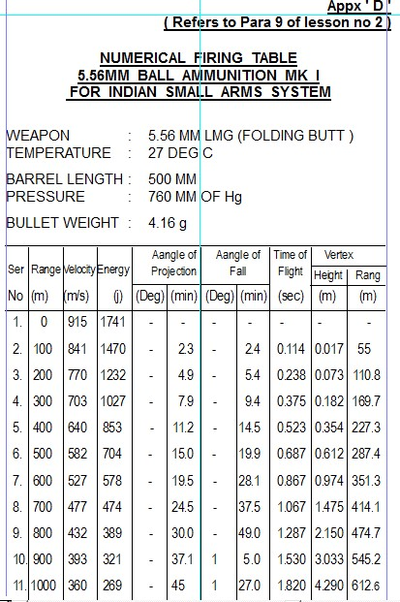

**APPX ‘E’**

**(Ref Para 5 of lesson No 13)**

**TSOET KA RECORD**

NO RANK NAME PL

_____________________________________________________________

**TSOETNO HIGHESTDATE Pts DATENODATE**

**NO PTS**

(a) (b) (c) (d) (e) (f) (g) (h)

____________________________________________________________

1. 10 1.3.70 6 10.3 70 8

2.

3.

4.

5.

6.

7.

8.

**Appx ‘F’**

**(Refers to para 11 of lesson 12)**

**ACCURACY SPECIFICATIONS**

|  |  |  |  |  |  |
| --- | --- | --- | --- | --- | --- |
| **Ser No** | **Range (m)** | **Sight set at (m)** | **No of rds** | **Accuracy HxV (mm)** | **MPI (mm)** |
|  | 30.5 | 200 | 4 out of 5 (SS) | 25.5 x 38 | 12.5 up, 12.5 L or R |
|  | 100 | 200 | 5 out of 6 (SS) | 84 x 84 | 0 - 125 up 42 L or R |
|  | 200 | 400 | 6 out of 7 (S.S.) | 168 x 168 | 0.250 up,  84 L or R |
|  | 400 | 400 | 6 out of 7 (S.S.) | 336 x 336 | 0 - 500 up, |

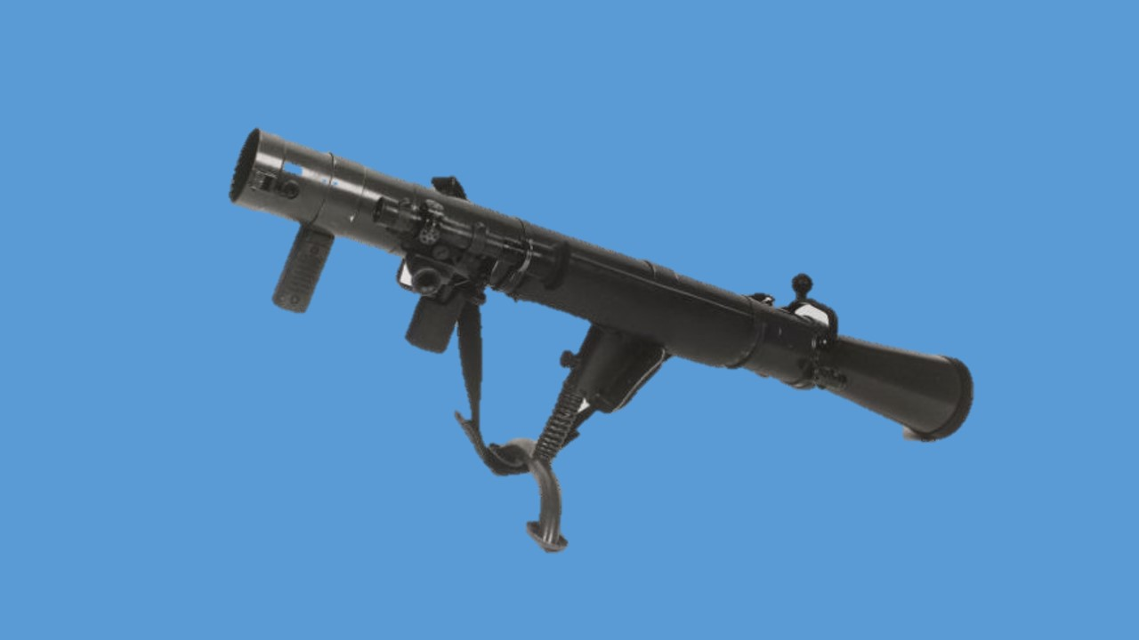

**84MM ROCKET LAUNCHER MK-II**

**84MM ROCKET LAUNCHER**

**SABAQ -1 LAUNCHER AUR AMMUNITION SE WAQFIAT**

**Ref- (Infantry Training Volume I, Infantry Platoon Weapons Pamphlert**

**No 5 84MM Rocket Launcher -2007)**

**Shuru Shuru ka Kam**

1. Class ki ginti det mein bant, launcher aur ammunition ka nirikshan.

**Pahunch**

1. Sabaq ke anusar Instructor khud apni banai hui pahunch class ko bataye. Instructor yaad rakhe pahunch chhota ho, saaf aur sabaq se taluq rakhta ho.

**Uddesh**

1. 84mm Rocket Launcher aur uske ammunition se waqfiat karana hai.

**Saman**

“Ek launcher, sight bag, bag No 1, No 2, “9mm Sub Calibre” aur do round har ek qism ke (HEAT, HE aur Smoke, Illuminating) aur packing.

**Bhagon mein baant**

1. Yeh sabaq teen bhagon mein chalaya jayega :-

(a) **Bhag-I** - Launcher ki visheshtaen.

* 1. **Bhag-II**  - Ammunition ki visheshtaen.
  2. **Bhag-III** - Launcher ke saath saman.

**Bhag-I -Launcher ki visheshtaen**

6. Is ki visheshtaen is prakar batao :-

(a) **Must Know.**

(i) Launcher, mount aur telescopic sight ka wazan, calibre aur length. (Chart par samjhao).

(ii) Laucher ke hisse purze (Har ek hisse ko pointer se samjhao).

(b) **Should Know.**

(i) Rate of fire.

(ii) Launcher ki barrel mein rifling ka round par asar.

**Bhag-II - Ammunition ki Visheshtaen**

1. Is ki visheshstaen is prakar batao:-

(a) **Must Know**

(i) Is launcher se 6 kitne prakar ka ammunition fire kiya jata hai.

(ii) HEAT, HE, TPT, Smoke aur illuminating ammunition ki visheshtaen batao.

(aa) Wazan.

(ab) Muzzle velocity.

(ac) Lohe ki chaddar mein ghusao ki taqat.

(ad) Kargar range.

(ae) HE ka khatarnak ilaqa.

(af) Smoke ke dhuen ke parde ki chaurai aur dhuan dene ka samay.

(ag) Illuminating round ke roshni ka ilaqa, zamin se phatne ki unchai aur roshni ka samay.

* + 1. Har ek ammunition ka maqsad aur role.
    2. 9mm Sub Calibre ki jankari.
  1. **Should Know**
     1. Packing ke bare mein jankari.
     2. Launcher, mount aur telescopic sight ka wazan, calibre aur length. (Chart par samjhao).
     3. Laucher ke hisse purze (Har ek hisse ko pointer se samjhao).
  2. **Could Know**

(i) HEAT, HE ammunition kis sidhant par kaam karte hain.

**Bhag-III - Launcher ke Saath Saman**

1. Is prakar bataen :-
   1. **Must Know**. Sight Bag, Bag No 1 aur Bag No 2 ka saman batao.
   2. **Should Know**. Saman aur accessories ke istemal par jankari.
   3. **Could Know**. Yadi student saman ke bare mein sawal kare to,

**Sankshep**

1. Instructor chale hue sabaq se sambandit baton par sawal aur jawab se sankshep karen.

**Nirikshan**

10. (a) hathiyar

(b) Saman.

**84MM ROCKET LAUNCHER**

**SABAQ 2 - KHOLNA, JORNA, CHAL AUR SAFAI**

**Ref - (Infantry Training Volume I, Infantry Platoon Weapons Pamphlert No 5**

**84MM Rocket Launcher -2007)**

**Shuru Shuru ka Kam**

1. Is prakar karen:-

(a) class ki ginti deton main bant.

(b) Hathiyar ka mulahiza karna class ko bayan aur namune ke saath bataen.

(c) Baqi saman ka bhi mulahiza karen.

(d) Telescopic sight ko launcher par chara den.

**Pahunch**

1. Sabaq ke anusar Instructor khud apni banai hui pahunch class ko batae. Instructor yad rakhe pahunch chhota ho, saaf aur sabaq se sambandit ho.

**Uddesh**

1. 84mm Rocket Launcher ka kholna, jorna, chal aur safai karna ka tariqa sikhana hai.

**Saman**

1. 84mm Rocket Launcher, sight bag, bag No 1, bag No 2 aur chal ka diagram.

**Bhagon mein baant**

1. Yeh sabaq char bhagon mein chalaya jayega :-

(a) **Bhag-I** - Telescopic sight ko chadana aur utarna.

* 1. **Bhag-II** - Launcher ko kholna aur jorna.
  2. **Bhag-III** - Safety catch aur launcher ki chal.
  3. **Bhag-IV** - Safai.

**Bhag- I - Telescopic Sight ko Chadana aur Utarna**

1. Is prakar batao :-
   1. **Must Know**. Class ko telescopic sight ko charane aur utarne ki karwai ka bayan ke sath namuna dein.
   2. **Could Know.** Telescopic sight ke kaam karne ke sidhant par jankari.

**Bhag- II - Launcher ko Kholna aur Jorna**

1. Is prakar batao:-
   1. **Must Know**.

(i) Launcher ke kholne ka bayan ke saath namuna do.

(ii) Launcher ke jorne ka bayan ke saath namuna do.

(iii) Kholne, jorne mein class ko abhiyas dein. (Akhir mein launcher khula ho).

* 1. **Should Know**.

(i) Class ko bataen yadi firing pin ki badli karna ho to launcher kahan tak khola jata hai.

* 1. **Could Know**.

(i) Launcher kholne ke liye bag No 1 ki zarurat parti hai. Is mein jo saman ata hai, woh class ko batao.

**Bhag- III - Safety Catch aur Launcher ki Chal**

1. Is prakar batao:-
   1. **Must Know**.

(i) Safety catch aur launcher ki chal, bayan ke saath namuna, class ko abhyas (Bad mein launcher ko jor dein).

* 1. **Should Know**.

(i) Venturi ko launcher ko bagair cock kiye nahi khol sakte, aise kyon?

* 1. **Could Know**.

(i) Launcher aur cocking rod ke hisson ka bayan karen.

(ii) Applied aur mechanical safety ke bare mein jankari.

**Bhag IV – Safai**

1. Is prakar batao:-

(a) **Must Know**.

* + 1. Firing ke pahle ki safai.
    2. Firing ke dauran ki safai.
    3. Firing ke bad ki safai.
    4. Namidar ilaqe ki safai.
    5. Ratile ilaqe ki safai.
    6. Sard ilaqe ki safai.
  1. **Should Know**.
  2. **Could Know**. Safai ka sara saman bag No 2 mein ata hai, saman kya kya hai.

**Sankshep**

1. Instructor chale hue sabaq se sambandit baton par sawal aur jawab se sankshep karen.

**Nirikshan**

11. (a) Hathiyar.

(b) Saman.

**84 MM ROCKET LAUNCHER**

**SABAQ 3 - FIRING POSITIONEN, BHARNA AUR KHALI KARNA**

**Ref- (Infantry Training Volume I, Infantry Platoon Weapons Pamphlert No 5**

**84MM Rocket Launcher -2007)**

**Saman**

1. 84mm Rocket Launcher, sight bag, drill round aur carrier.

**Shuru Shuru ka Kam**

1. Is prakar karo :-
   1. Squad ki ginti aur launcher ka mulahiza (mulahiza student dwara).
   2. Telescopic sight ko lagane aur kholne, jorne ka abhiyas dena. Akhir mein telescopic sight ko chara hua chor den.

**Pahunch**

1. Sabaq ke anusar Instructor khud apni banai hui pahunch class ko bataye.

**Uddesh**

1. 84mm Rocket Launcher ki Firing positionen, bharna aur khali karna sikhana hai.

**Bhagon mein baant**

1. Yeh sabaq 2 bhagon mein chalaya jayega.
   1. **Bhag I** - Firing positionen.
   2. **Bhag II**- Bharna aur khali karna.

**Bhag I - Firing Positionen**

1. Is prakar batao :-

(a) **Must Know.**

* + 1. Mount ki teen positionon ka bayan ke saath namuna do (Class ko abhyas karao).
    2. Class ko niche bataye positionon ke bare mein bayan karo aur namuna do :-

(aa) Standing position.

(ab) Kneeling position.

(ac) Sitting position.

(ad) Lying position.

(Class ko tamam firing positionon mein abhyas karao)

**Bhag II - Bharna aur Khali Karna**

1. Is prakar batao :-
   1. **Must Know.**
      1. Bharne ka bayan karo aur squad ke ek jawan ki madad se sitting position se namuna do.
      2. Khali karne ka bayan karo aur squad ke ek jawan ki madad se namuna do. (Squad ko bharne aur khali karne mein abhyas do). Back blast ka area batana hai.

(b) **Should Know**

(i) Round ko bharte samay, recess chamber guide mein phans jae, is ki ahmiyat class ko batao.

**Sankshep**

1. Instructor chale hue sabaq se sambandit baton par sawal aur jawab se sankshep karen.

**Nirikshan**

9. (a) hathiyar.

(b) Saman.

**84MM ROCKET LAUNCHER**

**SABAQ 4 - SIGHT LAGANA AUR SHIST LENA**

**Ref- (Infantry Training Volume I, Infantry Platoon Weapons Pamphlert No 5**

**84MM Rocket Launcher -2007)**

**Shuru Shuru ka Kam**

1. Is prakar karo :-
   1. Squad ki ginti aur launcher ka mulahiza (Mulahiza student dwara).
   2. Firing positionen, bharne aur khali karne ki dohrai karen.

**Pahunch**

1. Sabaq ke anusar Instructor khud apni banai hui pahunch class ko bataye.

**Uddesh**

1. Sight lagana, khare aur harkati targeton par shist lena ka tariqa sikhana hai. dfs

**Saman**

1. Launcher, sight bag, drill round, reticle pattern, model, tank target, launcher rest, blackboard aur chalk duster.

**Bhagon mein baant**

1. Yeh sabaq do bhagon mein chalaya jaye ga :-

(a) **Bhag-I** - Sight lagana.

* 1. **Bhag-II** - Shist lena.

**Bhag-I - Sight Lagana**

1. **Is prakar batao:-**

(a) **Must Know.**

* + 1. Telescopic sight ke range drum ki dono positionon par bayan aur sight lagane ka namuna dein..
    2. Telescopic sight par bana khaka model par samjhao.
    3. Telescopic sight par point of aim batao.
    4. Open sight ka bayan aur namuna.
    5. Raat ke waqt fire karne ke liye, luminous sight adapter ka bayan aur namuna.
    6. Open sight par point of aim batao. (Sight lagane ka abhyas lo).
  1. **Should Know**
     1. Telescopic sight, open sight aur luminous sight adapter ke hisson ke nam.
  2. **Could Know**
     1. Elevation drum ke upar alag - alag temperature ke liye teen positionen hain, iske bare mein jankari dein.

**Bhag-II - Shist Lena**

1. Is prakar batao:-

(a) **Must Know**.

(i) Khare targeton par shist lene ka tariqa, bayan aur namuna.

(ii) Harkati targeton par shist lene ka tariqa, bayan aur namuna:-

(aa) Sidhe ane ya jane wale target.

(ab) Cross karne wale target.

1. Model par chhote tank target ki madad se samjhao.
2. Launcher rest par rakh kar durust shist ki jagah class ko batao.
3. Class ko abhyas do aur sawal puchho.
   * 1. Telescopic sight par bana khaka model par samjhao.
     2. Telescopic sight par point of aim batao.
     3. Open sight ka bayan aur namuna.
     4. Raat ke waqt fire karne ke liye, luminous sight adapter ka bayan aur namuna.
     5. Open sight par point of aim batao. (Sight lagane ka abhyas lo).

(b) **Should Know**

(i) Telescopic sight, open sight aur luminous sight adapter ke hisson ke nam.

(c) **Could Know**

(i) Elevation drum ke upar alag - alag temperature ke liye teen positionen hain, iske bare mein jankari dein.

**Sankshep**

1. Instructor chale hue sabaq se sambandit baton par sawal aur jawab se sankshep karen.

**Nirikshan**

1. (a) Hathiyar.
   1. Saman.

# 84MM ROCKET LAUNCHER

**SABAQ 5 - HE, HEAT, SMOKE, 9MM SUB CALIBRE ADAPTOR AUR ILLUMINATING ROUND**

**Ref- (Infantry Training Volume I, Infantry Platoon Weapons Pamphlert No 5**

**84MM Rocket Launcher -2007)**

**Shuru Shuru ka Kam**

1. Is prakar batao:-
   1. Squad ki ginti aur launcher ka mulahiza (Mulahiza student dwara).
   2. Khare aur harkati targeton par shist lene ki karwai par dohrai karen.

**Pahunch**

1. Sabaq ke anusar Instructor khud apni banai hui pahunch class ko bataye.

**Uddesh**

1. HE, HEAT, Smoke aur illuminating round ke liye sight lagana, shist lena aur 9mm Sub Calibre se waqfiat karana hai.

**Saman**

1. Launcher, sight bag, 9mm Sub Calibre, HE, HEAT, Smoke aur illuminating ke ek ek round, black board aur chalk.

**Bhagon mein baant**

1. Yeh sabaq 5 bhagon mein chalaya jayega:-

|  |  |  |
| --- | --- | --- |
| (a) | **Bhag-I** - | HE round. |
| (b) | **Bhag-II** - | HEAT round. |
| (c) | **Bhag-III** - | Smoke round. |
| (d) | **Bhag-IV** - | Illuminating round |
| (e) | **Bhag-V**- | 9 mm Sub Calibre. |

**Bhag-I - HE Round**

1. Is prakar batao:-
   1. **Must Know**
      1. HE round ki visheshtaen.
      2. Teen alag alag tarah se fire karne ke tariqe batao :-

(aa) Zamin par takra kar.

(ab) Target ke upar kisi darakht ke tane se takra kar.

(ac) Target ke upar air burst.

* 1. **Should Know.**
     1. HE round ki nose scale samjhao.
     2. Alag - alag range par fuze setting ke bare mein class se sawal karen.

**Bhag-II - HE, HEAT Round.**

1. Is prakar batao:-

(a) **Must Know.**

* + 1. HEAT round ki visheshtaen.
    2. Fire karne ka tariqa.

(b) **Should Know.**

(i) HEAT round kis sidhant par kam karta hai.

**Bhag-III - Smoke Round**

1. Is prakar batao:-
   1. **Must Know**
      1. Smoke round ki visheshtaen.
      2. Dhuen ka parda banana aur samay.

**Bhag-IV - Illuminating Round**

1. Is prakar batao:-
   1. **Must Know.**
      1. Illuminating round ki visheshtaen.
      2. Angle hasil karne ke liye pendulum sight ka istemal.
   2. **Could Know.**
      1. Illuminating round fire karne ke liye positionen.
   3. **Should Know.**
      1. Round ke nose scale se jankari.
      2. Raat ke waqt range lagane ke liye click ka istemal.

**Bhag-V - 9mm Sub Calibre**

1. Is prakar batao:-

(a) **Must Know.**

* + 1. Iski visheshtaen.
    2. Fire ke liye taiyar karna - Bayan ke saath namuna.
    3. Bharna, fire aur khali karna - Bayan ke saath namuna.

(b) **Should Know.**

(i) Iske hisse purzon ke naam.

**Sankshep**

1. Instructor chale hue sabaq se sambandit baton par sawal aur jawab se sankshep karen.

**Nirikshan**

1. (a) Hathiyar.

(b) Saman.

**84 MM ROCKET LAUNCHER**

**SABAQ 6 - FIRE AUR MISFIRE KI KARWAI**

**Ref- (Infantry Training Volume I, Infantry Platoon Weapons Pamphlert   
No 5 84MM Rocket Launcher -2007)**

**Shuru Shuru ka Kam**

1. Is prakar batao :-
   1. Squad ki ginti aur launcher ka mulahiza (mulahiza student dwara).
   2. Firing positionen, bharne aur khali karne par abhyas dein. Akhir mein sight ko launcher par chara hua chhoren.

**Pahunch**

1. Sabaq ke anusar Instructor apni banai hui pahunch class ko bataye.

**Uddesh**

1. Fire karna aur misfire ki karwai sikhana hai.

**Saman**

1. Launcher, sight bag, drill round, launcher ke samne tank target laga hua aur firing mechanism diagram board.

**Bhagon mein baant.**

1. Yeh sabaq do bhagon mein chalaya jaega :-
2. (a) Bhag-I - Fire karna.

(b) Bhag-II - Misfire par karwai.

**Bhag-I - Fire Karna**

1. Is prakar batao:-
   1. **Must Know**.
      1. Trigger ki karwai - Bayan ke saath namuna (Firing mech diagram par).
      2. Class ke ek jawan se No 2 ka kam karaen aur Instructor fire karne ka bayan ke saath namuna de. (Class ko abhyas do)

(b) **Should Know.**

* + 1. Back blast area ke bare mein.
    2. Rate of fire.

**Bhag-II - Misfire par Karwai**

1. Is prakar batao:-

(a) **Must Know.**

* + 1. Bayan karo aur class ke ek jawan ki madad se namuna do.
    2. Class ko abhyas do aur kya hukam dena hai wah batao:-

(aa) Fire.

(ab) Fire nahi.

(ac) Misfire, khali kar.

(ad) Primer par chot nahi.

* 1. **Could Know.** 5 sec aur 15 sec ka waqfa kyon diya jata hai.

**Sankshep**

1. Instructor chale hue sabaq se sambandit baton par sawal aur jawab se sankshep karen.

**Nirikshan**

10. (a) Hathiyar.

(b) Saman.

**84MM ROCKET LAUNCHER**

**SABAQ-7 - ZEROING**

**Ref- (Infantry Training Volume I, Infantry Platoon Weapons Pamphlert No 5**

**84MM Rocket Launcher -2007)**

**Shuru Shuru ka Kam**

1. Bandobast mein ek launcher ko rest par rakhen aur dusre ko table par, launcher se 300 metre se ziada ki duri par koi bhi nishan chun lein aur rest par rakhi launcher ki barrel ko usi ki line mein rakhen.

**Pahunch**

1. Sabaq ke anusar Instructor khud apni banai hui pahunch class ko bataye.

**Uddesh**

1. 84mm Rocket Launcher aur 9mm Sub Calibre ko zero karne ka tariqa sikhana hai.

**Saman**

1. Do 84mm Rocket Launcher, sight bag, bag No 1, bag No 2, 9mm Sub Calibre, ek rest aur reticle pattern model.

**Bhagon mein baant**

1. Yeh sabaq 3 bhagon mein chalaya jaye ga:-

(a) **Bhag-I** - Telescopic sight ko zero karna.

* 1. **Bhag-II** - Open sight ko zero karna.
  2. **Bhag-III** - 9mm Sub Calibre ko zero karna.

**Bhag-I - Telescopic Sight Ko Zero Karna**

1. Is prakar batao:-
   1. **Must Know.**

(i) Telescopic sight ko zero karne ka bayan ke saath namuna do.

(ii) Upar niche dayen bayen ki correction ke bare main batao.

* 1. **Should Know.**

(i) Bore sight se jankari aur istemal.

* 1. **Could Know.**

(i) 300 metre par bore sight karte hain.

**Bhag-II - Open Sight Ko Zero Karna**

1. Is prakar batao:-
   1. **Must Know.**

(i) Bayan ke saath namuna do

* 1. **Should Know.**
     1. Larai ke dauran rest na mile to karwai kya hogi.

**Bhag-III - 9mm Sub Calibre Ko Zero Karna**

1. Is prakar batao:-
   1. **Must Know.**
      1. Bayan ke saath namuna do.
      2. Range, Target, MPI ki jagah, upar / niche aur daen / baen ki galti par correction ke bare mein batao.
   2. **Should Know.** Zeroing kab kiya jata hai.

**Sankshep**

1. Instructor chale hue sabaq se sambandit baton par sawal aur jawab se sankshep karen.

**Nirikshan**

10. (a) Hathiyar.

(b) Saman.

**84MM ROCKET LAUNCHER**

**SABAQ 8 - HANDLING, TANK KO BARBAD KARNE KE TARIQE**

**Ref- (Infantry Training Volume I, Infantry Platoon Weapons Pamphlert No 5**

**84mm Rocket Launcher -2007)**

**Note**

1. Yeh sabaq 5 bhagon mein banta gaya hai. Bhag 1 aur 2 lecture ke taur par chalae jayenge aur Bhag 3,4 aur 5 training area mein. Sabaq shuru karne se pahle firing positions, camouflage aur concealment ka ek demonstration de dena chahiye. Jis area mein sabaq chalana hai usmein niche likhi sahuliaten honi chahiyen:-

(a) Tank ke ane ke raste.

(b) Hathiyar ko site karne ki mumkin positionen jismein:-

(i) Achha camouflage.

(ii) Dabi zamin.

* + 1. Achha field of fire.

1. Bhag 3, 4 aur 5 ka alag - alag tarah ki zamin par practice karna chahiye.

**Bhag-I - defence mein taiyar ki gai position se tank barbad Karna**

1. Is prakar batao:-

(a) **Must Know.**

(i) **Tank appch ka chunao.**

* + - 1. Primary role.

(ab) Secondary role.

(b) **Should Know.**

* + 1. **Position mein ane par karwai.**

(aa) Chhupao aur camouflage ka mahatva.

(ab) Fasle ka anuman lagana aur zamini nishan fire ke ilaqe mein chunna.

(ac) Ammunition rakhne ke sthan.

(c) **Could Know.**

* + 1. Back blast area ke bare mein.
    2. Contingency posn ka istemal.
    3. Anya task jaise HHMT mein role.

**Bhag-II - Tank Hunting Aur Ambush Lagana**

1. Is prakar batao:-

(a) **General Points.**

* + 1. Stalking ka mahatva.
    2. Anti tank team aur rifle sec ko milap mein aur nazdiq rahna chahiye.
    3. Fire position aur supporting fire.
  1. **Must Know.**
     1. Ambush lagane ki drill batao.
     2. Ambush party ka composition batao.
     3. Ambush ke liye kaunsa sthan chuna jaye.
     4. Supporting fire.
  2. **Should Know**
     1. Ambush lagate samay dhyan mein rakhne wali baten.
     2. Counter ambush drill.

**Bhag-III - Larai Mein Hathiyar Ka Istemal**

(Yeh lesson training area mein chalaya jayega)

**Saman**

1. Ek launcher pure saman ke saath, harkati target ya garian aur drill rounds.

**Shuru Shuru ka Kam**

1. Launcher ka mulahiza karen aur telescopic sight lagayen.
2. Training area mein munasib jagah par morche khuda hua hona chahiye.
3. Agar harkati targeton ka bandobast na ho sake to garian honi chahiye jinki harkat ke liye ishare mukarar hone chahiye.

**Pahunch**

1. Instructor apni banai hui pahunch de.

**Uddesh**

1. 84mm Rocket Launcher team ko larai mein hathiyar ka istemal karne ka tariqa sikhana hai.

**Tartib**

1. **Yeh sabaq niche diye hue tariqe se chalaya jaye**:-
2. Rocket launcher Team ki banawat.
3. Target barbad karna
4. Nuktachini.
5. Alternate Position
6. **Yeh sabaq is prakar chalayen:**-

(a) **Must Know.**

* + 1. RL Team ki banawat batao.
    2. RL Team ke pas saman batao.

**Note** : Team ko morche mein jane dein. Dushman ki position, apni fauj ki position, tank ane ke mumkin raste batao. Zamini nishanon ke fasle ka anuman lagana batao. Ab RL team ko RL ke drill mein abhyas dein.

* + 1. Target barbad karne mein practice dein.

1. **Should Know.**
2. **Could Know.**
3. Nuktachini karen :-
   * + 1. Fasle ka anuman lagana.

(ab) Target ki raftar ka anuman lagana.

(ac) Firing position ka chunao.

(ad) Drill ke samay No 1 aur 2 ka milap.

(ae) Drill mein teji.

(af) Chhupao aur camouflage.

1. Alternate position mein jane ka abhyas den.

**Sankshep**

1. Instructor chale hue sabaq se sambandit baton par sawal aur jawab se sankshep karen.

**Nirikshan**

14. (a) Hathiyar.

1. Saman.

**Bhag-IV - Stalking**

(Yeh lesson training area mein chalaya jayega)

**Saman**

1. Tank target ya garion ka istemal karo. Baqi saman Bhag-III ke saman ke mutabiq.

**Shuru Shuru ka Kam**

1. Jis zamin par stalking karni hai use pahle se hi chun lena chahiye.
2. Stalking ka ilaqa start point se thora dur hona chahiye.
3. Hathiyar ka mulahiza karen aur class ko stalking ke liye taiyar karen.

**Uddesh**

1. Tank hunting aur ambush lagane mein abhyas dena hai.
2. Bhag teen ki tarah.

**Abhyas**

1. Anti-tank team aur section ki harkat batao, aur harkat karao. Ilaqe ke nazdik pahunchne par stalking shuru karna chahiye aur section ko aur RL team ko position pakadne ko kaho.
2. **Must Know.**
   1. RL lagane ka tariqa.
   2. Pahalu ki chal (side crawl).
   3. Cheetah chal.
   4. Toli mein crawling.
   5. Stalking mein practice.

**Sankshep**

1. Instructor chale hue sabaq se sambandit baton par sawal aur jawab se sankshep karen.

**Nirikshan**

* 1. Hathiyar.
  2. Saman.

**Bhag-IV - Ambush Lagana**

**(Yeh sabaq training area mein chalaya jaega)**

**Saman**

1. Bhag teen ki tarah. Target bhag teen ki tarah.

**Shuru Shuru ka Kam**

1. Ambush ka ilaqa pahale se chuna hua hona chahiye. Pahale se driver ko garian lane ki jagah par rehearsal kar lena chahiye.
2. Hathiyar ka mulahiza karen aur team ko taiyar karen.

**Uddesh**

1. Anti-tank team ko ambush lagane aur tankon ko barbad karne mein abhyas dena hai.
2. **Must Know Points.**
   1. Ambush party ko occupy karne mein abhyas.
   2. Rocket Launcher ke position ka chunav. Sentry ko lagana.
   3. Milap.
   4. Target ambush mein ane par fire kholne par practice.
3. **Should Know.**
   1. Counter ambush drill.
4. **Could Know.**
   1. RL team ko drill mein practice.

**Bhag-V - Test Of Elementary Training**

**Uddesh**

1. 84mm RL ki handling ke darje ko malum karna hai.

**Saman**

1. Ek launcher pure saman ke saath, drill round, sight ke khake aur chhote tank ke khake.

**TsOET - 1 Bharna**

1. **Sharten.** No 1 aur 2 hathiyar ke saath kneeling position mein hon. Jab hukam milta hai ‘Bhar ‘ tab se puri karwai karne ke liye samay 6 seconds.
2. **Darja.** Is test ko teen baar kiya jae. Sari karwai durust aur die hue samay mein puri karni chahiye.

**TsOET – 2 Misfire par karwai**

1. **Sharten.** No1 aur 2 puri misfire drill karen. Uski bad donon Nos ki apas mein badli karen taki donon ka test liya ja sake.

**Darja**. Puri karwai durust honi chahiye.

**TsOET - 3 Telescopic Sight se Shist Lena**

1. **Sharten.** Harkati targeton par shist ki jagah chunne ke liye teen sawal kiye jaen. Jawanon ko kahen ki woh tank ke model ko sight ke khake ke upar durust shist ki jagah par lagaen.

**Darja.** Sab sawalon ke jawab sahi hone chahiye.

**TsOET - 4 Telescopic Sight se Shist Lena**

1. **Sharten.** No 1 aur 2 ko boresight ki madad se telescopic sight ko zero karne ke liye kahen.
2. **Darja.** Puri karwai durust honi chahiye. Samay ka lihaz nahin rakha jaega.

**CHAPTER-1**

**HATHIYAR SE PARICHAY**

**Ref- (Infantry Training Volume I, Infantry Platoon Weapons Pamphlert No 5**

**84mm Rocket Launcher -2007)**

**Hathiyar**

1. 84mm Rocket Launcher Sweden ka bana hua hai. Yeh ek platoon ka bharose wala anti tank hathiyar mana gaya hai. Yeh anti tank role ke ilawa anti personnel.

Illuminating aur dhuan ka parda banane mein bhi ek asardar aur kargar hathiyar hai.

1. Yeh breech se bhara (Loaded) jata hai aur ismein pichhe ka dhakka nahin hota (Recoilless). Is ki banawat bahut saral hai parantu yeh ek bahut hi kargar hathiyar hai.
2. Ismein mount hone ke karan iski handling aur firing mein rifle se ziada farq nahi hai. Isliye isse alag alag position se fire kiya ja sakta hai. Yeh ek shoulder se fire karne wala hathiyar hai.
3. Iski firing mechanism (purze) hathiyar ke dahine hote hain aur iska sighting system baen taraf hota hai. RL mein anya prakar ke sighton se ham targeton ko engage kar sakte hain. Ismein open sight ke alawa telescopic sight, pendulum sight, night sight aur luminous sight bhi lagae jate hain.
4. Is hathiyar ke saath ek 9mm Sub Calibre device bhi ata hai, jisse ham ise short range par bhi fire karke HEAT round jaise mar ki qabliat hasil kar sakte hain.
5. Is hathiyar par do jawan asani se larai mein handling karke achha natija hasil kar sakte hain.
6. Is hathiyar se sikhlai dete waqt ziada zor iska anti tank role mein istemal per dena chahiye. Iske bad ek det ko itna mahir hona chahiye ki woh ek round ek tank ka mudda hasil kar sake.

**CHAPTER-2**

**84MM RL KA WAQFIAT, KHOLNA, JORNA AUR SAFAI   
KARNE KA TARIQA**

**Ref - (Infantry Training Volume I, Infantry Platoon Weapons   
Pamphlert No 5, 84MM Rocket Launcher-2007)**

**Shuru Shuru ka Kam**

1. Class ki ginti det mein bant, launcher aur saman ka nirikshan.

**Pahunch**

1. Sabaq ke smbandit ustad khud apni banai hui pahunch class ko bataye. Ustad yaad rakhe pahunch chhota ho, saaf aur sabaq se taluq rakhta ho.

**Uddesh**

1. 84mm Rocket Launcher se waqfiat, kholna, jorna aur safai ka tariqa sikhana hai.

**Saman**

1. 84mm RL, Sight bag, Bag No 1, Bag No 2, tank tgt, black bd, long easel, chalk duster, small pointer.

**Bhagon mein baant**

1. Yeh sabaq teen bhagon mein chalaya jayega:-

(a) **Bhag-I** - Launcher ki vish aur tech data.

* 1. **Bhag-II**  - Kholna, hisse purjon ke naam, kaam aur jorna.
  2. **Bhag-III** - Safai ka tariqa.

**Bhag-I - Launcher ki vish aur tech data**.

1. **Visheshtayen**

(a) Yeh Sweden desh ka bana hua hathiyar hai

(b) Yeh ek A/Tk hathiyar hai.

(c) Is hathiyar ko A/Pers role mein bhi istemal kiya jata hai.

(d) Yeh din ke samay dhuwan aur raat ke samay roshni ke liye bhi istemal kiya jata hai.

(e) Yeh ek breech loaded hathiyar hai.

(f) Isse 6 prakar ka amn fire kiya jata hai

1. **Tech Data**

|  |  |  |  |
| --- | --- | --- | --- |
| (a) | Caliber | - | 84mm |
| (b) | Khali launcher ka wt | - | 14.2kg |
| (c) | Mount ka wt | - | 0.8kg |
| (d) | Mount ke sath wt | - | 15kg |
| (e) | Telescopic sight ka wt | - | 1.1kg |
| (f) | T/Sight aur mount ke sath wt | - | 16.1kg |
| (g) | Wooden box ke sath wt | - | 29.5kg |
| (h) | Lambai | - | 113cm |
| (j) | Barrel ki lambai | - | 83cm |
| (k) | Ventury ki lambai | - | 30cm |
| (l) | Grooves | - | 24 RH |
| (m) | Open sight ka sight radius | - | 296mm |
| (n) | Trigger Pull | - | 2.5 to 5kg |
| (o) | Rate of fire | - | 06 rds/min |
| (p) | Back Blast | - | 15mtr lamba aur 12mtr chaourai  450 degree ke angle |
| (q) | Sidhant | - | Breech loaded laterally percussion fire |
| (r) | Striker Guage | - | 1.7mm to 2.5mm |
| (s) | Amn Fired | - | 6 Parkar |
| (t) | Auth per Inf Bn | - | 38 |
| (u) | Mech safety - Khali ventury aur band ventury Projection- Stop, Lock & Safe | | |

1. **Stop Projection**:- Jab venturi pura khula hota hain to stop projection kam karta hain, Jab trigger press karte hain cocking rod ka cam pichhe ki harqat karta hain, lekin pura pichhe nahin ja pata kyon ki raste mein safe projection utha huwa hota hain, cam pura pichhe na ja pane ke karan firing pin round ke primer per chot nahin mar pati, is prakar stop projection safe pradhan karta hain.
2. **Lock Projection**:- Jab venturi band hone se thora pahale ruk jati hain to lock projection safty pradhan karta hain, ismein bhi karwani same stop projection ki tarah hota hain, Trigger press karne per cocking rod pichhe ki harqat karta hain, lekin safe projection utha huwa hone ke karan cam plate pura pichhe nahin ja pata. Jiske karan firing pin cam per sawar nahi hoti aur rd ke primer per chot nahin marta hain aur fire nahi hota, is prakar lock projection safty pradhan karta hain.
3. **Safe Projection**:- Jab venturi puri tarah band ho jati hain to fastening strip pure centuri per aa jati hain jiske karan safe projection pura niche chala jata hain, Jab trigger ko press karte hain to cam pura pichhe aata hain aur firing pin cam per sawar ho kar primer per chot marta hain, jisse fire ho jata hain. Fire hone se hathiyar bhi safe hain aur firer bhi safe hain kyon ki venturi bhi puri band hain.
4. **Sight Bag ka Saman**. Telescope Sight, Pendulam Sight, Luminous Sight Adaptor, Safai ka Brush, Safai ka Kapra.
5. **Sight Bag**. Is bag mein nimnlikhit saman aata hai:-
   1. Telescopic sight
   2. Brush
   3. Safai ka kapra
   4. Luminous sight adaptor
   5. Pendulum sight with box

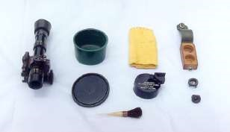

**Fig. 1 Sight Bag Mein Saman**

**Bhag-II : Kholna, hisse purjon ke naam, kaam, jorna ka tariqa:-**

13. 84mmRocketLauncher ko kholne ke liye yakin karen ki launcher cock nahi hai. Launcher ko kholne ke liye Bag No-1 ki zarurat parti hai. Bag No-1 ka saman:-

**Bag No 1**. Ismein nimnlikhit saman aate hai:-

(a) **Bore Sight Adapter.**

1. Front Bore sight adapter.
2. Rear Bore sight adapter.

(b) **Tool Roll**

* + 1. Main spring - 01
    2. Foresight assembly - 01
    3. Drift - 02
    4. Spanner fore Sight & rear sight - 01
    5. Screw drivers - 03 (5,10,15mm)
    6. Spare part box - 01

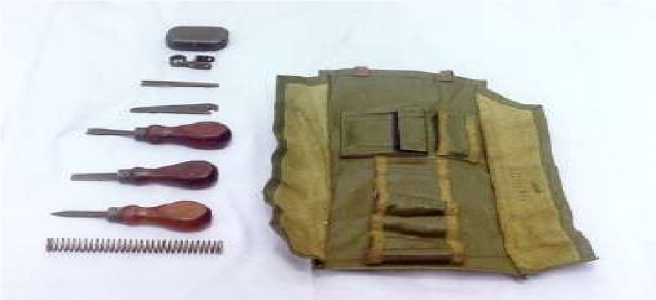

**Figure 2 Tool Roll ka Saman**

(c) **Spare part box ka saman:-** Fore sight locking screw, fore sight locking nut, Rear sight slide, rear sight slide locking screw, Trigger mech locking plate, trigger mech locking plate ka locking screw, trigger spring, sear, sear spring, trigger axis pin, sear axis pin, front cap, rear cap, firing pin, extractor spring, extractor spring locking screw, measuring plate 0.25mm.

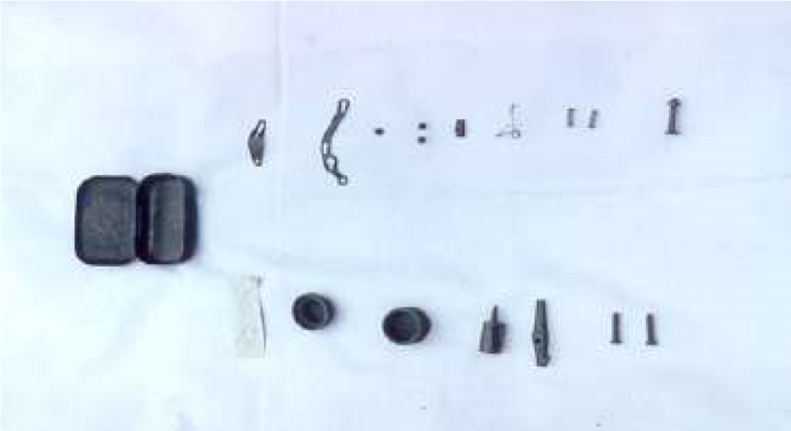

**Figure: 3 Spare Part Box ka Saman**

**Kholne ka tariqa**:- Launcher ko khara Karen, 15mm screw driver ki madad se front cap ko kholen aur main spring ko bahar nikalen. Rear cap ko kholen, cocking rod ko age jane den aur firing pin ko bahar nikalen. Ek firer ko itna hi kholna ki zazrurat parti hai. Iske hisse purjon ke naam:-

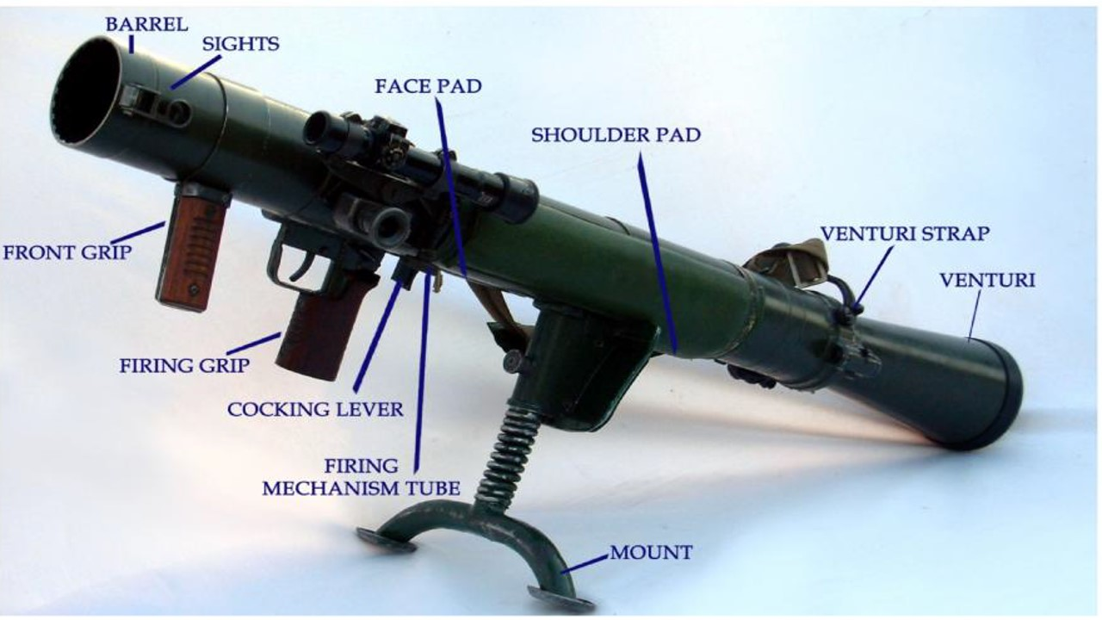

**HISSE PURJON KE NAAM**

**Safety Catch ki Chal**. Jab safety catch ki posn ‘S’ par hoti hai to safety catch ka gol wala bhag sear ke neeche aa jata hai jisse trigger ko dabane par sear neeche nahi dab pata hai aur trigger press nahi hota hai. Jab safety catch ki posn ‘F’ par kiya jata hai to safety catch ka kata hua bhag sear ke neeche aa jata hai jisse sear ko neeche ane ki jagah mil jati hai aur trigger press ho jata hain.

**Launcher ki Chal**. Jab launcher ko cock kiya jata hai to cocking rod age ki harkat karta hai, is dauran main spring front cap mein sikur jata hai aur firing pin cam se neeche utar jata hai. Jab main spring apni tanav ko poora karta hai to cocking rod ko peechhe dhakelta hai, is dauran cocking rod ke lug ka milap sear notch se ho jata hai aur launcher cock ho jata hai. Jab firer trigger ko dabata hai to cocking rod lug aur sear notch ka milap tut jata hai, jisse cocking rod peechhe ki harkat karta hai. Is dauran firing pin cam ke upar sawar ho jata hai aur chamber wale rd ke percussion cap par chot marta hai, jisse rd fire ho jata hai.

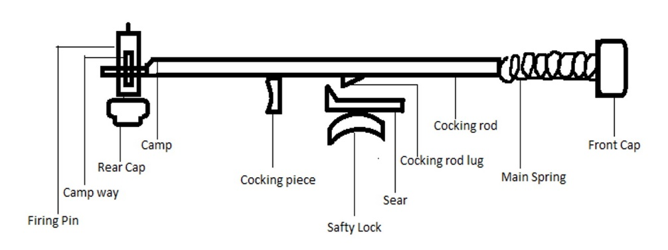

**Figure: 5 Spare Part Box ka Saman**

**Jorna.** Jorne ke liye sabse pahle firing pin ko dakhil karen aur rear cap ko band karen, trigger ko press karte huye cocking rod ko peechhe karen, launcher ko khara karen, main spring ko dakhil karen aur 15mm screw driver ki madad se front cap ko tight karen. Launcher ko neeche rakhen, cock karen aur trigger ko press karen.

**Bhag-III : Safai karne ka tariqa:-**

14 Safai karne ke liye Bag No-2 ki jarurat parti hai. Bag No-2 ka saman:-

(a) Cleaning rod three sec.

(b) Cleaning tool.

(c) Oiling brush.

(d) Cleaning brush. (e) Safai ka kapra.

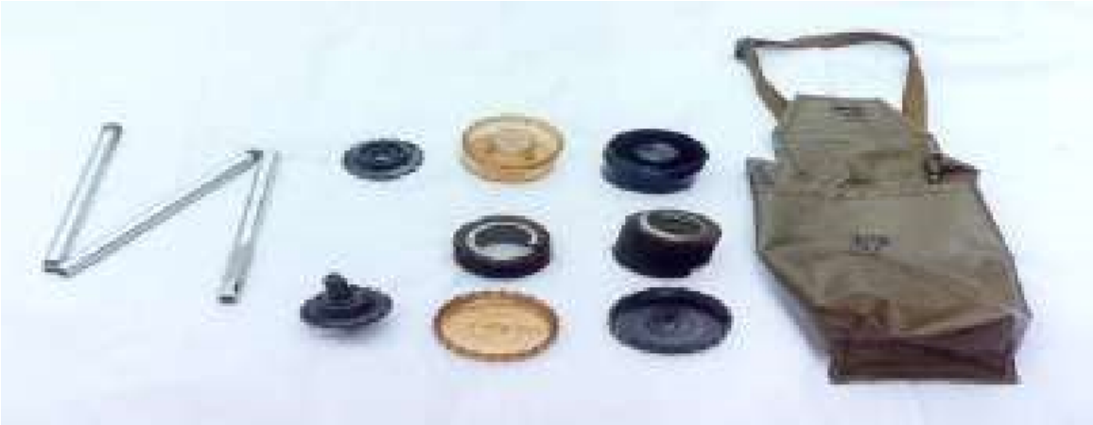

**Figure 6 : Bag No 2 ka Saman**

Safai karne ke liye cleaning rod ko joren, cleaning rod ko cleaning tool ke sath joren, Front cleaning tool ko kholte huye brush ko lagayen aur cleaning tool ko jor den. Barrel ya chamber kisi taraf se rod ka istemal karte huye safai ki ja sakti hai. Lubrication ke liye pahle bataye gaye tarike ki tarah hi oiling brush ko joren aur tel lagayen. Lubrication baki hathiyaron ki tarah.

**CHAPTER-3**

**AMMUNITION SE JANKARI AUR HE AUR ILL ROUND KI NOSE PER RANGE LAGANE KA TARIQA**

**Ref : (Infantry Training Volume I, Infantry Platoon Weapons Pamphlert No 5, 84mm Rocket Launcher -2007)**

**Shuru Shuru ka Kam**

1. Class ki ginti det mein bant, launcher aur saman ka nirikshan.

**Pahunch**

1. Sabaq ke smbandit ustad khud apni banai hui pahunch class ko bataye. Ustad yaad rakhe pahunch chhota ho, saaf aur sabaq se taluq rakhta ho.

**Uddesh**

1. 84mm Rocket Launcher se waqfiat, kholna, jorna aur safai ka tariqa sikhana hai.

**Saman**

1. Sabhi parkar ke drill round ke model, black bd, long easel, chalk duster, small pointer.

**Bhagon mein baant**

1. Yeh sabaq teen bhagon mein chalaya jayega:-

(a) **Bhag-I** - Sabhi parkar ke amn se jankari.

* 1. **Bhag-II**  - HE aur Illuminating round ki nose per range lagane ka tariqa.

**Bhag-I : Sabhi parkar ke amn se jankari:-**

1. 84mm RL se 6 prakar ke amn fire kiye jate hain:-

(a) HEAT (High Explosive Anti Tank). FFV 551, FFV 651, FFV 751.

(b) TPT (Target Practice Tracer) (FFV 65).

(c) HE (High Explosive). (FFV 441B).

(d) Illuminating (FFV 545).

(e) Smoke (FFV 469).

(f) 9mm Sub Calibre Adapter (219)

**Note** :- FFV - Forenade Fabrics Verkan - United Factory Works

1. **HEAT Round**. Is ammunition ko tank, bunker ya pill boxes ke khilaf istemal kiya jata hai. Round ke phatne se tgt ke kai tukre ho jate hain jisse aas pass dushman ke jawanon ko bhi nuqsan pahunchaya ja sakta hai. Iski visheshtaen is prakar hain:-

|  |  |  |  |
| --- | --- | --- | --- |
| (a) | Ek round ka wazan | - | 2.6kg |
| (b) | Do round container ke sath | - | 7kg |
| (c) | Muzzle Velocity | - | 310m/sec |
| (d) | Fuze | - | Direct Action |
| (e) | Sidhant | - | Hollow Charge |
| (f) | Range |  |  |
|  | (i) Khare Tgt | - | 500mtr |
|  | (ii) Harkati Tgt | - | 400mtr |
| (g) | Pentration | - | 400mm Armr Plate  1000mm RCC |
| (h) | Arming Distance | - | 5 se 15mtr |
| (j) | High Temp | - | 30000 C se 40000 C |
| (k) | High Speed | - | 16 se 20km/h |
| (l) | High Pressure | - | 1 se 2 million kg/cm2 |

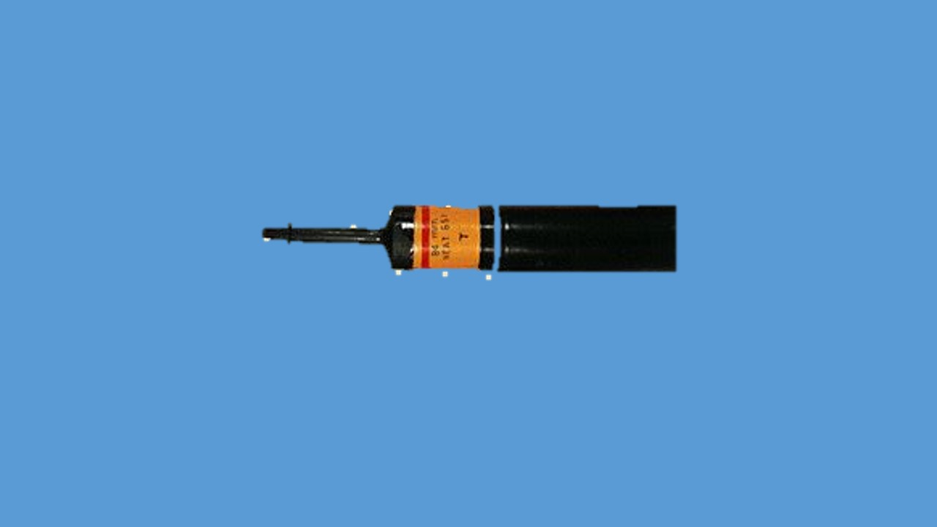  
  
  
  
  
  
  
  
  
  
  
  
  
  
 **HEAT ROUND**

**HEAT Round ki Chal**.

(i) Fire ke baad projectail barrel se aage nikal jata hai saath hi projectile ke pichhe bhag se tracer jalna shuru hota hai.

(ii) Rg mein pahunchne ke baad rd ka nose tgt mein hit karta hai saath hi nose plug tut jatha hai.

(iii) Projectile tgt mein hit karne ke shock mein projectile ke ander **enertia** ka dhakka lagta hai (Kampan).

(iv) Jis se arming device mein sticker spring sikkud jatha hai , stricker aage nikal kar detonator ke upar chot martahai jis se detonator fat jatha hai aur chingari paida hota hai.

(v) Yeh chingari booster ko aag detha hai aur auxiliary booster aag ko badhata hai aur bursting charge jaljatha hai.

(vi) Bursting charge ke jalne par athyadhik heat paida hota hai jis se 3 karwai hoti hai:-

1. High temp - 3000 se 4000 degree C.

(b) High speed - 16 se 20 km/sec.

(c) High pressure - 1 se 2 million kg/cm sq.

(vii) Liner (copper cone) heat se pighalna shuru hota hai

(viii) Distance tube ke jariya lawa tk ke lohe ke chadhar mein g hus jata hai aur tk barbad ho jata hai.

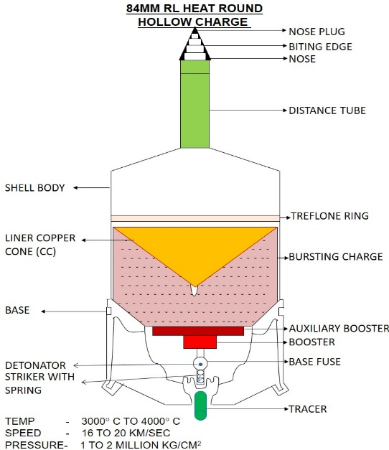

**HEAT ROUND**

1. **TPT Round**. Is round ka tech data hu-ba-hu HEAT round ki tarah hi hoti hai. Antar sirf itna hota hai ki ismein copper cone aur bursting charge nahi hota hai. Yeh rd tank ko barbad karne ki kabiliyat nahi rakhta hai. Iska istemal trg ke liye kiya jata hai.
2. **HE Round**. Is round ka istemal dushman ki paidal sena aur patli chadar se bani garion ke barkhilaf kiya jata hai. Iski tech data is prakar hain:-

|  |  |  |  |
| --- | --- | --- | --- |
| (a) | Ek round ka wazan | - | 3.1kg |
| (b) | Do round container ke sath | - | 8.2kg |
| (c) | Muzzle Velocity | - | 240m/sec |
| (d) | Fuze (FFV 447) | - | Time & Impact |
| (e) | Karger Range | - | 1000mtr |
| (f) | Max Range | - | 1250mtr |
| (g) | Steel Ball | - | 850 |
| (h) | Arming Distance | - | 40 se 70mtr |
| (j) | Killing Area | - | 10mtr radius |
| (k) | Air burst ki zamin se unchai | - | 6 se 9mtr |
| (l) | Time of Flight | - | 700mtr at 3.4sec |

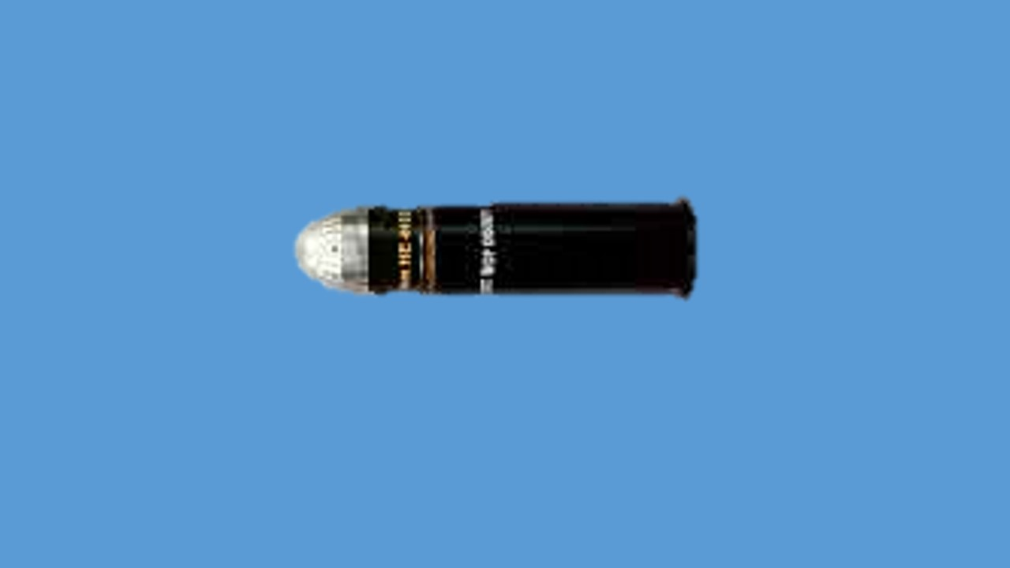

**HE ROUND**

**Note**  . Jab HE Round hawa mein phattha hain to ismein se chhoti chhoti steel ke charre/balls nikalte hain jo ki tgt ko barbad karte hain. Is round mein 850 steel balls jo Neroprene rubber ke sath filled hote hain.

1. **ILL Round.** Is round ke fire se kafi roshni paida hoti hain jiski wajah se hum raat ke waqt aimed fire dal sakte hain. Yeh round raat ke waqt battle fd mein roshni dene ka kaam karta hai. Iski visheshtaen is prakar hai:-

|  |  |  |  |
| --- | --- | --- | --- |
| (a) | Ek round ka wazan | - | 3.1kg |
| (b) | Do round container ke sath | - | 8.2kg |
| (c) | Muzzle Velocity | - | 260m/sec |
| (d) | Fuze (FFV 64C) | - | Time combustion |
| (e) | Karger Range | - | 2100mtr |
| (f) | Max Range | - | 2300mtr |
| (g) | Zamin se upar burst ki unchai | - | 200mtr |
| (h) | Roshini dene ka samay | - | 30sec |
| (j) | Roshini dene ki power | - | 6,50,000candla |
| (k) | Rate of decent | - | 5mtr/sec |
| (l) | 200 se fire karne per CP | - | 265mtr |
| (m) | 250 se fire karne per CP | - | 395 se 405mtr |

Raat ke samay click se rg laga sakte hain, teen click diye gaye hain   
1700mtr, 1100mtr, 600mtr. Factory se yeh ‘S’ per aata hai. Shuru mein isko rg lagan eke liye pahle anticlock wise hi ghumaya jata hai baad main kisi bhi taraf ghumaya ja sakta hai.

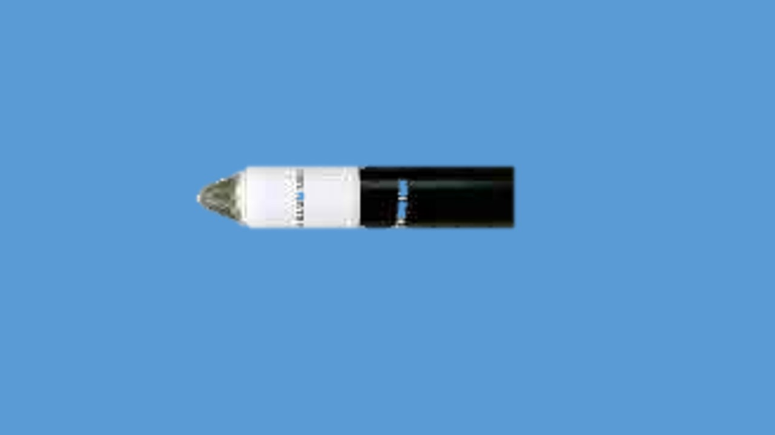

**ILL ROUND**

1. **Smoke Round.** Is round ka istemal dhuan ka pardha banana ke liye istemal kiya jata hai aur sath apne troops ki harkat ko chupane ke liye bhi iska istemal kar sakte hai. Sight lagana aur shist lena hu-ba-hu HE round ki tarah hai. Iski visheshtaen is prakar hain:-

|  |  |  |  |
| --- | --- | --- | --- |
| (a) | Ek round ka wazan | - | 3.1kg |
| (b) | Do round container ke sath | - | 8.2kg |
| (c) | Muzzle Velocity | - | 240m/sec |
| (d) | Karger Range | - | 1300mtr |
| (e) | Dhuan dene ka samay | - | 2 min |
| (f) | Smoke screen ki chaurai | - | 15mtr based on air |

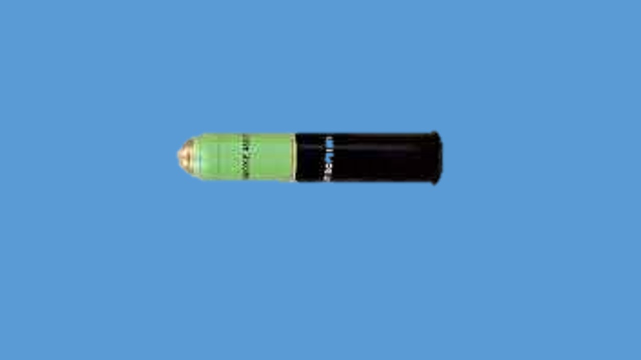

**SMOKE ROUND**

1. **9mm Sub Calibre Adapter (219).** Training ke dauran ammunition ki bachat karne ke liye 9mm Sub Calibre adaptor se 9mm tracer round fire kiya jata hai. Iska wazan 2.9kg hai aur grooves 06 (RH) hain. Iski vish is parkar se hai:-
   1. Is adaptor ka istemal karke det ko zyada se zyada firing main abhyas diya ja sakta hai.
   2. Amn ki bachat.
   3. Isko fire karne ke liye fd firing rg ki zarurat nahi padti hain.
   4. Iski trajectory HEAT round ki tarah hi banti hai.
   5. Is adaptor ka istemal karne se launcher ki barrel ki life per koi asar nahi parta hain.
   6. Isse fire kiye jane wala amn 9mm Tracer FFV-840 hai.
   7. Ek trg year main 450 rds auth hai.

1. 9mm Sub Calibre ek plastic container mein ata hai. Har container ke saath strap laga hota hai jisse isko asani se carry kiya ja sakta hain.

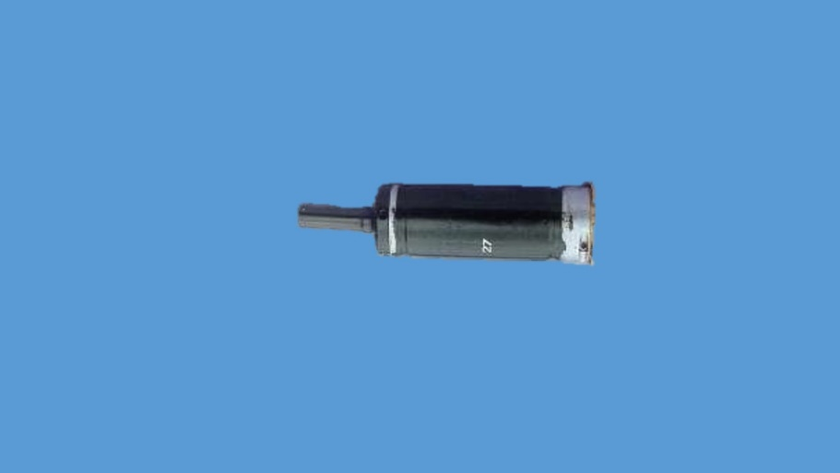

**9MM SUB CALIBRE ADAPTER 219**

Iske hisse puje – Nose, zeroing screw, zeroing screw locking screw, body, rim, round races, sited for primer with cap holder, engagement surface dis-engagement surface. Firing mech (Pressure plate, bolt catch, firing pin catch, sited for 9mm tracer, plunger, firing pin).

**Firing ke Liye Taiyar Karna**. Firing mech ko bahar nikalen, 9mm tracer ko sited for tracer mein fit karen, firing mech ko adaptor ke andar dakhil karen aur safe par karen. Baki amn ki tarah RL mein bhar ki karwai karen. Primer with cap holder ko uski jagah fit karen. Ventury ko band karne se pahle firing mech ki posn ko ‘F’ pa karen aur ventury ko band karen.

**Misfire Hone par Karwai**. Misfire hone par ventury ko kholen, firing mech ko ‘S’ par karen aur adaptor ko bahar nikalen. Primer with cap holder ko check karen. Agar uske primer par chot ho to firing mech ke tracer ko nikalte huye tracer ke primer ko check karen. Agar tracer misfire ho to tracer aur primer with cap holder dono ki badli karen. Agar tracer ke primer par chot na ho to primer with cap holder ki badli karen aur dubara fire kare.

**Bhag-II : HE aur ILL Round ke Nose par Rg Lagana**:-

1. **HE Round** Is round ko fire karne ke liye range drum ko bahar khench kar munasib range telescopic sight par lagaya jata hai. Is round ke nose ke upar ek scale bana hota hai jis par ek ‘S’ ka nishan hota hai aur 0 se 1250 M tak ke hisson mein banten hue hote hain. Nose ko ghuma kar zarurat shuda range indicator mark ke samne lagaya ja sakta hai. HE round ko teen alag alag tarikon se fire kiya jata hai:-

(a) Ground Burst (Zamin se takra kar phatna).

* 1. Tana Burst (Tane se takra kar phatna).
  2. Air Burst (Target ke upar air burst).

(i) **Ground Burst**. Is tarike ka istemal us samay kiya jata hai, jab dushman khule ilake mein harkat kar raha ho sath hi dushman ke patli lohe ki chadar se bani garion ke barkhilaf bhi istemal kiya jata hai. Is tarike mein tgt ka sahi rg telescopic sight par lagaya jata hai aur rd ki nose par ‘S’ lagakar fire kiya jata hai.

(ii) **Tana Burst**. Is tarike ka istemal us samay kiya jata hai jab dushman kisi ped ke neeche open trench mein baitha ho. Is tarike mein tgt ka sahi rg sight ke upar lagaya jata hai aur rd ke nose par sahi rg se 50m jiada lagaya jata hai. Shisht lete samay shisht jis tane se takrana ho uske upar liya jata hai.

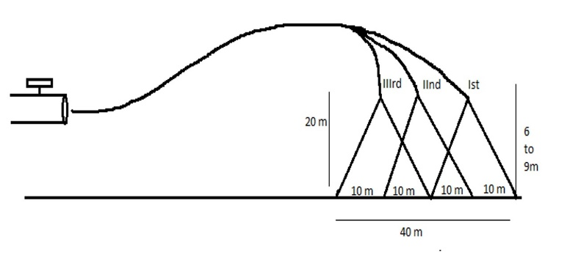 (iii) **Air Burst**. Is tarike ka istemal us samay kiya jata hai jab dushman kisi open trench mein baitha ho, upar se koi rukawat na ho ya dushman ki Inf open area mein harkat kar rahi ho. Waise to ek rd bhi air burst kiya ja sakta hai lekin sahi mudha hasil karne ke liye teen rd air burst kiya jata hai. Is tarike mein agar dushman 500m tak ke rg par ho to sight ke upar 600m rg lagaya jata hai. Agar dushman 600m se adhik rg par ho to sight ke upar actual rg se 100m jiada lagaya jata hai. Air burst ke liye teen rd taiyar kiye jate hain. Pahle rd ki nose par actual rg se 10m adhik, dusre rd ki nose par actual rg aur teese rd ki nose par actual rg se 10m kam rg lagaya jata hai. Fire karne ke liye sabse pahle adhik rg wala, phir actual rg wala aur akhir mein sabse kam rg wala rd fire kiya jata hai. Is prakar teen rd air burst karne par 20m x 40m ka ilaka cover hota hai.

**AIR BURST**

1. **Illumaniting Round**. Is rd ka istemal ilake ko roshni karne ke liye kiya jata hai. Iski nose par ek ‘S’ aur 0 se 23 tak ke ank khude huye hote hain jo 2300m tak ke rg ko jahir karte hain. Jab rd aata hai to yeh ‘S’ par set ho kar aata hai. Jab rd ki nose par ‘S’ laga hua ho us samay ise clock wise nahi ghumaya ja sakta yani rg decending order mein hi lagaya ja sakta hai. 23 se neeche ki taraf karte huye rg lagaya ja sakta hai. Rg lagane ke liye iska pahla click 1700m, dusra click 1100m aur teesra click 600m rg ko jahir karta hai. Agar rg kam lagaya gaya ho us samay usse adhik rg clock wise ghumate huye lagaya ja sakta hai. Is rd ko do angle se fire kiya jata hai, 20 degree aur 25 degree. Jab 20 degree ke angle se fire kiya jata hai to 500m se 1800m tak ka rg hasil hota hai aur jab 25 degree ke angle se fire kiya jata hai to 300m se 400m tatha 1900m se 2100m rg hasil hota hai.

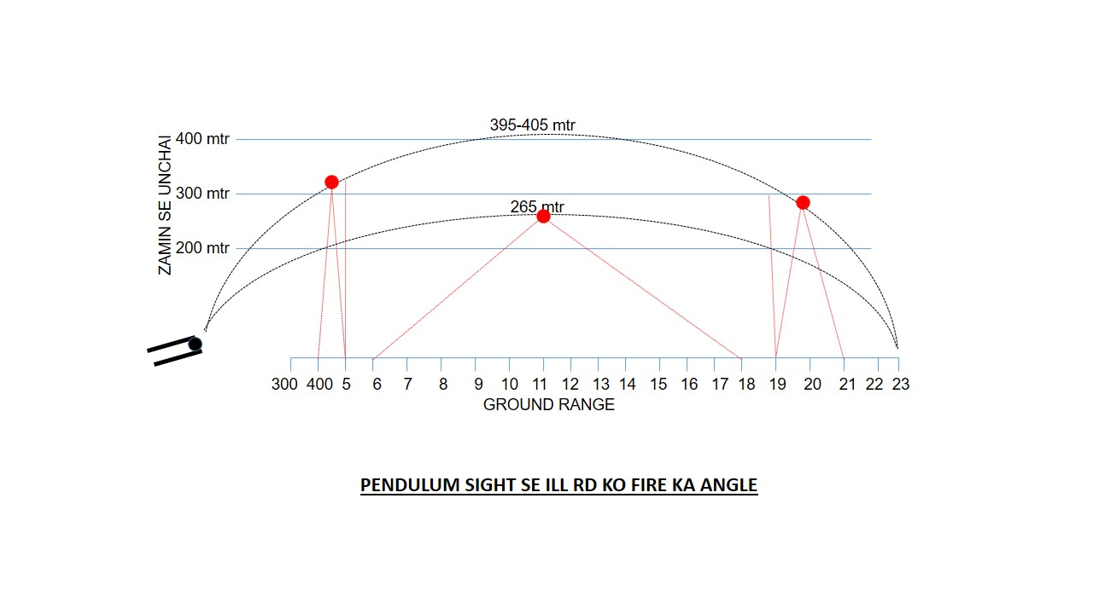

**CHAPTER-4**

**84MM RL KI FIRING POSITION, BHARNA, KHALI KARNA**

**Ref -(Infantry Training Volume I, Infantry Platoon Weapons Pamphlert No 5**

**84mm Rocket Launcher -2007)**

**Shuru Shuru ka Kaam**

1. Class ki ginti det mein bant, launcher aur saman ka nirikshan.

**Pahunch**

1. Sabaq ke smbandit ustad khud apni banai hui pahunch class ko bataye. Ustad yaad rakhe pahunch chhota ho, saaf aur sabaq se taluq rakhta ho.

**Uddesh**

1. 84mm Rocket ki firing posn, bharna aur khali karna ka tariqa.

**Saman**

1. 84mm RL, Sight bag, bag No 1, bag No 2, container, rifle, Tank tgt,   
   Fig 11 tgt, black bd, chalk, duster, small pointer, ground sheet.

**Bhagon mein baant**

1. Yeh sabaq teen bhagon mein chalaya jayega:-

(a) **Bhag-I** - Firing Position

* 1. **Bhag-II**  - Bharna aur khali karna ka tariqa.

**Bhag-I - Firing Position**

1. Firing posn bataun usse pahle zaruri samjhata hoon ki mount ki posn ke bare mein bata doon taki aapko firing posn ikhtiyar karne mein asani ho. Mount ki teen posns hoti hai:-

(a) Nicha Mount. (b) Uncha Mount. (c) Tircha Mount.

Ek firer mount ki posn ko kis parkar ikhtiyar karta hai issi karwai ka namuna hathiyar par byan ke sath doonga aap dekhen tatha samjhen. Sabse pahle,

**Uncha Mount** Zarurat, yeh posn tab ikhyiyar kiya jata hai Jab firer lying posn se fire kar raha ho. Karne ka tariqa sabse pahle dayen hath ki kalme bali ungli aur anguthe ki madad se mount catch ko upar ki taraf uthaen, mount ko bahar ki taraf kheenche, mount catch ko chhor den mount ko tab tak bahar ki taraf kheenche jab tak click ki awaj na aaye, dekhen is parkar, yeh tha uncha mount.

**Neecha Mount** Zarurat jab launcher ko kote main rakhna ho, rest posn main rakhna ho ya squad post main rakhna ho toh neecha mount posn main rakha jata hai. Karne ka tariqa mount catch ko seekhe hue tariqe se uthaen mount ko ander ki taraf dhakelen, mount catch ko chhor den, mount ko tab tak ander ki taraf dhakelen jab tak click ki awaj na aaye dekhen is parkar, yeh tha neecha mount.

**Tirchha Mount** Zarurat Jab lying posn ke alawa anya kisi posn se fire karna ho ya launcher ko ek jagah se dusri jagah par le jana ho to tirchha mount lagaya jata hai. Karne ka tariqa mount catch ko seekhe hue tariqe se upar ki taraf uthaen, mount ko clockwise turn Karen mount catch ko chhor den mount ko tab tak gumaen jab tak click ki awaj na aaye, Yeh thi mount ki position yahan tak kiye gaye bayan aur karwai main kisi bhi student ka koi swal. Swal nahi to up.

**Firing Position.** 84mm RL ko char posns se fire kiya jata hai. Standing Posn, Kneeling Posn, Sitting Posn aur Lying Posn.

* 1. **Standing Position.** Zarurat jab aarh 4 se 41/2 feet ki ho ya fire trench se fire karne ki zarurat pade toh standing posn ka istemal kiya jata hai karne ka tariqa:-

(i) **No 1 ki Position**. Mount ko tirchhi position mein karta hai aur launcher ko dahine kandhe par uthata hai. Donon pair kad ke mutabiq khule hue body wt donon pair ke upar. Eye relief takriban 2 inch ho. Baen haath front grip par aur dahina haath pistol   
 grip par. Agar harkat ki zarurat ho to harkat donon taknon se di jaye.

(ii) **No 2 ki Position.** No 2, No 1 ke dahine kandhe ke saath launcher ki taraf munh rakhte hue itna paas rahe ki No 1 ke   
 addesh ko sun sake aur sath hi bhar thatha khali kar ki karwai kar sake.

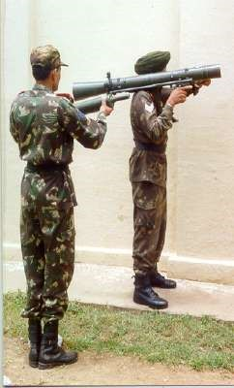

**Standing Position**

1. **Kneeling Position.** Zarurat, jab aarh 2 se 21/2 feet ki ho toh kneeling posn ka istemal kiya jata hai karne ka tariqa:-
   * 1. **No 1 ki Position.** (Khare tgt ke liye) aam kneeling posn ikhtyar kare. Pakar standing position ki tarah. (Harkati tgt ke liye) High kneeling posn ikhtyar Karen aur harkat kamar se di jayen.
     2. **No 2 ki Position.** (Khare tgt ke liye) Donon ghutnon ke bal No 1 ki taraf ke kandhe ke sath baitha ho No 1 ke saath harkat kare. (Harkati tgt ke liye) Donon ghutnon ke bal khada ho jaye aur No 1 ke sath harkat karen.

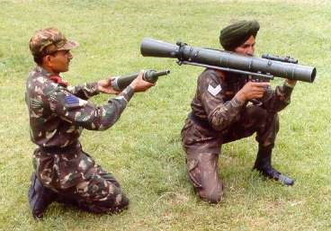

**Kneeling Position - Khare Target Ke Liye**

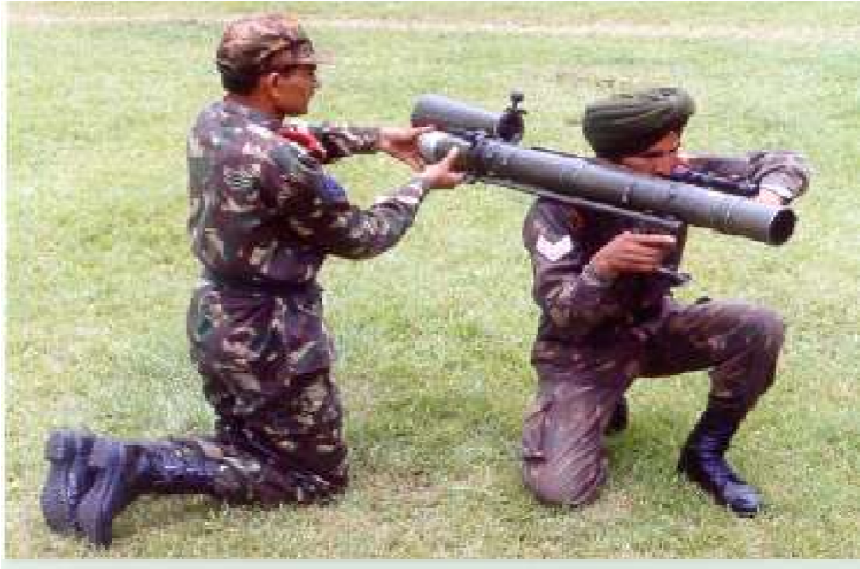

**Kneeling Position - Khare Target Ke Liye**

1. **Sitting Position.** Zarurat, jab upar se neche ya dhalwandhar zamin per fire karna ho toh sitting posn ka ikhtiyar ki jati hai:-

(i) **No 1 ki Position**. (Khare tgt ke liye) Aam rifle ki position ki tarah aur donon kohniyan ghutane par ho. (Harkati tgt ke liye) Harkati tgt ke liye donon paon close karen aur harkat kamar  
 se di jayen.

(ii) **No 2 ki Position.** (Khare tgt ke liye) No 2 ki posn kneeling posn ki tarah. (Harkati tgt ke liye) Donon ghutnon ke bal khada ho jaye aur No 1 ke sath harkat karen.

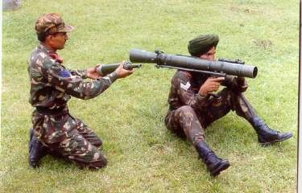

**Sitting Position - Khare Target Ke Liye**

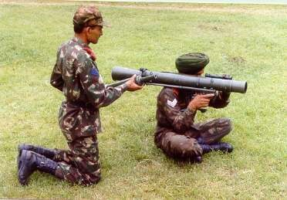

**Sitting Position - Harkati Target Ke Liye**

1. **Lying Position.** Zarurat, jab aarh 1 feet ya khule ilake main ya kisi anya position se fire karna munsib na ho toh lying position ikhtiyar ki jati hai:-

(i) **No 1 ki Position.** No1 launcher ko uncha mount karta hai aur launcher ke bayen 90 degre ke angle main position leta hain aur apne dayen paon ko bayen paon ke upar rakhta taki back blast se bacha ja sake.

(ii) **No 2 ki Position.** No 2 launcher ke bayen bayen   
 90 degre ke angle main position leta hain aur apne bayen paon ko dayen paon ke upar rakhta taki back blast se bacha ja sake.

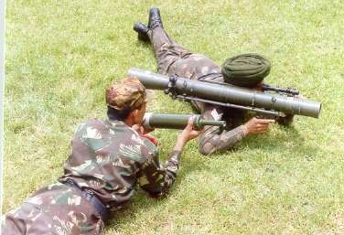

**Lying Position**

**Bhag-II - Bharna aur Khali karna**

1. **Bharna** Ek launcher firer kis parkar se bhar aur khali kar ki karwai karta hai namuna hathiyar par bayan ke sath doonga aap dekhen, sune tatha samjhen. Kneeling posn uthaen RL sight bag .

(a) **No 1 ka hassiyat se.** Jab No 1 ko tgt area mein tgt dikhai de ya hukam mile ‘Bhar’ toh No 1 launcher ko cock karta hai aur safety catch ki posn ko safe per karta hai aur No 2 ko addesh deta hai ‘Bhar’.

(b) **No 2 ka hassiyat se.** No 2, No 1 ke addesh ko dohrata hai aur venturi strap ko dabate hue venture ko kholta hai aur ventury aur chamber ka muliza karta hai aur saaf karta hai. Container se round ko nikalata hai aur round ka muliza karta aur saaf karta hai, round races aur chamber guide ko madad se chamber main dakhil karta hai. Back blast area ka nirikshan karta hai aur agar koi jaandhar vastu ya rukawat hai toh use hatata hain agar na hatne wali vastu hai toh apni firing posn ki jagah ki badly karta hai. Back blast area saaf toh ventury ko band karta hai aur No 1 ki peedh per thapki lagate huye up pukarata hai aur apni jagah per baith jata a hain.

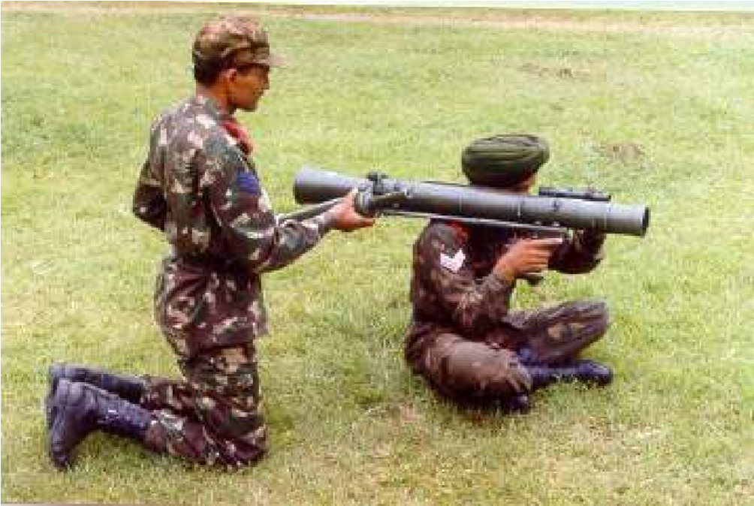

**Bharna Khali Karna**

1. **Khali Karna**. No 1 ko tgt na dikhai de ya sqd post trg ke dauran aadesh mile bina fire khali kar

(a) **No 1 ka hassiyat se.** No 1 yakin karta hai ki launcher cock hai aur safety catch ki posn “S’ per hai aur No 2 ko aadesh deta hai ki bina fire khali kar.

(b) **No 2 ka hassiyat se.** No 2, No 1 ke addesh ko dohrata hai aur ventury strap ko dabate hue ventury ko kholta hai aur fastening strap ko aage ki taraf ko karte hue round ko bahar nikalata hain aur round ko container main band karta hai aur sath hi ventury ko band karta hai aur No 1 ki peedh per thapki lagate huye up pukarata hai aur apni jagah per baith jata a hain. No ek safety catch ki position ko ‘F’ karta hai aur shist lete hue trigger press karta hai.

**CHAPTER 5**

**STALKING**

**Ref - (Infantry Training Volume I, Infantry Platoon Weapons Pamphlert No 5**

**84MM Rocket Launcher -2007)**

**Gen**

1. 84mm RL ke saath stalking (barhrana) hu-ba-hu anya hathiyaron ki tarah hai. Baki anya karwai aur harkat stalking karte waqt aam sikhlai se milti-julti hai isliye is hathiyar ke saath stalking karte waqt un sab baton par dhyan diya jae.

**Pahlu ki Chal**

1. Chitra ko dekhen aur samjhen.

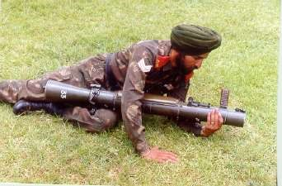

**Pahlu Ki Chal**

**Cheetah Chal (Leopard Crawl)**

1. Chitra ko dekhen aur samjhen.

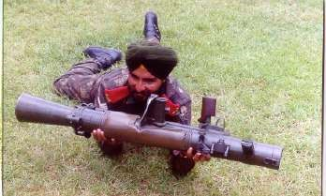

**Cheetah Chal**

**Jori mein Crawling**

1. **Hu-ba-Hu LMG ki tarah.**

**CHAPTER-6**

**84MM RL KE SIGHTING SYSTEM**

**Ref - (Infantry Training Volume I, Infantry Platoon Weapons Pamphlert No 5**

**84MM Rocket Launcher -2007)**

**Gen**

1. 84mm RL ke sath alag alag kism ke round fire karne ke liye nimnlikhit sighting system ka istemal kiya jata hai. Open sights ke ilawa anya sight is prakar hain:-

(a) Telescopic sight.

(b) Pendulum sight.

(c) Luminious Sight.

(d) Passive Night Sight.

**Telescopic Sight**

1. Is sight ka wazan 1.1kg, Magnification-2x, Field of view-17 degree hai aur iske hisse is prakar hain:-

|  |  |  |  |
| --- | --- | --- | --- |
| (a) | Eye Guard | (h) | Deflection drum |
| (b) | Eye piece | (j) | Deflection drum locking screw |
| (c) | Sight Bar | (k) | Slipping scale |
| (d) | Plunger | (l) | Slipping scale locking screw |
| (e) | Plunger Hook | (m) | Range drum |
| (f) | Elevation drum | (n) | Range indicator arm |
| (g) | Elevation drum locking screw | (o) | Objective glass |

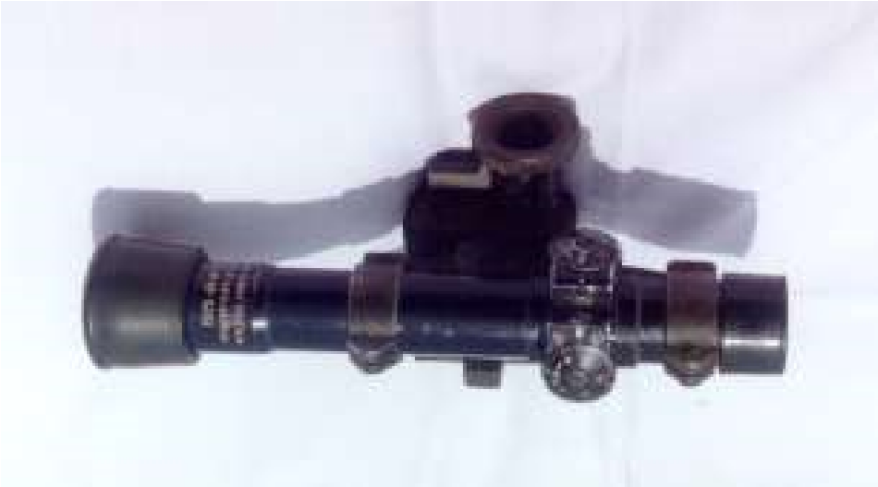

**Telescopic sight**

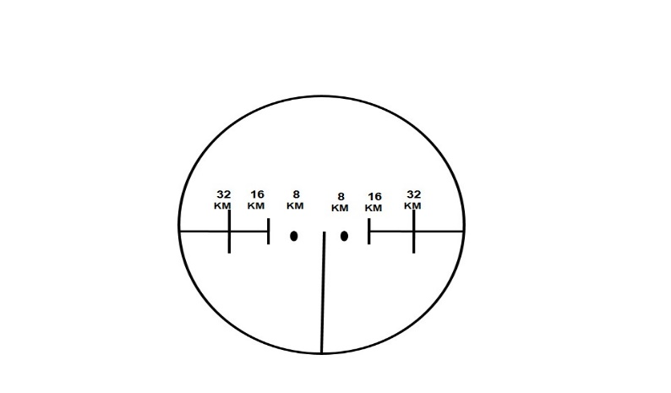

**TELESCOPIC SIGHT KA RETICLE PATTERN**

1. Elevation aur deflection drum zeroing ke dauran kaam mein ate hain. Elevation drum ke upar alag alag temperature ke liye teen position hain:-
   1. 10 degree C se kam tapmaan - Nila Nishan
   2. 10 degree C se 30 degree C - Safed Nishan
   3. 30 degree C se ziada tapmaan - Lal Nishan
2. Sleeping scale ke upar 15 division + ki taraf aur 15 division – ki taraf hote hain. Ek division 200 mtr range par tgt par 20 cm ka farak dalta hai. RL ko bore sighting aur zeroing karne ke baad slipping scale ke locking screw ko loose karke slipping scale ke 0 ko us nishan ke samne kar diya jata hai, jis tapman mein bore sighting ya zeroing ki ja rahi ho.
3. Range drum ki do positionen hain jab andar ki taraf ho toh safed range scale hasil hota hain. Ismen 0 se 6 tak ank khude hue hain jo ki HEAT, TPT aur 9mm Tracer round ko fire karne mein kaam ati hai. Is par 0 se 600 tak hisse bane hue hain aur har 50m par rg lagane ki suvidha di gayi hain Jab rg drum ko 0 per karke bahar kinchte hain toh green range scale hasil hota hain jisse HE aur Smoke round fire karne ke liye istemal kiya jata hain. Ismein 0 se 1300m tak ank khude hue hainjo 1300m tak ke rg ko Jahir karte hain. Is rg scale main 700m tak 50m-50m rg lagane ki suvidha di gai hain jabki 700m se 1300m tak 100m-100m rg lagane ki suvidha di gayi hain.

**Open Sight**

1. **Front Open Sight**. Yeh sight Rif ki tarah hi hai. Agar is ko istemal na karma ho to barrel ke sath baitha diya jata hai. Fore sight mein telescopic sight ki tarah ek khari line hai jo ki khare tgt par shist lene mein kaam aata hai. Vertical bar ke dayen aur bayen donon taraf horizontal baar bane hain jo harkati tgt ko engage karne ke liye istemal kiya jata hai. Isse aap samjhen aap black board ki madad se.

Vertical aur horizontal line ke beech ka ilaka 8 km, horizontal bar ka andar wala kinara 16 km aur bahar wala kinara 32 km ki raftar se chalne wale tank tgt ko engage karne ke liye istemal kiya jata hai.

1. **Rear Open Sight**. Eye guard, aperture, range drum, rear sight slide aur locking screw, rear sight adjusting screw aur nut. Isse aap samjhen model ki madad se, Rear sight par bhi do rg scale bane huye hain. Andar ki taraf safed rg scale jispar 0 se 5 tak ke ank khude huye hai. Green rg scale jispar 0 se 8 tak ke ank khude huye hain, lekin is rg scale mein 850m tak rg lagaya ja sakta hai. Open sight mein bhi range set karne ke liye Indicator arm aur alag-alag tapman ke liye teen nishan banaye gaye hain inka istemal telescopic ke nishano ki tarah hi kiya jata hai.
2. **Pendulum Sight**. Illuminating round ko fire karte samay is sight ka istemal kiya jaata hai. Is ke beech mein ek window aur andar ek kali line di gai hai jise hair line ke name se jana jata hai. Is sight ka istemal karte huye do angle hasil kiya jate hai yeh kis parkar se hasil kiye jate hai isse aap samjhen model ki madad se. Yeh model pandulam sight ko darshata hai. Jab hair line ko window ke madhya mein milaya jata hai to 20 degree ka angle hasil hota hai. Is angle mein 500m se 1800m tak ka rg hasil hota hai. Jab hair line ko window ke upar wale bhag se milaya jata hai to 25 degree ka angle hasil hota hai, jisse 300m se 400m aur 1900m se 2100m tak ka rg hasil hota hai.

**Note :**- Illuminating round sirf standing ya kneeling position se hi fire kia jata hai.

1. **Passive Night Sight** Is sight ka istemal raat ke samay fire karne ke liye kiya jata hain:-

|  |  |  |  |
| --- | --- | --- | --- |
| (a) | Weight without bracket | - | 1.76kg |
| (b) | Bracket ka weight | - | 670gms |
| (c) | Length | - | 265mm |
| (d) | Width | - | 93mm |
| (e) | Height | - | 93mm |
| (f) | Weight with bracket | - | 2.43kg |
| (g) | Operating life | - | 2000hrs |
| (h) | Magnification | - | 5x |
| (j) | Sidhant | - | Image Intensification |
| (k) | Field of view | - | 9 degree |
| (l) | Operating Temp | - | -300 C se 450 C |
| (m) | Storage Temp | - | -300 C se 650 C |
| (n) | II Tube | - | 2nd generation 18mm Micro channel |
| (o) | Range |  |  |
|  | (i) Gp of detection | - | 400m |
|  | (ii) Engagement | - | 300m |
|  | (iii) Tank Detection | - | 600m |
|  | (Iv) Engagement | - | 500m |

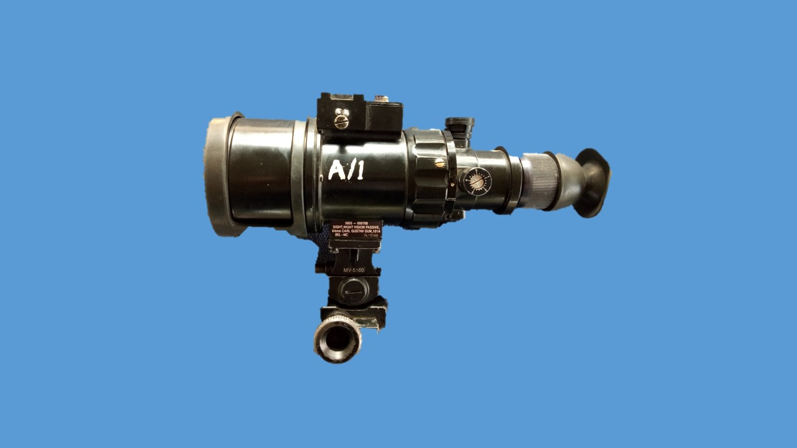

**PASSIVE NIGHT SIGHT**

**Hisse purjon ke Naam.** (04 Assy)

- Objective glass housing with rubber cap.

- Eye piece Assy.

- Graticule Adjuster Assy.

- II Tube with bty housing Assy.

**8**

**KM**

**16**

**KM**

**32**

**KM**

**8**

**KM**

**32**

**KM**

**16**

**KM**

**300**

**400**

**600**

**500**

**6**

**’**

**’**

**7**

**’**

**8**

**9**

**’**

**10**

**’**

|  |
| --- |
| **RANGE**  **ESTIMATION** |

|  |
| --- |
| **TANK**  **SPEED** |

**RETICLE PATTERN 84MM RL MK-II NIGHT SIGHT**

1. **Luminous Sight Adaptor**. Raat ke samay dushman ke upper kargar fire dalne ke liye luminous sight adaptor ko istemal kiya jata hai is sight ka istemal karte samay tgt par roshani jaruri hai. Iske bhi do bhag hote hain, front aur rear. Front luminous sight adaptor ko RL ke front open sight par aur rear luminous sight adaptor ko aperture ke upar lagaya jata hai.
2. **Bore Sight Adaptor**. Iska istemal RL ko boresighting karne ke liye kiya jata hai. Iske bhi do hisse hote hain, front boresight adaptor aur rear boresight adaptor. Front boresight adaptor ko RL ke muzzle ki taraf aur rear boresight adaptor ko chamber ki taraf se andar lagaya jata hai.

**Shist lene ka tariqa**

1. (a) **Khare tgt ke liye**. Khare tk tgt par open sight se shisht lene ka tarika bilkul rif ki tarah hi hota hai. Telescopic sight se tgt ko engage karne ke liye rg ka andaja lagayen aur range drum par range lagaye. Retical pattern ki pari line ki madad se RL ko seedha rakhen aur khare line ka upper wala kinara tgt ke madhya mein milayen.

(b) **Harkati Tgt Par**. Agar tgt 100m ki duri tak apni taraf aa raha hai to ya apne se dur jar aha ho to aise tgt par shist lene ka tariqa bilkul khare tk tgt ki tarah hi hota hai. Agar tk tgt 100m se dur ho aur apni taraf aa raha ho to shisht tgt ke madhya se thora niche aur agar tk tgt apne se dur ja raha ho to shist tgt ke madhya se thora upar lena chahiye. Agar tk bayen ya dayen se harket kar raha ho to sabse tgt ka rg malum kar rg drum ke upar lagayen, tk ki raftar ko malum karen, jis taraf se tk harkat kar raha ho telescopic sight ke usi taraf ka lead istemal kiya jaye. Firing ke lihaj se tk ki speed ko teen bhagon mein banta gaya hai 8 km/h, 16 km/h aur 32 km/h. Zaruri nahi ki jab tk tgt ko engage kiya ja raha ho us samay hawa na chal rahi ho. Hawa ke asar ko kam karne ke liye lead tk tgt par liya jata hai. Jis taraf se hawa chal rahi ho tk tgt ke usi taraf hawa ke liye lead liya jata hai.

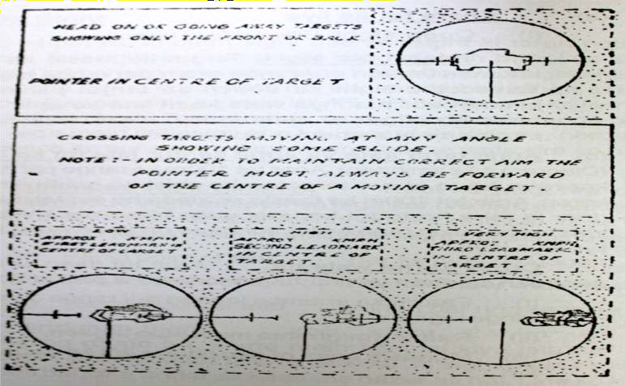

**Aiming Chart – Rules For Target Aiming**

**CHAPTER 7**

**84MM RL KA FIRE AUR MISFIRE**

**Ref- (Infantry Training Volume I, Infantry Platoon Weapons Pamphlert No 5**

**84MM Rocket Launcher -2007)**

**Fire Karna**

1. **Trigger Operation.** Anya hathiyaron ki tarah 84mm RL ke trigger ke do khichav hain, pehla halka aur lamba khichav dusra chota aur sakhat khichav, Jab firer ko target area mein target dikhai deta hai toh pehla khichav hasil karta hai drust shist mil jane par dusra khichav hasil karta hai. Trigger par 2.5kg se leakar 5kg ka dabav ane par trigger press ho jata hai. Trigger press hone par round fire ho jata hai, jisse brl ke raste projectile aur venturi se shola nikkalta hai jise back blast kehte hain. 84mm RL ka back blast ka ilaqa breach ke peeche se 45 degree ke angle par 15m lamba aur 12m choura hota hai. Fire karte waqt is ilaqe mein koi jandar chiz, ammunition ya rukawat nahi honi chahiye.
2. Jaha per RL det ko target dikhaya jata hain jis posn se fire karna ho usi posn se tgt dikhaya jae. Jab RL det ko target dikhai deta hai toh No 1, No. 2 ko hathiyar amn taiyar kar ka adesh deta hai. No 2, No 1 ke adesh ko dohrata hai. No 1 RL ki sight par range lagata hai aur No 2 amn ko taiyar karta hai. HEAT bhar ke aadesh per No 1 Launcher ko cock karta hai safety catch ki position ko safe par karta hai aur No 2 ko bhar ka adesh deta hai. No 2, No 1 ke adesh ko dohrata hai venturi ko kholta hai nirikshan karta hai aur venturi aur chamber ko saaf karta hai. Bhar karne se pahle No 1, No 2 ko "Stop" ka adesh deta hai, No 2 se check back report leta hai, check back report No 2 ke adesh par No 2 round ki kism aur tadad ka hawala deta hai aur durust bhar ki karwai karta hai. No 1 bhi check back karta hai check back No 1 ke adesh par No 1 Range, Range scale aur shist ka hawala deta hai. "Fire" ke adesh par No 1 safety catch ki position ko 'F' par karta hai, drust shist lete huye sahi trigger operation ki karwai karta hai. Is parkar round fire ho jata hai aur donon Nos target area mein round ki maar ko dekhte hain agar round on tgt nah o toh munasib correction dekar dusra round fire karte hain. Is tarah se ek sikhlai paya huya RL det 1 minute mein 6 rounds fire karta hai.
3. **Misfire**. Sune is parkar trigger ko dabane se rd fire na ho ya sqd post trg ke dauran adesh mile ‘**fire nahi**’ to No 1 usi posn pakar aur shist ko kayam rakhte huye 5 sec ka wafa deta hai, trg ke dauran is wakhwa ko jahir karne ke liye 5 tak ki ginti ki jati hai. Agar 5 sec ka wafa dene par bhi rd fire na ho to No 1 dubara RL ko cock karta hai aur durust shist lete hue trigger ko press karta hai. Agar dubara trigger press karne par bhi rd fire na ho ya adesh mile ‘**phir fire nahi**’ to No 1 usi posn, pakar aur shist ko kayam rakhte huye   
   15 sec ka wakhwa deta hai, trg ke dauran 15 tak ki ginti ki jati hai, Agar 15 sec ka wafa den ke bad bhi round fire na ho to No 1 launcher ko cock karta hai aur safety catch ko S par karta hai aur No 2 ko 2 min ka wakhwa dene ka aadesh deta hai, 02 minute ka wakhwa note ho jane per No 1 ki peeth par thapki marta hai aur up pukarta hai. 2 minute ka wakhwa note karne ke bad bhi rd fire na ho to ‘**misfire khali kar ka adesh deta hai**’. No 2 khali kar ki karwai karta hai. Yahan par No 2 se check priemer report li jati hai. Report No 2 ke aadesh par No 2 rd ke primer ko check karta hai, agar primer par chot na ho to donon milkar firing pin ki badli karte hain. Agar primer par chot ho toh misfire round ko nose tgt ki taraf, firing posn se 50mtr aage aur dahine rakha jata hai. No-1 dusra HEAT bharne ka adesh deta hai. Fire ke aadesh per No 1 durust shisht lete huye trigger ko press karta hai. Rd fire hone par donon tgt area mein rd ki maar ko dekhte hain Is parkar tgt barbad ho jata hai. Yeh tha misfire hone par karwai karne ka tariqa.

Misfire hone ke karan:-

* 1. Main spring ka kamjor hona.

(b) Firing pin ka tut jana ya ghis jana.

(c) Rd ki primer mein nuqs hona.

**CHAPTER 9**

**BORESIGHTING & ZEROING**

**Ref- (Infantry Training Volume I, Infantry Platoon Weapons Pamphlert No 5**

**84MM Rocket Launcher -2007)**

**Gen**

1. 84mm RL ka agar round ek bar tank par miss ho jaye to ek jagruk tank apko dusri bar us par fire karne ka mauqa nahi dega. Isliye zaruri hai kih iski durust zeroing kari jae.

**Zeroing ke Mauqe**

1. Hu-ba-hu anya hathiyaron ki tarah.

**Zeroing ka Saman**

1. Launcher ko zero karne saman ki niminlikhit saman ki zarurat parti hain:-

(a) Boresight adopter.

* 1. Screw driver.
  2. Launcher rest.
  3. RL zeroing tgt.
  4. Sight bag.
  5. Bag No 1 aur 2.

**Boresighting**

4. Axis of bore aur line of sight ko di hui rg par chune hue nishan par milane ki karwai ko bore sighting kahte hain. Bore sighting bina fire ki jati hai, jabki zeroing hum fire karke karte hain.

**Bore sighting ke liye saman**.

* 1. Boresighting stand.
  2. 84mm RL
  3. Telescopic sight.

(d) Bag No 1

(e) Tgt 4 x 4

**Karne ka tariqa:**-

(i) **Front Boresight Adopter**. Front boresight adopter ko muzzle bare wale trikon ko upar ki taraf hona chahiye aur zamin ke samananter ho.

* 1. **Rear Sight.** Rear bore sight mein ek aperture hota hai. Yeh venturi ko khol kar breech mein fit kiya jata hai. In donon boresighton ke madad se line of sight ko tgt ke POA per milaya jata hain.

**Open Sight ko Zero Karna**

5. (a) Launcher stand ko zamin par hamwar rakhen.

(b) RL ko stand par fit karen.

(c) Yakin karen ki pistol grip zamin se 90 degree main ho.

(d) Bore sight attachment len aur rear bore sight ko venturi khol kar chamber mein fit karen aur front bore sight ko muzzle mein age se fit karen.

(e) Yakin karen ki front bore sight attachment zamin ke hamwar hai. (Bare wala trikon uper ki taraf hona chahiye).

(f) Open sight ko upar uthaen aur rg drum ko pura niche karen, Jis tapman mein boresight kar rahen hain, indicator arm ko us tapman ke lihaz se zero ke samne karen.

(g) Bore sighting tgt ko 258m ya 300m ki duri par rakhen.

(h) Ventury ke zariye bore sight se stand ko harkat dete hue chune hue POA par shist len.

(j) Launcher ke open sight se usi nishan par shist len. Agar durust shist chune hue POA par mil jati hai to open sight durust bore sight hai. Yadi dono shist chune hue nishan par nahi milti hai to karwai is prakar karen:-

**Uper niche ki galti**. Elevation drum ko ghumayen yadi shist niche mil rahi ho to elevation drum ko ghadi ke ulte rukh ghumao, yadi upar mil rahi ho to ghari ke sulte rukh ghumao.

**Dayen / Bayen ki galti**. Back sight adjusting nut ko spanner ki madad se dhila karen. Ab screw ko ghuma kar dayen / bayen ki munasib harkat den, dobara shist check karen. Yadi shist thik mil jati hai to nut ko spanner ki madad se tight karen.

Ab range indicator arm ko dhila karen jis tapman wale ilake main boresight kar rahe ho us nishan ko zero ke samne karen aur  
 screw ko tight karen.

**Note**:- Ek mils ki correction 200m per 40cm ka farak dalta hain.

**Telescopic Sight Zero Karna**

6. Telescopic sight ko zero karne ka tariqa:-

(a) Boresight fit karne ke baad launcher ko rest par rakhen.

* 1. Telescopic sight ko lagaen aur range drum zero par karen.
  2. Elevation drum aur deflection drum ke locking screw ko dhila karen dhyan rahe slipping scale ka locking screw tight ho.
  3. Boresight aopter ke beech se dekhen aur 300m ya usse ziada range par chune hue nishan par boresight ke zariye shist len.
  4. Telescopic sight se dekhen aur reticle pattern ki khadi line ko tgt ke POA milana chaiya. Agar donon shist mil rahi hain toh locking screw ko tight karen. Yadi POA per nahi mil rahi hain toh karwai is parkar karen:-

**Uper / Niche ki galti**. Elevation drum ko plus ki taraf ghumane se retical pattern upar jata hai aur minus ki taraf ghumane se niche ki taraf uthta hai. Is prakar elevation drum ko munasib   
 harkat dete hue reticle pattern ki khari line ke upar wale hisse ko POA se mila den.

**Dayen / Bayen ki galti**. Deflection drum ko right ki taraf  
 ghumane se reticle pattern dayen ki taraf harkat karta hai aur left ki taraf ghumane se bayen ki harkat karta hai. Is prakar eflection drum ko munasib harkat dekar reticle pattern ki khari line ke  
 upar wale hisse ko POA par mila den. Ab dobara shist check karen yadi shist thik mil jati hai to Elevation aur deflection  
 locking screw ko tight karen. Range indicator arm ko dhila karen aur zero ko us tapman ke samne karen jis tapman wale ilake main zeroing ki ja rahi ho aur slipping screw ke locking screw ko tight karen.

**Note**:- Ek mils ki correction 200m per 20cm ka farak dalta hain.

7. **Zeroing 9mm Sub Calibre Adapter**

**Sub Calibre Device ke faide**

1. Koi vishesh firing range ki jarurat nahi.
2. Squad post trg ke dauran bhi istemal.

(c) RL Det ko FC order mein abhyas.

(d) Tgt ka bayan thik dhang se.

(e) Det ko durust angle se fire karne mein abhyas.

(f) Det ko correction dene mein abyas.

(g) Hathiyar (RL) ki zindagi par koi asar nahi.

(h) Ise unit mein banaya ja sakta hai.

(j) Kam samay mein adhik abhyas.

(k) Amn ki bachat.

8. **Zeroing ka tarika**:-

(a) **Tgt** : 4’ x 4’ jis mein 20 x 20 cm ka (+) ka nishan ho.

(b) **Amn** : 9mm tracer primer ke sath.

(c) **Gp** : 3 ya 5 rds ka gp fire.

(d) Yadi gp POA se 10cm niche banta hai toh 9mm sub caliber adapter thik zero hai.

**Uper / niche ki galti**. Yadi MPI sahi jagah par na bane to karwai is prakar se karen 9mm sub calibre adapter ke rd races ko zamin ki taraf karte hue sub calibre ko pakden. Yadi MPI upar ban raha hai to Niche wale elevation screw ko dhila karen aur upar wale elevation screw ko tight karen. Yadi MPI upar ban rahi hai to upar wale elevation screw ko dhila karen aur niche wale elevation screw ko tight karen.

**Dayen / bayen ki galti** 9mm sub calibre ko usi prakar pakren  
 jaise ki uper niche ki galti dur karte samay pakra tha. Yadi MPI dahine ban raha ho to bayen wale deflection screw ko dhila  
 karen aur dahine wale deflection screw ko tight karen. Yadi  
 MPI bayen ban raha hai to karwai is ke viprit karen.

(e) **Dobara check gp fire karen**.

(i) 100m se 250m tak - MPI 10cm POA se niche

(ii) 300m - MPI POA par

(iii) 350m - MPI 20cm POA se upar

(iv) 400m - MPI 50cm POA se upar

Note:- 100m par elevation aur deflection screw ko ek chakar dene se MPI mein 36 cm ka farak parta hai.

**CHAPTER-11**

**RANGE PAR SURAKSHA SAMBANDHI NIYAM**

**Ref-(Infantry Training Volume I, Infantry Platoon Weapons**

**Pamphlert No 5 84MM Rocket Launcher -2007)**

**Gen**

1. Haadson se bachane ke liye yeh zaruri hai ki 84mm RL ke saath karwai karte waqt savdhani se kaam liya jae takih hathiyar aur detachment ko kisi kism ki chot na pahunche.

**HEAT Round**

1. (a) HEAT round ko durust tariqe se banae hue morche se hi fire kia jae. Yakeen karen kih venturi hamesha zamin ke satah se upar ho aur pichhe wala bhag morche se bahar nikla ho.
   1. Do firing point ke beech ka faisla kam se kam 12m ho aur sab ek line mein ho.
   2. HEAT range par sirf HEAT, TPT aur 9mm Sub Calibre rounds hi fire kia jaye.

**TPT Round**

1. TPT round ko kisi bhi firing position ya khule mein fire kiya ja sakta hai. Yakeen karen kih back blast ka ilaqa jo kih venturi se 45 degree ke angle par 15m ka hota hai aur iske alawa venturi se 30m pichhe koi rukawat na ho aur is ilaqe mein ammunition na rakha ho.

**Firing Point Officer aur Waiting Detail**

1. Firing point officer ke liye ek control tower banaya jaega. Yeh aisi jagah par hona chahiye jahan se yeh officer sare firing point, waiting details aur target ke area ko dekh sake. Target ke pichhe ka ilaqa bhi nazar ana chahiye takih who koi round blind ho to use dekh sake. Waiting detail ke lie bhi morche banaye jaenge jo kih firing point ke ek taraf aur kam se kam 25m pichhe ho.

**Target ka Faisla**

1. HEAT round ke liye koi bhi target 200m se kam ke faasle par nahin hona chahiye. Danger Area mein ane wale sare admion ko steel helmet pahanna chahiye. TPT round ke lie target 200m se bhi kam ho sakta hai.

**Target ki qismein**

1. HEAT round ke lie target sakht satah ka hona chahiye jaise kih koi barbad tank ya steel plate aur target ke pichhe sakht zamin takih miss round blind na ho. TPT round ke lie sakht target ki avashyakta nahin hai aur koi kapre ka target 16’ x 8’ ya hessian cloth tgt banane ke liye istemal kiya ja sakta hai.

**Note** :- Harkati targeton ke lie haden bant deni chahiye aur sirf TPT round ka istemal kiya jaye.

**HEAT, HE, SMOKE AUR ILLUMINATING ROUND**

1. Inke suraksha sambandhi niyam milte hi sanshodhan dwara prakashit kie jaenge. Parantu dhyan rahe ki HEAT ke suraksha sambandhi niyam inke liye bhi lagu hain, khaskar HE round ko ek jagah se dusre jagah le jate waqt khas dhyan rakha jaye. Smoke ya illuminating round fire karne se pahle dhyan rakhe kih target

**Note** :- Zinda round ko ek jagah se doosre jagah lejate waqt donon haathon se uthaya jaye.

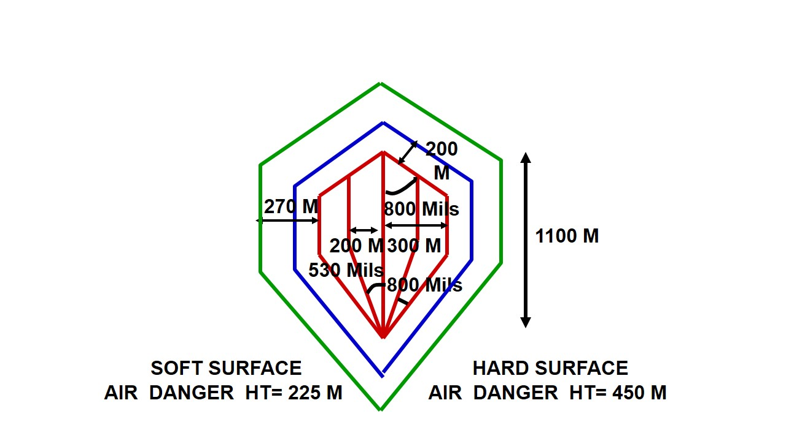

**DA TEMPLATE FOR 84MM RL HEAT**

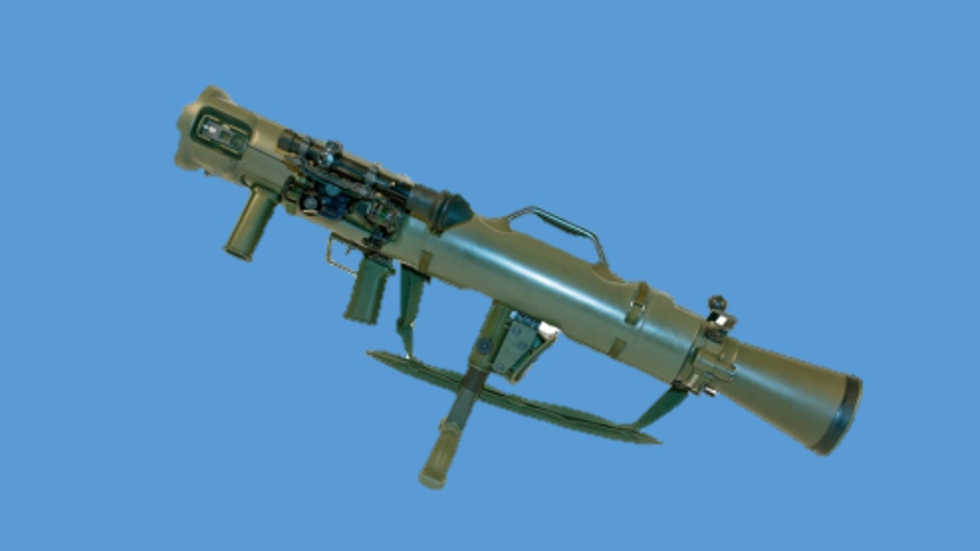

**84MM ROCKET LAUNCHER MK-III**

**LESSON-1**

**84MM ROCKET LAUNCHER MK-III SE WAQFIAT, KHOLNA,**

**JORNA AUR SAFAI**

1. **Shuru Shuru ka Kaam**

(a) Class ki ginti groupon mein bant

(b) Hathiyar aur saman ka nirikshan

(c) Bandobast ki karwai

2. **Dohrai**

Pichle lesson se kiya jaye.

3. **Pahunch**

84mm Rocket Launcher Mk-III ek new generaton weapon hain. Zaruri hain ki har jawan iske bare main jankari rakhta hon taki zarurat parne per iska istemal kar saken.

4. **Uddesh**

84mm Rocket Launcher ki Waqfiat, kholna, jorna aur safai karne ka tariqa sikhana hain.

5. **Saman**

84mm RL, Bag No 1, Bag No 2, Black board,chalk, duster, Ground sheet.

6. **Bhagon Mein Bant**

Yeh sabaq teen bhagon mein chalaya jayega:-

(a) **Bhag-I** - 84mm RL MK-III ki visheshtayen aur tech data

(b) **Bhag-II** - Kholna, hisse purjon ke naam, kaam, Jorna aur safai karne ka tariqa.

(c) **Bhag-III** - Telescopic sight se jankari

**(a) Bhag-I - 84mm RL ki visheshtayen aur tech data**.

**Visheshtayen**

(i) Yeh Sweden desh ka bana hua hain.

(ii) Iske upar poly urothene ka cover laga hua hain.

(iii) Barrel ke upar Epoxy carbon ka lap hain jiske karan barrel ko zaida majbooti mil saken.

(iv) Telescopic sight ke sath sabhi sighton ki suvidha di gayi hain.

(v) Carry handle ki suvidha hain jiske karan carry karna assan hain.

(vi) Wazan kaam hain aur ventury ki lambai kam hain.

(vii) Iske sath 9 parkar ka amn fire kar sakte hain.

**Tech Data**

|  |  |  |  |
| --- | --- | --- | --- |
|  | Khali launcher ka wazan | - | 10 kg (Approx) |
|  | Bipod ka wazan | - | 300 gms |
|  | Telescopic sight ka wazan | - | 800 gms |
|  | Wooden box ke sath wazan | - | 29 kg |
|  | Launcher ki lambai | - | 1065 mm |
|  | Barrel ki lambai | - | 850 mm |
|  | Ventury ki lambai | - | 215 mm |
|  | Grooves | - | 24 (RH) |
|  | Open sight ka sight radius | - | 296 mm |
|  | Trigger Pull | - | 2.5 kg se 5 kg |
|  | Rate of fire | - | 06 rds/min |
|  | Mech Safety | - | Khuli ventury aur band ventury |
|  | Applied safety | - | Safety catch |
|  | Sidhant | - | Breech loaded laterally percussion fire |
|  | Black blast | - | 45 degree ke angle main  60 mtr lamba (5 mtr killing area  aur 55 mtr danger area) |
|  | Movements of parts | - | Pistol Grip - 15mm  Shoulder pad - 20mm  Bipod - 25mm |
|  | Fire hone wala amn | - | 9 parkar |

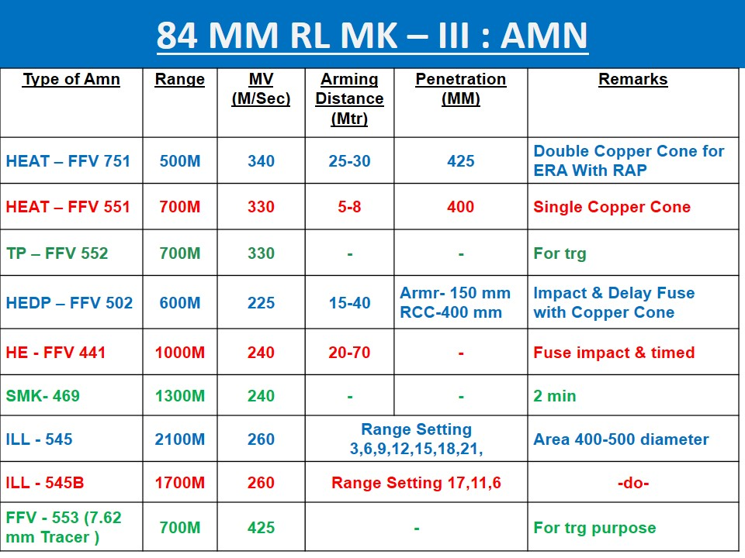

(b) **Bhag-II - Kholna, Hisse purjon ke naam, kaam, jorna aur safai karne ka tariqa**. Launcher ko kholne ke liye sabse pahle yakin karen ki launcher cock nahi hain. Launcher ko kholne ke liye bag No 1 ki zarurat padti hain.

(i) **Bag No 1 ka saman**

(aa) Telescopic sight

(ab) Cleaning cloth

(ac) Brush

(ad) Carrying sling

(ae) Screw Driver 3.5mm, 5.5mm, 8mm (Taparia Company)

(af) Bore sight adopter

(ag) Spare part box

- Rear cap, front cap, screw long-02, screw shot-02, extractor spring, firing pin, measuring plate (size 0.25mm)

**Kholne ka tariqa**. Launcher ko kholne ke liye launcher ko khara karen. Front cap ko kholen aur main spring ko bahar nikalen. Rear cap ko kholen aur firing pin ko 5.5mm screw driver ki madad se bahar nikalen. Ek firer ko itna hi kholne ki zarurat padti hain. Yeh tha kholne ka tariqa.

**Safety Catch ki Chal**. Jab safety catch ki posn ‘S’ par hoti hai to safety catch ka gol wala bhag sear ke neeche aa jata hai jisse trigger ko dabane par sear neeche nahi dab pata hai aur trigger press nahi hota hai. Jab safety catch ki posn ‘F’ par kiya jata hai to safety catch ka kata hua bhag sear ke neeche aa jata hai jisse sear ko neeche ane ki jagah mil jati hai aur trigger press ho jata hai.

**Launcher ki Chal**. Jab launcher ko cock kiya jata hai to cocking rod age ki harkat karta hai, is dauran main spring front cap mein sikur jata hai aur firing pin cam se neeche utar jata hai. Jab main spring apni tanav ko poora karta hai to cocking rod ko peechhe dhakelta hai, is dauran cocking rod ke lug ka milap sear notch se ho jata hai aur launcher cock ho jata hai. Jab firer trigger ko dabata hai to cocking rod lug aur sear notch ka milap tut jata hai, jisse cocking rod peechhe ki harkat karta hai. Is dauran firing pin cam ke upar sawar ho jata hai aur chamber wale rd ke percussion cap par chot marta hai, jisse rd fire ho jata hai.

**Jorna**. Jorne ke liye sabse pahle firing pin ko dakhil kare aur rear cap ko band karne. Trigger ko press karte huye cocking rod ko peeche karen, launcher ko khara karen aur main spring ko dakhil karen, front cap ko lagayen. Luncher ko neeche rakhen, cock karen aur trigger press karen.

**Safai karne ka tariqa**. Safai karne ke liye bag No 2 ki zarurat padti hain.

**Bag No 2 ka saman**

* + 1. Cleaning rod three sec
    2. Cleaning Tool
    3. Cleaning brush
    4. Oiling brush
    5. Cloth (Kapra)

Safai karne ke liye cleaning rod ko joren, cleaning tool ko cleaning rod ke sath joren, front cleaning tool ko kholte huye brush ko lagayen aur cleaning tool ko jor den. Barrel ya chamber kisi bhi taraf se rod ka istemal karte huye safai ki ja sakti hain. Tel lagan eke liye oiling brush ko cleaning tool ke sath lagayen aur barrel kea age se ya chamber ki taraf se tel laga sakte hain. Lubrication baki hathiyaron ki tarah hi lagaya jata hain.

(b) **Bhag-III - Sighton se jankari.** 84mm RL Mk-III par teen parkar ki suvidha diya gay ahin.

(i) Open Iron Sight

(ii) TDLS

(iii) PNS (Passive Night Sight)

(i) **Open Iron Sight**. Iske range pillar par do parkar ki range scale diya gaya hain.

(a) White range scale yeh do parkar ki hain.

(aa) FFV 551 (ab) FFV 651

(b) Green range scale

Open sight per harkati tgt per shist lene ka tariqa is parkar se hain:-

(aa) Open sight se khare tgt ko barbad karne ke liye vertical  
 bar ko tgt ke POA par milayen.

(ab) Open sight se harkati tgt jiski speed 15 km/h ho horzintal bar ke ander wale kinare ko tgt ke POA per milayen.

(ac) Open sight se harkati tgt jiski speed 30 km/h ho horzintal bar ke bahar wale kinare ko tgt ke POA per milayen.

(ad) Open sight main night mein fire karne ke liye bhi sight ke upar suvidha diya gaya hain.

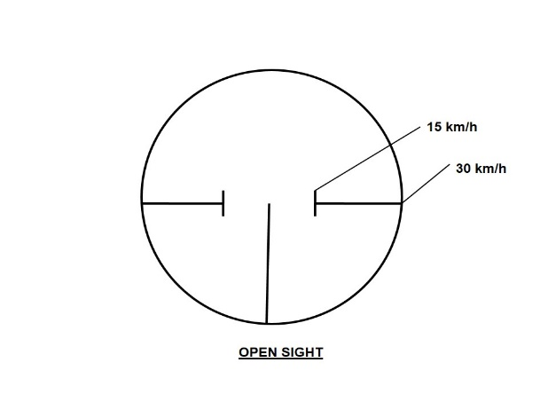

(ii) **Telescopic Day Light Sight (TDLS).**

Wazan - 800gms, FOV - 12 degree, Magnification - 3 guna

**Hisse purjon ke naam**. Objective glass, eye piece, mounting rail, plunger, plunger hook, thimble, elevation drum, elevation drum locking screw, deflection drum, deflection drum locking screw, slipping scale, slipping scale locking screw, range drum, range indicator arm, Illuminating device (DLPT), axial, luminous grooves, beval.

Mils - ki aur 10 aur + ki aur 10 div

Ek div ka correction se 200mtr per 30 cm ka fark apdta hain.

Elevation drum per teen rangon ke nishan banaye gaye hain jo alag alag tapmaan wale ilaqe mein istemal kiya jata hain.

1. Neela - 0 se kam tapmaan ke liye
2. Safed - 0 se 30 degree tak tapmaan ke liye
3. Lal - 30 degree se jaida tapmaan ke liye

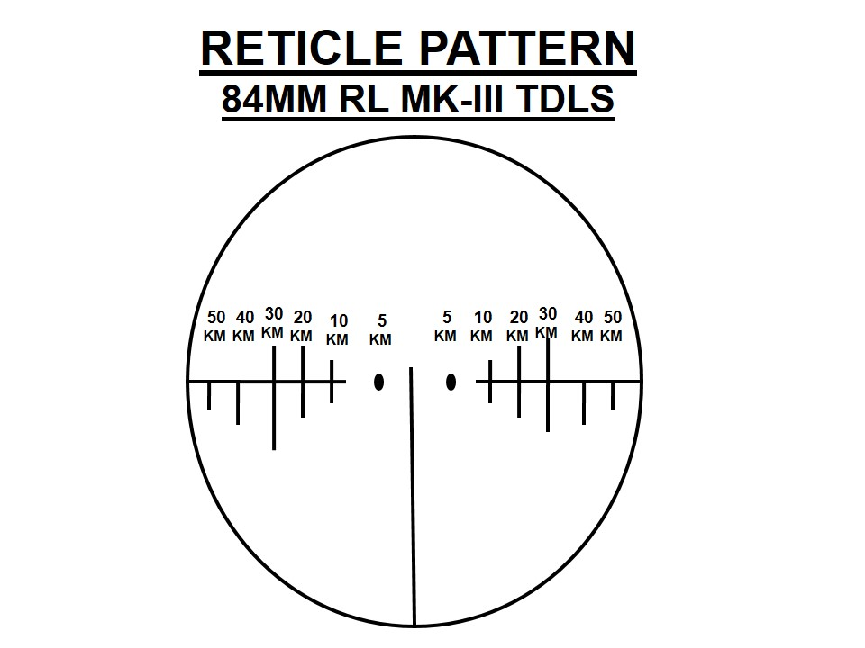

**Telescopic sight se** **Illuminating round ko fire karne ka tariqa**

- 551 wali knob se 20 degree angle hasil hota hain, jisse 500m se 1800m tak range hasil hota hain.

- 651 wali knob se 25 degree angle hasil hota hain jisse 300m se 500m aur 1800m se 2100m range hasil hota hain.

- Dhyan rahe luminous grooves zamin ke samantar hona chaiya.

**LESSON-2**

**84MM RL MK-III KE HEAT-751, HEDP-502, SMOKE 469C**

**AMN SE JANKARI**

1. **Shuru Shuru ka Kaam**

(a) Class ki ginti groupon mein bant

(b) Hathiyar aur saman ka nirikshan

(c) Bandobast ki karwai

2. **Dohrai**

Pichle lesson se kiya jaye.

3. **Pahunch**

84mm Rocket Launcher Mk-III ek new generaton weapon hain. Apne desh ne sena ko majboot aur sec level per fire power badane ke liye Sweeden desh se HEAT-751, HEDP-502 aur Smoke 469C round ko hamari sena main shamil kiya hain. Zaruri hain ki har jawan iske bare main jankari rakhta hon taki zarurat parne per iska istemal kar saken.

4. **Uddesh**

84mm RL MK-III ke HEAT-751, HEDP-502, Smoke 469C round ke bare main jankari dena hain.

5. **Saman**

HEAT-751, HEDP-502, Smoke 469C round ka model.

6. **Bhagon Mein Bant**

Yeh sabaq teen bhagon mein chalaya jayega:-

(a) **Bhag-I** - HEAT**-**751 round ke bare main jankari.

(b) **Bhag-II** - HEDP-502 round ke bare main jankari.

(c) **Bhag-III** - Smoke-469C round ke bare main jankari.

**(a) Bhag-I - HEAT-751 round ki Visheshtayen aur Tech data**

­

**Visheshtayen**

(i) Yeh ek high explosive Anti tank amn hain.

(ii) Yeh round tgt main ghusav karne ke baad maar karne wala tandem war head round hain.

(iii) Is round ko A/tks ke elawa RCC bunker, dushman ke khare jahaj aur anya protective veh ke khilaf bhi istemal kaya ja sakta hain.

(iv) Yeh round flat trajectory ke sath sath rocket motorke dwara fins stability ke sath tgt per pahunch kar maar karta hain.

(v) Yeh electric short circuit functianable round hain.

**Tech Data**

|  |  |  |  |
| --- | --- | --- | --- |
|  | Ek round ka wazan | - | 3.8 kg |
|  | Projectile ka wazan | - | 2.9 kg |
|  | Container with 2 round | - | 11.5 kg |
|  | Wooden box ke sath wazan | - | 52 kg |
|  | Lambai | - | 760mm |
|  | Effective Range | - | >500 mtr |
|  | Muzzle velocity | - | 310 mtr/sec |
|  | Maximum velocity | - | 336 mtr/sec |
|  | Time of flight  (i) 400mtr  (ii) 500mtr  (iii) 600mtr | -  -  - | 1.44 sec  1.75 sec  2.07 sec |
|  | Arming range | - | 20 se 40 mtr |
|  | Max angle of impact penetration  90 degree+ 25 degree | - | >500mm Armour |
|  | Operating temp | - | -40 to +60 degree C |

**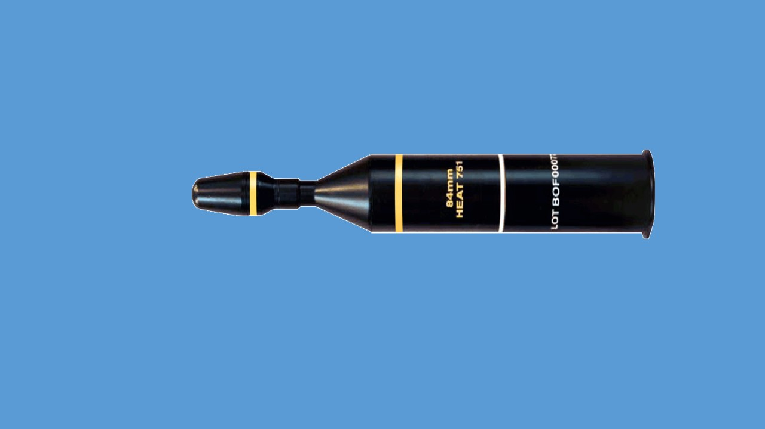  
  
  
HEAT-751 ROUND**

**Hisse purjon ke naam**

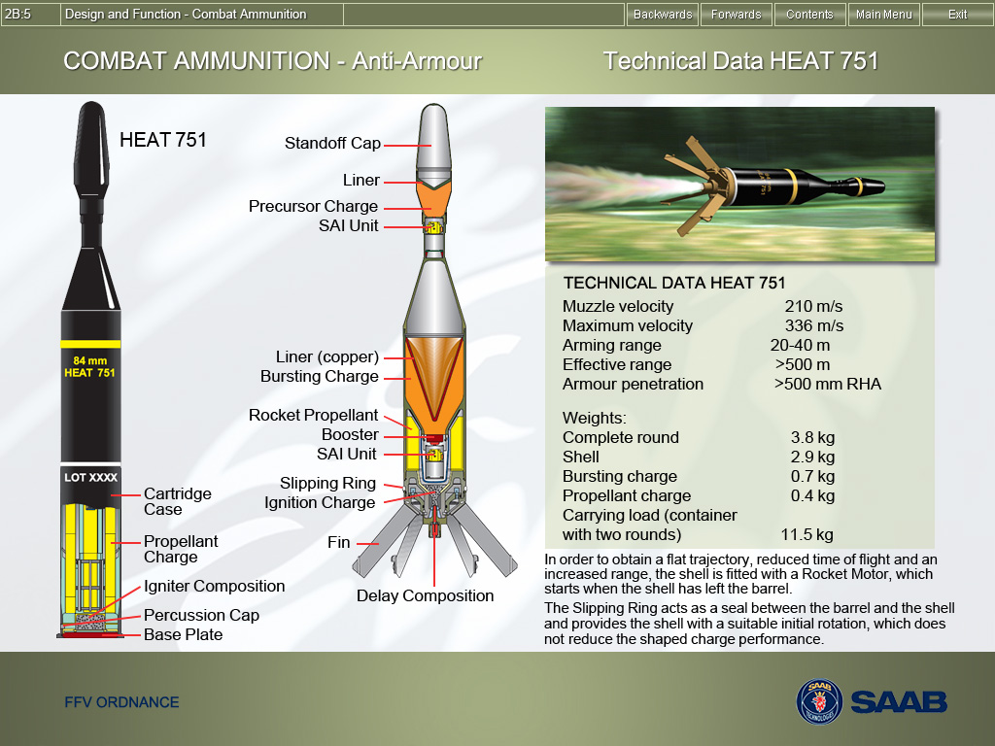

(i) Standoff cap

(ii) Liner Copper cone

(iii) Precursor charge (PC)

(iv) SAI Unit

(v) Shell body

(vi) Liner Copper cone

(vii) Bursting Charge

(ix) Rocket Propellent

(x) Booster

(xi) SAI Unit

(xii) Sliping ring

(xiii) Ignition charge

(xiv) Fin

(xv) Delay composition

(xvi) Cartridge case

(xvii) Propellent charge

(xviii) Igniter composition

(xix) Percussion cap

(xx) Base plate

**HEAT round ki chal**. Jaise RL ka firing pin percussion cap percussion cap thokar marta hain toh percussion cap se nikla ignition charge main aag laga deta hai jisse projectile aage ki taraf harkat karta hain, isi dauran delay unit main aag lag jati hain aur delay unit takriban 45 mili sec ke baad rocket motor charge main aag laga deta hain. Rocket motor jalne se deformation nose per pressure padta hain, jisse fin khul jate hain ye fin muzzle end se takriban   
12 se 20 mtr ki duri par khul jate hain is tarh rocket motor puri tarah takriban 1.4 sec tak jalta hain aur projectile 210 se 336 mtr/sec ki rafter se aage harkat karta hain.

**Arm hone per karwai**. Jab round ka projectile 20-40mtr ka safar tey karta hain to sabhi safety device arm ho jata hain. Jis main shutter detent pin , rotor lock, rotor driving plunger aur short circuit contact kam karta hain. Jaise hi projectile aage ki harkat karta hain toh shutter detent pin niche ki taraf harkat karta hain. Jo ki spring ki takat se ruka hota hain.Isi dauran rotor lock, centre wheel ki madad se 180 degree free hokaar clock wise ghumata hain. Esi ke sath rotor driving plunger electric detonator ko arm posn main badal deta hain. Abhi round puri tarah se tgt barbad karne ke liye tayar ho jata hian.

Jaise hi standoff cap tgt per takrata hain to projectile mein shock wave paida hota hain jisse SAI (Safety Arming Initiation) unit se current paisa hokar processer main aag laga deta hain. Jisse aage wala copper cone pighal kar 2000 mtr/sec ki rafter se ERA (Explosive Reactive Armr) plate main ghusav karta hain aur takriban 17 mili sec ke baad dusra SAI (Safety Arming Initiation) unit bhi bursting charge main aag laga deta hain jisse dusra copper cone bhi jet ka rup main tgt main 500mm mote lohe ki chader main 10,000 mtr/sec ki rafter se andar penetration karke tgt ko apni garmi se barbad kar deta hain.

(b) **Bhag-II - HEDP-502 round ki Visheshtayen aur Tech data**

­

**Visheshtayen**

(i) HEDP ka full form High Explosive Dual Purpose hain.

(ii) Is round ko hum field fortification ke khilaf istemal karte hain.

(iii) Iske elawa hum dushman ke bina ERA plate ke khilaf bhi istemal karte hain.

(iv) Yeh round HEAT ki tarah dushman ke unprotected veh ke khilaf max lethality achieve karta hain.

(v) Is round main fuse do mode main kaam karta hain I & D jo ki I for impact and D for Delay mode, jo ki load karte samay round ko ghumane se parpat hota hain.

(vi) Yeh round ki fin stability ke sath dheere se ghum kar apni trajectory banata hain.

**Tech Data**

|  |  |  |  |
| --- | --- | --- | --- |
|  | Ek round ka wazan | - | 3.3 kg |
|  | Projectile ka wazan | - | 2.5 kg |
|  | Container with 2 round | - | 8.3 kg |
|  | Transport case with three container | - | 34 kg |
|  | Lambai | - | 437mm |
|  | Effective Range (veh) | - | 300 mtr |
|  | Effective Range Fd Fortification | - | 500 mtr |
|  | Muzzle Velocity | - | 225 mtr/sec |
|  | Time of flight  (i) 125 mtr  (ii) 300 mtr  (iii) 600 mtr | -  -  - | 0.71 sec  1.49 sec  3.36 sec |
|  | Arming Distace | - | 12 se 40 mtr |
|  | Minimum Max Angle of Impact | - | 90 + 15 degree |
|  | Penetration Solid armr | - | 100mm |
|  | Operating Temp | - | -40 to + 60 degree C |

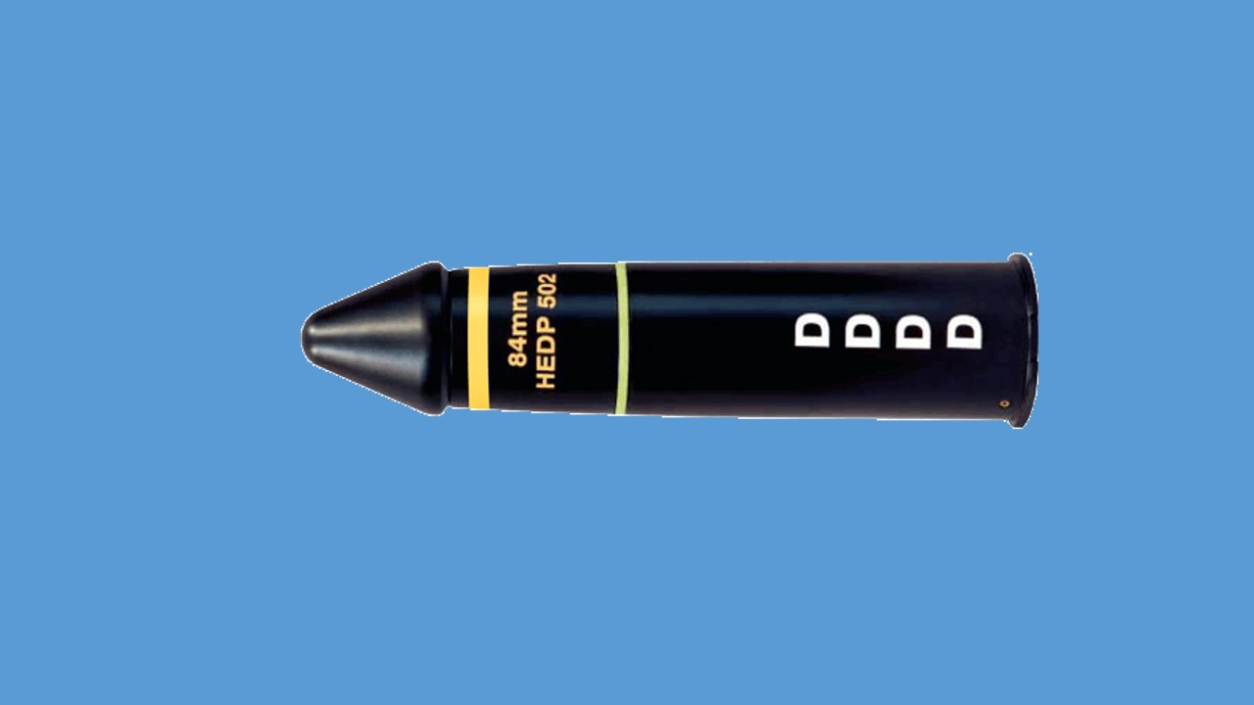

**HEDP-502 ROUND**

**Hisse purjon ke naam**

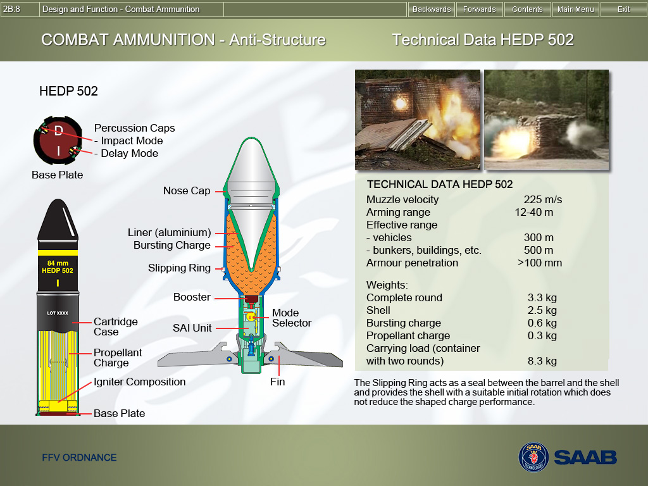(i) Nose Cap

(ii) Liner Aluminium cone

(iii) Bursting charge

(iv) Slipping Ring

(v) Booster

(vi) Mods Selector

(vii) SAI Unit

(viii) Fin

(ix) Cartridge Case

(x) Propellant Charge

(xi) Igniter Composition

(xii) Base Plate

**HEDP round ki chal**. Jab RL ka firing pin round ke precaution cap per thokar marta hain to precaution cap se chingari nikalti hain jo ki propellent main aag laga deti hain jisse round fire ho jata hain. Isse dauran jab projectile muzzle end se 12 se 40 mtr ki duri tay karta hain to gas ke pressure aur speed se arm ho jata hain. Isi dauran projectile ke fin khul jate hain.

**Arm hone per karwai**. Gas ke pressure aur speed ke karna detent pin  
pichhe ki taraf harkat karta hain. Issi dauran detent pin aur escarpment locking pin ke beech laga ball apni jagah sw hil jata hain, jiske karan rotor lock, driving plunger ki madad se anti clock wise ghum jata hain. Ghumne ke karan Magnetic inertia pellet main current paida hota hain. Ab jaise hi nose cap tgt per takrata hain to is ke takrane se shock wave paida hota hain joki SAI (Safety Arming Initiation) unit main current paida karta hain. Current ke karan bursting charge main aag laga deta hain. Bursting charge ke jalne se aluminium cone pigal jata hain jo ki 100mm mote lohe ki chadar main ghusav ke baad tgt ko barbad karne ki takat rakhta hain. Abhi ye nirbhar iss per karta hain ki hum ne round ko I (Impact mode) per fire kiya hain ya D (Delay mode) per yadi hum Impact mode per fir karte hain toh round 8 Inch moti diwar main apni takat se ghusav ke baad 8 mili sec ke baad ander jakar blast ho jata hain.

**Note**: Aluminium cone main penetration kam hota hain.

(c) **Bhag-III - Smoke-469C round ki Visheshtayen aur Tech data**

­

**Visheshtayen**

(i) Is round ko ladai ke maiden main khule main apni harkat ko chupane ke liye istemal karte hain taki dushman hamare upar aimed fire na kar saken.

(ii) Yeh round 10 se 15 mtr choura dhuyen ka parda deta hain.

(iii) Jab hame khule ilake main harkat karna ki zarurat hot oh lagatar hum smoke roud fire karke smoke screen bana sakte hain.

**Tech Data**

|  |  |  |  |
| --- | --- | --- | --- |
|  | Ek round ka wazan | - | 3.1 kg |
|  | Projectile ka wazan | - | 2.2 kg |
|  | Container with 2 round | - | 8.0 kg |
|  | Transport box with three container | - | 34 kg |
|  | Lambai | - | 442mm |
|  | Effective Range | - | 1300 mtr |
|  | Muzzle Velocity | - | 240 mtr/sec |
|  | Smoke Screen | - | 15 mtr |
|  | Time of flight  (i) 400 mtr  (ii) 800 mtr  (iii) 1300 mtr | -  -  - | 1.8 sec  3.9 sec  7.2 sec |
|  | Arming Distace | - | 40 se 70 mtr |
|  | Operating Temp | - | -40 to + 60 degree C |

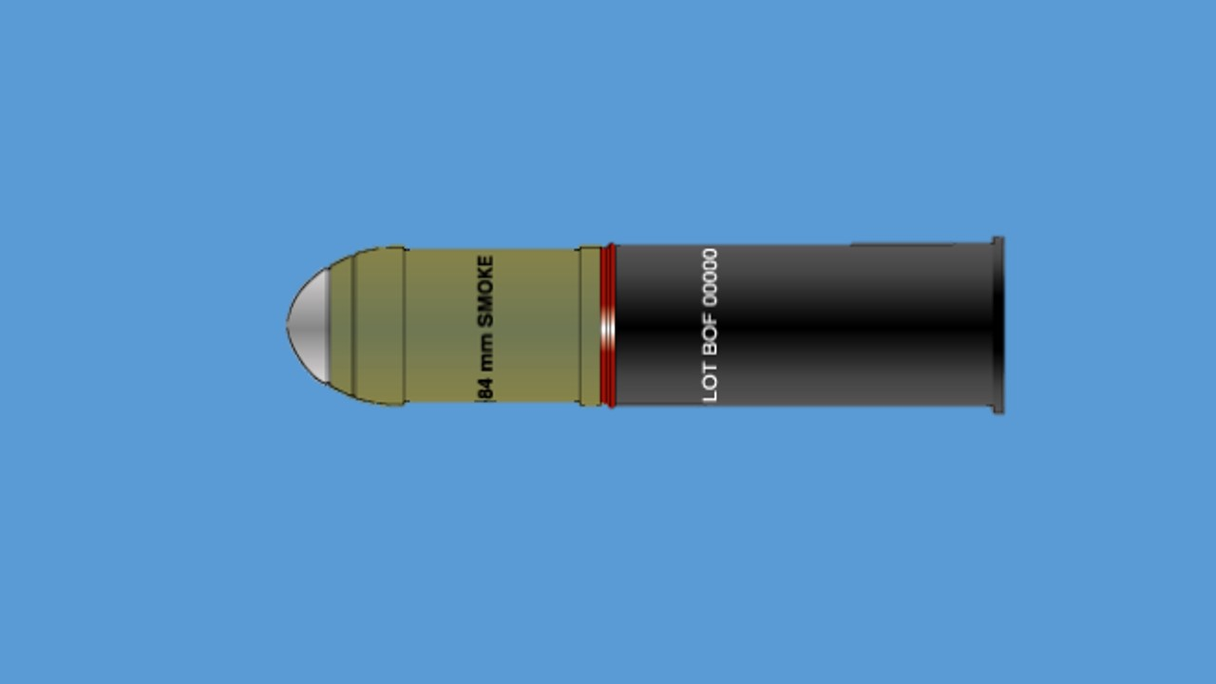**SMOKE-469C ROUND**

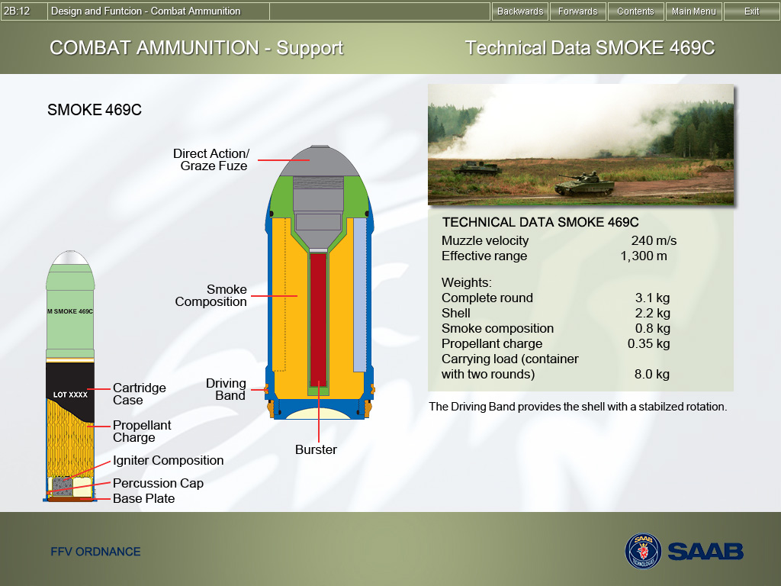**Hisse purjon ke naam**

(i) Direct Action Fuze

(ii) Smoke Composition

(iii) Driving Band

(iv) Cartridge Case

(v) Propellent Charge

(vi) Igniter Composition

(vii) Precussion Cap

(viii) Base Plate

**SMOKE-469C round ki chal**. Jab projectile muzzle end se 40 se 70 mtr duri tay karta hain to pressure speed aur spin ke karan Axial safety Device aur detent bolt ke beech main laga ball hil jata hain. Abhi jo shutter ghadi ke ulte rukh ¾ ghumta hain aur aur electric detonator open ho jata hain, sath hi donon safety plunger bhi apni jagah se hil jata hain aur firing pin bhi azad ho jata hain. Jab round nose ke bal hard surface main takrata hain toh nose ke pressure se firing pin electric detonator main aag paida karta hain, jo bullet main aag laga deta hain aur sath hi booster bursting charge main aag laga deta hain.

**LESSON-3**

**7.62MM SUB CALIBRE ADAPTOR FFV 553 SE JANKARI**

1. **Shuru Shuru ka Kaam**

(a) Class ki ginti groupon mein bant

(b) Hathiyar aur saman ka nirikshan

(c) Bandobast ki karwai

2. **Dohrai**

Pichle lesson se kiya jaye.

3. **Pahunch**

84mm Rocket Launcher Mk-III ek new generaton weapon hain. Zaruri hain ki har jawan iske bare main jankari rakhta hon taki zarurat parne per iska istemal kar saken. 84mm RL MK-III ke sath 7.62mm Sub Calibre adaptor diya gaya hain jisse ki jawan ko adhik se adhik abhyas diya jaye.

4. **Uddesh**

7.62mm Sub Calibre Adaptor FFV 553 ke bare main jankari dena hain.

5. **Saman**

84mm RL MK-III, 7.62mm Sub Calibre Adaptor FFV 553, Launcher rest, Bag No 1, Bag No 2, Black board, chalk, duster, Ground sheet.

6. **Bhagon Mein Bant**

Yeh sabaq teen bhagon mein chalaya jayega:-

(a) **Bhag-I -** 7.62mm Sub Calibre Adaptor FFV 553ki  
 visheshtayen aur tech data

(b) **Bhag-II** - Hisse purjon ke naam, firing mech ki chal aur fire karne ka tariqa.

(c) **Bhag-III** - Zeroing karne ka tariqa.

**(a) Bhag-I - 7.62mm Sub Calibre Adaptor FFV-553 ki visheshtayen aur tech data**.

­

**Visheshtayen**

(i) Yeh ek hathiyar hain. Is adaptor ka istemal karte hue RL det ko zaida se zaida abhyas diya ja sakta hain.

(ii) Isse amn ki bachat hoti hain.

(iii) Isko fire karne ke liye fd firing range ki zarurat nahi padti.

(iv) Is adaptor se fire karne se barrel ki life per koi asar nahi padta.

(v) Isse 7.62mm tracer round FFV-553 aur cap with holder FFV-840 fire kiya jata hain.

**Tech Data**

|  |  |  |  |
| --- | --- | --- | --- |
|  | Origin | - | Sweeden |
|  | Calibre | - | 7.62mm |
|  | Wazan | - | 3.3kg |
|  | Lambai | - | 595mm |
|  | Muzzle velocity | - | 425m/sec |
|  | Effective range | - | 700m |
|  | Grooves | - | 04 (RH) |

**(b) Bhag-II - Hisse purjon ke naam, firing mech ki chal aur fire karne ka tariqa**

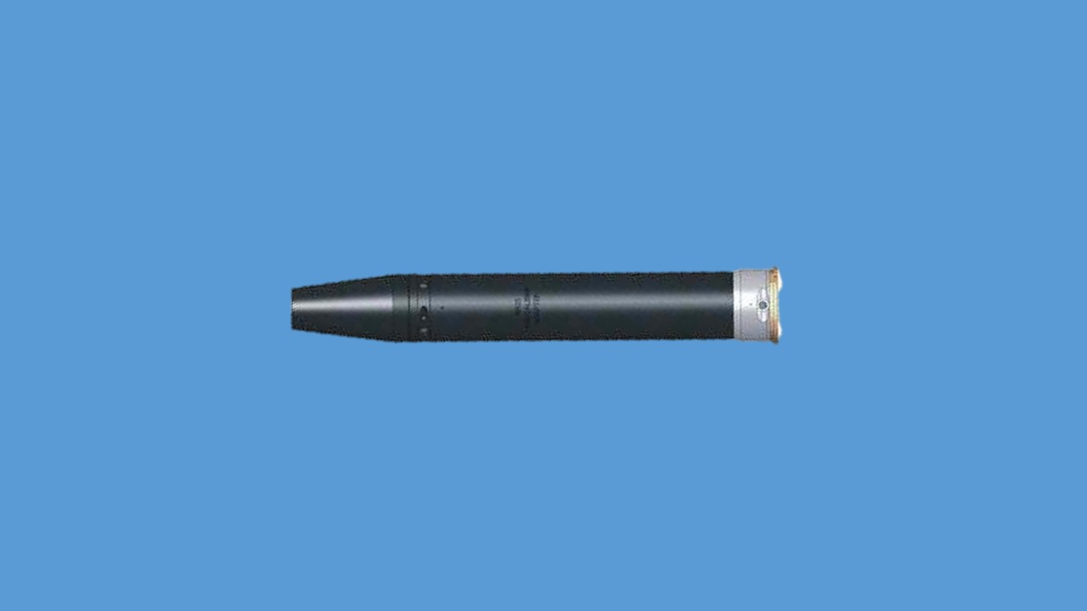

**7.62MM SUB CALIBRE ADAPTER**

**Hisse purjon ke naam**. Nose cone, elevation screw, elevation screw locking screw, deflection screw, deflection screw locking screw, barrel mounting front, barrel, body, barrel mounting, rear, sitted for cap with holder, flash aperature, rim, round, races, grooves for bolt catch, barrel nut, locking shoulder, disengagement surface, firing pin catch.

**Firing Mech ke naam**. Hammer, bolt catch, firing pin catch, sitted for 7.62mm tracer round, firing pin, spring, engagement surface, disengagement surface, 7.62mm tracer round ki pechan bullet ke nose per white colour aur carts ka aadha hissa black colour ka hota hain.

**Firing Mech ki chal**. Firing mech ko adapter ke ander dakhil karenne ke baad jab firing mech ke katav ko ‘F’ per karte hain toh bolt catch grrooves for bolt catch ke sath lock ho jta hain, hammer flash aperature ki sidh main aa jata hain. Firing pin catch engagement surface ke dayen wale locking shoulder ke sath lag jata hain, jisse fg mech ke firing pin unlock ho jata hain.

Jab 84mm RL ko fire karte hain, firing pin cap per chot marta hain jisse flash (shock wave) paida hota hain, yahi flash hammer ke upar dabav dalta hain, jisse hammer aage ki harkat karta hain toh firing pin apne hole se nikal kar 7.62mm tracer round ke primer per chot marta hain aur tracer round fire ho jata hain. Spring ki takat se firing pin aur hammer peeche apne jagah mein aa jata hain.

Jab firing mech ke katab ko ‘S’ per karte hain toh hammer flash aperature ki sidh main nahi hota hain aur firing pin catch engagement surface ke dayen wali locking shoulder aur barrel nut ke sath milap nahi hota hain, jisse firing pin lock hi rehta hain. Is dauran agar galti se trigger dab jaye toh cap with holder phat jaiga lakin tracer round fire nahi hoga.

**7.62mm Sub Calibre Adaptor FFV-553 ko fire ke liye tayar karna**.

(i) Firing mech ko anti clock wise gumaye.

(ii) Jaise hi firing mech ko katav ko direction mark ke sath mil jaye firing mech ko bahar nikalen.

(iii) 7.62mm tracer round ko sited for tracer round main fit karen.

(iv) Firing mech ke katav ko direction mark ke sath milate huye adaptor ke ander dakhil karen aur firing mech ko clock wise gumate huye firing mech ke katav ko ‘S’ke sidh mein karen.

(v) Cap with holder ko sited for cap with holder ki jagah per niche ke taraf dabate hue fit karen.

**7.62mm Sub Calibre Adaptor FFV-553 ko 84mm RL main bharna karna**.

(i) Anya amn ki tarah RL main bhar ki karwai karen.

(ii) Ventury ko band karen se pahle firing mech ki posn ko ‘F’per karen.

(iii) Ventury ko band karen.

**7.62mm Sub Calibre Adaptor FFV-553 ko khali karna**.

(i) Yakin karen launcher cock ho aur safety catch ki posn ‘S’ per ho, ventury ko kholen.

(ii) Firing mech ko anti clock wise gumate huye ‘S’ per karen aur adaptor ko bahar nikalen.

(iii) Cap with holder ko nikalen. Firing mech ko anti clock wise gumate huye firing mech ke katav ko direction mark ke sath milate hue bahar nikalen aur tracer round ko alag karen.

(iv) Dobara firing mech ko adaptor ke ander dakhil karen aur clock wise gumate huye ‘S’per karen.

**Misfire hone per karwai**.

(i) Misfire hone per ventury ko kholen, firing mech ko ‘S’ par karen aur adaptor ko bahar nikalen.

(ii) Cap with holder ko check karen.

(iii) Agar cap par chot hot oh firing mech ko nikalte huye tracer ke primer ko check karen.

(iv) Tracer misfire ho toh tracer aur primer with cap holder donon ke badly karen.

(v) Tracer ke primer per chot na ho toh firing mech ke firing pin ko check karen.

(vi) Firing pin tuta ho toh firing pin ki badly karwaya jaye.

(vii) Yadi cap holder per chot na ho toh RL ki firing pin ki badly karen.

**(c) Bhag-III - Zeroing karne ka tariqa.**

(i) 7.62mm Sub Calibre adaptor ko zeroing karne se pahle yakin karen ki RL zero hain.

(ii) 7.62mm Sub Calibre adaptor ko 300m par zeroing karna chaiya.

**Saman**. RL Mk-III, Bag No 1, 7.62mm Sub Calibre Adaptor, 7.62mm Tracer Round, Cap with holder.

(i) Standing supported Posn.

(ii) Tgt 3m x 3m, + ka size 40 x 40cm, chaurai 3 x3cm aur ek sq=20cm.

(iii) Open sight range 300m.

(iv) 06 round ka gp fire karne ke baad MPI 20cm POA se bayen banana chaiya.

**Upar/niche ka correction**

(i) 7.62mm Sub Caliber Adaptor ke round races ko zamin ki taraf karte huye sub calibre ko pakren.

(ii) Yadi MPI upar ban raha hain toh niche wale elevation screw ko dhila karen aur upar wale elevation screw ko tight karen.

(iii) Yadi MPI niche ban raha hain toh upar wale elevation screw ko dhila karen aur niche walen elevation screw ko tight karen.

**Dayen/Bayen ka correction**

(i) Yadi MPI dayen ban raha hain toh bayen wale deflection screw ko dhila karen aur dayen wale deflection screw ko tight karen.

(ii) Yadi MPI bayen ban raha hain toh dayen wale deflection screw ko dhila karen aur bayen wale deflection screw ko tight karen.

(iii) Is parkar se 300m par elevation/deflection screw ko ek chakar dene per tgt ke upar 20cm ka fark padta hain.

(iv) Alag alag range per MPI ka height is parkar hain:-

200m - 35 cm

300m - +/- 0 cm

400m - +25 cm

500m - +35 cm

600m - +15 cm

700m - -45 cm

**Safai karne ka tariqa**

Firing se pahle firing mech ke bahar nikalen aur sited for firing mech body ke grease ko saaf kar lena chaiya aur barrel ko bhi saaf karna chaiya lubrication anya hathiyaron ki tarah.

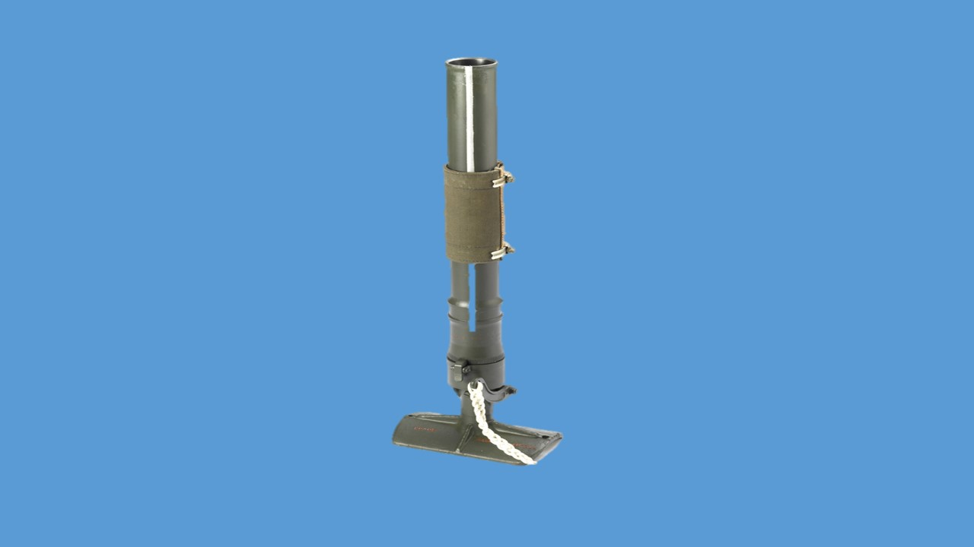  
 **51 MM MORTAR**

**LESSON-1**

**51MM MORTAR SE AAM JANKARI**

1. Is precis ko ek jawan ko 51mm Mortar se achi tarah kaam lena aur fire karna sikhane ke liye taiyar kiya gaya hai.
2. 51mm Mortar ko Infantry mountain division mein istemal ke liye baanta gaya hai. Is se bombs fire karke hamle ke hathiyar ke roop mein HE bomb aur dhuen ka parda banane mein smoke bomb, ilaqe ko roshan karne ka liye para illuminating bomb istemal kiya ja sakta hai. Isse reserve fire power ke rup mein istemal karke faida liya ja sakta hai.
3. 51mm Mortar ek smooth bore aur muzzle se bhara jane wala kshetra marak infantry hathiyar hai. Iska istemal bombon ko kisi chune hue ilaqe mein girane ke liye kiya jata hai naaki kisi target ko hit karne ke liye. Mortar ki accuracy badhane ke liye is ke saath ek dial sight bhi aata hai. Sight se badi aasani se range hasil kar sakte hain.
4. Isse platoon commander ka kargar topkhana maante hai. Kyonki yeh high trajectory hathiyar hai isliye pahadi ilaqe mein karger hai jis kaaran se mountain mein ek infantry battalion ko ek platoon mein ek mortar laagu kiya gaya hai. Ek detatchment mein do jawan authorise hai. Do jawan milkar aasani se mortar ko bhar, lay aur fire karte hain lekin is hathiyar ko ek jawan bhi aasani se handle aur fire kar sakta hai. Lekin aise maukon mein rate of fire par fark padta hai.

**Hathiyar ke Hisse Purze**

1. 51mm mortar ko mote taur par nimnlikhit hisson mein baant sakte hai:-

* 1. 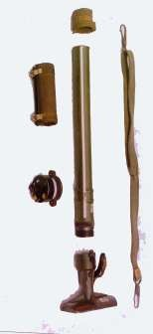Barrel.
  2. Breech Assembly.
  3. Sight.
  4. Carrying Handle.
  5. Muzzle Cover.
  6. Sling.

**LESSON-2**

**51MM MORTAR SE WAQFIAT, KHOLNA, JORNA AUR SAFAI**

**Shuru-Shuru ka Kaam**

1. Class ki ginti groupon mein baant. Hathiyar ka mulaiza karein. Yadi sikhlai paane wale jawaan is ke bare mein kuch bhi nahi jaanta ho toh mulaiza ki karwai bayaan ke saath karni chahiye.

**Dohrai.**

1. Pichle lesson se kiya jaen.

**Pahunch.**

1. 51mm Mortar platoon commander ka topkhana hai. Yeh sikhlai lene mein aur fire karne mein bahut hi assan hathiyar hai. Is se pura faidha uthane ke liye do ya teen jawan ki zarurat parti hain. Magar zarurat parne par ek jawan ise assani se handle aur fire kar sakta hai.

**Uddesh.**

1. 51mm Mortar ko kholna, jorna aur safai karna sikhana hai.

**Saman.**

1. 51mm Mortar, Spare part box, Spanner, Cleaning brush, long easel, board, chalk, duster.

**Bhagon mein Baant.**

1. Yeh sabak teen bhagon mein sikhaaya jayega:-
   * 1. **Bhag-I** - 51mm Mortar se waqfiat aur tech data.

* + 1. **Bhag-II** - Kholna, hisse purzon ke naam, kaam aur jorna.
    2. **Bhag-III** - Safai karne ka tariqa.

**Bhag-I : 51mm Mor se waqfiat aur tech data**

(a) **Visheshtayen**

(i) Iska barrel chrome plated hai.

(ii) Iski lambai jyada hai.

(iii) Barrel bell shaped hai.

(iv) Rg hasil karne ke liye dial sight ki suvidha di gai hai.

(v) Firing lever bada hai.

(vi) Barrel nut catch upar se hai.

(vii) Base plate chaura hai aur spike diye hain.

(viii) 4 parkar ka bomb fire kiye jate hain.

(b) **Tech Data**

|  |  |  |  |
| --- | --- | --- | --- |
| (a) | **Weight** |  |  |
|  | (i) Khali Mor | - | 4.88kg |
|  | (ii) Barrel | - | 2.14kg |
|  | (iii) Breech | - | 2.74kg |
|  | (iv) Sling aur muzzle cover | - | 300gms |
|  | (v) Carrying pad | - | 280gms |
|  | (vi) Mor ka kul wt | - | 5.46kg |
| (b) | **Lambai** |  |  |
|  | (i) Barrel ki lambai | - | 540mm |
|  | (ii) Breech ki lambai | - | 130mm |
|  | (iii) Mor ki kul lambai | - | 670mm |
|  | (iv) Base plate | - | 110mm |
|  | (v) Base plate ki chaurai | - | 190mm |
|  | (vi) Spike ki lambai | - | 25mm |
| (c) | Muzzle velocity | - | 107m/sec |
| (d) | Safety distance | - | 135mtr |
| (e) | Firing Pin | - | Pulsing type |
| (f) | Low Calibre | - | 51.18mm |
| (g) | High Calibre | - | 51.28mm |
| (h) | Barrel ki life | - | 4000bomb EFC |
| (j) | Condemning limit | - | 51.78mm |
| (k) | High Angle | - | 45 se 820 |
| (l) | Low Angle | - | 450 tak |
| (m) | Service Pressure | - | 163.2kg/cm2 |
| (m) | Sidhant | - | Muzzle loaded trip action |
| (n) | Mech safety | - | Chupa hua firing pin |
| (o) | **Rate of fire** |  |  |
|  | (i) Normal | - | 8 bomb/min |
|  | (ii) Intense | - | 12 bomb/min |
| (p) | **Range** |  |  |
|  | (i) Min range | - | 180mtr |
|  | (ii) Max range | - | 1080mtr |

* + 1. **Accessories**:-

(i) Box wooden IA

(ii) Mid Pad lock IG 4 levers

(iii) Brush Cleaning Artillery Tool 12A

(iv) Can oil MG MK 3

(v) Cover Muzzle, 51mm Mortar

(vi) Holdaal, Spare Parts, 51mm Mortar

(vii) 40mm Sling

(viii) **Spare Part Box**

**Spare Part Box**. (Box Spanner 6A, Screw driver 6 x 100mm, Firing pin, firing pin spring, fixing screw, striker gauge, Allen key 5mm, Allen key 3mm, wing nut).

Ek bomb **extraction key** aata hai. Jab barrel jyada garm ya  
 ganda ho jaye to misfire bomb barrel mein phans jata hai, use nikalne mein kam aata hai.

**Bhag-II : Kholna, Hisse Purjon ke Naam, Kaam, Jorna**

**Kholna**. Barrel nut catch ko dabate huye barrel ko kholen. Box spanner 6A ki madad se steel pad ko kholen aur firing pin spring tatha firing pin ko bahar nikalen. Ek firer ko itna hi kholna ki zarurat parti hain. Purje - Barrel, carryind pad, jubilee clip, steel pad, firing pin, firing pin spring, firing mech fixing screw, lever, base plate, shoes.

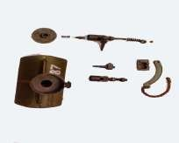

**Jorna**. Jorne ke liye sabse pahle firing pin ko housing mein dakhil karen, firing pin spring ko lagayen aur steel pad ko tight karen. Barrel nut catch ko dabate huye barrel ki safed line ko ek chauthai dahine rakhte huye jor den. Firing lever ko dabakar check karen.

**Bhag-III : Safai karne ka tariqa**. Safai baki hathiyaron ki tarah hi ki jati hai. Antar sirf itna hota hai ki agar Mor ko lagatar fire kiya ja raha ho to har 30 bomb fire karne ke baad iski safai nishchit roop se ki jaye. Lubrication baki hathiyaron ki tarah hi ki jati hai. Firing pin main oil OM-58 ka istemal kiya jata hai aur greese XO-285. Firing mech ki safai ke liye C-70 tel ka istemal kiya jata hain.

**LUBRICANTS ( TEL/GREASE)**

|  |  |  |  |  |
| --- | --- | --- | --- | --- |
| **S No** | **Hathiyaar ka hissa** | **Taapmaan ke lihaaz se tel/grease ka istemaal** | | |
| **40 Cse adhik** | **40C to -180 C** | **-180 Cto -400 C** |
| **1.** | Barrel ki choodi/ breech piece | Grease  X0-280 | Grease  X0-285 | Grease X0-285 |
| **2.** | Jahan C-70 tel ka istemaal nahin  hota. (saadharan uddeshya ke liye) | Tel C-70 | Tel OX-13 | Tel OX-13 aur aale darje ka kerosene oil 1:1 ke mishran mein |
| **3.** | Firing Mechanism | Tel C-70 | Tel CX-13 | Tel CX-13 aur aale darje ka kerosene oil 1:1 ke mishran mein |

**Sankshep.**

1. Yaad rahe ki ek detachment ka kam kewal hathiyar ko fire karne tak seemit nahi hai. Ek mortar detachment hathiyar ke saaf safai ke liye bhi zimmewar hai. Isliye zaruri hai ki unhe mortar ke general maintenance ke baare mein jaankari ho.

**LESSON-3**

**FIRINIG MECHANISM KI CHAL.**

1. Mortar detachment ko firing mechanism ke bare mein bhi jankari hasil kar lena chahiye. Iske bare mein jankari hone se mortar detachment apne hathiyar ko behtar tariqe se samajh payenge.

**Firing Mechanism.**

2. Firing mechanism breech piece ke andar rahta hai. Firing mechanism mein kaam aane waale hisse purzon ke naam is prakar hain:-

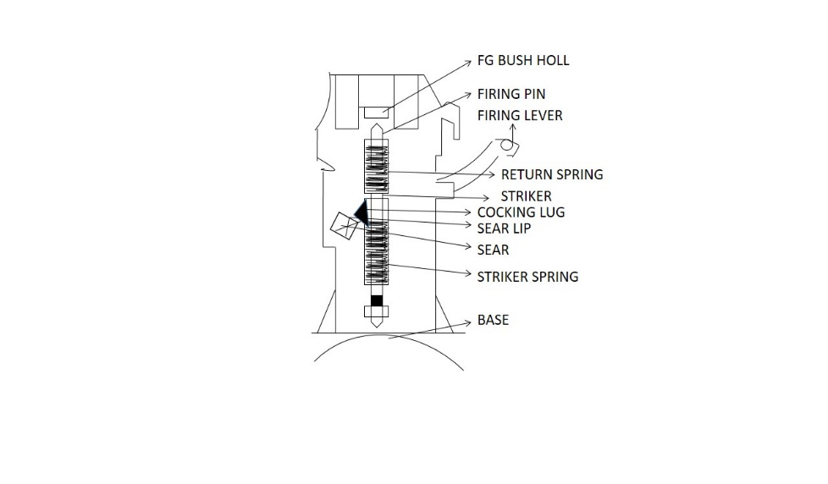

* 1. Sear
  2. Sear Lip
  3. Cocking Lug
  4. Striker Spring
  5. Firing Pin
  6. Firing Bush Hole
  7. Return Spring
  8. Sear Housing
  9. Firing Lever.

3. **Firing Mech ki chal**. Firing lever ko nichhe ki aur dabane se sear assy apne spindle par ghumta hai. Sear lip jis ka lagao striker body ke cocking lug se hota hai uske barkhilaf ghumta hai Sear lip striker body ko pichhe ki taraf dhakelta hai jisse striker spring sikud jatha hai. Sear 36 degree ghumne ke baad sear lip cocking lug se juda ho jatha hai aur strlker azad ho jata hai. Striker spring ab apna tanao ko kam karta hai aur striker ko aage dhakelta hai, striker pichhe se firing pin par thoker marta hai. Firing pin bush hole se bahar nikalta hai aur bomb ke percusion cap par thokar martha hai. Bomb ka fire hone ke baad firing pin return spring ki takat se wapis firing bush hole mein dakhil ho jata hai. Firing lever ko chorne par sear, cocking lug per sawar ho jata hai aur Mor dobara fire ke liye tayar ho jata hai.

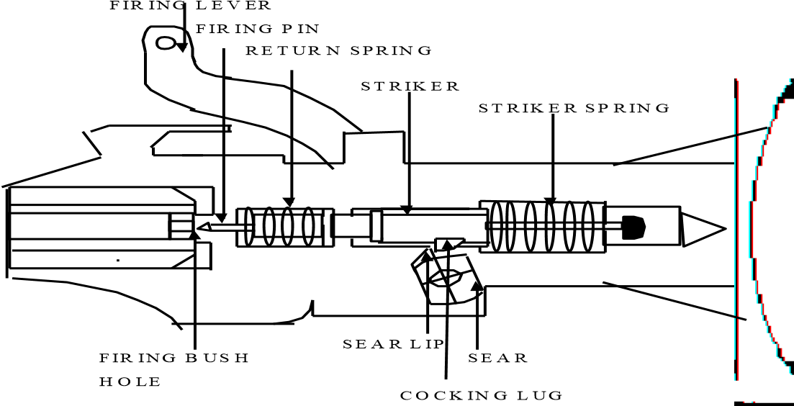

**NORMAL POSITION**



**TRIPPING POSITION**



**FIRED POSITION**

**Sankshep**

1. Firing mechanism ki chal ko samajh lene se aap firing ke dauran mortar mein padne wali rokon ko pehchan kar door kar sakenge. Mortar detachment ke numbers ko iske baare mein jankari hone se woh apna kaam behtar tariqe se kar sakte hain.

**LESSON-3**

**51MM MORTAR KE AMN SE JANKARI**

**Shuru-Shuru ka Kaam**

1. Durghatanaon se bachne ke liye aam hidayatein di jayein.

**Dohari**

1. Pichle lesson se liya jaye.

**Pahunch**

1. Har detachment ke jawaan ko mortar se zyada se zyada faida uthane ke liye zaroori hai ki woh bombon ke baare mein achhi jaankari haasil kare. Numainde bombon ki pehchan karna aur unki visheshtaon se bhali bhanti parichit ho toh woh fire se accha nateeja haasil kar sakta hai. Har ek jawan ko bomb ki chaal ke baare mein jankari ho toh woh haadson se bach sakhenge aur drill ki zarurat behtar samajh paayenge.

**Uddesh**

1. 51mm Mortar se fire hone wale amnunittion se jankari dena hain.

**Saman**

1. Sabhi parkar ke drill bomb, Bomb ki chal ke diagram ke bd, Sectionised bomb, Bd, chalk duster, long pointer.

**Fire hone wale Ammunition**

1. 51mm Mortar se 4 parkar ke bomb fire kiye jate hain:-
   1. HE Bomb
   2. Smoke Bomb
   3. Illuminating Bomb
   4. HE Inert

(a) **HE Bomb**:- Is bomb ka istemal hum anti personal role main karte hain. Yeh bomb bhi do kism ke hota hain.

(i) HE Mk-I

(ii) HE Mk-II

(i) **HE MK-I**

|  |  |  |  |
| --- | --- | --- | --- |
| (a) | Wazan | - | 1.120kg |
| (b) | Lambai | - | 270mm |
| (c) | Explosive | - | RDX (88%) & Wax (12%) |
| (d) | Fuze | - | Fuze Percussion DA 161 Mk-III (M-I) |
| (e) | Killing area | - | 8mtr radius |
| (f) | Danger area | - | 80mtr |
| (g) | Lethal area | - | 25mtr |
| (h) | Agumanting charge | - | 0.43gm |
| (j) | Min Range | - | 180mtr |
| (k) | Max Range | - | 850mtr |
| (l) | HE Mk-I Ch-I ka rg | - | 180mtr se 600mtr |
| (m) | HE Mk-I Ch-II ka rg | - | 600mtr se 850mtr |

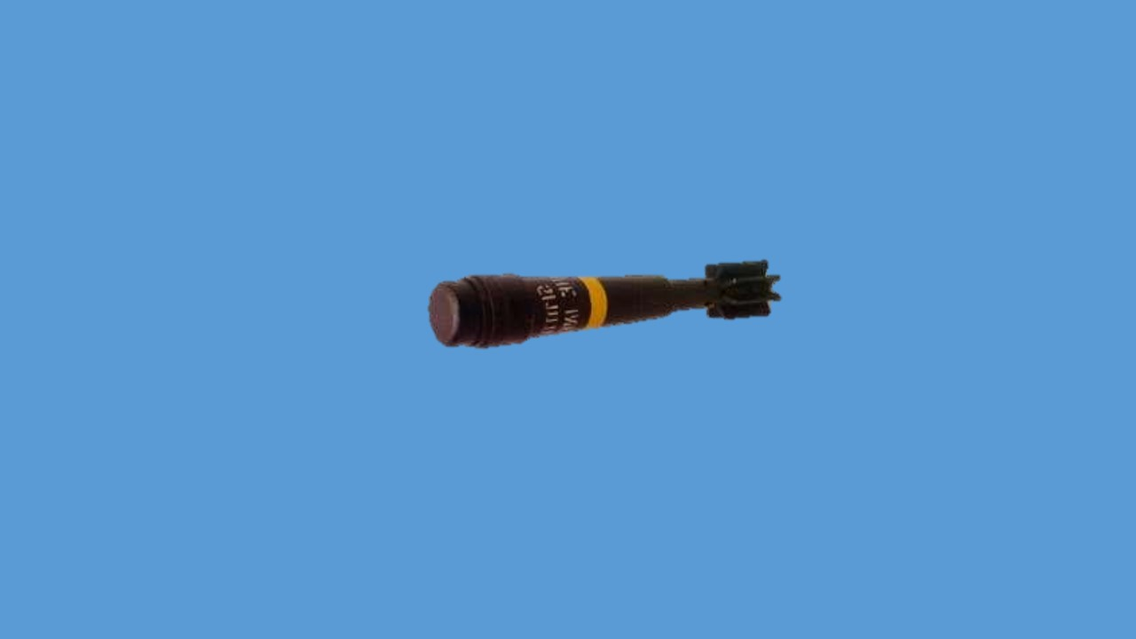

**HE MK-I CH-I BOMB**

(ii) **HE MK-II**

|  |  |  |  |
| --- | --- | --- | --- |
| (a) | Wazan | - | 850gm |
| (b) | Fuze | - | Fuze No 5 DA 161 |
| (c) | HE Mk-II Ch-I ka rg | - | 200mtr se 750mtr |
| (d) | HE Mk-II Ch-II ka rg | - | 750mtr se 1080mtr |

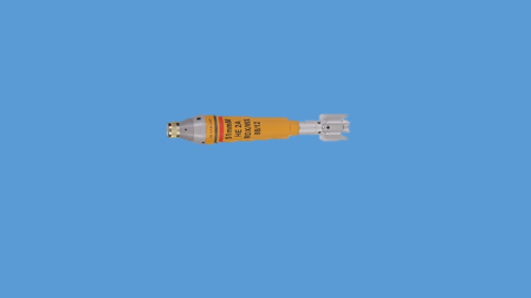

**HE MK-II CH-I BOMB**

**HE Bomb ke Hisse Purje**. Brass cap, striker, striker spring, detent, detent spring, diagonal channel, detonator, CE stem, CE pallet, septum, mag.

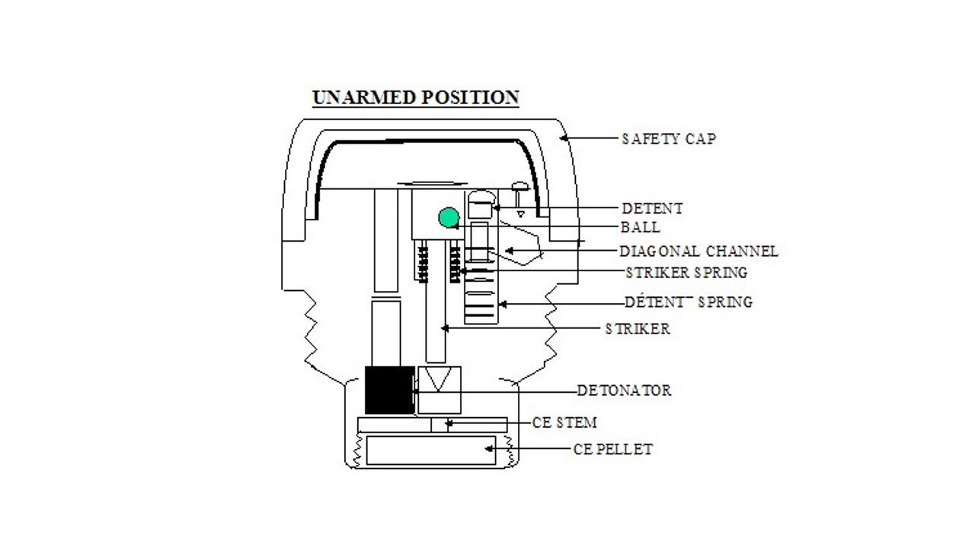

**HE Bomb ki Chal**

1. Bomb fire hone ke baad bomb ko hawa mein discharge ka dhakka lagta hai, jisse detent aur striker donon peeche dabta ha. Is dauran diagonal channel khul jata hai aur safety ball striker shoulder se azad hokar diagonal channel mein chal jata hai. Striker aur detent wapas apne spring ki madad se aage jata hai. Is dauran striker brass cap ke sath lag jata hai aur detent diagonal channel ko band kar deta hai. Jyonhi striker aage ki harkat karta hai detonator shutter par ghumkar detonator ke nok ki sidh mein aa jata hai. Is samay bomb armed halat mein ho jata hai. Jyonhi bomb nose ke bal kisi satah ya thosh vastu se takrata hai to brass cap tut jata hai, brass cap ke dabne se striker ke upar dabav parta hai, jisse striker harkat karta hai aur striker nok detonator ke upar chot marta hai, jisse aag ki chingari nikalti hai. Aag ki yeh chingari CE stem se hoti hui, CE pallet mein aati hai, CE pallet mein bhare huye barood mein aag lag jata hai. Is aag ki garmi se septum pigal jata hai aur mag mein bhare barood mein aag laga deta hai, jisse bomb body dhamake ke sath phat jata hai aur 8mtr radius mein ane wale kisi bhi jandar vastu ko barbad kar deta hai.

**DURING FLT**

**ON IMPACT**

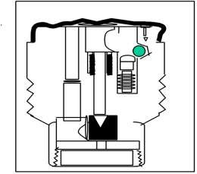

1. **Smoke Bomb**:- Is bomb ka istemal dhuan ka parda banana ke liye kiya jata hain. Iske concial adopter main char surakh hote hain. Iske ander ek delay holder hota hain jiske ander pyrotechnic delay composition hota hain aur 10 sec ka delay paida karta hain. Yeh bomb piche se dhuan dene wala ek bomb hain.

|  |  |  |  |
| --- | --- | --- | --- |
| (a) | Wazan | - | 935gms |
| (b) | Lambai | - | 283mm |
| (c) | Range | - | 850mtr |
| (d) | Dhuan ka samay | - | 2 min |
| (e) | Bomb ka Colour | - | Green |
| (f) | Main Filling | - | Hexachlorothane Base |
| (g) | Main filling | - | 450gms |
| (h) | Dhuan ka parda | - | 15 mtr chaura based on air |
| (j) | Muzzle Velocity | - | 110mtr/sec |

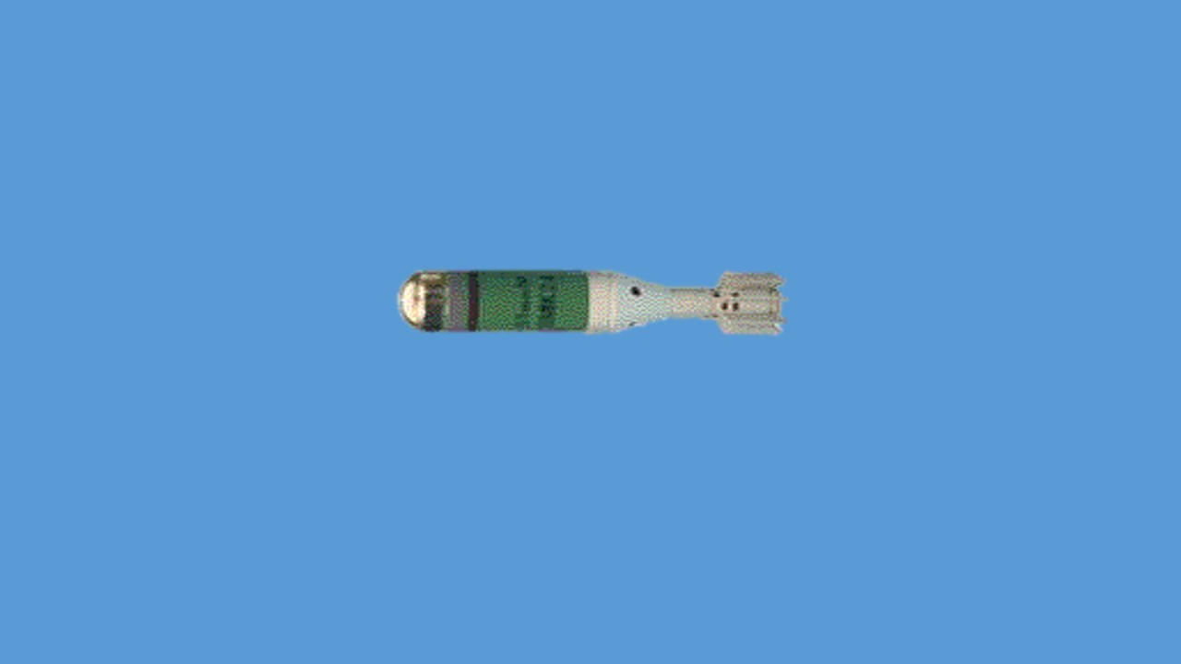

**SMOKE BOMB**

1. **Illumaniting Bomb**:- Is bomb ka istemal raat ke waqt roshini ke liye kiya jata hain.

|  |  |  |  |
| --- | --- | --- | --- |
| (a) | Wazan | - | 925gms |
| (b) | Roshini dene ka samay | - | 35 sec |
| (c) | Roshini dene ki takat | - | 2,50,000 candla power |
| (d) | Roshini dene ka ilaqa | - | 400m dia |
| (e) | Pt of burst | - | 150mtr + 30mtr |
| (f) | Rate of descent | - | 3mtr/sec |
| (g) | Range | - | 900mtr |

Is bomb ke rotating ring par 3, 5, 7 aur 9 ke ank khude hua hain jo 300m, 500m, 700m aur 900m ke rg ko jahir karte hain. Is rotating ring ko kisi bhi disha mein ghumaya ja sakta hai. Raat ke samay rg lagane ke liye steel ball ki suvidha di gai hai. 1 ball 300m, 2 ball 500m, 3 ball 700m aur 4 ball 900m Range ko jahir karta hai. Click ki awaz par ek setting jahir hota hain.

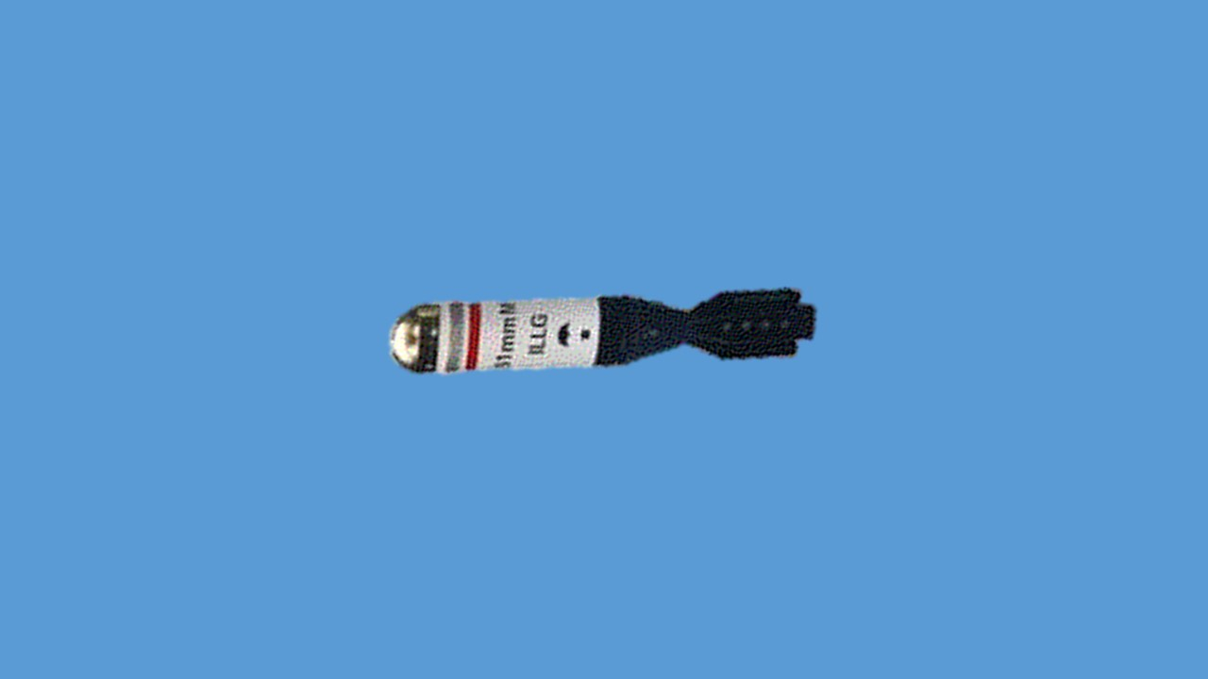  
  
  
  
  
 **ILLUMINATING BOMB**

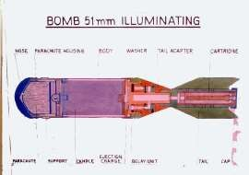

(d) **HE Inert Bomb**:- Is bomb ka istemal Mortar det zaida abhyas dene ke liye kiya jata hain.

|  |  |  |  |
| --- | --- | --- | --- |
| (a) | Wazan | - | 970gms |
| (b) | Lambai | - | 196mm |
| (c) | Range | - | 200mtr se 220mtr |
| (d) | Carts | - | NGB (Nitrogen Glaseriane Base) |
| (e) | Cartridge ka wt | - | 1.43gms |

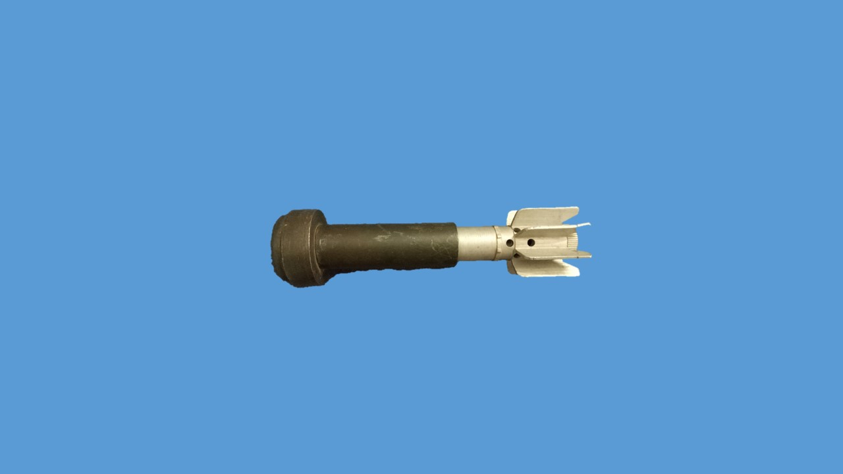

**HE INERT BOMB**

**LESSON-3**

**51MM MOR TAR KE DIAL SIGHT 101/102A SE JANKARI**

**Shuru-Shuru ka Kaam**

1. Durghatnayon se bachne ke liye hathiyar ka mulaiza zaroor kar lena chahiye.

**Dohrai**

1. Pichhe wale sabaq se dohrai ki jaye.

**Pahunch**

1. 51mm Mortar ke fire mein dursti lane ke liye 51mm Mor ke sath dial sight

ki suvidha diya gaya hain. Sight ki madad se hum range hasil karke kafi taadad mein fire gira kar dushman ko barbad kar sakte hain.

**Uddesh**

1. 51mm Mortar ke dial sight se waqfiat aur range hasil karne ka tariqa

sikhana hai.

**Saman**

1. 51mm Mortar, dial sight 101A/102A, canvas bag. Dial sight ka model.

**Bhagon mein Bant**

1. Sabaq teen bhagon mein sikhaya jayega:-

(a) **Bhag-I** - Dial sight se waqfiat.

(b) **Bhag-II** - Range Hasil karna.

(c) **Bhag-III** - Suraksha sambandhi batein.

(a) **Bhag-I** - **Dial sight se waqfiat**

Dial sight is hathiyar ke sath diya gaya hai, jiski madad se munasib rg hasil kiya ja sakta hai. Dial sight ka wt 350gms hain. Dial sight ki mukhya do assy hai:-

(i) Clamp assembly

(ii) Housing assembly

(i) **Clamp assembly**.

(aa) **Mounting bracket**. Yeh dial sight ko Mor par mount karne  
 ke kaam ata hai. Mounting bracket mein do ardh semi circular  
 clamp hain. Clamp ko tight karne ke liye do allen head  
 screw diye gaye hain.

(ab) **Range drum**. Rg drum ko sthai roop se clamp assembly mein lagaya gaya hai. Iske upar charge-I aur charge-II ka rg mark kiya gaya hai.

(ac) **Central spindle**. Yeh clamp assembly ke beecho beech lagaya gaya hai. Yeh housing assembly ko sahara deta hai.  
 Spindle ke upar churiyan hain jis par wing nut ko tight kiya jata hai.

(ii) **Housing Assembly**.

(aa) **TF Source**. TF source ko aise jagah fit kiya gaya hai jahan par Mor ke dauran asar kam se kam hota hai. TF source raat ke samay range scale aur spirit bubble ko illuminate karta hai.   
 (Range drum mein 03 aur sprit bubble ke andar 02 hota hai.)

(ab) **Spirit bubble**. Spirit bubble ko madhya mein karne se angle hasil hota hai.

(ac) **Index**. Index ke neche TF source hota hai. Ise ghumakar range hasil kiya jata hai. Index ke upar ek cursor kale rang ki line hoti hai, jiski madad se rg hasil kiya jata hai.

(ad) **Plunger**. Plunger Index ko apni jagah lock karke rakhta hai taki firing ke dauran Index hil na jaye.

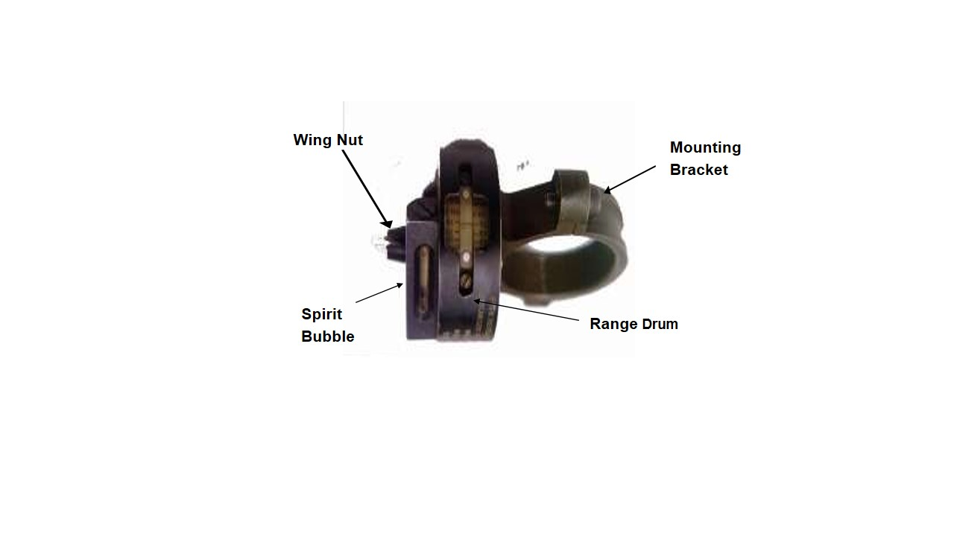

**DIAL SIGHT**

(b) **Bhag-II -**  **Range Hasil karne ka tariqa**

7. Dial sight ke upar do prakar ke rg scale khude hote hain. Isse CH-I aur CH-II amn fire kiya jata hai. Bayen taraf ka rg scale CH-I ke liye aur dayen taraf ka scale CH-II amn ke liye istemal kiya jata hai. Mortar ko do angle se fire kiya jata hai.

(i) **Low Angle**. 0 se 45 degree ke angle ko low angle kahte hain. Is angle par fire karne se bomb ke uran ka samay aur hawa ka asar kam hota hai.

(ii) **High angle**. 45 se 80 degree ke angle ko high angle kahte hain. Aam taur par high angle se crestline ko clear kiya jata hai.

Rg lagane ke liye wing nut ko dhila karen, housing assembly ko ghumakar zarurat shuda range lagayen, wing nut ko tight karen.

(c) **Bhag-III - Suraksha sambandhi batein** TF source ek phosphorus coated sealed glass capsule hai. Jo raat ke samay chamkata hain. TF source ke tutne per karwai:-

(i) Jis jagah par tuta hai us jagah ke 10m ki duri par par 30 min tak na jayen.

(ii) Tute huye glass capsule ko polythene bag mein chimte ki madad se band karen.

(iii) Polythene bag ko 2 feet gadhe mein daba den.

(iv) Jis aadmi se tuta ho uske sharir ke khule hisse ko sabun pani se achi tarah dhulai karen.

(v) Jo aadmi uske nazdik ho uska urine test karayen.

(vi) Jo aadmi usse prabhavit hua ho use 10 din tak pani aur juice jaida den.

(vii) Workshop ko khabar karen. Woh use Radiation Technologhy Division, BARC (Baba Automic Research Centre), Trombay, Bombay Pin-400085 per bhej deta hai.

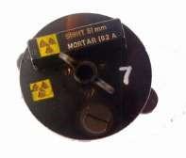

Radiation Sign

**LESSON-3**

**51MM MORTAR KE DIAL SIGHT 101/102A SE JANKARI**

**Shuru Shuru ka kaam**

1. Class ki ginti deton main

**Dohrai**

1. Pichle lesson se liya jaye.

**Pahunch**

1. 51mm mortar ek Pl cdr ka topkhana hai. Ek jawan isko assani se carry kar sakta hain lekin bhar, khali kar aur tez Mor fire ke liye No 2 ki zarurat parti hain.

**Uddesh**

1. Bombon ko fire ke liye taiyar karna, bharna, khali karna, lay aur fire karna ka tariqa sikhana hai.

**Saman.**

1. 51mm mortar, Convas bag, drill bomb, 9mm CMG, ground sheet,   
   fig 11 tgt
2. **Bhagon mein Baant.**

Yeh sabaq char bhagon mein sikhaya jayega:-

* 1. **Bhag-I** - Bombon ko Fire ke liye Taiyar karna
  2. **Bhag-II** - Bharna aur khali karna
  3. **Bhag-III** - Lay aur fire
  4. **Bhag-IV** - Misfire per karwai

**Bhag-I : Bombon ko Fire ke liye Taiyar Karna.**

1. Convas bag ko len, ek convas bag mein 6 bomb tube aate hain. Convas bag ke strap ko kholen aur bomb tube ko bahar nikalen. Bomb tube ke upar chipakne wale pheete ko utaren aur surakshit sthan par rakhen. Bomb tube ke cap ko kholen, tail unit se pakarte huye bomb ko bahar nikalen, bomb ki body ka nirikshan karen ki body dabi to nahin hai, fins ko check karen, agar tuti ya muri hon to use bhi fire ke liye taiyar na karen. Agar bomb thik ho to safety cap ke upar chipkane wale pheete ko utaren, safety cap ko kholen, retainer ko tight karen. Agar No-1 akela hi fire kar raha ho to safety pin bhi isi samay nikal diya jata hai. Agar No-1 aur No-2 donon milkar fire kar rahe hon to safety pin ko bharte samay nikala jata hai. Dhyan rahe bomb utne hi taiyar kiye jayen, jitni zarurat ho sath hi bomb ko jyada der pahle taiyar na kiya jaye. Yeh tha bombon ko fire ke liye taiyar karne ka tariqa.

**Repack**:- Agar bomb ko fire na karna ho use repack karne ki jarurat parti hai. Dhyan rahe jin bombon ke safety pin nikal diye gaye hon, unhe repack nahi kiya jaye balki blind samajhkar barbad kar diya jaye. Jin bomb ka safety pin nahi nikala gaya ho unhi bombon ko repack kiya jata hain. Repack karne ke liye kisi saaf chindi ya kapre ki madad se brass cap ko saaf karen kyoki brass cap ke upar nami ka asar jaldi ho jata hain, safety cap ko lagayen, safety cap ke upar chipakne wale pheete ko lagayen, bomb ki tail unit ko upar ki taraf rakhte huye bomb tube mein dakhil karen, bomb tube ke cap ko lagayen, bomb tube cap ke upar chipakne wale pheete ko laga den, bomb tube ko convas bag mein band karen aur convas bag ka strap band karen. Yeh tha repack karne ka tariqa.

**Bhag-II : Bharna aur khali karna**

1. 51mm Mor se kneeling posn se fire kiya jata hai. Postiton ikhtiyar karen aur Mor ko mount karen. Mor det ko tgt dikhai de ya squad post trg ke duran aadesh mile bhar to No-1 karwai is parkar karta hai, dahine hath se muzzle cover ko utarta hai aur bayen hath se Mor ko apni taraf karte hue barrel ka nirikshan karta hai agar koi dul ya garda hai to kisi saaf chindi ya kapre se saaf karta hai aur Mor ko neche rakhta hai. Convas bag se bomb tube ko bahar nikalata hai aur bomb ko taiyar karta hai, safety pin ko bhi nikal deta hai aur surakshit jagah par rakhta hai, bayen hath se Mor ko uthata hai aur dahine hath se bomb ko is parkar se leta hai ki tail unit neeche ki taraf ho, bomb ko barrel main dakhil karta hai, bomb barrel main teen chauthai dakhil ho jata hai to dahine hath ko nazdiki raste se cut karte hain aur barrel ko hilata hain taki bomb steel pad par thik se baith jaye. Yeh tha No-1 ki hasiyat se bharna. Agar No-2 sath hai toh, No-2 No-1 ke diye hue addesh ko dohrata hai aur sath No-1 ke dahine aur itna nazdik aam kneeling posn ikhtiyar karta hai ki woh No-1 ke addesh ko sun sake aur bharna tatha khali karne ki karwai kar sake. No-2, No-1 ke diye hue addesh ko dohrata hai aur seekhe hue tariqe se bomb ko taiyar karta hai. Donon hathon se bomb ko is parkar se leta hai ki tail unit neche ki taraf ho bomb ko barrel main dakhil karta hai jyonhi bomb barrel main teen chouthai dakhil ho jata hai to dahine hath se safety pin ko nikalta hai aur donon hathon ko nazdiki raste se cut karta hain.
2. **Khali Karna**:- Agar Mor det ko tgt dikhai na de ya squad post trg ke duran addesh mile bina fire khali kar toh No-1 apne dayen hath ko muzzle ke upar le jata hain aur mortar ko itna dayen turn karta hain ki bomb apne hi weight se bahar aa jaye, tail unit ko apni taraf rakhte huye saaf jagah per rakhta hai. Agar No-2 sath hain toh bomb ke tail unit ko apni taraf rakhte huye No-2 ke hath main deta hain aur No-2 saaf jagah per rakhta hain.

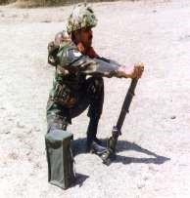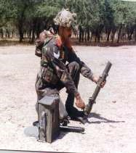

**KNEELING POSITION MEIN EK JAWAN AASANI SE BHAR SAKTA  
HAI AUR KHALI KAR SAKTA HAIN**

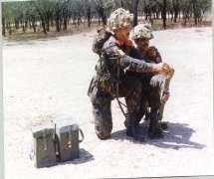

**NO-1 AUR NO-2 KI KNEELING POSITION**

**Bhag-III : Lay Aur Fire karne ka tariqa**

1. **Lay**. Lay kise kahte hain. Tgt, Mor ki safed line aur firer ke sir ko ek sidh mein karne ki karwai ko lay kahte hain. Lay karne ki jimmewari No-1 ki hoti hai.

**Fire karna**. Jahan per Mor det ko tgt dikhaya jata hain, Mor det ke addesh per mor det savdhan ho jata hain aur rg milne per mor det bishram ho jata hain. Mount mor ho jane ke baad fire ke liye hatihyar an tayar kar ke addesh per No 1 dial sight per rg lagata hain aur No 2 bombon ko tayar karta hain. Bhar ki karwai ho jane ke baad No 1 lay ki karwai karta hain, apne dwara ki gayi lay ko check karne ke liye No 1 ON pukarata hain On ke addesh per No 2 No 1 ke piche aata hain aur No 1 dawara ki gayi lay ko check karta hain agar correction dene ki zarurat pade toh correction base plate ko utha kar di jaye na ki base plate ko ghist kar. Durust lay ho jane ke baad No 1 apni muthi ko band karta hain aur No 1 ki pith per thapki marta hai aur up pukarate hue apni jagah baith jata hai. Fire ke addesh per No 1 spirit bubble ko Madhya main karta hua lever ko press karta hain is parkar lever press hone per bomb fire ho jata hain aur donon Nos bomb ki maar ko dekhte hain agar bomb on tgt nah o toh correction dekar dusra bomb fire karte hain is parkar ek achi sikhli paya hua mor det ek min main 8 bomb normal aur 12 bomb tez fire karta hain.

**Bhag-IV : Misfire per karwai**

**Misfire.** Agar lever ko dabane se bomb fire na ho ya trg ke dauran adesh mile ‘FIRE NAHI’, to No-1 Mor ko hilata hai aur spirit bubble ko madhya mein rakhte huye dubara lever ko dabata hai, is prakar dobara lever ko dabane se bhi bomb fire no ho ya adesh mile ‘PHIR FIRE NAHI’, to No-1 sikhe huye tarike se khali kar ki karwai karta hai aur dusra bomb bharne ka adesh deta hai. Bhar aur lay ki karwai ho jane ke baad No 1 spirit bubble ko madhya mein rakhte huye lever ko dabata hai. Is parkar teesri baar lever dabane par bhi bomb fire na ho ya trg ke dauran adesh mile ‘PHIR BHI FIRE NAHI’ to No 1 misfire khali kar ka addesh deta hai. Khali kar ho jane ke baad No 1, No 2 se check primer report leta hai. No-2 donon bombon ko apni donon hatheli par rakhte huye bomb ke cartridge ke primer ko check karta hai. Agar primer par chot na ho to donon milkar firing pin ki badli karte hain. Agar primer par chot ho to No 2 donon bombon ko nose tgt ki taraf rakhte hue, firing posn se aage aur dahine 10 mtr ki duri par rakhta hain. No 1 teesra bomb bharne ka adesh deta hai, bhar aur lay ki karwai ho jane ke baad spirit bubble ko madhya mein rakhte huye lever ko dabata hai. Is parkar bomb fire ho jata hain aur tgt barbad ho jata hain

**Misfire hone ke karan**

(a) Striker spring ka kamjor hona.

(b) Firing pin ka tut jana ya ghis jana.

(c) Steel pad par dhatu ka jama hona

(d) Bomb ka steel pad per thik na baitha hona.

(e) Retaining cap ka dhila hona.

(f) Bomb ke carts ke primer mein nuqs hona.

**Sankshep**

1. Jawanon se sawal pooche jayein aur unhe bhi sawal poochne ka mauqa diya jaye.
2. Jawan ko Jaida abhyas diya jaye.

1. Akhir mein poore sabaq ka confirmation karna nihayat zaruri hai.

**LESSON-4**

**51MM MORTAR SE DIRECT AUR INDIRECT FIRE**

**Shuru Shuru ka Kaam.**

1. 51mm Mortar, 9mm carbine, tatha baki saman ka nirikshan karo.

**Dohrai.**

1. Pichle lesson se liya jaye.

**Pahunch.**

1. Larai ke maidan mein chand ek aise target hote hain jo hamen dikhai dete hain aur apne flat trajectory hathiyar se engage kar sakte hain. Kuch aise target jo dikhai nahin dete unhen hamen indirect fire se barbad karna parta hai. 51mm mortar se hum donon kism ke targeton ko barbad kar sakte hain. Zaruri hai ki har mortar detachment ko seedha aur paroksh fire se target ko barbad karna sikh le.

**Uddesh.**

1. 51 mm mortar se sidha aur paroksh fire karne ka tariqa sikhana hai.

**Saman.**

1. 51mm mortar, 9mm carbine, drill bomb, convas bag, Auxillary aiming mark, black bd, chalk duster.

**Bhagon mein Baant.**

1. Yeh sabaq do bhagon mein sikhaya jayega:-

(a) **Bhag I** - Direct fire

(b) **Bhag II** - Indirect fire

**Bhag-I : Direct Fire**

1. Jab ek mor det tgt ko dekate hue tgt ke uper mor ko lay karke, hawa ka haq rakhte hue tgt per fire karta hai use direct fire kahte hai.
   1. Direct fire main Mora ur tgt ke beech kisi parkar ki rukawat jaise crest, makan, ped aadhi nahi hona chaiya, jisse ki bomb ki uddan main badha pare.
   2. Jaha tak ho sake direct fire hamesha low angle se karna chaiya. Low angle se bomb ki uddan main hawa ka asar kaam hota hain.
   3. Tirchi hawa bomb ko tgt se dur le jati hain.

**Bhag-I : Indirect Fire**

1. Jab mor det bina tgt ko dekhe apni mor ko kisi kudrati ya banavati nishan ki madad se mor ko lay karke hai aur hawa ka huk rakhaten hua tgt ko barbad karta hai to is prakar ke fire ko Indirect fire kahte hai. Indirect fire ko kamyab banane ke do tarike hain.

(a) Subsidiary Aiming Marks

(b) Auxiliary Aiming Marks

(a) **Subsidiary Aiming Marks**. Veh nishan jo tgt ilake mein pahle se majud ho ye nishan banawati ya kudrati ho sakten hain jiski madad se Mor ko tgt par lay karke hawa ka hak rakhten hua fire kiya jata hai aur tgt ko barbad karta hai, use Subsidiary Aiming Mark kahte hain. Jahan tak ho sake yeh nishan   
12 baje ki line mein hone chahiye. Agar 12 baje na mile to nishan 6 baje ki line mein bhi ho sakta hai, dhyan rahe agar nishan 6 baje ki line main ho toh bomb ki uran ke raste mein badha na ho. Agar 6 baje na mile toh nishan 11 baje aur 1 baje ki line main bhi ho sakta hain aur mor posn ko 7 baje ya 5 baje ki line main chune jaye is duran bhi bomb ki uran main koi bhi badha na ho. Abhi ke liya nishan 12 baje ki line main. Mor det ko line of adv diya jata hain. Mor det diya hue adv per march karta hain dusman ka fire aane per mor det adv jari rakhta hain, dushman ka kargar fire aane par ya det cdr ke sakat fire ke addesh per Mor det fire & mov ke tariqe se crest line tak jata hai aur tgt ko jayeja leta hai. Tgt ka sahi rg malum karta hai aur dial sight per range lagata hain. Det tgt ilaqe mein subsidiary aiming mark chunta hain. Det cdr ya No-2 aur No-1 crest line se firing posn batata hain aur mor mount ka addesh deta hain. No-2 shot fall se bachne ke liye line of fire se dayen ya bayen posn leta hain aur No-1 ko fire ka addesh deta hain. No-1 fire ki karwai karta hain.  
No-2 tgt area mein bomb ki maar ko dekhta hai, agar bomb on tgt na ho toh munasib corection deta hai agar bomb on tgt ho to No-2, No-1 ke sath mil kar tez mor fire main madad karta hain aur dubara crest line per jata hai aur tgt ko dekhta hai, agar tgt barbad ho gaya ho to No-1 ko dismount Mor ka addesh deta hai. No-1 dismount karke No-2 ke sath mil jata hai.

(b) **Auxiliary Aiming Marks**. Aise nishan jisko banawati taur par taiyar karke unki madad se tgt ko barbad kiya jata hai, unhe auxillary aiming mark kahte hai. Jaise lakri, pather, thatha bayonet etc. Auxillary aiming mark lagate samey dhyan dene wali baten:-

(i) Back ground se milta julta ho.

(ii) Sky line par na lagaya jaye.

(iii) Lagane wala dushman ko na dikhai de.

(iv) Kam se kam 2 aur jiada se jiada 3 lagaya jaye.

(v) Mazbooti se gada jaye.

(vi) Control item ka istemal kiya ja raha ho to dismount mor par  
 wapas nikal lena chahiye.

**Auxilliary aiming mark lagane ka tariqa*:-*** Crest line per pahuchne ke baad donon No tgt ka dekhte hain aur tgt ka range malum karte hain aur dial sight per range lagata hain. No-2, No-1 ko firing posn batata hain aur Mor ko mount karne ka addesh deta hain, No 1 Mor ko mount karta hain aur No-2 tgt aur Mor posn ko dekhte hua pahla auxilliary mark lagata hain, agar dusra auxiliary mark lagane ki zarurat pade toh pahle auxiliary aiming mark aur firing posn ko dekhte hua dusra auxiliary aiming mark lagata hain is parkar agar teesra auxiliary mark lagane ki zarurat pade toh No-1 ki madad se teesra auxiliary aiming mark bhi lagaya jata hain. Yeh tha auxiliary aiming mark lagane ka tariqa.  
  
**Correction Dene ka Tariqa**. Agar tgt 500m tak ki duri par ho to 50 dayen / bayen aur 50m upar / neeche ka correction nahi diya jata hai. Agar tgt 1000m ki duri par ho to 30 dayen / bayen aur 50m upar / neeche ka correction nahi diya jata hai. Agar isse jyada correction ho to correction pura diya jata hai

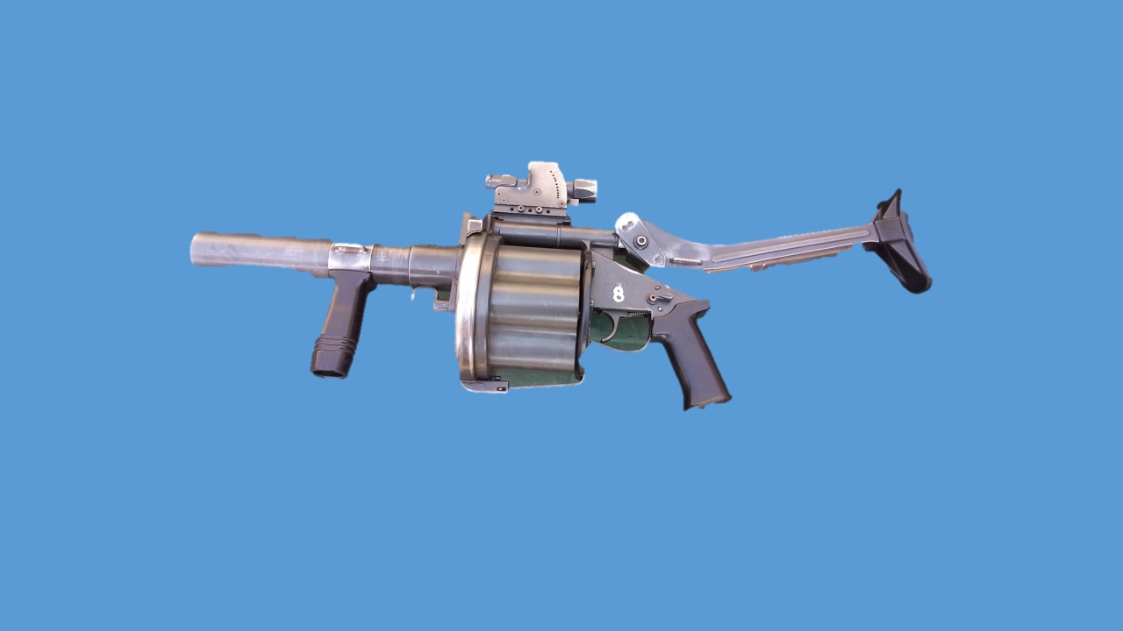

**40MM MULTI SHOT GRENADE LAUNCHER MK-I**

**LESSON-I**

**40MM MULTI SHOT GRENADE LAUNCHER MK-I SE AAM JANKARI**

**Ref- (Multi Shot Granade Launcher MGL-40)**

1. 40mm Multi Shot Grenade Launcher Mk-I halke wajan, semi automatic aur kandhe se fire hone wala grenade launcher hai. Yeh hathiyar South Africa ka bana hua hai. Yeh hathiyar revolver ke siddhant par aadharit hai, is hathiyar mein 6 grenade bharne ki kshamta hai.

**Visheshtaen**.

1. 40mm multi shot grenande launcher ki visheshtaen is prakar se hain:-

* 1. 40mm Multi Shot Grenade Launcher ek halke wajan ka, kandhe se fire hone wala hathiyar hai aur ek badi size ke revolver ki tarah dikhai deta hai.

* 1. Multi Shot Grenade Launcher mein 6 revolving cylinder hain, jo ki 6 grenade rakhne ki khsamata rakhta hai.

* 1. Multi Shot Grenade Launcher mein upar ki taraf Occluded Eye Gun Sight lagi hui hai. Is prakar ki sight ek firer ko dono ankhon ko khula rakhte hue shist lekar fire karne mein madad deti hai.

* 1. Multi Shot Grenade Launcher ko istemal karna asan aur iska rakhrakhav karna bhi asan hai.

**Mukhya Bhag**.

1. 40mm Multi Shot Grenade Launcher ke mukhya bhag is prakar se hain:-

* 1. Barrel with Front Frame Group.
  2. Cylinder Group.
  3. Rear Frame and Trigger Mechanism Group.
  4. Sight Group.
  5. Butt Group.

1. **Barrel with front frame group**.Barrel group grenade launcher mein sabse aage fit kiya gaya hai. Barrel group ka mukhya uddesh anya hisson purjon ko sahara dena hai. Barrel group ke chhote hisse, naam aur unke kaam is prakar se hain:-

* 1. **Barrel**. Barrel ki lambai 300mm aur dia 44 mm hai. Iski barrel steel ki bani hui hai aur is prakar se banaya gaya hai ki grenade ko sahi trajectory ke sath fire kiya ja sake. Barrel mein 6 grooves hain aur inka ghumav dahine ki taraf hai.Barrel mein bane grooves grenade ko ghumav dene aur udaan ke dauran grenade ko arm karne mein madad karte hain.

* 1. **Hand Grip**. Hand grip nylon ka bana hai aur ise clamp ke dwara barrel par lagaya gaya hai. Hand grip firing ke dauran launcher ko majbooti se pakadne aur seedha rakhne mein madad karta hai.

* 1. **Launcher Housing**. Launcher housing steel ka bana hai. Yeh barrel, pistol grip, index mechanism aur gas plug ke liye housing ka kaam karta hai.

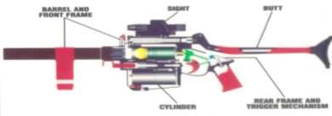

**40mm Multi Shot Grenade Launcher ke Mukhya Bhag**

1. **Cylinder Group**.Cylinder group ko launcher ke beech mein lagaya gaya hai. Cylinder ka mukhya kaam 6 grenade ke liye housing ka kaam karna hai. Cylinder group ke mukhya bhag aur unke kaam is prakar se hain:-

* 1. **Cylinder**. Cylinder ki lambai 100mm aur bahri dia 135 mm hai. Cylinder aluminium ka bana hai aur ise is prakar se design kiya gaya hai ki 6 grenades ko bhara ja sake.
  2. **Release Handle**. Release handle ke mukhya 2 kaam hain jo ki is prakar se hain:-
     1. Rear frame ko kholna jiske liye release handle ko aage ki taraf khinchana padata hai.

* + 1. **Extractor ko Activate Karna**. Release handle ko peeche ki taraf dabane se iske sath jude extractor ke dwara fired case aur cylinder mein bhare grenade ko bahar nikala jata hai.

1. **Rear Frame and Trigger Mech Group**. Rear frame aur trigger assembly ko launcher ke pichhle hisse mein lagaya gaya hai. Iska kaam grenade ko sahi tariqe se fire karne mein madad dena hai. Rear frame aur trigger mech group ke mukhya hisson ke naam aur kaam is prakar se hain:-

* 1. **Pistol Grip**. Pistol grip nylon ka bana hai aur ise screw ki madad se rear frame par joda gaya hain. Pistol grip shist lete samay aur firing ke dauran majbooti se pakadne mein madad karta hain.

* 1. **Rear Frame**. Rear frame steel ka bana hain aur ismein trigger mechanism ko lagaya gaya hain.

* 1. **Trigger Mechanism**. Trigger mechanism steel ka bana hai aur iske mukhya bhag trigger, hammer assembly, firing pin, firing pin assembly aur safety lever hote hain.

* 1. **Hammer Assembly**. Hammer assembly steel ka bana hua hain aur iske mukhya hisse hammer, spring aur alignment pin hote hain .

1. **Sight Assembly**. Sight assembly ko launcher ke sabse upar fit kiya gaya hain aur iske mukhya hisse is prakar hain:-

* 1. **Range Plates**. Range plate par 0 se 375m tak ke ank khude hain jismein 50 mtr ke baad 300 mtr tak 25-25 mtr ka antraal main range lagaya ja sakta hain.

* 1. **Sight**. Sight ka kaam hathiyar se shist lena hai. Sight ka naam Occluded Eye Gun Sight hain aur iski madad se target par donon ankhon ko kholkar shist liya jata hain. Sight ko kharab mausam mein bhi istemal kiya ja sakta hai jahan tak target dikhai de raha ho. Sight ke vertical red bar ki madad se target ke range ka anumaan bhi lagaya ja sakta hai yeh 200mtr ke range par target ke barabar hota hai.

1. **Butt Group**. Butt group ko multi shot grenade launcher ke sabse akhir mein fit kiya gaya hai. Butt ka kaam firing ke dauran support pradan karna aur kandhe se fire karne mein madad karna hai. Butt ki lambai 300mm hoti hai aur butt ke sabhi hisse steel ke bane hote hain, butt plate ko chodkar jo ki nylon ki bani hai. Butt ko teen alag-alag position mein set kiya ja sakta hai.

**LESSON-2**

**40MM MULTI SHOT GRENADE LAUNCHER MK-I SE WAQFIAT,**

**KHOLNA, JORNA AUR SAFAI KA TARIQA**

**(Multi Shot Granade Launcher MGL-40)**

**Shuru Shuru ka Kaam**.

1. Is mein nimn karwai ki jayegi:-

(a) Bandobast ki karwai

(b) Class ki ginti groupon mein bant

(c) Hathiyar saman ka nirikshan.

**Dohrai**.

1. Dohrai pichhle sabak se do sawal puch kar liya jaye.

**Pahunch**.

1. 40mm Multi Shot Grenade Launcher ko Infantry Platoon mein shamil kiya gaya hai. Infantry platoon se sambandhit hathiyar hone ke karan zaruri hai ke har jawan ko is hathiyar ke bare mein jankari ho.

**Uddesh**.

1. 40mm Multi Shot Grenade Launcher se waqfiat, kholna jorna aur safai karne ka tariqa sikhana hai.

**Saman**.

1. 40mm MGL, Cleaning kit holdall, Board, Easel, Ground sheet, Chalk aur Duster.

**Bhagon Mein Bant**.

1. Sabaq teen bhagon mein chalaya jayega:-

(a) **Bhag-I** - 40mm MGL ki visheshtayen aur technical data

(b) **Bhag-II** - Kholna, hisse purjon ke naam, kaam aur jorna

(c) **Bhag-III** - Accessories se jankari aur safai karne ka tariqa.

(a) **Bhag-I : 40mm MGL Ki visheshtayen aur technical data**

**Visheshtayen**.

(a) Yeh hathiyar South Africa ka bana hua hain.

(b) Is mein ek sath 6 grenade bhar sakte hain.

(c) Is ka sight system upar diya gaya hai aur isse shist lete samay donon ankhon ko khula rakha jata hain.

(d) Isse point target aur area target ko barbad kar sakte hain.

(e) Ek jawan asani se carry aur handling kar sakta hain.

(f) Iske sight se target ka range bhi pata kar sakte hain.

**Technical Data**.

|  |  |  |  |
| --- | --- | --- | --- |
|  | Calibre | - | 40mm Inner, 44mm Outer |
|  | Weight | - | 5.3kg |
|  | Lambai Butt Extended | - | 778mm |
|  | Lambai Butt folded | - | 566mm |
|  | Barrel ki Lambai | - | 300mm |
|  | Butt ki lambai | - | 300mm |
|  | Cylinder ki lambai | - | 100mm |
|  | Cylinder ka dia | - | 135mm |
|  | Muzzle velocity | - | 76m/sec |
|  | Barrel ki banawat | - | Steel |
|  | Cylinder ki banawat | - | Aluminium |
|  | Grooves | - | 06 (RH) |
|  | Rifling pitch | - | 1200mm |
|  | Safety distance | - | Trg-80mtr & Operational-30mtr |
|  | Arming distance | - | 9-28mtr |
|  | Sight | - | Occulded eye Gun Sight |
|  | Range | - | Min-50tr, Max-375mtr |
|  | Sidhant | - | Semi automatic gas operated |
|  | Killing Area | - | 5mtr |
|  | Barrel ki life | - | 5000gren |
|  | Applied safety | - | Safety catch |
|  | Mech safety | - | Index pin, Drop safety & Hung fire |
|  | Rate of fire | - | 18 gren/min (Practical) |
|  | Max rate of fire | - | 06 gren/3 sec |
|  | Origin | - | South Africa |
|  | Point target | - | 50 se 150mtr |
|  | Area Target | - | 150 se 375mtr |

**Ammunition**. 40mm Multi Shot Grenade Launcher mein 6 prakar ka ammunition fire kiya jata hain.

(i) HEAP (HIGH EXPLOSIVE ANTI PERSONAL)

(ii) HEDP (HIGH EXPLOSIVE DUAL PURPOSE)

(iii) SBRP (SMOKE BURSTING RED PHOSPHORUS)

(iv) TMO (TARGET MARKER ORANGE)

(v) TP (TRAINING PURPOSE)

(vi) MITA (MGL INERT TRAINING AMMUNITION)

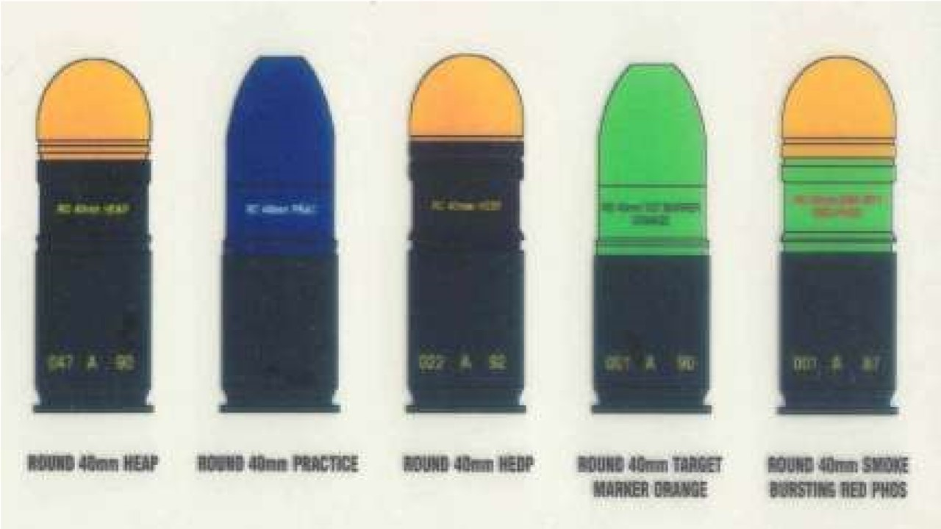

**40MM MGL AMMUNITION**

(i) **High Explosive Anti Personal (HEAP)**

|  |  |  |  |
| --- | --- | --- | --- |
|  | Wazan | - | 277gms |
|  | Lambai | - | 103mm |
|  | Projectile ki lambai | - | 82mm |
|  | Projectile ka wazan | - | 180gms |
|  | Killing area | - | 5mtr radius |
|  | Explosive (RDX & TNT) | - | 40gms (60:40) |
|  | Arming distance | - | 9-28mtr |
|  | Safe distance | - | 0-9mtr |
| (j) | Fragmentation | - | 425 (Pre pattern steel cup size) |
| (k) | Fragmentation ka wazan | - | 120mg  Size 3x3x2 |
| (l) | Fuse | - | Nose percussion PDM-851 |

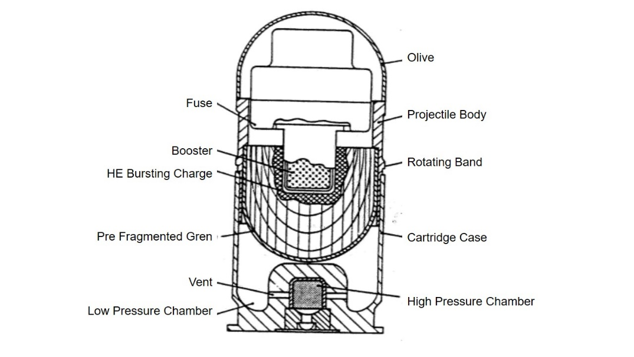

**High Explosive Anti Personnel Cut Section**

(ii) **High Explosive Dual Purpose (HEDP)**

|  |  |  |  |
| --- | --- | --- | --- |
|  | Wazan | - | 227gms |
|  | Lambai | - | 103mm |
|  | Projectile ki lambai | - | 82mm |
|  | Projectile ka wazan | - | 180gms |
|  | Arming distance | - | 9-28mtr |
|  | Pentration | - | 50mm Armr Plate  400mm Concrete |

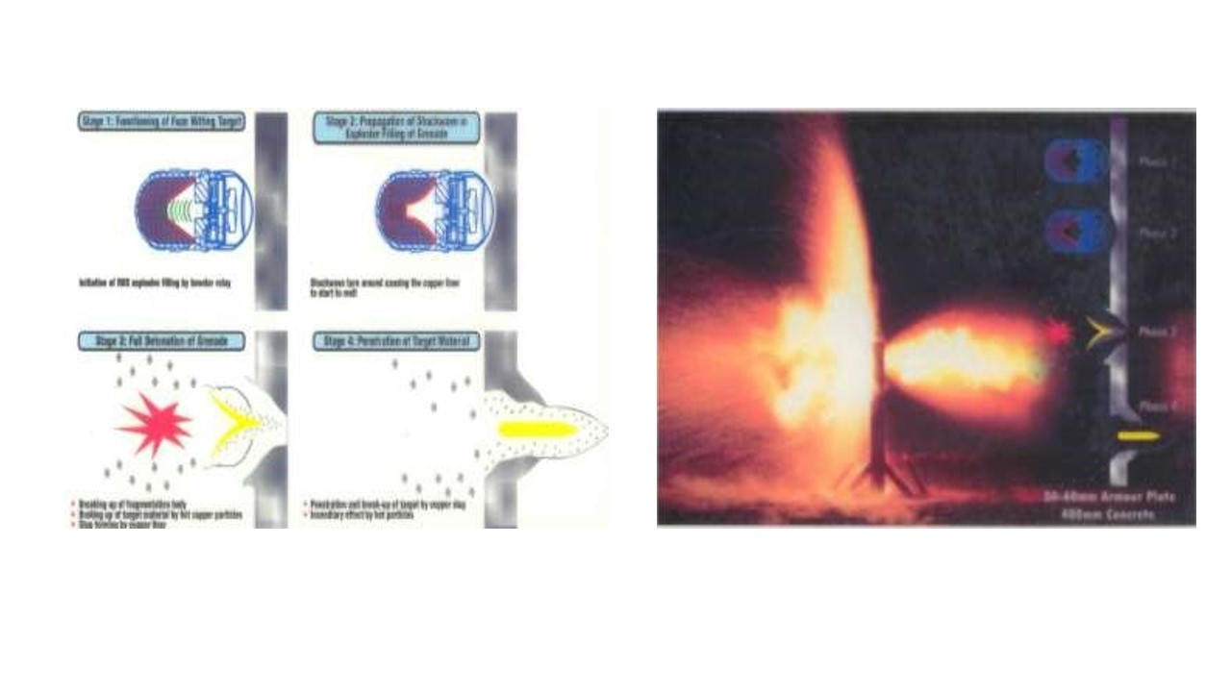

**HEDP Gren ki Chal**

**HEDP Pentration**

(iii) **Smoke Bursting Red Phosphorus** (**SBRP)**

|  |  |  |  |
| --- | --- | --- | --- |
|  | Wazan | - | 225gms |
|  | Lambai | - | 103mm |
|  | Projectile ki lambai | - | 82mm |
|  | Projectile ka wazan | - | 175gms |
|  | Arming distance | - | 9-28mtr |
|  | Red Phosphorus | - | 32gms |
|  | Dhuan ka samay | - | 45sec |
|  | Dhuan ka parda | - | 10mtr radius |

(iv) **Target Marker Orange (TMO)**

|  |  |  |  |
| --- | --- | --- | --- |
|  | Wazan | - | 227gms |
|  | Lambai | - | 101mm |
|  | Smoke emission | - | 2 min se jyada |
|  | Colour | - | Highly visible orange |

(v) **Practice**

|  |  |  |  |
| --- | --- | --- | --- |
|  | Wazan | - | 226gms |
|  | Lambai | - | 101mm |
|  | Projectile ki lambai | - | 75mm |
|  | Projectile ka wt | - | 174gms |
|  | Arming distance | - | 9 se 28mtr |
|  | Range | - | 200 se 260mtr |

(v) **MGL Inert training ammunition (MITA)** Training ke liye istemal kiya jata hain.

7. **High Explosive Anti Personnel/High Explosive Dual Purpose Grenade ki Mark kshamta.** High explosive anti personal / high explosive dual purpose grenade ki mark kshamta ka area 5 mtr radius hai jismein 50% casualty ki umeed ki jati hai. Grenade High Explosive Anti Personnel aur High Explosive Dual Purpose ke 6 grenade ki mark kshamata ka area 60 mtr x 20 mtr hai. 6 grenade ka marak area diagram ki madad se niche dikhaya gaya hai.



**High Explosive Anti Personnel / High Explosive Dual Purpose ka Mark Area**

**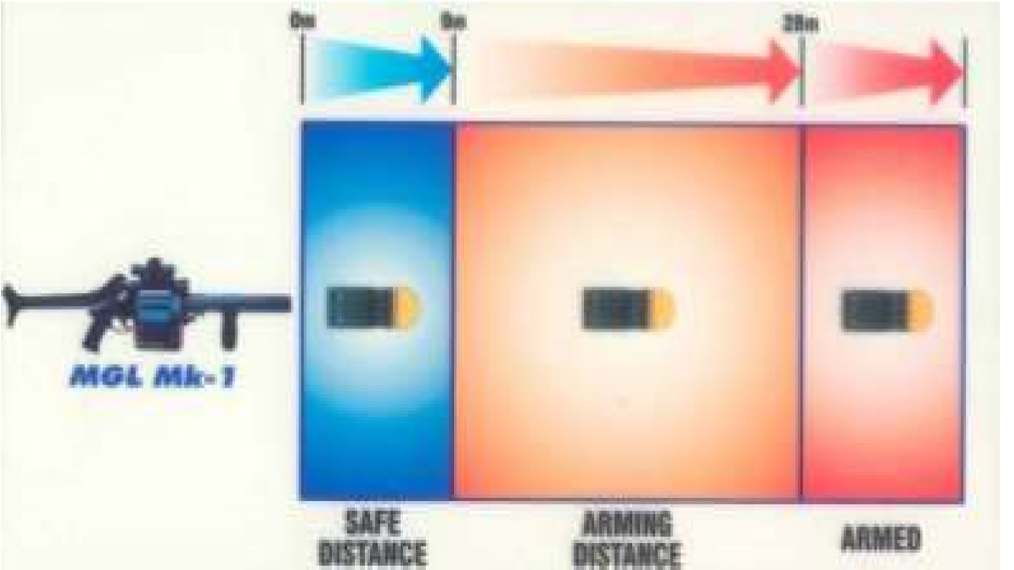  
  
SAFE ARMING DISTANCE**

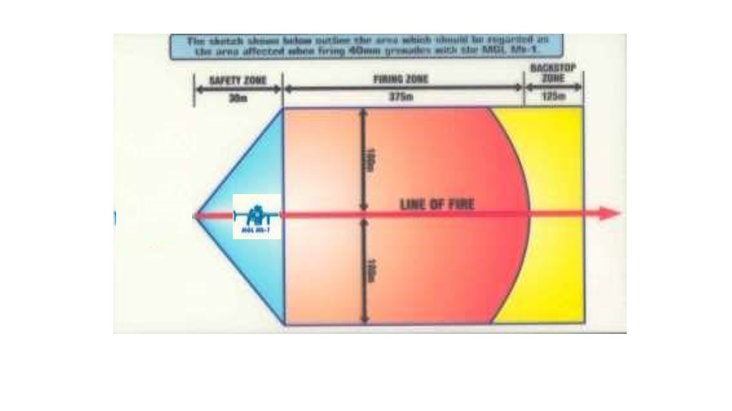

**DA TEMPLATE**

**Bhag-II : Kholna hisse purjon ke naam, kaam aur jorna**

7. Kisi bhi hathiyar ki saaf safai aur purjon ki tutfut ko badli karne ke liye kholne ki zarurat padti hai. Usi prakar se 40 mm Multi Shot Grenade Launcher ko bhi kholne ki zarurat pad sakti hai. 40mm Multi Shot Grenade Launcher   
5 bhagon mein banta gaya hai:-

1. Barrel with front frame group.
2. Cylinder group.
3. Sight group.
4. Rear frame aur trigger mechanism group.
5. Butt group.

8. **Kholna**. Ek firer ko MGL mein kewal gas plug aur index mechanism cover hi kholna ki zarurat padti hai. Isse jyada hisse purjon ko kabhi bhi ek firer na khole, kyonki iske liye special tool ki zarurat padti hai. Yeh tool ek firer carry nahi karta hai.

(a) Sabse pehle jakin kare ki MGL unwind hain.

(b) Sight ko zero par karen.

(c) Produding Gas plug locking spring ko 5mm allen key ki madad se dabate hue gas plug ko anti clockwise ghumaye aur sidha upar uthate hue bahar nikalen.

(d) Index mechnaism cover ko kholne ke liye manual release catch ko dabate hue upar ki taraf nikalen.

1. **Hisse Purjon ke Naam**.

* 1. **Barrel with Front Frame**. Barrel, Hand grip, Front frame, Front sling loop, Release handle, Gas pot.
  2. **Cylinder Group**. Cylinder, Ejector assy, Index pin hole, Center pin, Stopper, Index mechanism cover.
  3. **Rear Frame with Trigger Mechanism**. Rear frame locking plate, Index pin, Firing pin, Firing pin locking plate, Pistol grip, Trigger mechanism, Safety catch.
  4. **Sight Group**. Range plate, Plunger, Range indicator, Red bar, Elevation screw aur Deflection screw.

* 1. **Butt Group**. Butt release plate, Butt plate, Rear sling loop.

1. **Jorna**. Gas plug ko gas pot mein dakhil karen. Produding spring ko kisi 5mm allen key se dabate hue gas plug ko clock wise ghumate hue joren. Index mechanism cover ko lagayen.

**Bhag-III : Accessoriess se waqfiat aur safai karna**

1. Yeh hathiyar kafi low maintenance hathiyar hai. Phir bhi kisi bhi hathiyar ki zindagi uske maintenance ke upar nirbhar karta hai.

(a) **Accessories**

(i) Cleaning kit holdall (Tool rool)

(ii) Cleaning rod 2 section

(iii) Copper with Nylon brush

(iv) Mob brush

(v) Brush cleaning small arms/gas cylinder brush

(vi) Allen key 5 mm long series

(vii) Applicator bottle

(viii) Storage aur Transport Box

(ix) User pamphlet

(x) Sling

1. **Safai karne ka tariqa**. Safai karne ke liye launcher ko kholen, brush cleaning small arms ki madad se gas pot ki safai karen. Cleaning rod ke 2 section ko joren aur uske sath copper with nylon brush ko joren. Launcher ko pura wind karen aur barrel tatha cylinder ki safai karen. Pehla cylinder saaf hone ke baad manual release catch ki madad se cylinder ko aage karen aur dusre cylinder ki bhi usi tarah safai karen. Is prakar barrel aur cylinder donon ki ek sath safai ki jati hai.

1. **Lubrication**. Niminlikhit tapman mein prayog karne hone wale lubricant ki suchi is prakar hai:-

|  |  |  |
| --- | --- | --- |
| **Istemal** | **Tapman** | **Lubricant** |
| Body aur trigger mech ke sabhi purje | 4 degree C se adhik tapmaan  4 degree C se -18 degree C  -18 degree C se -40 degree C  -40 degree C se -50 degree C | Oil OX 52  Oil OX 13  Oil OX 13 + Superior quality K/Oil 1:1(ASC/9140-000008)  Oil OX 13 + Superior quality K/Oil 2:3 |

1. **Sankshep**. Sabhi bhagon se sawal kiye jayen.

**LESSON-2**

**40MM MULTI SHOT GRENADE LAUNCHER KI FIRING POSITION, BHARNA, KHALI KARNA, FIRE AUR MISFIRE**

**Ref - (Multi Shot Granade Launcher MGL-40)**

**Shuru Shuru Ka Kam**.

1. Is mein nimn karwai ki jayegi:-

(a) Bandobast ki karwai.

(b) Class ki ginti aur groupon mein bant.

(c) Hathiyar saman ka nirikshan.

**Dohrai**.

1. Dohrai pichhle sabak se do sawal puch kar liya jaye.

**Pahunch**.

1. 40mm Multi Shot Grenade Launcher ek semi automatic hathiyar hai, isse area target ko barbad karne ke sath sath dushman ke bunker par assani se fire dal sakte hain. Ek infantry platoon ka hathiyar hone ke karan zaruri hai ki sabhi jawanon ko iski firing position, bharna, khali karna fire aur misfire hone par karwai karne ka tariqa aana chahiye.

**Uddesh**.

1. 40mm Multi Shot Grenade Launcher ki firing position, bharna khali karna, fire aur misfire hone par karwai karne ka tariqa sikhana hai.

**Saman**.

1. 40mm Multi Shot Grenade Launcher, Drill grenade, Fig 11 tgt, Board, Easel, Duster, Chalk aur Ground Sheet.

**Bhagon Mein Bant**.

1. Yeh sabak 4 bhagon mein chalaya jayega:-

(a) **Bhag-I** - 40mm Multi Shot Gren Launcher ki firing position

(b) **Bhag-II** - Bharna aur khali karna

(c) **Bhag-III** - Range lagana aur Shist lene ka tariqa

(d) **Bhag-IV** - Fire aur Misfire hone par karwai karne ka tariqa

(a) **Bhag-I** : **40mm Multi Shot Gren Launcher ki firing position.**

Firing position bataon use pehle butt ki posn batana zaruri samajta hon taki apko posn lene men assani ho. Multi Shot Gren Launcher ke butt ki 3 posn hain:-

(i) Folded Butt

(ii) Semi extended Butt

(iii) Fully Extended Butt

(i) **Folded Butt**

**Zarurat**. Jab launcher ko istemal mein na laya ja raha ho ya kote mein rakhna ho, us samay folded butt mein rakha jata hai.

**Karne ka Tariqa**. Bayen hath ke anguthe aur kalme wali ungli ki madad se butt release plate ko ander ki taraf dabayen. Dayen hath ki madad se butt ko upar ki taraf harkat den, butt release plate ko chod den butt ko tab tak harkat den jab tak click ki awaz na aa jaye.

(ii) **Semi Extended Butt**

**Zarurat**. Jab launcher ko 150 mtr se adhik range par fire karna ho us samay semi extended butt lagaya jata hai.

**Karne ka Tariqa**. Dayen hath ke anguthe aur kalme wali ungli ki madad se butt release plate ko ander ki taraf dabayen. Bayen hath ki madad se butt ko upar ki taraf harkat den, butt release plate ko chod den butt ko tab tak harkat den jab tak click ki awaz na aa jaye.

(iii) **Fully Extended Butt**.

**Zarurat**. Jab launcher ko 150 mtr se kam range par fire karna ho to fully extended butt ko lagaya jata hai.

**Karne ka Tariqa**. Bayen hath ke anguthe aur kalme wali ungli ki madad se butt release plate ko ander ki taraf dabayen. Dayen hath ki madad se butt ko niche ki taraf harkat den, butt release plate ko chod den butt ko tab tak harkat den jab tak click ki awaz na aa jaye.

**Firing Position.** 40mm Multi Shot Gren Launcher se hum 4 parkar ki firing posn se fire karte hain.

(i) Standing Position

(ii) Kneling Position

(iii) Sitting Position

(iv) Lying Position

(i) **Standing Position**.

**Zarurat** Yeh posn us samay ikhtyar kiya jata jab arh 4 ft se 4.5 ft ki ho ya fire trench se fire karne ki zarurat pare toh standing posn se fire kiya jata hain.

**Position lene ka tariqa** Bayen paon ko tgt ki seedh main aage rakhen aur dayen paon ko dayen aur thoda peeche rakhe. Is posn mein dekhne wali baten :-

(aa) Bayen paon tgt ki sidh mein.

(ab) Donon paon kad ke mutabik khule huye ho.

(ac) Bayen hath ki pakar front grip par.

(ad) Dayen hath ki pakar pistol grip par charon unguliyan bahar se angutha andar se, kalme wali unguli trigger se bahar.

(ae) Dayen khuni zamin ke samantar.

(af) Donon ankhen khuli hui nigah samne.

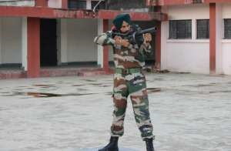

**Standing Position**

(ii) **Kneeling Position**.

**Zarurat** Yeh posn us samay ikhtyar kiya jata jab arh 2 ft se 2.5 ft ki ho ya niche se upar ki taraf fire karne ki zarurat pare toh kneeling position se fire kiya jata hain.

**Position lene ka tariqa** Bayen paon ko tgt ki seedh main aage rakhen aur dayen ghutne ke bal kneeling position ikhtiyar karen. Is posn mein dekhne wali baten:-

(aa) Bayen paon tgt ki sidh mein.

(ab) Dahina ghutna pura dahine aur zamin par laga hua body weight dahine paon ki eddi par ho.

(ac) Bayen hath ki pakar front grip par aur bayen hath ki kohini bayen khutne ke upar.

(ad) Dayen hath ki pakar pistol grip par charon unguliyan bahar se angutha andar se, kalme wali unguli trigger se bahar.

(ae) Dayen khuni zamin ke samantar.

(af) Donon ankhen khuli hui nigah samne.

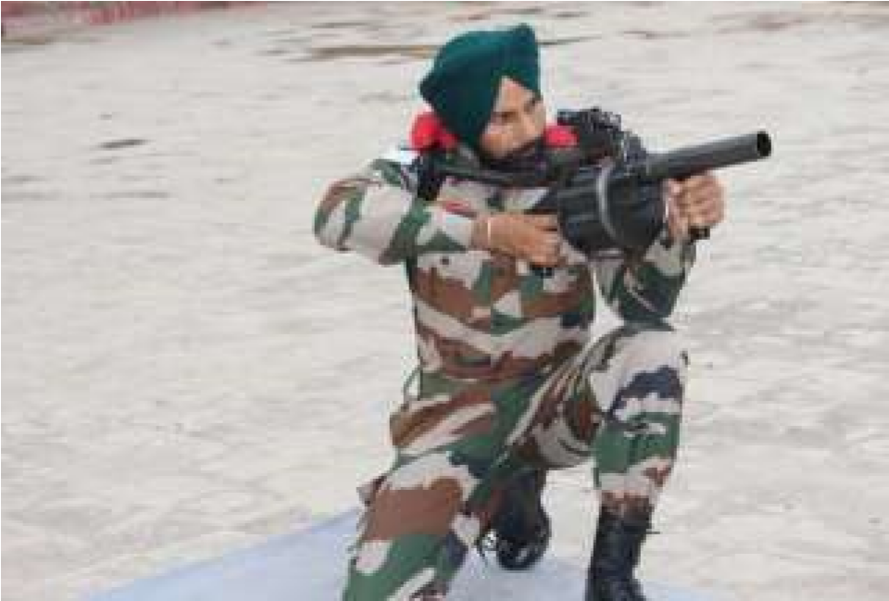

**Kneeling Position**

(iii) **Sitting Position**.

**Zarurat** Yeh posn us samay ikhtyar kiya jata jab upar se niche ki taraf ya dhalandar zamin par fire karne ki zarurat pare toh sitting position se fire kiya jata hain.

**Position lene ka tariqa** Bayen paon ko tgt ki seedh main aage rakhen aur dayen paon dayen, donon paon kadh ke mutabik hon. Launcher ko bayen hath main pakden aur butt bayen kandhe ke upar aur dayen hath ko zamin per lagate hua sitting position ikhtiyar karen. Is posn mein dekhne wali baten:-

(aa) Bayen paon tgt ki sidh mein aur dayen paon dayen aur donon eriyan zamin per lagi hui panje aasan ko point karte hua.

(ab) Dono kohniyan donon gutne ke upar.

(ac) Bayen hath ki pakar front grip par aur bayen hath ki kohini bayen khutne ke upar.

(ad) Dayen hath ki pakar pistol grip par charon unguliyan bahar se angutha andar se, kalme wali unguli trigger se bahar.

(ae) Dayen kohini dayen ghutne ke upar.

(af) Body weight seat ke upar.

(ag) Donon ankhen khuli hui nigah samne.

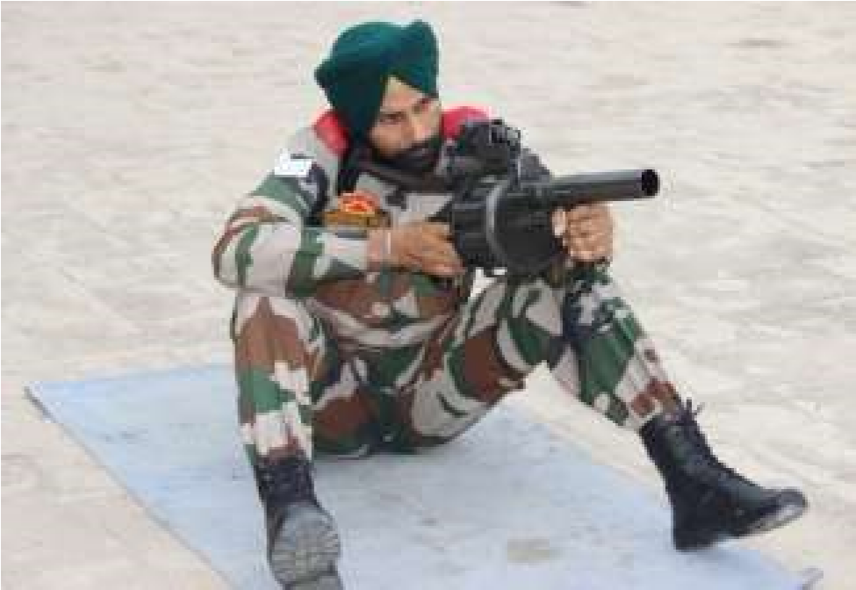

**Sitting Position**

(iv) **Lying Position**.

**Zarurat** Yeh posn us samay ikhtyar kiya jata jab arh 1 feet ya usse niche ki ho ya khule maidan main fire karne ki zarurat pare toh lying position se fire kiya jata hain.

**Position lene ka tariqa** Dayen paon ko tgt ki seedh main aage rakhen aur bayen paon ko chalti halat main aage len launcher ko bayen hath main pakde aur butt ko bayen kandhe per rakhen, dayen hath se zamin per lagate hue lying position ikhtiyar karen. Is posn mein dekhne wali baten:-

(aa) Target, launcher, firer ka dayen kandha aur dayen tang ek sidh main honi chaiya.

(ab) Donon kohniyan zami per lagi hui.

(ac) Badan line of fire se tirchha ho.

(ad) Dayen hath ki pakar pistol grip par charon unguliyan bahar se angutha andar se, kalme wali unguli trigger se bahar. Khada hone ke liye launcher ko bayen kandhe per rakhe aur dayen tang ko close karen aur dayen hath ka sahara lete hua khade ho jaye.

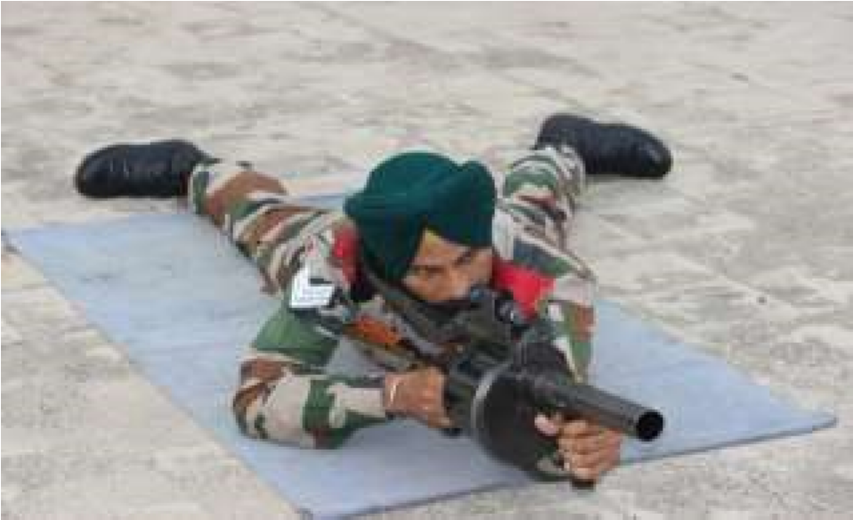

**Lying** **Position**

(b) **Bhag-II** : **Bharna aur khali karna.** Jab firer ko fire karne ki zarurat ho ya trg ke dauran addesh mile bhar to karwai is prakar se karen:-

**Bharna.** Sabse pehle grenade ko bahar nikalen aur mulahija karen agar grenade ki body dabi ho to aise grenade ka istemal na kiya jaye. Agar grenade thik ho toh, grenade ko saaf karen aur saaf jagah par rakhen.

(i) Barrel ko surakshit disha main karen.

(ii) Safety catch ‘S’ per karen, manual release catch ko dabate hue zakin karen ki launcher unwind hain.

(iii) Barrel ko niche ki taraf rakhte hue launcher ke rear frame ko kholen.

(iv) Cylinder ka nirikshan karen agar dhul, mitti ho to saaf kapde ya chindi ki madad se saaf karen.

(v) Dahine hath ki madad se cylinder ko wind karen.

(vi) Saaf kiye hua grenade ko len aur pehle grenade ko barrel ki seedh wale cylinder mein dakhil karen. Baki grenade ko anti clock wise ek ek karke bharen. Rear frame ko band karen. Sight par 50mtr range lagayen.

**Khali karna**. Jab firer ko fire karne ki zarurat na ho ya training ke dauran addesh mile bagair fire khali kar to karwai is parkar se karen:-

(i) Barrel ko surakshit disha mein karen.

(ii) Yakin karen ki safety catch ki position ‘S’ par hai.

(iii) Manual release catch ko dabaen aur cylinder ko unwind karen.

(iv) Release handle ko anguthe ki madad se khinche aur rear frame ko kholen.

(v) Bayen hath ki madad se release handle ko andar ki taraf dabayen aur ek ek karke grenade ko bahar nikalen aur saaf jagah par rakhen.

(vi) Rear frame ko band karen. Range ko down karen.

(vii) Grenade ko pouch mein band karen.

(c) **Bhag-III** : **Range lagana aur shist lena**j Range lagana aur shist lena bataun use pahle zaruri samjhta hun ki aapko sight ke hisse purje ke naam nataye jayen taki shist lene main assani hon. 40mm MGL ki sight Occluded Eye Gun Sight hai (OEG). Iske niminlikht hisse hai:-

Eye glass, Glass protector, Red bar, elevation screw, deflection screw, range plate, left and right plunger, range indicator arm left and right.

**Range Lagana**

(i) **Din ke samay**. Range milne par dayen hath ke anguthe aur kalme wali ungali ki madad se plunger ko dabate hue range indicator arm ko mile hue range ke seedh mein milayen aur plunger ko chhod den. Yeh the din ke samay rg lagane ka tariqa.

(ii) **Raat ke samay**. Is sight ka istemal kam roshini ya raat ke samay bhi kiya ja sakta hain jahan er tgt dikhai de raha hon. 40mm Multi Shot Grenade Launche ki range plate par 375 mtr tak ka range hasil kiya ja sakta hai. Bhar ki karwai karne ke baad sight par 50 mtr range laga diya jata hai. Sight par bayen wale plunger ko andar aur upar ki taraf dabate hue 25mtr rg hasil hoga. Is parkar bina dekhe 25- 25 mtr ke antral mein 300 mtr tak range lagaya ja sakta hai. 375 mtr range hasil karne ke liye donon plunger ko andar ki taraf dabate huye sight ko pura upar karen.

(iii) **Shist lene ka Tarika**. 40mm Multi Shot Grenade Launcher mein OEG sight ki suvidha hone ke karan donon aankhon ko khula rakhte hue shist liya jata hai. Target aur red bar ko dekhen. Jaise hi red bar target ke point of aim par mil jata hai toh durust shist mana jata hai.

(iv) **Range Estimation**. Red bar ko range estimation ke liye bhi istemal kiya ja sakta hai. Agar red bar kisi human target ko barabar cover karta hai to target ka range 200 mtr mana jata hai. Agar red bar bada aur target chhota dikhai de toh range 200 mtr se jyada mana jata hai. Agar red bar chhota aur target bada dikhai de toh target ka range 200 mtr se kam mana jata hai. (Range estimation ustad ke dwara board ki madad se bataya jayen).

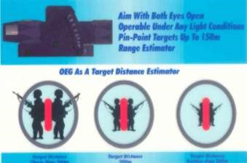

**Range Extimation**

(d) **Bhag-IV** : **Fire aur misfire per karwai.** 40mm Multi Shot Grenade Launcher mein trigger operation ki karwai baki hathiyaron ki tarah hi hoti hai. Is hathiyar mein bhi trigger ke do khinchav hain. Pahle halka aur lamba khinchav aur dusra chotta aur sakhat khinchav.

(i) **Fire Karne ka Tarika**. Bhar ki karwai karne ke baad, diya hua range sight par lagayen, launcher ko kandhe par le jayen. Target ko dekhen aur trigger ke pehla khinchav hasil karen, durust shist milne par trigger ka dusra khinchav bhi hasil karen. Is prakar trigger press karne se grenade fire ho jata hai. Grenade fire ho jane ke baad target area mein grenade ki mar ko dekhen. Ek firer 1 min mein 18 grenade fire kar sakta hai.

(ii) **Stop**. Agar firing ke dauran target area mein koi jaandar vastu aa jaye ya training ke dauran addesh mile ‘**STOP’** toh butt kandhe ka milap toren, launcher ko kandhe se niche layen, safety catch ki position ko ‘S’ par karen aur agle hukum ka intezar karen.

(iii) **Jari Kar**. Agar target area se jaandar vastu hat jaye ya training ke duran adesh mile ‘**GO ON’ ya ‘JARI KAR’** to safety catch ki position ko fire par karen, butt kandhe ka milap karen aur durust shist lete hue launcher ko fire mein shamil karen.

(iv) **Misfire hone par Karwai**. Agar trigger ko press karne par grenade fire na ho ya training ke dauran adesh mile ‘**FIRE NAHI’** to pakad aur shist ko kayam rakhte huye trigger ko teen baar press karen. Agar teen baar trigger ko press karne ke baad bhi grenade fire na ho ya adesh mile ‘**PHIR FIRE NAHI’** toh pakad aur shist ko kayam rakhte hue 30 sec ka waqfa den. Agar 30 sec ke waqfa dene ke baad bhi grenade fire na ho ya adesh mile ‘**PHIR BHI FIRE NAHI**’ toh agar aap operation area mein hain toh manual release catch ko dabate hue agle cylinder ko barrel ki seedh mein layen aur fire ko jari karen. Agar training ke dauran launcher ka istemal kar rahe hon to durust khali kar ki karwai karen, grenade ke primer ko check karen, agar primer par chot na ho toh firing pin ka badli karwayen. Agar primer par chot ho toh misfire grenade ko firing position se 10 mtr aage aur dahine rakhen. Rear frame ko bandh karen. Manual release ko dabate hue agle cylinder ko barrel ki seedh mein layen aur fire ko jari karen. (Misfire grenade ko blind samajhkar barbad kar diya jaye). Misfire hone ke karan:-

* 1. Firing pin ka ghis jana ya tuta hona.
  2. Grenade ke primer mein nuqs hona.

(v) **Abhiyas ke liye Aadesh**.

(a) Fire nahi ke addesh per Trigger ko 3 baar press karen.

(b) Phir fire nahin ke addesh per 30 sec ka waqfa den.

(c) Phir Bhi fire nahin ke addesh per misfire khali kar ki karwai karen.

**Sankshep**. Sabhi bhagon se sawal kiye jayen.

**LESSON-3**

**40MM MULTI SHOT GRENADE LAUNCHER KA MECHANISM**

**KE BARE MAIN JANKARI**

**Ref - (Multi Shot Granade Launcher MGL-40)**

**Shuru Shuru Ka Kam**.

1. Is mein nimn karwai ki jayegi:-

(a) Bandobast ki karwai.

(b) Class ki ginti aur groupon mein bant.

(c) Hathiyar saman ka nirikshan.

**Dohrai**.

1. Dohrai pichhle sabak se do sawal puch kar liya jaye.

**Pahunch**.

1. 40mm Multi Shot Grenade Launcher ko hamari sena main shamil kiya gaya hain iska pura faida uthane ke liye zaruri hain ki har jawan iske mechanism ke bare main janta hon taki rok parne par usko dur kar saken aur launcher ko fire main shamil kar saken.

**Uddesh**.

1. 40mm Multi Shot Grenade Launcher ka mechanism ke bare main jankari dena hain.

**Saman**.

1. 40mm Multi Shot Grenade Launcher, Assy bag, chalk a diagram ka board, Easel, Duster, Chalk aur Ground Sheet.

**Bhagon Mein Bant**.

1. Yeh sabak 3 bhagon mein chalaya jayega:-

(a) **Bhag-I** - Index mechanism ki chal

(b) **Bhag-II** - Trigger mechanism ki chal

(c) **Bhag-III** - Safety aur roken

(a) **Index mechanism ki chal**. Chal batane se pahle chal main kaam aane wale hisse purjon ke naam.

(i) Gas Plug

(aa) Piston

(ab) Cross Shaft

(ii) Index Mechanism

(aa) Manual release catch

(ab) Manual release projection

(ac) Manual release spring

(ad) Index Plate

(ae) Index plate hook

(af) Index plate projection

(ag) Index plate cam

(iii) Cylinder catch, cylinder catch spring

(iv) Toggle guide, toggle guide spring

(v) Cylinder

(aa) Chamber ka index pin

(ab) Cylinder stop

(ac) Cylinder stopper

**Winding ke dauran karwai**

(i) Jab cylinder ko wind karne ke liye anti clock wise ghumate hai toh index pin, index plate cam ko upar utha deta hai jisse index plate hook niche ki harkat karta hai.

(ii) Jab dusra index pin wind ke liye ata hai to index plate hook ko upar utha deta hai jis se cam niche ki harkat karta hai.

(iii) Jab index pin cam ke niche se gujarta hai to cam ko upar utha deta hai jisse hook niche ki taraf ata hai.

(iv) Yeh karwai tab tak jari rahti hai jab tak akhri index pin cam ko upar uthae hue age chala jata hain.

(v) Isi duran cylinder stop, stopper ke sath takrata hai. Ab cylinder spring ki taqat se clockwise ghumta hai.

(vi) Isi duran 1st wale chamber ka index pin, index plate ki hook ke sath takrata hai aur cylinder catch index pin ko lock karta hai ab chamber aur barrel ek sidh mein hote hai.

(vii) Yeh harkat cylinder ke pure ghumav ka 1/8 bhag hota hai.

**Note** :- Toggle guide spring index plate hook ko upar/niche rokne mein madad deta hai. Yadi ham cylinder ko pura wind ke bina chor dete hain to hum phir tab tak cylinder ko wind nahi kar sakte jab tak manual release catch ko na dabaen. Kyoki cylinder catch ne index pin ko lock kiya hota hain.

**Firing ke dauran karwai.**

(i) Gren fire hone se gas paida hoti hai jo ki gren ko age dhakelti hai.

(ii) Jab projectile gas port ke samne se gujarta hai, kuch gas piston ko upar utha deti hai. Jisse piston mein laga cross shaft index  
 mechanism hook ko upar utha deta hai aur hook aur index pin ka milap tut jata hai.

(iii) Cylinder spring ki taqat se apni harkat jari rakhta hai, isi duran dusra index pin cam ko upar uthata hai jisse hook niche ki harkat karta hain.

(iv) Jab index pin hook ke pass pahunchta hain toh hook dubara index pin ko rokta hai aur cylinder catch lock kar deta hai, ab dusra gren   
 barrel ki sidh mein aa jata hai.

(v) Yeh karwai tab tak jari rehti hai jab tak akhri gren fire hota hain.

(vi) Isi dauran cylinder barrel se 1/8 bhag aage ki harkat karta hai aur stop, stoper se takrakar ruk jata hai.

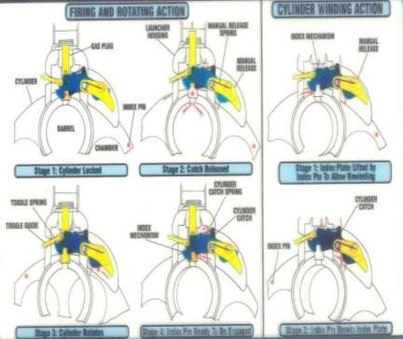

**Cylinder aur Index Mechanism**

(b) **Trigger mechanism ki chal**. Chal batane se pahle chal main kaam aane wale hisse purjon ke naam.

(i) Safety catch

(ii) Trigger

(iii) Trigger guide & spring

(iv) Trigger toe & spring

(v) Index Pin

(vi) Index pin guide hole

(vii) Hammer

(viiii) Hammer guide and spring

(ix) Firing pin

(x) Firing pin spring

**Safety catch ‘S’ par**. Safety catch ka gol wala bhag hammer guide ke pichhe aa jata hai, jisse trigger sear hammer ko play nahi kar pata. Kyoki hammer guide ko safety catch ka gol wala bhag pichhe jane se rokta hai. Is halat mein trigger ka toe hammer ke vent se azad nahi ho pata.

**Safety catch ‘F’ par**. Jab safety catch ko ‘F’ par karte hain to safety catch ka kata hua bhag hammer guide aur spring ke upar ho jata hai. Ab trigger press karne par trigger toe vent se azad ho jata hai aur trigger sear ki madad se hammer apni axis mein pichhe ki harkat karta hai. Isi duran index pin apne hole se nikal kar index pin guide hole mein chala jata hai. Trigger par lagatar dabav rehne se trigger sear aur hammer vent ka milap tut jata hai. Hammer, hammer guide ki taqat se aage ki harkat karta hain aur firing pin ke pichhe thokar marta hai. Jis se firing pin aage ki harkat karta hain aur gren ki primer par chot marta hai jis se gren fire ho jata hain. Firing pin spring apne tanav ko kam karte hue firing pin ko pichhe dhakelta hain, Isi dauran firing pin ka pichhe wala bhag hammer par thokar marta hai jisse hammer apni jagah par beth jata hai. Ab jab tak dubara hammer firing pin par chot nahin marega jab tak trigger release karke press na kiya jae. Kyoki trigger sear hammer vent se aage hota hai. Dubara trigger release karne par trigger sear aur hammer vent ka milap ho jat hain aur launcher fire ke liye tayar ho jata hain.

**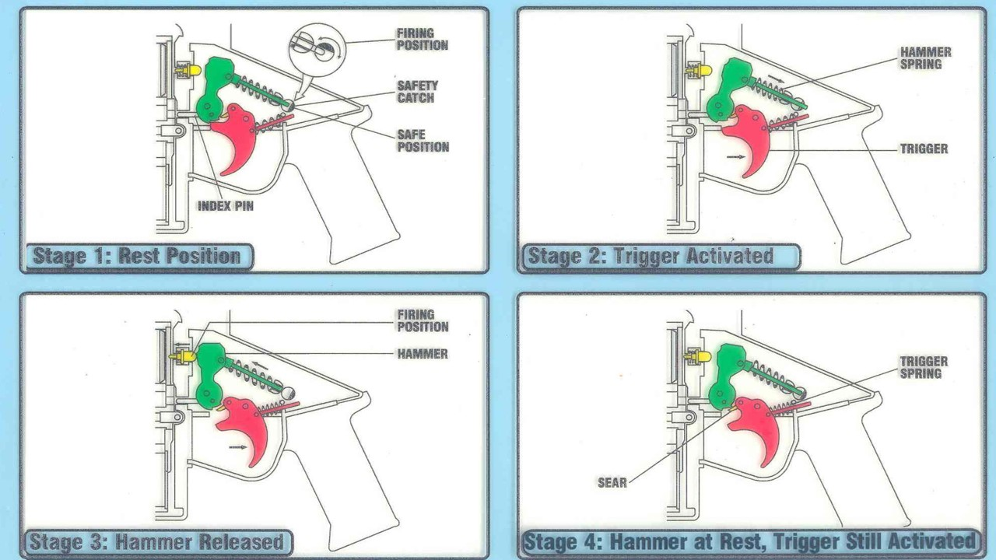  
  
  
  
  
  
  
  
  
  
  
  
  
 Trigger Mechanism**

(c) **Safety aur roken**. Safety do parkar ki hain.

(i) Applied Safety (ii) Mechanical safety

(i) **Applied safety**. Isme ek safety catch diya gaya hain jiski do posn hain “S’ aur ‘F’. Jab hum safety catch ko ‘S’ per karte hain toh safety catch ka gol wala bhag hammer guide piche jane se rokta hain,   
 jisse trigger press nahin hota hain.

(ii) **Mechanical Safety**. Mechanical safety teen parkar ki hain.

(aa) Index Pin Safety

(ab) Drop safety

(ac) Hung Fire

(aa) **Index Pin Safety**. Jab tak cylinder barrel ki sidh mein nahin hoga aur rear frame puri tarah se band nahin hoga aata hain tab tak index pin corresponding hole main nahin jata, tab tak trigger press nahi hota hain.

(ab) **Drop Safety**. Jab safety catch ki position ‘F’ par hota hain aur bhara hua MGL niche ghir jaye toh bhi fire nahi karega kyoki hammer per dabav parne se hammer vent per trigger sear,   
 triggr toe main phans jata hain jiske karan hammer firing pin per chot nahi mar pata hain.

(ac) **Hung Fire**. Kisi karan agar grenade fire nahi hoga to cylinder aage harkat nahi karega, jab tak pichla grenade fire nahi hoga. Isliye agar cylinder aage advance nahi hoga to cylinder barrel ki seedh mein hi rahega. Jab firer misfire ya hang fire drill ke baad manually cylinder ko advance nahi karta tab tak aage activate nahi hoga. Yadi trigger dabane se gren fire na ho to  
 dusra cylinder ko dahine aane ke liye gren fire hona parega, nahi to cyl ko manual release karna padega.

**Roken**

|  |  |  |  |
| --- | --- | --- | --- |
| **S No** | **Rok** | **Sambhav Karan** | **Fauri Ilaj** |
| (a) | Trigger ka press na hona | - Safety Catch ki position ‘S’ par.  - Cylinder ka poori tarah band na hona. - Cylinder ka poori tarah unwind hona. | * Safety catch ‘F’ par Karen.      * Cylinder ko poori tarah band karen.      * Cylinder ko wind karen. |
| (b) | Trigger press ke bawjood grenade  fire na ho | - Amn mein kami.    - Firing pin ka tootna ya trigger mechanism mein nuks. | * Missfire/hangfire drill karen.      * Armourer ki madad lein. |
| (c) | Cylinder ka age advance na hona | - Cylinder ka sahi wind na hona.  - Grenade ke primer ka firing pin ki seedh mein na hona. | * Cylinder ko sahi wind karen.      * Misfire drill ko karen aur firing pin hole ko saaf karen. |
|  |  | - Index  mechanism or gas plug ka dheela hona. | - Manual release ki madad se operate karen firing ke baad safai karen. Agar yeh karwai ke baad bhi launcher kaam na kare to armourer ko dikhayen. |
|  |  | Main spring mein nuqs hona. | - Armourer ko dikhayen. |

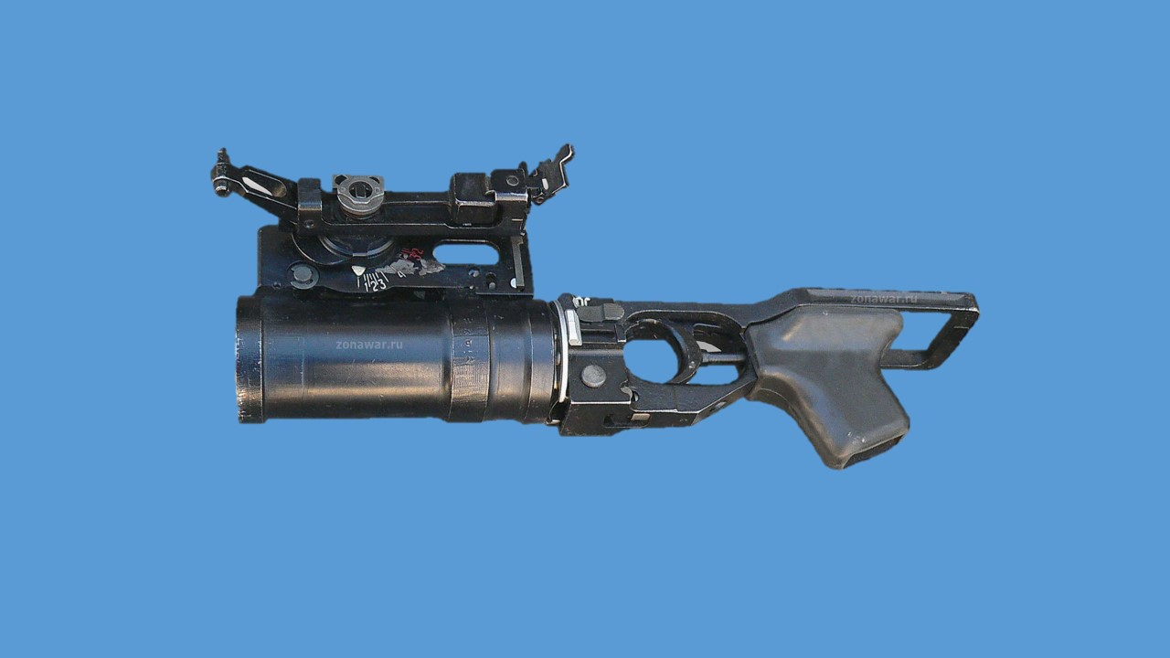

**40MM UNDER BARREL GRENADE LAUNCHER (GP-25) BULGARIA**

**CHAPTER-1**

**INTRODUCTION TO 40MM UBGL GP-25**

Ref - (Under Barrel Grenade Launcher, UBGL-2006)

1. **Parichay.** 40mm GrenadeLauncher se dushman ki khule mein chal rahi paidel sena ke sath sath bunker, pill box aur reverse slopes mein chupi hui Infantry par bhi fire daal sakte hain.UBGL ko full size assault rifle AKM, AKMS, AK47, AK74M, AK101,AK103 aur AN94 par fit karke fire kiya ja sakta hai.UBGL ko assault rifle par chada kar hi fire kiya ja sakta hai .Firer rifle aur grenade launcher dono ko ek sath bhi fire kar sakta hai lekin ye ladai ki halat par nirbhar karta hai.Is pustak se firer ko UBGL GP-25 ka technical vivran, parichalak anudesh, karyavidhi, hisse purjon ka vivran aur UBGL ki hadbandiyon ke bare mein jankari milegi.

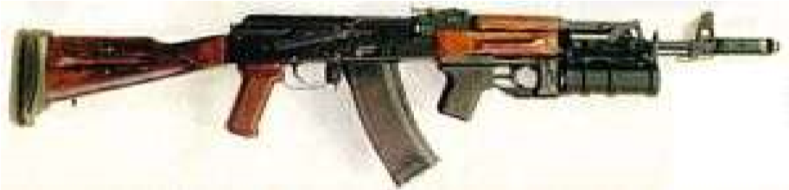

**40MM UBGL FITTED WITH AK 47 RIFLE**

1. **Tech Data.**

|  |  |  |  |  |
| --- | --- | --- | --- | --- |
|  | (a) | Calibre | - | 40mm. |
|  | (b) | Weight | - | 1.5kg. |
|  | (c) | Barrel ki Lambai | - | 98mm. |
|  | (d) | Sight Radius | - | 120mm. |
|  | (e) | Muzzle Velocity | - | 76mtr/sec. |
|  | (f) | **Range.** |  |  |
|  |  | (i) Direct | - | 50 se 400 mtr. |
|  |  | (ii) Indirect | - | 200 se 350 mtr. |
|  | (g) | Grooves | - | 12 (RH). |
|  | (h) | Rate of Fire | - | 4 se 5 grenade/minute. |

1. **Grenade Launcher ki Sub Assemblies.** UBGL nimnlikhit assemblies se milkar bana hai:-

(a) Barrel with support.

(b) Body with breech piece.

(c) Receiver cover latch unit.

(d) Damper with strip.

4. **Functioning of Assembly Units.**

1. **Barrel with Support.** Barrel with support group ki madad se UBGL ko Rifle AK-47 par chadaya jata hai. Barrel with support gp, Barrel support aur sight ko milakar banayagaya hai.**(Fig:1)** Aur sight ko support ke sath fit kiya gaya hai.

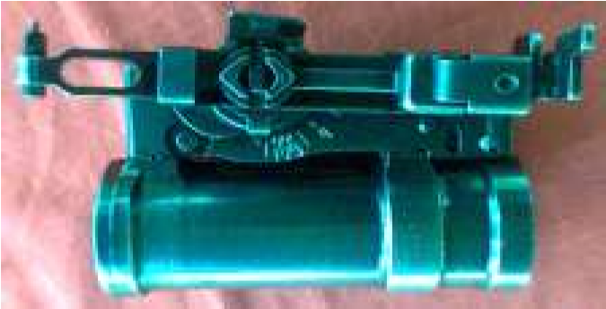

**3**

**1**

**2**

**Fig: 1 ( 1. Barrel 2. Support 3. Sight)**

1. **Barrel.** Barrel grenade ko sidhai deta hai. Barrel mein   
   12 grooves hote hain. Iska calibre 40mm hota hai. Barrel ke ander ek retainer aur ek blocking mechanism laga hota hai. **(Fig: 2)** Retainer Grenade ko lock karke rakhta hai aur blocking mechanism UBGL ko mech safety pardan karta hai. Barrel ke breech ki taraf wale hisse par teen knurled projections hote hain, jo ki barrel ko breech piece ke sath lock karta hai.

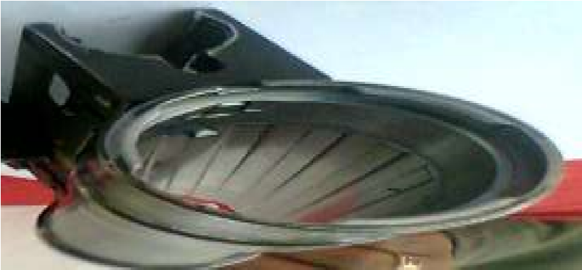

**2**

**1**

**3**

**Fig: 2 ( 1. Retainer 2. Blocking device 3. Knurled buldge)**

1. **Support.** Support ko is prakar se banaya gaya hai ki yeh UBGL ko Rifle AK-47 par fit karta hai aur sath hi iske upar sight ko fit kiya gaya hai. Support ke aage aur bayen ek latch diya gaya hai jo ki UBGL ko Rifle se lock aur unlock karne ke kam aata hai.**(Fig:3)** Support par bayen aur aage ek blocking device lever lagaya gaya hai jo ki mechanical safety pardan karta hai.

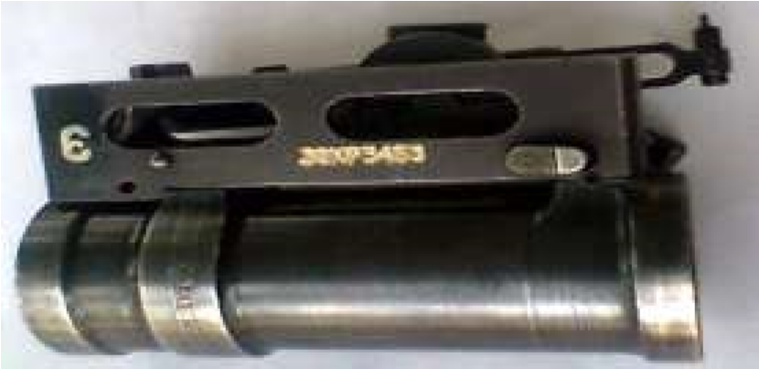

**1**

**Fig: 3 ( 1. Latch)**

1. **Sight Group.** Sight ko target par sisht lene ke liye lagaya gaya hai. Ismein adjustable front sight pole type aur adjustable rear sight 'U' type lagaya gaya hai. Iske sight par do range scale diya gaye hai. Direct fire ke liye white range scale aur indirect fire ke liye red range scale hai. White range scale par 50mtr se400mtr tak range lagane ki suvidha hai. Chhoti line 100mtr ko aur bari line 50mtr kojahir karti hai. Red range scale par 200mtr se lekar 350mtr takrange lagane ki suvidha hai. **(Fig: 4).**Sight par ek detent catch lagaya gayahai jisko press karke range lagaya jata hai. Range scale kesath ek range indicator hota hai joki range ko indicate karta hai. Indirect fire ke dauran angle hasil karne ke liye plumb sightdiya gaya hai. Plumb sight ko lockkarne ke liye plumb hai. RearSight ke sath ekadjustingscrew diya gaya hai jo ki zeroing ke dauran rear sight ko correction dene kekam aata hai.

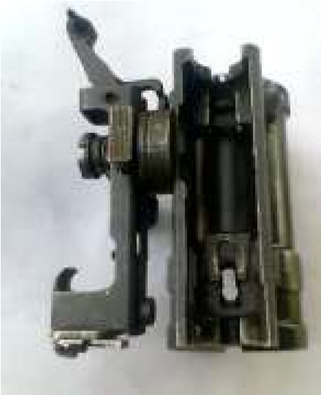

**1**

**2**

**4**

**5**

**3**

**6**

**Fig: 4 ( 1. Fore sight 2. Detent catch 3. Plumb sleeve**

**4. Plumb retainer 5. Rear sight 6. Zeroing screw)**

1. **Body with Breech Piece.** Jab UBGL ko bag for artillery GP-25 mein rakhna ho to body with breech piece ko UBGL se alag kar liya jata hai. Yeh group breech piece aur body with pistol grip ko milakarbanaya gaya hai.Inko body axispin aur safety lock kimadad sejora gaya hai aur catch pin body axis pin aur safetylock ko lock karke rakhta hai.**(Fig: 5,6)**

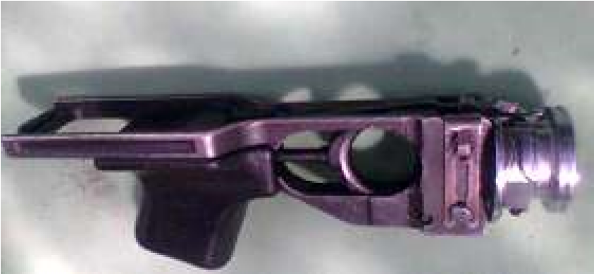

**1**

**2**

**3**

**4**

**5**

**6**

**Fig: 5 (1. Feed arm 2. Barrel locking catch 3. Catch pin 4.**  **Trigger 5. Pusher 6. Body axis pin)**

**Fig: 6 ( 1. Safety lock 2. Manual extractor 3. Body axis pin)**

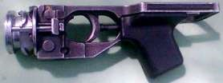

**3**

**2**

**1**

1. **Breech Piece.** Breech piece ke chamber ko is parkar se banaya gaya hai ki yeh barood ke high pressure ko sehan kar sake. Ismein knurled projection diya gaya hai, jo ki breech piece ko barrel with support gp ke sath lock karke rakhta hai. Breech piece ke pichhe wale bhag par do ears diye gaye hai jo ki breech piece ko trigger mech with pistol grip ke sath jor kar rakhta hai. Breech piece ke beech mein striker fit kiya gaya hai.**(Fig: 7)**Breech piece ke upar feed arm aur barrel locking catch diya gaya hai. Feed arm mechical safety pardan karta hai aur barrel locking catch barrel with support aur trigger mechanism with pistol grip ko lock karta hai. Breech piece ke bayen side manual extractor fit kiya gaya hai joki grenade ko bahar nikalne ke kam karta hai. Extractor ki harkat iski pin ki lambai par nirbharhai. Breech piece ke sath do compensators riveted hain jo ki breech pieceaurbarrel ke gap ko cover karta hai aur fire ke dauran lagne wale dhakke ko jajab karta hai.

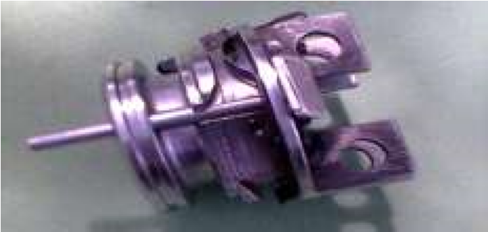

**Fig: 7 ( 1. Breech piece)**

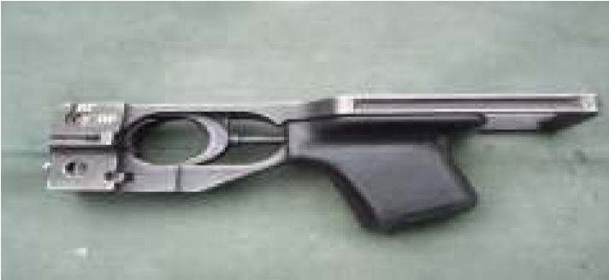

**Fig: 8 (Trigger mechanism with pistol grip)**

1. **Trigger mechanism with pistol grip.** Trigger mechanism ke ander hammer aur trigger mechanism ko fit kiya gaya hai. Ismein ek trigger bar aur trigger bar hook diya gaya hai.Pistol grip UBGL ko fire karte samay grip karne ke kam aata hai. Iske upar ek safety lock diya gaya hai jo ki UBGL ko applied safety pardan karta hai.**(Fig: 8)**

1. **Trigger mechanism ki chal.** Yeh ek self cocking trigger mech hota hai. Jab firer trigger ko press karta hai to trigger bar hook aur hammer hook ka milap ho jata hai. Jisse hammer spring sikud jata hai. Jab trigger pura press ho jata hai tab trigger bar hook aur hammer hook ka milap tut jata hai.Jisse hammer spring ke karan piston aage ki harkat karta hai. Jiske karan hammer ke sath jura huwa striker grenade keprimer par chot marta hai. Jisse grenade fire ho jata hai. Jab firer trigger ko release karta hai tospring ke karan trigger apni jagah par wapis aa jata hai. Jisse trigger bar hook hammer hook ke upar aa jata hai. Aur UBGL dobara fire ke liye taiyar ho jata hai.**(Fig: 9,10)**

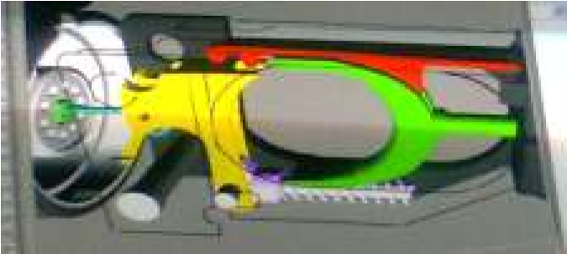

**Fig:9 (Triggermechanism normal position)**

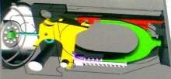

**Fig: 10 (Trigger mechanism coocking position)**

1. **Safety.** Safety do parkar ki hoti hain. Applied safety aur Mechnical safety.

(i) **Applied Safety.** UBGL mein applied safety ke liye safety lock diya gaya hai. Jiski do position hoti hain "NP","OR". Jab safety lock"NP"(verticle position) par hota hai, UBGL fire nahin hoga, kyonki safety lock ka gol walabhaghammer ke katav mein aa jata hai jisse hammer pichhe ki harkatnahinkar pata hai. Jabsafetylock ki position "OR" (horizontal position) par hotahai tab fire ho jata kyonki safety lock ka kata bhag hammer ko pichhe aaneke liye jagah de deta hai. (Knob in Horizontal position is fire).

(ii) **Mechanical safety.** Jab UBGL ke dono hisson (barrel with support &trigger mechanism with pistol grip) ko jora jata hai to barrel ke andar fit kiyahuwa blocking device feed arm ke head ke upar dabav dalta hai jisse feed arm ka tail hammer ki tail ke upar aa jata hai. Jiske karan hammer ko pichhejane ke liyejagah nahin milpata hai jissetrigger press nahin hota.Jab UBGLko Rifle AK-47 par fit kiya jata hai tab Rifle AK-47 ka front cupUBGL ke support par lage lever par dabav dalta hai jisse lever upar sebahar aur nichhe se ander ki aur harkat karta hai jiske karan horizontallever bayen se dayen ki taraf harkat karta hai. Jissebarrel ke andar fit kiyagaya blocking device upar ki aurharkat karta hai aur feed arm ke head se dabav hata deta hai. Jis karan feedarm ki tail ka hammer tail se milap tut jata hai.

1. **Catch Pin.** Catch pin U aakar ki pin hoti hai jo safety lock aur body axis pin ko lock karke rakhta hai aur safety lock ko "NP", "OR" par rok kar rakhta hai.

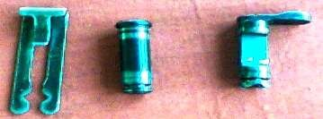

**1**

**2**

**3**

**Fig: 11 (1.Catch pin, 2. Body axis pin, 3. Safety lock)**

1. **Accessories**:-

* 1. Bag for artillery GP-25.
  2. Bag for projectile VOG-25.
  3. Damper with strap.
  4. Cleaning brush.

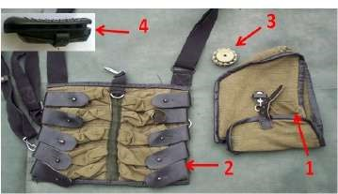

**(1. Bag for artillery GP-252. Bag for projectile**

**VOG-25 3. Cleaning brush4. Damper with strap )**

* + 1. **Bag for artillery GP-25.**Is bag mein UBGL,damperaur cleaningbrush ko rakha jata hai.

* + 1. **Bag for projectile VOG-25.**Is bag ka istemal grenade ko carry karne ke liye kiya jata hai. Ismein 10 grenade rakhe jate hain. Is bag par ek fixing belt hota hai jisko kamar ke sath fit kiya jata hai aur ek adjustable shoulder strip hota hai jisse isko shoulder par carry kiya jata hai.
    2. **Cleaning Brush.** Cleaning brush UBGL ke barrel ki safai aur lubricating ke liye istemal mein laya jata hai. Brush ko Rifle AK-47 ki rod ke sath fit kiya jata hai.

* + 1. **Damper with strap.** Damper fire ke dauran firer ke shoulder ki suraksha aur support ke liye diya gaya hai. Iske sath ek strap diya gaya hai jiski madad se damper ko Rifle AK-47 ke butt par lagaya jata hai.

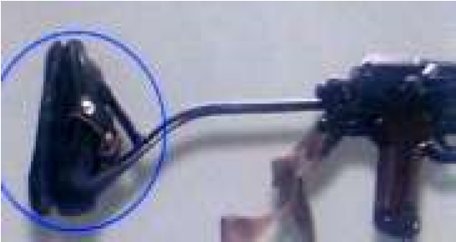

1. **Group SPTA Set (Spare Parts Tools and Accessories).** Group SPTA set ko UBGL ke technical maintenanceaur repair ke liye diya gaya hai. 20 UBGL parek SPTA set lagu hota hai.

1. **Ammunition.** UBGL se fire hone wale grenade ko "case less" banaya gaya hai jiske karan fire ke baad barrel mein grenade ka koi bhi hissa nahin bachta hai. Grenade ki body steel ki banaya gaya hai. Grenade ke nichhe wale bhag mein primer KVM-3 fit kiya gaya hai joki super quick point detonation impect fuse hota hai. Iske ander fuse VMG-K hota hai.UBGL ke grenade ke upar driving band diya gaya hai jo ki barrel ke ander obturation ki karwai mein madad karta hai jisse grenade ko spin milta hai. **(Fig: 12 &13)**

* 1. **Grenade ke mechanism.**  UBGL ke grenade mein 4 mechanism hote hain.

* + 1. **Safety Mechanism**. Jab grenade 3mtr upar se gir jata hai to grenade apni chaljari nahi karta.

* + 1. **Remote Arming Mechanism.**Jab grenade10-40mtr ki duri ke beech pahunchtahaito grenade arm ho jata hai.

* + 1. **Impact & Punching Mechanism.** Grenade arm hone ke bad kisi bhi vastu se takratahai to blast ho jata hai. Jaise snow, water aur swamp (daldal).

* + 1. **Auto Destruction Mechanism.**Yadi grenade kisi bhi vastu se nahi takrata hai to bhi 14 se 19sec ke baad grenade ke ander laga huya self destruction mechanism chal jari kar deta hai aur grenade blast ho jata hai.
  1. **UBGL se 3 prakar ke grenade fire kiye jate hain.**
     1. **VOG 25.** Yeh ek fragmentation type ka grenade hota hai jiska rang purple hai. VOG 25 grenade ki vishestaen niminlikht hain:-

(ba) Calibre - 40mm.

(bb) Length - 102.64mm.

(bc) Weight - 250gms.

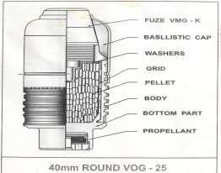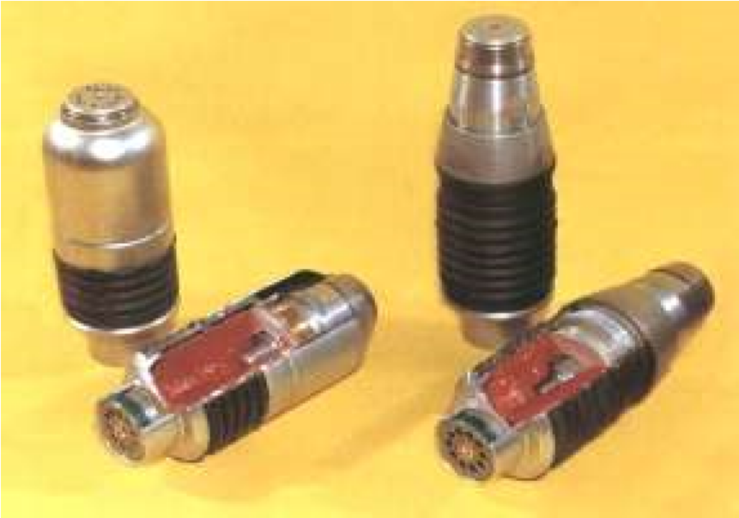 (bd) Killing Area - 7mtr radius.

**Fig: 12 (Grenade VOG-25) Fig: 13 (1.VOG-25, 2. VOG-25P)**

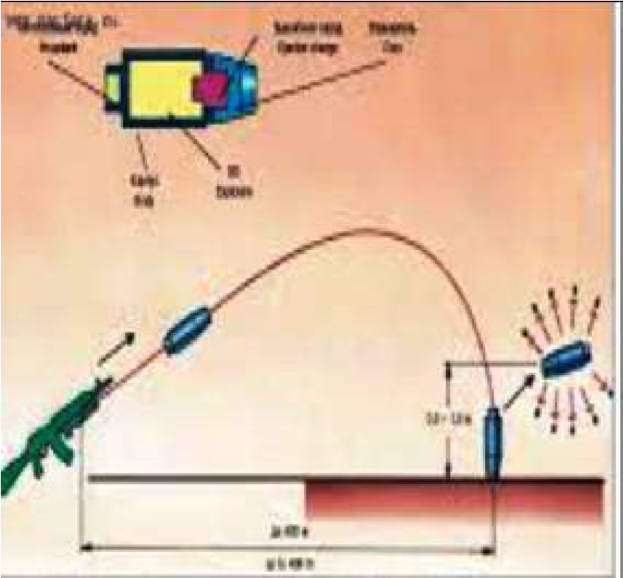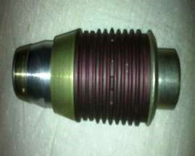

**Fig: 13 A ( VOG-25P) Fig: 13 B ( VOG-25P)**

* + 1. **VOG 25P.** VOG 25P ek uchalne wala grenade hai. Iska rang green hota hai aur iska aakar aerodynamic hota hai. VOG 25P grenade ki nose mein ek special charge diya gaya hai jo grenade ko kisi bhi vastu yajamin se takrane par ignite karta hai aur 50se150 cm ke jump ke sath grenade koblast kar deta hai.**(Fig: 13 A, B).**

* + 1. **Inert (Niskriya) Grenade.**Yeh Grenade trainingaur zeroing ke dauran istemal kiya jata hai.Is Grenade ka range 200-220 mtr hota hai.**(Fig: 13C).**

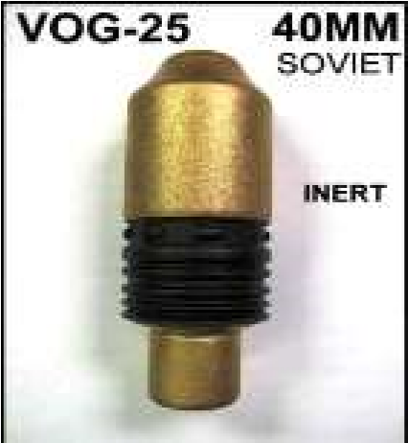

**Fig: 13 C ( Inert Grenade)**

1. **UBGL Zeroing.**

* 1. Position - Lying supported.
  2. Ground range - 100 mtr.
  3. Sight range - 100 mtr.
  4. Ammunition - Inert grenade.
  5. Target - 3x3 mtr plywood board.
  6. Target par circle - 35cm radius.

1. **Zeroing karne ka tariqa.** 100 mtr ki duri se lying supported position se 4 grenade fire kiye jate hain. Grenade ki MPI 35cm ke circle ke ander banta hai to UBGL ko sahi zero mana jata hai. Agar grenade ki MPI 35cm ke circle mein nahi banta hai to jarurat suda correction diya jata hai.

1. **Correction dene ka tariqa.**

* 1. **Upar niche ka correction**. Upar niche ka correction fore sight se diya jata hai. Fore sight ko ek chhaker dene se 75cm ka farq parta hai. Fore sight ko clock wise ghumane se MPI upar aata hai aur anti clock wise ghumane se MPI niche aata hai. Iski fore sight pole type hone ke karan minor correction bhi diya ja sakta hai.

* 1. **Dayen bayen ka correction**. Dahine bayen ka correction rear sight ke screw se diya jata hai. Rear sight ke niche 8 runner line di gai hain 4 line madhya se bayen aur 4 line madhya se dayen. Ek runner se dusre runner ka correction dene par 75cm ka antar parta hai. Ek runner 4 click ko jahir karta hai aur ek click se dusre click ka correction dene par 18.75 cm ka antar parta hai. Rear sight screw ko clock wise ghumane se MPI dahine jata hai aur anti clock wise ghumane se MPI bayen jata hai.Is prakar upar/ niche aurdayen/bayenka correction dekar MPI ko circle ke ander laya jata hai.

1. **Safai.** UBGL ki safai anya hathiyaron ki tarah hi ki jati hai. Is ke liye lubrication ke oil is prakar se hain:-

* 1. Yadi temp +50 se -50 degree centigrade ho to Gun oil RANGE GOST 9811-61 kaistemal kiyajata hai.

* 1. UBGL ke mechanism ke ander Grease SOTY 38.101.1315.90 ka istemal kiya jata hai jabtapman 5 degree centigrade se upar ho.

* 1. Safai aur lubrication ke liye dry aur soft cloth ka istemal kiya jaye.

* 1. Barrel ke grooves, cut aur holes ki safai lakri ki sticks se bhi kar sakte hain.

1. **Storage & Transportation.** UBGL ko store karte samay Rifle AK-47 se alag karke bag ke ander rakh kar wooden box mein store kiya jaye. Storage box ko windows (khirki) aur heating devices (stoves) addi se door rakha jaye.Combat situation ke dauran yadhi UBGL ko Rifle AK-47 par fit karke rakhna pade to yakin karen ki safety lock ki position NP (safe) par ho.

1. **Grenade ki Packing.** UBGL ke grenade wooden box mein aate hain. Ek wooden box mein teen steel ke box hote hain ek steel box mein 40 grenade aate hai.

1. **Transportation of UBGL &Grenade.** UBGL ko wooden case ke ander pack karke transport se ek sathan se dusre sathan par le jaya ja sakta hai. Speed aur distance ki koi limit nahi hoti.Grenade ko transportation ke dauran speed aur distance ka koi limit nahi hai lekin grenade ko acchhi tarah se pack kar liya jaye. Parantu paved (pakka) aur earth (kachha) roads par transportation ke dauran 500 m ki duri aur speed 40 km/hrs se adhik nahi honi chahiye.

1. **Suraksha sambhandi batein.**

* 1. UBGL ko fire karne se pahle yakin karen ki Rifle AK-47 ke butt pardamper laga hua hai.
  2. Yakin karen ki UBGL ka elevation angle 80 degree seadhik na ho.
  3. UBGL ko Rifle AK-47 par mount karne ke bad Rifle AK-47 ka butt fold karke firena karen.
  4. Misfire ya blind grenade ke sath chherkhani na karen.

(e) Yadi grenade asani se na bhara ja raha ho to usejabardasti bharne kikosis na karen. Aisi sthiti meinUBGL ka nirikshan karen.

**LESSON-2**

**40MM UNDER BARREL GRENADE LAUNCHER SE WAQFIAT, KHOLNA JORNA AUR SAFAI KARNE KA TARIQA**

Ref - (Under Barrel Grenade Launcher, UBGL-2006)

**Shuru Shuru ka Kam**

1. Shuru-shuru ke kaam mein nimnlikhit baton par gaur kiya jaye:-
   1. Bandobast ki karwai.
   2. Class ki ginti groupon mein bant.
   3. Hathiyar saman ka nirikshan.

**Dohrai**

1. Prashn pichhle sabaq se kiye jayen.

**Pahunch**

1. 40mm Under Barrel Grenade Launcher Bulgaria desh ka bana huya hai.Is hathiyar ko Infantry section mein shamil kiya gaya hai. Infantry section se sambandhit hathiyar hone ke karan zaruri hai ke sabhi jawanno ko is hathiyar ke bare mein jankari ho.

**Uddesh**

1. 40mm under barrel grenade launcher se waqfiat, kholna jorna aur safai karne ka tariqa sikhana hai.

**Saman**

1. 40mm UBGL, Rifle AK-47, Pointer, Balck board, Easel, Ground sheet, Chalk aur Duster.

**Bhagon Mein Bant**

1. Yeh sabaq teen bhagon mein chalaya jayega:-

|  |  |  |
| --- | --- | --- |
| (a) **Bhag-I** | - | UBGL ki visheshtayen aur technical data. |
| (b) **Bhag-II** | - | Kholna, hisse purjon ke naam, kam aur jorna. |
| (c) **Bhag-III** | - | UBGL ki accessories se jankari aur safaikarne ka |
|  |  | tariqa. |

**Bhag-1:UBGL ki visheshtayen aur technical data**

1. **Visheshtayen**:-

1. Direct aur Indirect fire kar sakte hain.
2. Halka hathiyar hai.
3. Kargar range adhik hai.
4. Yeh ek muzzle loaded hathiyar hai.
5. Ek hi samay par UBGL aur AK-47 se fire kar sakten hain.
6. UBGL se teen parkar ka amn fire kiya jata hai.
7. UBGL ko full size assault riflele AKM, AKMS, AK74, AK47, AK101, AK103 aur AN94 par fit karke bhi fire kiya ja sakta hai.
8. 80 degree tak ke angle par fire kiya ja sakta hai.

(j) UBGL Bulgaria desh ka bana huya hathiyar hai.

1. **Tech Data.**

* 1. Calibre - 40mm.
  2. Grooves - 12 (RH).
  3. Weight - 1.5kg.
  4. Lambai - 323mm.
  5. Barrel - 98mm.
  6. Sight radius - 120mm.
  7. Muzzle velocity - 76 mtr/sec.
  8. Maximum range - 400 mtr.
  9. Direct range - 50 to 400 mtr.
  10. Indirect range - 200 to 350 mtr.
  11. Arming Distance - 10 to 40 mtr.
  12. Applied Safety - Safety Lock.
  13. Mechnical Safety - Blocking device & Lever.
  14. Rate of fire - 4 to 5 grenade/min.

1. **Grenade.**

* 1. Weight - 250 gms.
  2. Lambai - 102.64mm.
  3. Explosive - 48 gms.
  4. Fuze - KVM-3.
  5. Type of fuze - Super Quick Point Detonation

Impact Fuze.

* 1. Primer - VMG-K.
  2. Killing area - 7mtr radius
  3. Principle - Direct action and inertia.

(j) **Ammunution.**

* + 1. VOG 25.
    2. VOG 25P.
    3. Inert Grenade.

(k) **Grenade ka mechanism.** UBGL ke grenade mein 4mechanism hote hain.

* + 1. **Safety Mechanism.** Jab grenade 3mtr upar se gir jata hai to grenade apni chal jari nahi karta.

* + 1. **Remote Arming Mechanism.** Jab grenade 10 se 40mtr ki doorikebeechpahunchta hai to woh arm ho jata hai.

* + 1. **Impact & Punching Mechanism.** Grenade arm hone kebaad kisibhivastu se takrata hai to blast ho jata hai; jaise snow, wateraur swamp(daldal).

* + 1. **Auto Destruction Mechanism.** Yadi grenade kisi bhivastu se nahitakrata hai to bhi 14 se 19sec ke baad grenade ke anderlaga huya selfdestruction mechanism chal jari kar deta hai aur grenade blast hojata hai.

**Bhag-II:Kholna, Hisse Purjon ke Naam, Kam aur Jorna**

1. **40mm UBGL ko 3 bhagon mein khola jata hai.**

* 1. Pistol gp with trigger mechanism.
  2. Barrel with support.
  3. Breech piece.

1. **Kholna.** Dahine hath ke anguthe se barrel lockingcatch ko dabayen aurbayen hath se barrel ko ghari ke ulterukh 60 degree ghumayen aur barrel ko alag karen. Breech piece ko kholne ke liye AK-47 ki driflet ki madad se catch pin ko bhar nikalen. Safety lock aur body axis pin ko bahar nikalen aur breech piece ko trigger mechanism se alag karen. Ek firer ko itna hi kholna lagu hai.

1. **Hisson purjon ke naam.**

* 1. **Pistol gp with trigger mechanism.** Trigger bar, trigger bar hook, trigger,hammer, piston, striker aur hammer tail.

* 1. **Barrel with support.** Barrel, latch, fore sight pole type, rear sight 'U' type,detent, detent sleeve, plumb,plumb sleeve, plumb retainer, runner, blocking device, leaver, compensator aur knurled bulge.

* 1. **Breech piece.** Sitted for projectile, Mannual extractor, Single limb compensator, double limb compensator, Feed arm, Feed arm tail aur Barrel locking catch.

1. **Jorna**. Breech piece ke striker hole se striker ko milate hue joren. Body axis pin ko lagayen aur safety lock ko lagayen. Body axis pin aursafety lock ke upar catch pin kolagayen.Barrel with support ko pistol grip with trigger mechanism ke sath jorne ke liye breech piece ko dahine ye bayen rakhte huye barrel mein dakhil Karen aur tab tak ghumayen jab tak click ki aawaj na aa jaye.

**Bhag-III: UBGL ki accessories se jankari aur safai karne ka tariqa.**

1. **40mm UBGL ke sath 4 prakar ki accessories aati hai.**

* 1. **Bag for artillery GP-25.** Is bag mein UBGL, damperaur cleaning brushko rakha jata hai.

* 1. **Bag for projectile VOG-25.** Is bag ka istemal grenade ko carry karne ke liye kiya jata hai. Ismein 10 grenade rakhe jate hain. Is bag par ek fixing belt hota hai jisko kamar ke sath fit kiya jata hai aur ek adjustable shoulder strip hota hai jisse iskoshoulder par carry kiya jata hai.

* 1. **Cleaning Brush.** Cleaning brush UBGL ke barrel ki safai aur lubricating ke liye istemal mein laya jata hai. Brush ko Rifle AK-47 ki rod ke sath fit kiya jata hai.

* 1. **Damper with strap.** Damper, fire ke dauran firer ke shoulder ki suraksha aur support ke liye diya gaya hai. Iske sath ek strap diya gaya hai. Jiski madad se damper ko Rifle AK-47 ke butt par lagaya jata hai.

1. **Safai.** UBGL ki safai anya hathiyaron ki tarah hi ki jati hai.

16 **Lubrication.**

1. Yadi temp +50 se -50 degree centigrade to Gun oil RANGE GOST 9811-61ka istemal kiya jata hai.

1. UBGL ke mechanism ke ander grease SOTY38.101.1315.90 ka istemal kiya jata hai jab tapman 5 degree centigrade se upar ho.

1. Safai aur lubrication ke liye dry aur soft cloth ka istemal kiya jaye.

1. Barrel ke grooves, cut aur holes ki safai lakri ki sticks se bhi kar sakte hain.

1. **Storage & Transportation.** UBGL ko store karte samay Rifle AK-47 se alag karke bag ke ander rakh kar wooden box mein store kiya jaye. Storage box ko windows (khirki) aur heating devices (stoves) addi se door rakha jaye.Combat situation ke dauran yadi UBGL ko Rifle AK-47 par fit karke rakhna pade to yakin karen ki safety lock ki posn NP (safe) par ho.

1. **Grenade ki Packing.** UBGL ke grenade ek wooden box mein aate hain. Ek wooden box meinteen steel ke box aate hain ek steel box mein 40 grenadehote hai.

1. **UBGL Zeroing.**

* 1. Position - Lying supported.
  2. Ground range - 100 mtr.
  3. Sight range - 100 mtr.
  4. Ammunition - Inert grenade.
  5. Target - 3x3 mtr plywood board.
  6. Target par circle - 35cm radius.

1. **Zeroing karne ka tariqa.** 100 mtr ki doori se lying support position se   
   4 grenade firekiye jate hain. Grenade ka MPI 35 cm ke circle ke ander banta hai to UBGL ko sahi zero mana jata hai. Agar grenade ki MPI circle mein nahi banta hai to jarurat suda correction diya jata hai.

1. **Correction dene ka tariqa.**

* 1. **Upar niche ka correction.** Upar nichhe ka correction fore sight sediya jata hai. Fore sight ko ek pura chhaker dene se 75cm ka farak parta hai. Foresight ko clockwise ghumane se MPI upar aata hai aur anti clock wise ghumane seMPI nichhe aata hai. Iski fore sight pole type hone ke karan minor correction bhi diya ja sakta hai.

* 1. **Dahine bayen ka correction.** Dahine bayen ka correction rear sight ke screw se diyajata hai. Rear sight ke nichhe 8 runner line di gai hain 4 line madhya se bayen aur 4 line madhya se dahine. Ek runner se dusre runner ka correction dene par 75 cm ka farak parta hai. Ek runner 4 click ko jahir karte hain aur ek click se dusre click ka correction dene par18.75 cm ka farak parta hai. Rear sight screw ko clock wise ghumane se MPI dahine jati hai. Aur anti clock wise ghumane se MPI bayen jati hai.Is parkar upar/ nichhe aur dahine/bayen ka correction dekar MPI ko circle ke ander laya jata hai.

**Sankshep.**

1. Sabhi bhagon se prashna puchhe jayen.

**LESSON-2**

**40MM UNDER BARREL GRENADE LAUNCHER KI FIRING POSITION, BHARNA KHALI KARNA, FIRE AUR MISFIRE HONE PAR KARWAI KARNE KA TARIQA**

Ref - (Under Barrel Grenade Launcher, UBGL-2006)

**Shuru Shuru ka Kam**

1. Shuru-shuru ke kaam mein nimnlikhit baton par gaur kiya jaye:-

* 1. Bandhobast ki karwai.
  2. Class ki ginti gp mein bant.
  3. Hathiyar saman ka nirikshan.

**Dohrai**

1. Prashna pichhle sabaq se kiya jayen.

**Pahunch**

1. 40mm Under Barrel Grenade Launcher ek Infantry section ka direct aur indirect fire karne wala hathiyar hai, iski madad se hum dushman ke upar karger fire girakar uska jiada se jiada nukshan kar sakte hain. Ek infantry section ka hathiyar hone ke karan zaruri hai ki sabhi jawanon ko iski firing position, bharna, khali karna fire aur misfire hone par karwahi karne ka tariqa aana chahiye.

**Uddesh**

1. 40mm under barrelgrenade launcher ki firing position, bharna khali karna, fire aur mis fire hone par karwai karne ka tariqa sikhana hai.

**Saman**

1. 40mm UBGL, Rifle AK-47, Drill grenade, Chindi, Pointer, Board, Easel, Ground sheet, Chalk aur Duster.

**Bhagon Mein Bant**

1. Yeh sabaq 4 bhagon mein chalaya jayega:-

* 1. **Bhag-I** - UBGL ki firing position.
  2. **Bhag-II** - Bharna khali karna.
  3. **Bhag-III** - Range lagana aur shist lene ka tariqa.
  4. **Bhag-IV** - Fire aur misfire hone par karwai karne katariqa.

**Bhag-1 : UBGL ki Firing Position**

1. Firing position waise to jamin ki banawat aur larai ki halat par nirbhar karti hain. Lekin traning ki lihaz se 40mm UBGL ko 4 prakar ki firing position sefire kiya jata hai.

* 1. **Lying Posn.**

* + 1. **Jarurat.** Jab firer ke samne aad 1'ya 1' se nicche ho ya khule madan se firekarne ki jarurat ho to lying positionko istemal mein laya jata hai.

* + 1. **Position lene ka tariqa.** Dahine paon ko target ki sidhmein rakhen, bayen paon ko chalti halat mein aage len sath hi dahine hath se UBGL ko badan kesamneitna uchhale ki bayen hath ki pakar UBGL ke pistol grip par aa jaye, aurdahine hath ka take lete huye lying position ikhtiyar karen. Butt aurkandhe kamilapkaren. Is position mein dekhne wali batein:-

(aa) Target, UBGL, firer ka dahina kandha aur dahina paon ek sidh mein ho.

(ab) Badan line of sight se tirchha ho.

(ac) Ho sake to dono paon ki arhiyan jamin par tiki hon.

(ad) Dono kohniyan jamin par tiki hon.

(ae) Bayen hath ki pakar UBGL ke pistol grip par teenon unguliyan bahar se angutha andar se kalme wali unguli trigger ke bahar. Dahine hath ki pakad AK-47 ke pistol grip par teeno unguliyan bahar se angutha andar se kalme wali unguli trigger ke bahar.

(af) Najar samne.

(ag) 100 mtr range se jaida range par fire karne ki   
 jarurat ho to firing position ki badli ki jati hai.

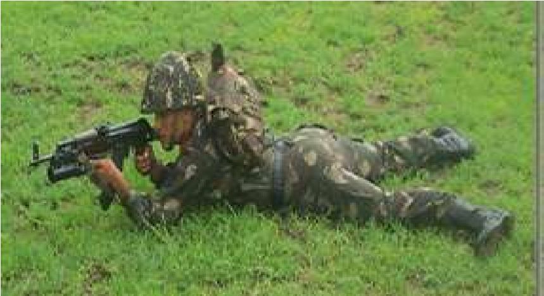

**Fig- 14 Lying Position**

1. **Sitting Position.**

* 1. **Jarurat.** Jab firer ke samne aad kneeling position se nicha ho ya dhalwandar jamin se upar se niche fire karne ki jarurat ho to sitting position koistemal mein laya jata hai.
  2. **Position lene ka tariqa.** Bayen paon ko target ki sidh mein rakhen.UBGL ko bayen hath mein pakren aur dahine hath ki hathli ka take lete huye sitting position ikhtiyar karen. Butt aur kandhe ka milap karen. Is position mein dekhne wali batein:-

(aa) Bayen pair target ki sidh mein dahina paon dahine aur dono paon kadke mutabiq khule huye.

(ab) Donon paon ki erhiyan jamin par tiki hon.Toe aasman ko point karta huya ho.

(ac) Donon kohniyan dono ghutne pardhyan rahe haddi se haddi kamilap naho.

(ad) Baki pakar lying positon ki tarah.

(ae) Yadi 150 mtr se adhik range par firekarne ki jarurat ho to AK-47 kebutt kodahine bagal mein lagakar fire kiya jata hai.

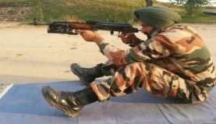

**Fig-15 Sitting Position**

1. **Kneeling position.**

* + 1. **Jarurat.**  Jab firer ke samne aad 2 se 2.5 ft ki ho ya niche se upar fire karne ki jarurat ho to kneeling position istemal mein laya jata hai.

* + 1. **Position lene ka tariqa.** Bayen paon ko target ki sidh mein rakhen aurdahine ghutne ke bal kneeling position ikhtiyar karen. Is position mein dekhnewali batein:-

(aa) Bayen paon target ki sidh mein.

(ab) Dahina ghutna pura dahine aur jaminpar tika huya.

(ac) Bayen hath ki kohni bayen ghutne par. Dhyan rahe ki haddi sehaddi ka milap na ho.

(ad) Dahine hath ki kohni jamin ke samanantar.

(ae) Body weight dahine paon ki addi par.

(af) Najar samne, baki pakar sitting position ki tarah.

(ag) Yadi 150 mtr se adhik range par fire karne ki jarurat ho to AK-47 ke butt ko dahine bagal mein lagakar fire kiya jata hai.

**Fig**

**-**

**15**

**Kneeling Position**

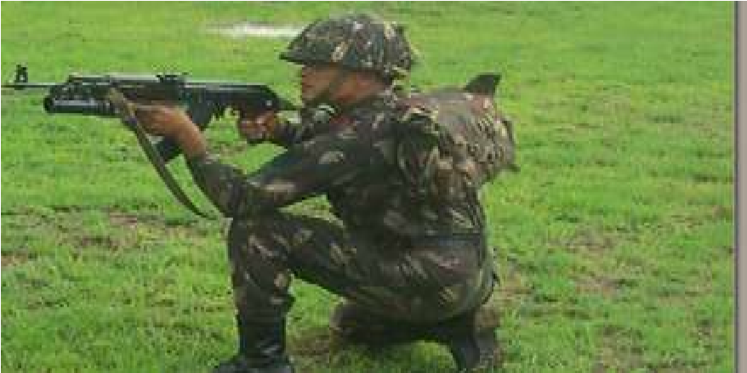

1. **Standing Position.**

* 1. **Jarurat.** Jab firer ke samne 4 se 4.5 ft ki aad ho ya fire trench se fire karne ki jarurat pade to standing position koistemal mein laya jata hai.

* 1. **Position lene ka tariqa.** Bayen paon ko target ki sidh mein rakhen, dahine paon kodahine aur thora picche len. Butt aur kandhe ka milap karen. Is positionmeindakhne walibatein:-

|  |  |  |  |  |
| --- | --- | --- | --- | --- |
|  |  |  | (aa) | Bayen paon target ki sidh mein ho. |
|  |  |  | (ab) | Dahina paon thora dahine aur pichhe. |
|  |  |  | (ac) | Dahine hath ki kohni jamin ke samananter. |
|  |  |  | (ad) | Najar samne, baki pakar sittingposition ki tarah. |

**Fig**

**-**

**16**

**Standing Position**

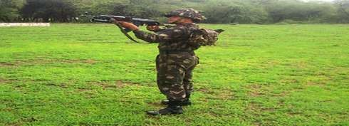

(e) **Elevated position.**

1. **Jarurat.** Jab firer ko 45 degree se 80 degree ke elevation ke beech fire karne ki jarurat ho to elevatedposition ko istemal mein laya jata hai.

1. **Elevated position lene ka tariqa.**

(aa) Kneeling position ikhtiyar karen. Rifle AK-47 ke butt ke upar wale bhag ko sandbag par tikayen aur niche wale bhag ko jamin partikayen.

(ab) Bayen hath ki pakar UBGL ke pistol grip par aur dahine hath ki pakar AK-47 ke small of the butt par.

(ac) Butt firer ke dahine ghutne ke sathlaga ho.

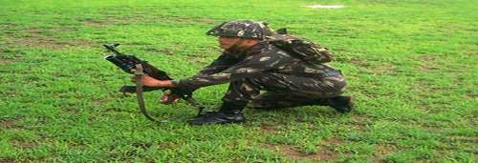

**Fig-17 Elevated Position**

**Bhag-II : Bharna khali karna**

1. **Bhar karne ka tariqa.** Jab firer ko fire karne ki jarurat ho ya traning ke dauran aadesh mile bhar to karwahi is prakar se karen:-

* 1. UBGL ko saaf jagah par rakhen. Bag for projectile VOG 25 se grenade ko bahar nikalen.

* 1. Grenade ka mulaiza karen. Yadi grenade ki bodykahin se dabi ya crack ho to aise grenade ka istemal na kiya jaen. Aise grenade ko anya grenade se alag rakhen. Yadi grenade istemal ki lihaz se thik to chindi ya kapre ki madad se Grenade ki safai karen. UBGLko len aur safety lock ki position ko safe par karen. Barrel ka mulaiza karen yadidhul, mitti ho to chindi ya kapde ki madad se safai karen. Dahine hath se taiyar kiye huye grenade ko len. Nose ko upar ki taraf karte huye grenade ko barrel mein dakhil karen. Dono hathon ke anguthe se grenade ko tab tak press karen jab tab click ki aawaj na aa jaye.

1. **Khali karne ka tariqa.** Jab firer ko fire karne ki jarurat na ho ya traning ke dauranaadesh mile bagair fire khali kar to karwahi is parkar se karen:-

* 1. Yakin karen ki safety lock ki position safe par ho.

* 1. Bayen hath ke anguthe se mannual extractor ko aage ki aur press karen aur dahine hath ko muzzle ke aage le jayen. Bayen hath se UBGL ko aage ki aur jhukayen. Jisse grenade bahar aa jata hai.Grenade ko bag for projectile VOG 25mein band karen.

**Bhag-III : Range lagana aur shist lene ka tariqa**

1. **Sight ke hisson purjon ke naam.** Fore sight - 'Pole' type, Rear sight 'U' type, detent, detent catch, detent sleeve, plumb sight, plumb sleeve, plumb catch, range indicator aur rear sight.

1. **Range scale.**Iske upar do prakar ki range scale di gayi hain. White range scale aur red range scale.UBGL se do prakar ka fire kiya jata hai. Direct fire aur indirect fire. Direct fire ke liye white range scale ka itemal kiya jata hai. Iske upar 50 to 400 mtr tak range lagane ki suvidha di gayi hai. Jiske upar chotti line 100mtr aur badi line 50 mtr ko jahir karti hain.Indirect fire ke liye red range scale ka istemal kiya jata hai. Iske upar 200 to 350 mtr takrange lagane ki suvidha di gayi hai. Iske upar bhi chhoti line 100mtr aur badi line 50 mtr ko jahir karti hai.

1. **Range lagane ka tariqa.** Direct fire ke liye aadesh mile range 200 mtr to bayen hath ke anguthe se detent catch ko niche ki aur dabate huye range indictor ko white range scale parmile huye range ki sidh mein milayen. Yakin karen ki range thik lag gaya.

1. **Shist lene ka tariqa.** Rear sight ko khara karen. Butt aur kandhe ka milap karen. Rear sight ke katav mein fore sight tip ko milate huye target ke POA par milayen. Indirect fire ke liye adesh mile range 300 mtr to bayen hath ke anguthe se detent catch ko niche ki aur dabate huye range indictor ko red range scale par mile huye range ki sidh mein lagayen. Yakin karen ki range thik lag gaya.

1. **Angle hasil karne ka tariqa.** UBGL ko target ki sidh mein align karen. Plumb retainer ko dabate huye plumb sight ko azad karen. Plumb sleeve aur detent sleeve ko milate huye durust angle hasil karen.

**Bhag-IV : Fire aur Misfire hone par karwai karne ka tariqa**

1. **Fire karne ka tariqa.** Firing position ikhtiyar karen. Bhar ki karwai ho jane ke bad mila huwa range, sight par lagayen. Aadesh mile ready tab safety lock ki position ko fire par karen. Rangekeanusar butt aur kandhe ka milap karen. Durust sisht lete huye trigger ko press karen. Is prakar trigger press karne se grenade fire ho jata hai. Firer target area mein grenade ki mar ko dekhta hai. Yadi grenade on target na ho to munasib correction dete huye dusra grenade fire karta hai. Isprakar ek achchhi training paya huwa jawan ek minute mein 4-5 grenade ke hisab se fire kartahai.

1. **Misfire hone par karwai karne ka tariqa.** Agar trigger dabane se grenade fire na hoya training ke dauran aadesh mile “**FIRE NAHIN”** to karwai is prarkar se karen. Pakad aur shist ko kayam rakhte huye dubara se trigger ko press karen. Dubara trigger press karne ke bad bhi grenade fire na ho ya training ke dauran aadesh mile“**PHIRFIRE NAHIN”** to pakad , shist aur trigger par dabav kayam rakhte huye 1 minute ka waqfa diya jaye. Agar 1 minute ka waqfa pura ho jane ke bad bhi grenade fire na ho yatraining ke dauran aadesh mile “**PHIR BHI FIRE NAHIN”** to misfire khali kar ki karwahi ki jati hai. Karne ka tariqa. Kalme wali unguli ko trigger se bahar nikalen. Butt aur kandhe ka milap toden. Safety lock ki position ko safe par karen. Grenade ko manual extractor ki madad se bahar nikalen. Grenade ke primer ko check karen. Grenade ke primer par chot na ho to striker ki badli karwaya jaye. Yadi grenade ke primer par chot ho to grenade ki noseko target ki taraf rakhte huye firing positon se 10mtr aage aur dahine rakhen.Dusra grenade bharen. Safety lock ki position ko fire par karen aur butt kandhe ka milap karen. Durust shist len aur UBGL ko firemein shamil karen.

1. **Misfire hone ke karan.**

* 1. Striker ka ghis jana ya tut jana.

* 1. Grenade ke primer mein kami hona.

* 1. Grenade ka barrel mein thik se na baithna.

1. **Abhiyas ke liye aadesh.**

* 1. “FIRE NAHIN” ke aadesh par dobara trigger press kiya jayega.

* 1. “PHIR FIRE NAHIN” ke aadesh par 1 minute ka waqfa diya jayega.

* 1. “PHIR BHI FIRE NAHIN” ke adesh par misfire khali kar ki karwai ki jayega.

**Sankshep**

1. Sabhi bhagon se prashna puchhe jayen.

**FAQ**

1. UBGL kaun se desh ka bana hai?
2. Ek Battalion mein kitne UBGL auth hain?
3. UBGL ki barrel mein kitne grooves hote hain?
4. UBGL se kitne prakar ka Ammunition fire kiya jata hai?
5. UBGL ka arming distance kitna hain?
6. UBGL mein grooves ka ghumav kis taraf hai?
7. UBGL ki muzzle velocity kitni hai?
8. UBGL ke grenade ka killing area kitna hai?
9. UBGL ka grenade kis sidhant par kam karta hai?
10. UBGL ka sight radius kitna hai?
11. UBGL ko kitne bhagon mein khola jata hain?
12. UBGL mein kitne parkar ki sight di gayi hain?
13. UBGL mein indirect fire ke liye kaunsi sight ka istemal kiya jata hai?
14. UBGL ka rate of fire kitna hai?
15. UBGL se direct fire kitne range tak kar sakte hain?
16. UBGL mein kaun se lubrication ka istemal hota hai?
17. UBGL se jyada se jyada kitni degree se fire kiya jata hain?
18. UBGL mein damper ka istemal kyon kiya jata hain?
19. UBGL mein MGL ka Amn fire kar sakte hain ki nahi?
20. UBGL ki fore sight ka ek chakkar 100mtr par kitna farak dalta hai?
21. UBGL ka Defence, attack aur Counter Insurgency mein kya role hain?
22. UBGL mein grenade ko sithirta kaise pradan hoti hai? 23 UBGL ke grenade mein kaun sa fuze hota hai?
23. UBGL ka grenadekitne distance par arm hota hai?
24. UBGL ka grenade snow, water aur daldal se takraka bhe blast kaun ho jata hai?
25. UBGL ke grenade ko colour se kaise pehchanege?
26. UBGL ke grenade VOG-25 aur VOG-25P mein kaya antar hain?
27. UBGL ka safety lock safe par hone se trigger press kyon nahi hota hai?
28. UBGL ka striker kaun se hisse mein laga hua hain?
29. UBGL ka mechnical safety kya hai?
30. UBGL Rifle AK-47 par fit kiye bagair fire kyon nahi karta hai?
31. UBGL ke sath kitne prakar ki assy aati hai?
32. UBGL ko zeroing ke dauran fore sight tip ko kis tool se correction denge?
33. UBGL ke grenade ka auto destruction mechanism kab kaam karta hain?
34. Rifle AK-47 par UBGL ko fit karne ke baad bayonet laga sakte hain ki nahi?
35. UBGL se Elevated postion se fire kab kiya jata hai?
36. UBGL ke rear sight zeroing screw ko clock wise ghumane se MPI kis taraf jata hai?
37. Zeroing karte samay kaun se Grenade ka istemal kiya jata hai?
38. Kya UBGL ko bayen master eye (aankh) ka firer bhee fire kar sakta hai?
39. UBGL se indirect fire ke liye kaun se range scale se fire kiya jata hai?
40. UBGL mein catch pin ka kya kaam hota hai?
41. UBGL ke Grenade VOG-25P ka shape kaisa hota hai?
42. UBGL ke bag for projectile VOG-25 mein kitne grenade aatehain?
43. UBGL mein misfire hone ke karan kya hain?
44. UBGL ka first line Amn kitna hota hai?
45. Inert Grenade ka range kitna hota hai?
46. UBGL ke grenade ki lambai kitna hai?
47. UBGL mein compensators kahan par lagaya gaya hai?
48. UBGL ke Grenade ka barrel mein jam hone ka karan?
49. UBGL ki barrel mein grenade jamming hone par aap kaya karwai karenge?
50. UBGL ke mechanisim mein kaun sa grease ka istemal kiyajata hai?
51. Grenade VOG 25 mein kitna explosive aata hai?
52. UBGL is fore sight aur rear sight kis parkar ki hoti hain?
53. Rear Sight par kam se kam correction kitna diya ja sakta hai?
54. UBGL ka sight radius kitna hota hai?
55. UBGL ko Infantry section mein kis jawan ko diya gaya hai?
56. UBGL ke Grenade ek steel box mein kitne aate hain?
57. UBGL ke zeroing target ki size kitna hai?
58. UBGL ke zeroing target par bane circle ka size kitna hota hai?
59. UBGL ko zeroing karte samay sight par kitna range lagaya jata hai?
60. UBGL ko zeroing ke dauran koun se range scale ka istemal kiya jata hai?
61. Loaded halat mein UBGL ko carry kiya ja sakta hai ya nahin?
62. Yadi MPI zeroing ke dauran POA se 150cm upar ban rahi hai to kon se sight ko kitna correction kis disha mein diyajayega?
63. 150 mtr range se adhik range par UBGL ko kandhe se firekyon nahin kiya jata?
64. SPTA ka full form kya hota hai?
65. UBGL ki cleaning brush ka istemal kis parkar se kiya jatahai?
66. UBGL ke trigger machanisam ki chal batao?
67. UBGL ke grenade ka fuze ki type kiya hai?
68. UBGL ke grenade mein driving band kyon diye gaye hain?
69. UBGL mein fire ke dauran obturation ki karwai hoti hai yanahin?
70. UBGL ke sight mein lage huye spring ka kya kam hota hai?

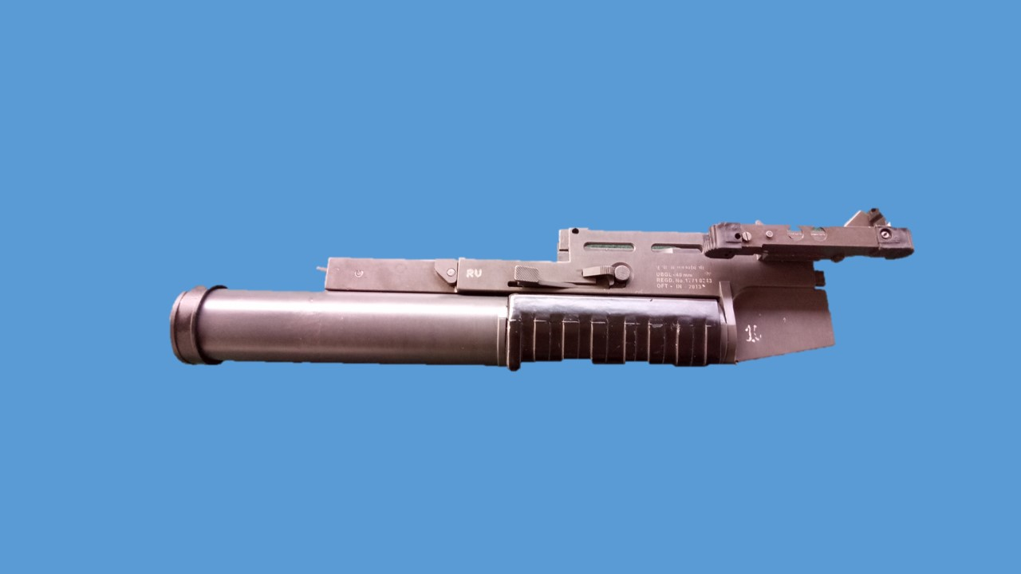

**40MM UNDER BARREL GRENADE LAUNCHER (INSAS)**

**LESSON-1**

**40MM UNDER BARREL GRENADE LAUNCHER (INSAS)**

1. **Shuru Shuru ka Kaam**

(a) Class ki ginti groupon mein bant

(b) Hathiyar aur saman ka nirikshan

(c) Bandobast ki karwai

2. **Dohrai**

Pichle lesson se kiya jaye.

3. **Pahunch**

40mm under barrel grenade launcher (INSAS) ek new generaton weapon hain. Zaruri hain ki har jawan iske bare main jankari rakhta hon taki zarurat parne peer iska istemal kar saken.

4. **Uddesh**

40mm Under barrel grenade launcher ki visheshtayen, kholna, jorna aur safai karne ka tariqa sikhana hain.

5. **Saman**

40mm UBGL (INSAS), Insas Rif , Rif Ak-47, ground sheet, Black board, chalk, duster.

6. **Bhagon Mein Bant**

Yeh sabaq teen bhagon mein chalaya jayega:-

(a) **Bhag-I** - 40mm UBGL (INSAS) ki vish aur tech data

(b) **Bhag-II** - 40mm UBGL (INSAS) ko kholna, hisse purjon ke naam, kaam aur Rifle per fit karna aur utarana.

(c) **Bhag-III** - Safai karne ka tariqa

**(a) Bhag-I - 40mm UBGL (INSAS) ki vish aur tech data**.

**Visheshtayen**

(i) Yeh apne desh ka bana hua hathiyar hain.

(ii) Yeh ek halka hathiyar hain aur karger range adhik hain.

(iii) Yeh ek breech loaded hathiyar hain.

(iv) Isse hum direct aur indirect fire kar sakte hain.

(v) Isse hum 4 parkar ka amn fire karte hain.

(vi) 80 degree ke angle tak fire kar sakte hain.

(vii) Rif aur UBGL se ek sath fire kar sakte hain.

**Tech Data**

|  |  |  |  |
| --- | --- | --- | --- |
|  | Calibre | - | 40mm |
|  | Wazan | - | 1.5kg |
|  | Lambai | - | 450mm |
|  | Barrel ki ambai | - | 350mm |
|  | Grooves | - | 06 (RH) |
|  | Rifle pitch | - | 1200mm (Progressive) |
|  | Muzzle Velocity | - | 60 mtr/sec |
|  | Fore Sight | - | Post type |
|  | Rear Sight | - | Ladder Type |
|  | Direct Range | - | 100, 150, 200, 250, 300 aur 400mtr (Ladder Sight) |
|  | Indirect range | - | 300mtr aur 400mtr  (bubble sight) |
|  | Rate of fire | - | 5 se 7 gren/min |
|  | Effective range | - | 400mtr |
|  | Recoil energy | - | 17 joules |
|  | Applied safety | - | Safety catch |
|  | Mech Safety | - | In built safety for trigger ops and barrel locking |
|  | Sight | - | Open sight and bubble sight |
|  | Sidhant | - | Single shot, pump action |
|  | Cartridge ka size | - | 40 x 46mm |
|  | Raat ke samay Beta light ki suvidha | - | 100 mtr aur 200 mtr |
|  | Amn | - | HE, HEDP, RP, SMOKE, TPT |

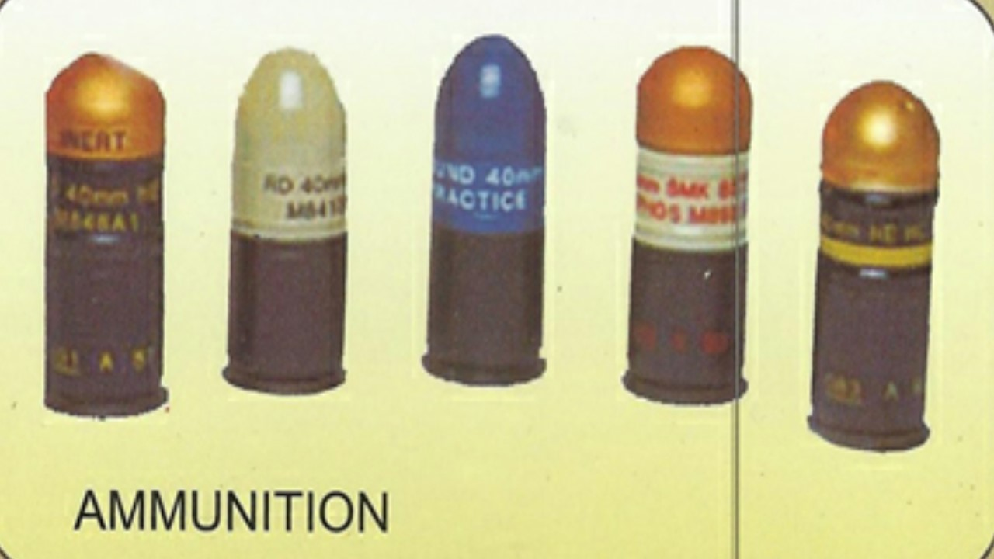

**(b) Bhag-II - 40mm UBGL (INSAS) ko kholna, hisse purjon ke naam, kaam aur Rifle per fit karna aur utarana**

**Kholna**. Sabse pahle yakn karen ki UBGL khali hain. Bayen hath ke anguthe ki madad se barrel locking catch ko dabayen aur dayen hath se hand guard se pakarte hue barrel ko aage ki taraf karen aur body se barrel ko alag karen. Is parkar UBGL (INSAS) do bhagon main khulta hain.

(a) Body Housing Assy (b) Barrel Assy

(a) **Body Housing Assy**. Bayonet lug catch Insas Rif, Bayonet lug catch Rif AK-47, Spring lug catch, races for cocking arm, barrel locking lever, end plate, back plate, trigger, safety catch, sitted for gren primer, ejector, extractor, firing pin, recoil spring, recoil spring housing way, extractor spring, guide spring, retainer, retainer guide, retainer guide spring.

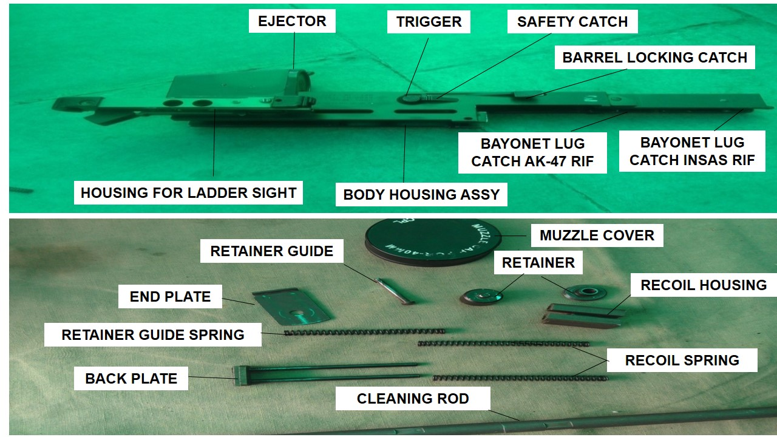**BODY HOUSING ASSY**

(b) **Barrel Assy**. Barrel, hand guard, leaf spring, cocking arm,   
 rivet, cocking arm.

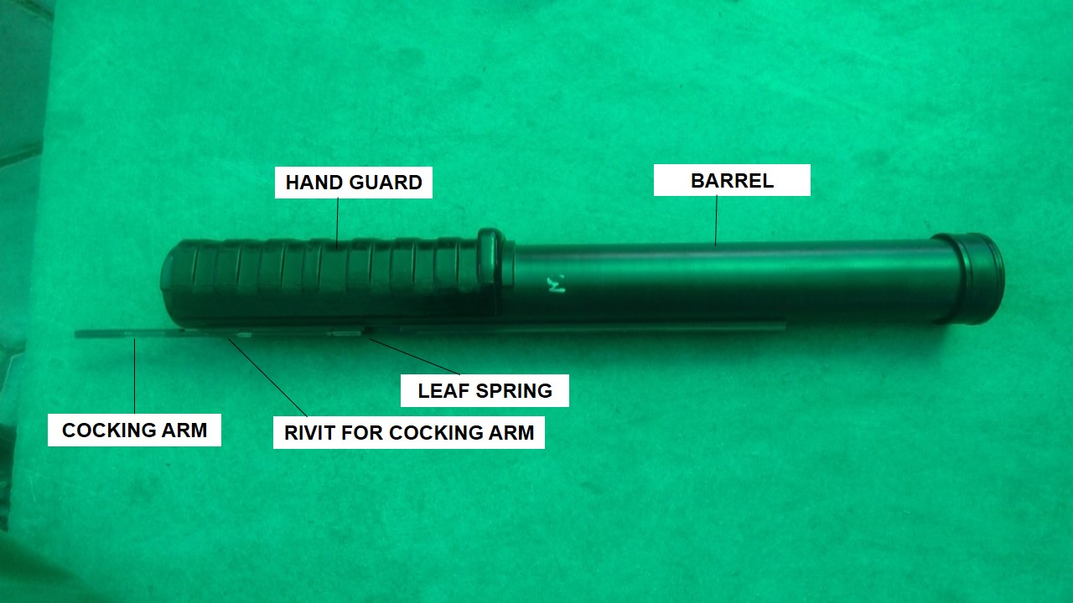

**BARREL ASSY**

**Jorna**. Jis parkar se khola gaya tha uske vipreet karwai karte hue jor den.

**INSAS Rif per charane ka tariqa**.

(i) INSAS Rif ke fore hand guard ko kholen.

(ii) UBGL (INSAS) ko len aur bayonet lug catch INSAS Rif main fit karen.

(iii) Rif ke cup hand guard ko upper ki taraf karen.

(iv) UBGL (INSAS) ke niche wale bhag ko Rifle main fit karen aur cap ko lagayen.

**AK-47 Rif per charane ka tariqa**.

(i) AK-47 Rifle per chadane ke liye pahle Rifle ko kholen aur fore hand guard ko bhi nikalen.

(ii) UBGL (INSAS) ko len aur bayonet lug catch AK-47 main fit karen.

(iii) Rif ke cup hand guard ko upper ki taraf karen.

(iv) UBGL (INSAS) ke niche wale bhag ko Rifle main fit karen aur cap ko lagayen.

(v) AK-47 ko jor den.

**UBGL (INSAS) ko Rifle se utarane ka tariqa**.

(i) Cup hand guard ke locking catch ko 90 degree main khara karen aur cap hand guard ko upper ki taraf khinche.

(ii) Bayonet lug catch ko niche ki taraf dabate hue UBGL (INSAS) ko Rifle se alag karen.

(iii) Rif ke hand guard ko lagayen.

**(c) Bhag-III - Safai karne ka tariqa** Safai karne ka tariqa bhi aanya hathiyaron ki tarah hain. Safai karne ke liye clening rod ke sath claning brush diya hua hain. Cleaning rod se barrel ko khol kar safai karen. Lubrication anya hathiyaron ki tarah hi hain.

**DO’s**

(i) Diye hue brush se hi safai ki jayen.

(ii) Jab UBGL (INSAS) ka istemal nahi kiya jar aha ho ladder sight ko down karke rakha jae aur muzzle cover lagayen.

(iii) UBGL (INSAS) ko cock karte samay jhatke se cock nahi kiya jayen.

**DON’T**

(i) Kisi dusre brush se safai na karen.

(ii) Jab UBGL (INSAS) ka istemal nahi kiya ja raha ho ladder sight ko khara na karen.

(iii) UBGL (INSAS) ko cock karte samay jhatke se cock nahi kiya jayen.

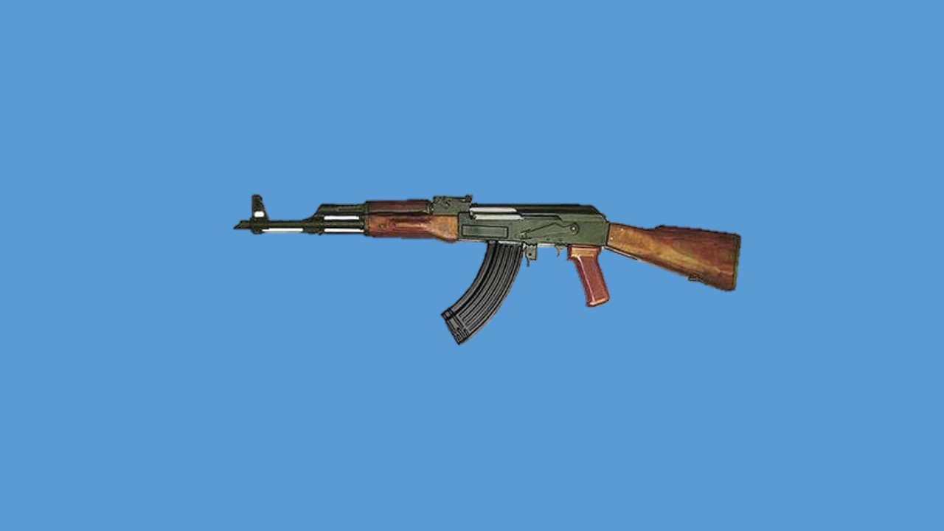

**RIFLE 7.62MM AK-47**

**(AVTOMAT KALASHNIKOVA)**

**LESSON-1**

**RIFLE 7.62MM AK-47**

1. **Shuru Shuru ka Kaam**

(a) Class ki ginti groupon mein bant

(b) Hathiyar aur saman ka nirikshan

(c) Bandobast ki karwai

2. **Dohrai**

Pichle lesson se kiya jaye.

3. **Pahunch**

Rif AK-47 hamari sena main Inf sec mein Rifleman No 3 ko auth kiya gaya hain. Is hathiyar ke upar UBGL ka istemal karte hue fire power ko badhaya ja sakta hain. Zaruri hain ki sena ka hare k jawan is hathiyar ke bare main jankari rakhta ho taki zarurat parne per iska istemal kar saken.

4. **Uddesh**

Rif 7.62mm AK-47 se waqfiat, kholna, jorna aur safai karne ka tariqa sikhana hain.

5. **Saman**

Rif 7.62mm AK-47, magazine, Black board, chalk, duster, ground sheet,.

6. **Bhagon Mein Bant**

Yeh sabaq teen bhagon mein chalaya jayega:-

(a) **Bhag-I** - Rif 7.62mm AK-47 ki visheshtayen aur tech data

(b) **Bhag-II** - Rif AK-47 ko kholna, hisse purjon ke naam, kaam aur jorne ka tariqa.

(c) **Bhag-III** - Assy se jankari aur safai karne ka tariqa

**(a) Bhag-I - Rif 7.62mm AK-47 ki visheshtayen aur tech data**.

**Visheshtayen**

(i) Yeh ek automatic hathiyar hain.

(ii) Mag capacity zaida hain.

(iii) Carry karne main assan hain.

(iv) Yeh hathiyar Russia desh ka bana hua hain.

(v) Is hathiyar ko lambe range ke sath sath CQB role main bhi istemal kar sakte hain.

(vi) UBGL ko iske sath fit karke donon ko ek sath fire kar sakte hain.

(vii) Maintenance kam hain aur rken kaam parti hain.

**Tech Data**

|  |  |  |  |
| --- | --- | --- | --- |
|  | Calibre | - | 7.62mm |
|  | Khali Rif ka wazan | - | 3.15kg |
|  | Khali mag ka wazan | - | 322gms |
|  | Bhari mag ka wazan | - | 827gms |
|  | Bhari Rif ka wazan | - | 4.6kg |
|  | Bayonet ka wazan | - | 450gms |
|  | Sling ka wazan | - | 180gms |
|  | Rif ki lambai | - | 874mm |
| (j) | Butt fold lambai | - | 645mm |
| (k) | Barrel ki lambai | - | 414mm |
| (l) | Sight radius | - | 378mm |
| (m) | Muzzle Velocity | - | 715mtr/sec |
| (n) | Grooves | - | 06 (RH) |
| (o) | Rifling pitch | - | 235mm |
| (p) | Sidhant | - | Gas operated selective fire |
| (q) | Gas Regulator | - | Constant volume type |
| (r) | Throw off | - | 2 baje ki line |
| (s) | Compensator | - | 7 baje ki line |
| (t) | Rate of fire |  |  |
|  | (i) Single shot  (ii) Burst | -  - | 40rds/min  100rds/min |
| (u) | Karger range | - | 300mtr |

**(b) Bhag-II – Rif AK-47 ko kholna, hisse purjon ke naam, kaam aur jorne ka tariqa**

**Kholna**.

(i) Mag catch ko dabate hue mag ko utaren.

(ii) Agar Rif ke sath bayonet laga hua hain toh use utaren.

(iii) Sling ko kholen.

(iv) Rif ko cock karen aur chal wale purjon ko aage jane den.

(v) Retainer ko ander ki taraf push karte hue body cover ko alag karen.

(vi) Bolt carrier ko bahar nikalen.

(vii) Gas tube locking catch ko 90 degree ke angle par khara karen aur gas tube ko bahar nikalen.

(viii) Bolt carrier se rotating bolt ko alag karen.

(ix) Agar firing pin aur extractor ko kholna ho toh Insas Rif ki tarah hi kholen.

**Hisse purjon ke naam**.

Body Housing, Trigger, trigger guard, hammer, bolt, operating handle, Receiver cover, fire selective lever, Bolt carrier.

**Jorna.** Agar ek se Jaida **h**athiyar khule hain toh regd No check kar len. Firing pin ya extractor kholagaya ho tohsabse pahle use joren. Gas tube locking catch ko 90 degree main khara karen aur gas tube ko fit karen. Gas tube locking catch ko lock karen. Bolt carrier ko len aur bolt ko joren. Bolt carrier ko body housing main dakhil karen aur receiver cover ko lagayen. Rif le ko cock karen aur trigger press karen. Mag ko len aur mag way main fit karen. Bayonet aur sling ko lagayen.

(c) **Bhag-III - Assessories se jankari aur safai karne ka tariqa**

**Assy se jankari**

(i) Bayonet (ii) Sling

(iii) Recoil Hardner (iv) Mag pouch

(v) Oil Bottle (vi) Pull Through

(vii) Cleaning Rod (viii) Cleaning Brush

(ix) Wrench case (x) Luminous sight adopter front & rear

**Wrench Case ka saman**

(i) Drift (ii) Scorer (iii) Punch (iv) Bore brush

(v) Tool adjusting foresight & rear sight

**Safai ka saman** Safai anya hathiyaron ki tarah ki jati hain. Safai karne ke liye nimnlikhit saman ki zarurat padti hain.

(i) Cleaning rod

(ii) Cleaning Brush Chindi ka size

(iii) Chindi (a) Sukha - 4”x 2”

(iv) Pull Through (b) Oil - 4”x 1.5”

(v) Oil with oil bottle

Safai karne ke stages aur lubrication anya hathiyaron ki tarah.

**Zeroing karne ki tariqa**

Tgt - 4’x 4’

Range- 100m

Sight Rg - 300m

Round - 05

MPI - 28cm upar POA se

**Note**:- Correction sirf firesight tip per hi diya jata hain aur donon correction par galti per galti kiya jata hain.

Ek chakar 100mtr per 20cm ka farak padta hain.

Ek scriber line 100mtr per 26cm ka farak padta hain.

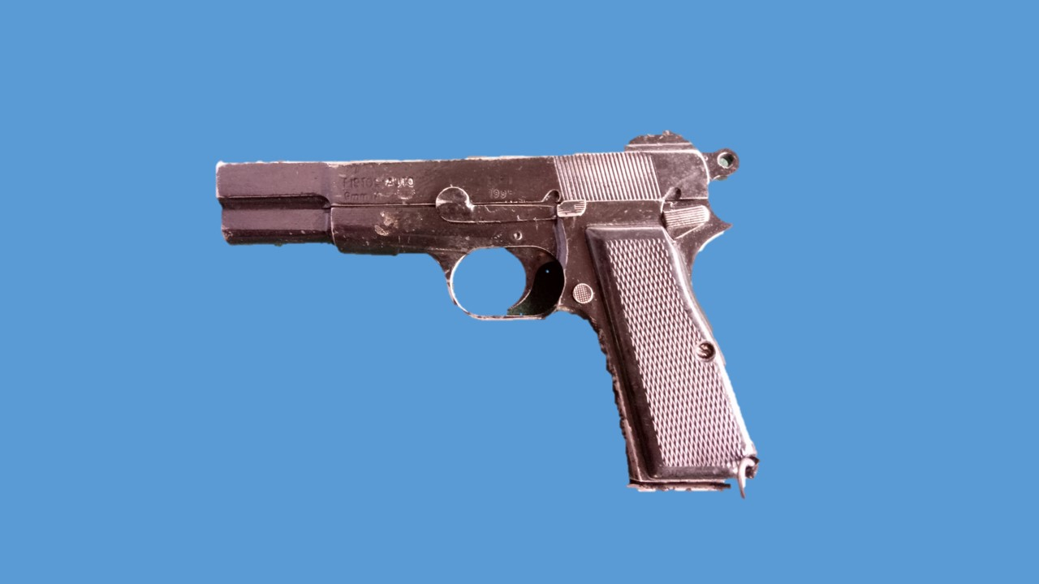

**9 MM PISTOL**

**LESSON-1**

**9MM PISTOL KA AAM BAYAN VISHESHTAEN AUR TECH DATA**

**Ref - (Infantry Training Volume I – Infantry Platoon Weapons Pamphlet No 4 Carbine Machine Pistol and Close Quarter Battle 1982)**

**Aam Jankari**

1. 9mm Pistol CQB ka bahut achha hathiyar hai, isse nazdik niklane wale dushman ke upar jaldi se fire karke barbad kiya ja sakta hai. Zaruri hai ki ek firer jaldi se jaldi pistol ko bharna, khali karna aur fire karne ka tariqa achhi tarah janta ho taki is ka pura faida uthaya ja sake aur samay ki bachat karte hue ek goli ek dushman ka mudda hasil kiya ja sake.

**Visheshtaen**

2. Iski visheshtaen is parkar hain:-

(a) CQB role main istemal kiya jata hain.

(b) Carry karne main assan hain.

(c) Chupao acha hain.

(d) Nazdik dushman per fire karna asan hain.

(e) Wazan kam hain.

**Tech Data**

3. Iska tech data is parkar se hain:-

|  |  |  |  |
| --- | --- | --- | --- |
|  | Caliber | - | 9mm |
|  | Khali pistol ka wazan | - | 900gms |
|  | Khali mag ka wazan | - | 75gms |
|  | Bhari mag ka wazan | - | 200gms |
|  | Bhari pistol ka wazan | - | 1.1kg |
|  | Mag capacity | - | 13 Rds, 12 Rds bhare jate hain |
|  | Pistol ki lambai | - | 7.8 inch |
|  | Barrel ki lambai | - | 4.75 inch |
|  | Sight radius | - | 6.25 inch |
|  | Muzzle velocity | - | 305mtr/sec |
|  | Rate of fire | - | 06 rds/06 sec |
|  | Sidhant | - | Short Recoil |
|  | Grooves | - | 06 (RH) |
|  | Firing Pin | - | Slotted type |
|  | Applied safety | - | Safety catch |
|  | Mech safety | - | Mag, Half Vent, Barrel aur slide ki 5mm ek sath aage pichhe ki harkat |
|  | Trigger Pull | - | 5 se 8 lbs ya 2.270 se 3.630kg |
|  | Fore sight | - | Blade type |
|  | Rear sight | - | U type |
|  | Battle crouch range | - | 10mtr |
|  | Support ke sath range | - | 25mtr |
|  | Fore sight blade type | - | 0.125”, 0.135”, 0.145”, 0.155”, 0.165” |
| Note:- Jab pistol aata hain toh 0.145” wala blade laga hota hain.  1 blade ki badly karne per 10mtr per ½ inch ka farak parta hain. | | | |

**LESSON-2**

**9MM PISTOL KO KHOLNA, JORNA AUR SAFAI**

**Ref - (Infantry Training Volume I – Infantry Platoon Weapons Pamphlet No 4 Carbine Machine Pistol and Close Quarter Battle 1982)**

**Shuru Shuru ki Karwai**

1. Shuru-shuru ke kaam mein nimnlikhit baton par gaur kiya jaye:-
   1. Bandobast ki karwai.
   2. Class ki ginti groupon mein bant.
   3. Hathiyar saman ka nirikshan.

**Dohrai**

2. Pichle lesson se liya jaye.

**Pahunch**

3. Pistol short recoil ke sidhant par kam karne wala ek semi automatic CQB ka hathiyar hai. Ek jawan ko iski achhi dekhbhal ke liye ise kholna, jorna aur safai karne ka tariqa ache tariqa se aana chaiya.

**Uddesh**

1. 9mm Pistol ko kholna, jorna aur safai karne ka tariqa sikhana hai.

**Saman**

1. 9mm Pistol, chindi, sutli, tel, cleaning rod aur ground sheet.

**Bhagon Mein Bant**

1. Yeh sabaq teen bhagon mein pura kiya jaega:-

(a) **Bhag-I**  - Pistol firer ki acchi aadaten

(b) **Bhag-II** - Pistol ko kholna aur jorna

(c) **Bhag-III**  - Safai karne ka tariqa

7. **Bhag-I : Pistol firer ki acchi aadaten**

(a) Pistol ko hamesha bhara hua samajna chaiya.

(b) Pistol ko lete samay ya dete samay nirikshan karna chaiya.

(c) Pistol ko jab tak istemal na karna ho tab tak pistol case se bahar na nikalein.

(d) Chahe pistol khali ho ya drill carts ka istemal ho raha ho, majak mein bhi pistol ka rukh kisi admi ki taraf nahi karna chahiye.

(e) Dushman ko kabi bhi pistol ke nazdik nahi aane dena chaiya.

8. **Bhag-II : Pistol ko kholna aur jorna**

(a) **Kholna**. Yakin karen ki pistol khali hain. Mag catch ko dabate hueye mag ko utaren. Slide ko pichhe karen aur safety catch ko slide ke aage wali jhiri mein lagayen. Dayen hath se slide locking lever ko dayen se bayen push karte huye bahar nikalen. Slide ke upar kabu   
 rakhte huye safety catch ko jhiri se alag karen aur slide aur frame ko alag karen. Main guide spring age ki taraf push karte huye bahar nikalen.   
 Barrel ko bahar nikalen. Is prakar se pistol char bhagon mein khulta hai. Slide, Frame, Barrel aur Mag.

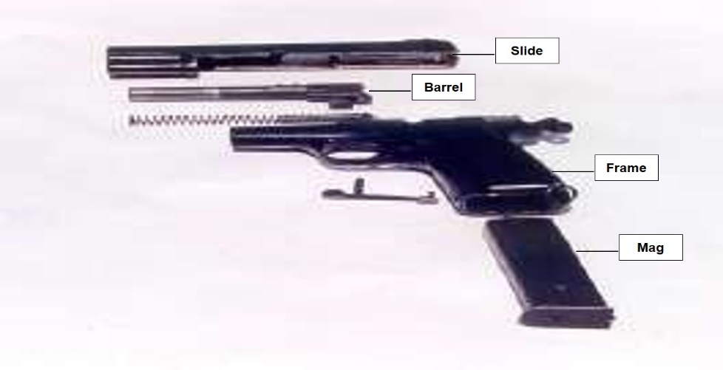

**Khula hua pistol**

(b) **Hisse Purjon ke Naam**. Fore sight blade, slide locking thread, feed piece, firing pin, extractor, sighted for positional lug, slide locking lever, main guide spring, guide, sear connecting lever, barrel,  
 positional lug, bullet guide, frame, pistol grip, mag way, tripping  
 lever head, tripping lever tail, ejector, sear, sear arm, hammer, full  
 vent, half vent.

(c) **Jorna**. Barrel ko slide mein dakhil karen aur main guide spring ko joren. Slide aur frame ko milate huye joren aur slide locking lever ko lagayen. Slide ko aage jane den. Mag ko chadhayen aur trigger ko press karen.

9. **Bhag-III : Safai karne ka tariqa**

Safai karne ke liye saman is parkar hain:-

(a) Cleaning rod.

(b) Chindi.

(c) Cleaning brush.

(d) Sutli.

(e) Pull through.

(f) Oil.

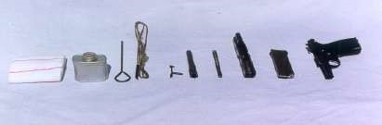

**9mm Pistol : Safai ke liye taiyar**

10. **Safai ke parkar**

(a) Aam Safai

(b) Firing ke lihaj se safai

(c) Mausam ke lihaj se safai

11. **Lubrication** - Anya hathiron ki tarah

12. **Chindi ka size**

Dry - 4” x 3”

Oil - 4” x 2”

**Sankshep**

13. Ustad sabaq se sambandhit sawal jawab karke sankshep kare.

**LESSON-3**

**9MM PISTOL KO BHARNA, KHALI KARNA, FIRING POSITION**

**AUR FIRE KARNA KA TARIQA**

**Ref - (Infantry Training Volume I – Infantry Platoon Weapons Pamphlet No 4 Carbine Machine Pistol and Close Quarter Battle 1982)**

**Shuru Shuru ka Kam**

1. Class ki ginti groupon mein bant karein. Hathiyar aur saman ka nirikshan karein aur bandobast ki karwai class se karwaein.

**Dohrai**

1. Pichle lesson liya jayen.

**Pahunch**

1. Pistol CQB ka hathiyar hai. Is ko achanak aur najdik range par nikalne wale dushman par istemal kiya jata hai. Jawan ko is kabil hona chahiye ki woh pistol ko bharna, khali karna aur firing posn ikhtiyar karne mein samay zaya na kare aur dushman ko aasani se barbad kar sake.

**Uddesh**

1. 9mm Pistol ko bharna, Ready, makesafe aur fire karne ka tariqa sikhana hain.

**Saman**

1. Pistol, mag, line yard, drill carts, ground sheet aur fig 11 tgt.

**Bhagon Mein Bant**

1. Yeh sabaq teen bhagon mein chalaya jaega:-

(a) **Bhag-I ­**- Pistol ki mag ko bharna aur khali karna

(b) **Bhag-II** - Pistol ko bharna, ready, make safe aur khali karna

(c) **Bhag-II** - Firing posn aur fire karna

**Bhag-I : Pistol ki Mag ka Bharna aur Khali Karna**

### Mag ko Bharna**. Cartoon se amn ko nikalen aur ek ek rd ki safai karen. Agar samay kam hain toh kai sare roundon ko ek sath bhi saaf kar sakte hain. Dhyan rahe roundon ka aapas mein ragad nahi honi chahiye. Mag ko len aur nirikshan karen. Agar mag dabi ho tuti ho to use alag rakhen. Agar mag thik ho to saaf kiye huye rd ko len aur ek ek karke mag mein bharen. Agar koi rd niche gir jata hai to use aakhir mein saaf karke bharen. Is prakar mag mein 13 rd aate hai aur 12 rd bhare jate hain.**

### **8.** Khali karna**. Khali karne ke liye mag ko is prakar pakren ki bullet wala hissa niche ki taraf ho. Dayen hath ke anguthe ki madad se ek ek karke bahar nikalen. Rd ko saaf karen aur cartoon mein band karen.**

**Bhag-II : Pistol ka Bharna, Ready, Makesafe aur Khali Karna**

9. **Pistol ko Bharna.** Agar firer ko tgt dikhai de ya trg ke dauran addesh mile ‘**BHAR’** to pistol ko case se bahar nikalen, barrel ko surakshit disha mein rakhte huye mag catch ko dabayen aur khali mag ko utaren. Pouch se bhari hui mag ko len aur mulahija karte huye mag way mein dakhil karen. Yakin karen ki mag thik lag gaya hai. Pistol ko wapis case mein rakhen.

10. **Ready**. Agar firer fire ka irada rakhta ho ya trg ke dauran addesh mile ‘**READY’** to pistol ko case se bahar nikalen, brl ko surakshit disha mein rakhte huye cock karen aur agle hukum ka intezar karen

11. **Make Safe**. Agar pistol ko bhari hui halat mein ek jagah se dusri jagah par le jana ho to makesafe ki karwai ko amal mein laya jata hai. Makesafe karne ke liye mag catch ko dabate huye mag ko utaren, dayen turn karte huye do baar clear karen, pouch se bhari hui mag ko len aur mulahija karte huye mag way mein dakhil karen, yakin karen ki mag thik lag gaya hai, pistol ko case mein band karen, kneeling posn ikhtiyar karen, eject huye rd ko len aur saaf karke dusre mag mein bharen.

12. **Khali Karna.** Hukam mile khali kar to karwai is tarah karein. Pistol ko case se nikalen, bhara hua mag utaren aur slide se pakrate huye pistol ko do baar cock karen, khali mag lagaen aur trigger ko dabaen. Pistol ko wapas pistol case mein band karein.

**Bhag-III : Firing Posn aur Fire Karna ka tariqa**

1. 9mm Pistol se do positions se fire kiya jata hain

(a) Battle crouch posn

(b) Standing posn.

(a) **Battle Crouch Position.** Is posn ko us waqt ikhtiyar karte hai jab dushman 10m se kam duri par nikalta hai. Is posn mein bayen paon ko tgt ki sidhai mein len, bayen ghutane mein khamb dale, dayen paon ko pura pichhe sidha karen aur body ko hip se age ki aur jhukayen. Dayen kohni ko belt ki line mein kamar ke sath lagayen aur sir ko age jhukayen. Posn aram-deh hona chahiye. Pistol ko pet ke bicho bich aur bayen paon ke anghuthe ke line mein rakhte hue tgt ki sidh mein karein, yakin kare ki kohini se aage pistol wala haath zamin se samantar ho aur baju ka kohni se agla hissa aur pistol ki barrel ek hi line mein ho. Is samay firer ki nabhi (navel), pistol aur dushman ek line mein hona chahiye. Yadi aapki goliyan tgt par upar lag rahi hon to bayen paon ke khamb ko thoda adhik karen. Yadi niche lag rahi hon toh bayen paon ke khamb ko kam karen. Agar bayen lag rahi hon toh dayen paon ko bayen karen. Yadi dayen lag rahi hon toh dayen paon ko thoda dayen karen. Agar dushman acahnak aap ke bayen ya dayen se nikal jata hai to apne aage wale paon ko pivot banakar bayen ya dayen ghum jayen. Agar dushman piche se surprise karta hain toh pistol ko bayen kandhe se lagate hue bayen paon ka pivot banate hue pura piche ghum jayen.

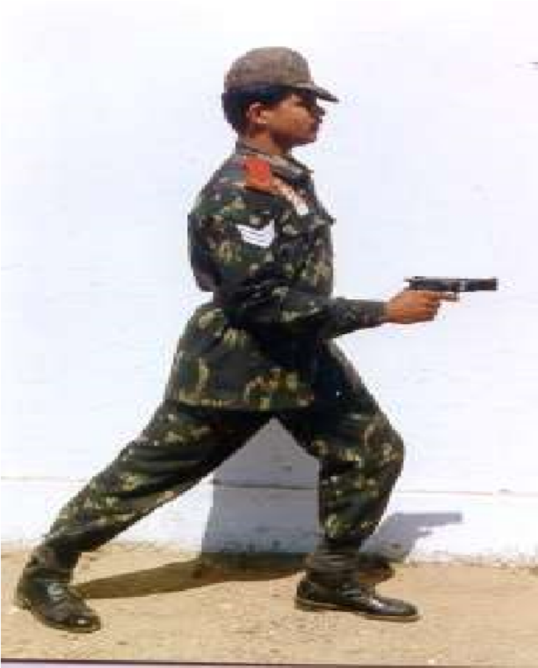

.

**Battle Crouch Position**

(b) **Standing Position.** Yeh position tab ikhtiyar karte hain jab dushman 10m se 25m tak ki duri par ho. Jis hath se fire karna ho usi payon ko aage le jaen aur badan ko tircha karein. Baju ko sidha karein aur dusre baju ko sharir ke pichhe, kamar pe ja hath ko pocket main le jayen.

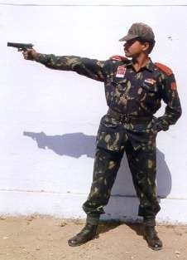

**Standing position**

**Fire Karna ka tariqa** Munashib posn ikhtiyar karen, pistol ko kalmewali ungali aur angute ke beech wale bhag se mazbooti se pakren. Shist lete huye pahla khichav ko hasil karen. Durust shist mil jane par saans par control rakhte huye dusre khichav ko bhi hasil karen. Is parkar trigger per 2.270 se 3.630 kg (5 se 8 lbs) ka dabav aane per trigger press ho jata hain aur round fire ho jata hain. Is parkar ek firer 6 rds per 6 sec main fire kar sakta hain. Agar firing ke dauran tgt area mein koi jandar chiz nikal aaye ya adesh mile ‘**STOP’** to pistol ko neeche layen aur safety catch ko lagayen aur pistol ko case mein band karen. Agar tgt area se jandar chiz hat jayen ya trg ke dauran addesh mile **‘GO ON’** pistol ko bahar nikalen, safety catch ki posn ki badly karen aur durust shisht lete huye fire ko jari karen. Yeh tha fire karne ka tariqa.

**Sankshep**

14. Sankshep sabaq se sambhandit sawal jawab se kiya jaye.

**LESSON-4**

**9MM PISTOL KI CHAL AUR ROKEIN**

**Ref - (Infantry Training Volume I – Infantry Platoon Weapons Pamphlet No 4 Carbine Machine Pistol and Close Quarter Battle 1982)**

**Shuru Shuru ka Kam**

1. Class ki ginti groupon mein bant karein. Hathiyar aur saman ka nirikshan karein aur bandobast ki karwai class se karwaein.

**Dohrai**

1. Pichle lesson se kiya jaye.

**Pahunch**

1. 9mm Pistol CQB ka hathiyar hai. Ek firer ko ismein puri nipunata hasil kar leni chahiye taki, larai ke dauran parne wali rokon ko asani se pehchan kar jaldi se jaldi dur kar sake aur pistol ko fire mein shamil kar sake.

**Uddesh**

1. 9mm Pistol ki chal, parne wali roken aur unhen door karne ka tariqa sikhana hai.

**Saman**

1. 9mm Pistol, magazine, drill cartridges, ground sheet, pistol case, fig 11 tgt, Black board, chalk, duster.

**Bhagon Mein Bant**

1. Yeh sabaq do bhagon mein chalaya jayega:-

(a) **Bhag-I** - 9mm Pistol ki chal.

(b) **Bhag-II** - Parne wali roken aur unhein dur karne ka tariqa.

**Bhag-I : 9mm Pistol ki Chal.**

1. Pistol ki chal 8 action mein puri hoti hai isse samjayen aap board per bane chal ke diagram ki madad se.

**FIRE**

**UNLOCK**

**EXTRACT**

**FEED**

**LOAD**

**LOCK**

**EJECT**

**CHAL**

**COCK**

1. Pistol ki chal mein kam aane wale hisse purjon ke naam is prakar hain:-

Mag, tripping lever head, tripping lever tail, sear connecting lever, sear arm, hammer, hammer vent, firing pin, barrel, locking thread, slide locking races, extractor, ejector, feed piece, positional lug, sited for positional lug, Unclined surface, limiter.

**Chal.** Jab firer mag ko chadhata hai to mag ka agla kinara tripping lever head ke upar dabav dalta hai, jisse tripping lever tail sear connecting lever ki sidh mein aa jata hai. Jab trigger ko dabaya jata hai to tripping lever tail sear connecting lever ke agle hisse par dabav dalta hai, jisse sear connecting lever ka pichhle hissa sear arm ke upar dabav dalta hai aur hammer azad hokar firing pin retainer par chot marta hai, firing pin apne hole se nikalkar chamber wale rd ke primer par chot marta hai aur rd fire ho jata hain, Ise **fire** ki karwai kahte hain.

Rd fire hone se ek dhakka lagta hai jise short recoil ke naam se jante hain. Is dhakke ki madad se brl aur slide piche ki harkat karte hain. Jab brl aur slide donon ek sath lock halat mein 5mm peeche ki harkat karta hai to unclained surface limitor se takra kar neeche ki taraf dab jata hai aur brl locking thread tatha slide locking races ka milap tut jata hain, karwai **unlock** ki hoti hai.

Yahan par brl ke peechhe ki harkat samapat ho jati hai lekin slide ke peeche ki harkat jari rahti hai. Is peeche ki harkat ke dauran extractor fire case ko peeche lata hai, karwai **extract** ki hoti hai.

Fired case ejector se takrakar ejection slot ke raste dahine aur neeche gir jata hai, karwai **eject** ki hoti hai.

Slide hammer ke pura upar se gujar jata hai aur forward lug se takrane ke karan peeche jane se ruk jata hai. Is dauran hammer vent ka milap sear ke sath ho jata hai, karwai **cock** ki hoti hai.

Main guide spring sikur jata hai. Jab spring apne tanav ko pura karta hai to slide ko aage dhakelta hai. Is aage ki harkat ke dauran feed piece mag ke upar wale rd ko chamber mein dakhil karta hai, karwai **feed** ki hoti hai.

Extractor round ke pende par sawar ho jata hai, karwai **load** ki hoti hai. Positional lug, sited for positional lug ke upar dabav dalta hai jisse brl upar ki taraf uthta hai, is dauran brl locking thread aur slide locking races ka milap ho jata hai, karwai **lock** ki hoti hai. Lock hone ke baad bhi brl aur slide lock halat mein donon ek sath 5mm aage ki harkat karta hai. Is dauran sear connecting lever ka agla kinara tripping lever tail ki sidh mein aa jata hai aur pistol dubara fire karne ke liye taiyar ho jata hai.

**Bhag-II : Parne wali roken aur unhen door karne ka tariqa:-** Bhar, ready**,** samne tgt, fireke addesh per pistol fire na karen ya fire karte karte ruk jaye toh rok ko pechane. Pechane ka tariqa, kalme wali ungli ko trigger se bahae nikalen. Pistol ko bhar posn mein layen. Pistol ko bayen turn karen aur ejection slot ke raste dekhen. Dekhne se pata chala hammer pura aage slide pura aage to **Misfire** ki rok samajh kar dur karen. Pistol ko dayen turn karte huye cock karen, slide ko aage jane den aur fire mein shamil karen. Misfire ki rok ko dur karne ke baad bhi pistol fire na karen yak arte karte ruk jaye toh kalme wali ungli ko trigger se bahar nikale pistol ko bhar posn main layen, pistol ko bayen turm karen dekhne mein aaye hammer pura peeche slide aage se thora peeche to **Unfit round** ki rok samajh kar dur karen. Bayen hath ki hatheli se slide par thapki lagayen, unfit rd fit ho jayega, pistol ko fire mein shamil karen. Misfire aur unfit round ki rok ko dur karne ke baad bhi pistol fire na karen ya karte karte ruk toh kalme wali ungli ko trigger se bahar nikale pistol ko bhar posn main layen, pistol ko bayen turm karen, dekhne mein aaye hammer pura peeche slide peeche se thora aage to **Body mein atke huye round** ki rok samajh kar dur karen. Slide ko pakarte huye pistol ko cock karen, pistol ko dayen turn karte huye hilayen, body mein atka hua round neeche gir jayega, pistol ko fire mein shamil karen. Misfire aur unfit round ki rok aur body main atka huya round ya fire case ke rok ko dur karne ke baad bhi pistol fire na karen ya karte karte ruk jayen toh rok ko pechane. Pechane ka tariqa kalme wali ungli ko trigger se bahar nikale pistol ko bhar posn main layen, pistol ko bayen turm karen, dekhne mein aaye hammer pura peeche slide pura peeche to **Khali mag** ki rok samajh kar dur karen. Mag catch ko dabate huye khali mag ko utaren, pouch se bhari hui mag ko len, mag ka mulahija karte huye mag way mein dakhil karen, yakin karen ki mag thik lag gaya hai, slide ko aage jane den aur pistol ko fire mein shamil karen.

**Abhyas**

9. Abhyas ke liye addesh is parkar se honge, hammer pura aage slide pura aage toh misfire ki rok samajh kar dur karen, hammer pura peeche slide aage se thora peeche, toh unfit round ki rok samajh kar dur karen, hammer pura peeche slide peeche thora aage toh aap body mein atka huye round ki rok samajh kar dur karen, hammer pura peeche aur slide pura peeche toh aap mag ki rok samajh kar dur karege.

[

**Sankshep**

10. Class se sabaq se sambhandhit sawal aur jawab karein.

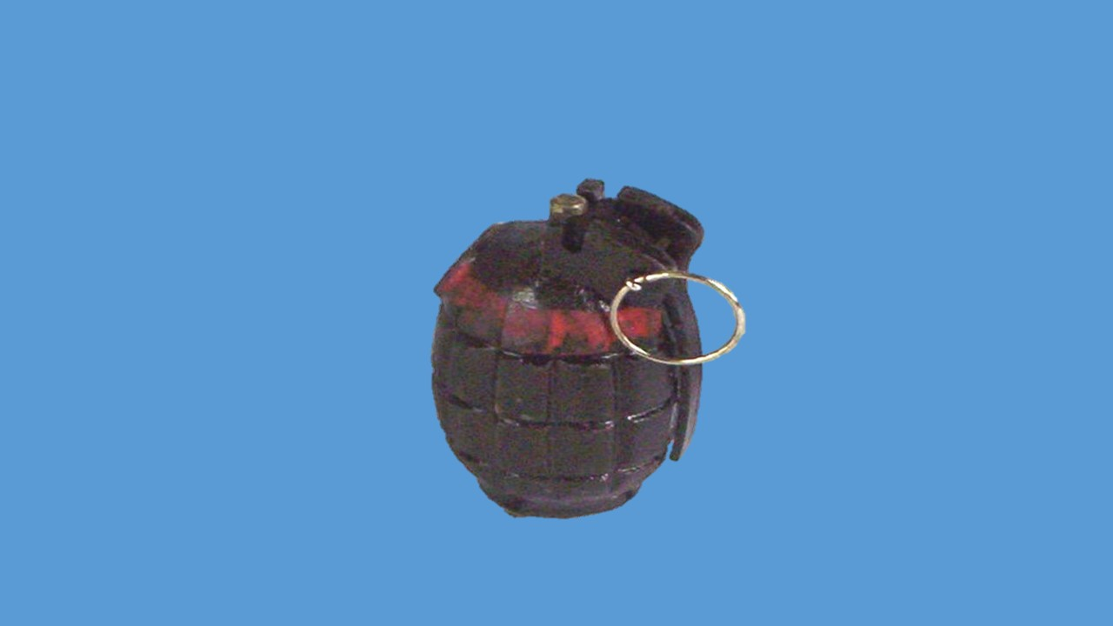

**No 36 HAND GRENADE AUR**

**TRIP FLARE**

**LESSON-1**

**No 36 HAND GRENADE KI PEHCHAN, CHAL,**

**VISHESHTAEN AUR ISTEMAL**

**Ref - (Infantry Training Volume-I Infantry Platoon Weapons Pamphlet No 7 Grenade All Arms 2006)**

1. **Prakar.** No 36 Grenade istemal ke lihaj se teen prakar ke hote hain:-

(a) Drill Grenade.

(b) Instructional Grenade.

(c) Live Grenade.

1. **Pehchan aur Istemal.**
   1. **Drill Grenade.** Yeh grenade sikhlai ke dauran istemal kiya jata hai. Is ki body par safed rang ki line aur 5 surakh hote hai. Wajan ko pura karne ke lie is ke andar ret bhari hoti hain.
   2. **Instructional Grenade.** Yeh grenade ke purjon ki jankari dene ke kam ata hai. Is ki body par jinda grenade ki tarah rang kiya hota hai lekin is par lal nishan nahi hote aur body ka ¼ hissa kata hota hain.
   3. **Live Grenade.** Yeh jaan se maar dalne wala grenade hai. Iske body ka rang gahra bhura hota hai. Is ke upar hare rang ki dhari aur lal rang ke cross hote hai. Rat ke samay grenade ko is ki body par bani jhirion ki madad se pehchana ja sakta hain.
2. **Vishestayein**. Yeh grenade jaan se maar dalne wala grenade hai. Yeh phatne ki jagah se 8 mtr charon taraf maar dalne ki shamta rakhta hai. Is grenade ko us jagah istemal kiya jata hai jahan par chapti trajectory wale hathiyar kargar nahi hote jaise:-
   1. Morchon, makanon ke andar, tutifuti zamin, raat ke samay, hamle ke akhir mein dushman ke khilaf, agar tank turret khula ho to us mein phenk kar crew ko kafi nuksan pahunchaya ja sakta hai. Is ke alawa booby traps ke lie bhi istemal kiya jata hai. Yad rahe agar ilaqa maidani hai to grenade phenkne se pahle yakin kar lena chahiye ki apne jawan posn mein hain.
   2. Grenade ki body dhale lohe ki bani hoti hai. Is ki body par jhiriyan kati hoti hai jo grenade ko puri tarah tukre hone mein madad deti hai. Grenade mein HE barud bhara hota hain. Is ke andar do nalian hoti hain. Beech wali striker aur spring ke liye aur dusri detonator ke liye. Striker aur spring ko lever ke jariye apni jagah kayam rakha jata hai jo ki striker ki kati hui jhiri mein laga hota hain.
   3. Lever ko kabu mein rakhne ke liye ek safety pin hota hai jise lever ke upar se aur grenade ke kandho mein bane hue surakhon mein se nikalkar lagaya jata hai.
3. **Technical Data.**

|  |  |  |  |
| --- | --- | --- | --- |
| (a) | Wt | - | 700gms |
| (b) | Explosive | - | 100 gms |
| (c) | Killing Area | - | 8 mtr radius |
| (d) | Danger Area | - | 274.3 mtr |
| (e) | Ignitor set | - | 4 sec |

5. **Prime se pahle ki taiyari.** Grenade ko istemal karne se pehle mulahija, safai aur achhi tarah striker ka test kar lena chahiye taki is baat ka yakin ho jaye ki yeh mauke par thik kam karega.

* 1. **Mulahija.** Grenade ko hath mein lein. Is baat ka yakin karein ki lever striker ki jhiri mein acchi tarah laga huwa hai aur body se jyada bahar ki taraf to nahi nikla hai. Agar nikla hai toh daba diya jai. Is baat ka bhi yakin karein ki grenade ke body aur kandhe tute hue to nahi hai aur safety pin aur ring thik laga hai.
  2. **Kholna.** ‘Key’ ki madad se base plug ko kholen, lever ko unglion ke niche kabu mein rakhte hue safety pin ko nikalo. Grenade ke khule hisson ko boot ke toe par rakhte hue lever ko ahista se azad kar do aur striker aur spring ko bahar nikalo.
  3. **Safai.** Grenade mein aam taur par grease lagi hoti hai, istemal se pahle ise achhi tarah se saaf kar lena chahiye. Striker sleave ko kapre se achi tarah saaf kar lena chahiye. Isse yeh faida hoga ki striker aur spring apni sleeve mein thik kaam karenge.
  4. **Striker test se pehle jorna.** Striker aur spring ko beech wali sleeve mein is prakar rakho ki striker ki jhiri grenade ke kandho ki taraf ho. Striker ko kisi nokdar cheez ki madad se upar ki taraf dhakelein aur lever striker ki jhiri mein lagakar jor se niche dabate hue kabu mein rakho.
  5. **Striker test.** Grenade ke khule sire ko boot par rakhte hue lever ko azad kar do. Yakin karo ki striker pure jor se niche aata hai. Agar aisa na ho, to jahir hai ki safai achhi tarah nahi ki gai hai. Dobara safai karo aur striker test karo agar phir bhi kam na kare to koi nuks ho sakta hai. Aise grenade ka istemal na karein.
  6. **Purjon ko antim bar jorna.** Striker test se pehle grenade ko yahan tak jorna sikh chuke ho toh sikhe hue tariqe se jor de. Ab lever ko unglion ke niche kabu mein rakhte hue sath hi filling screw ko apni taraf rakhte hue pin ko is tarah lagaen ki jo jawan grenade ko dahine hath se fekne wala ho woh pin ko dayen se bayen aur bayen hath se fekne wala hai woh bayen se dayen lagaega. Uske bad pin ki nokon ko thora sa khol do. Jyada kholne se pin ko nikalna kathin hoga. Akhir mein base plug ko jor do.

6. **Ignitor Set.** Ignitor set grenade ko phatane ke liye istemal kiya jata hai. Is ke hisse purje, cap chamber jis ke uper .22 cap lagi hai, fuze aur detonator ko bari sawdhani se pakarna chahiye. Ise hamesha fuze aur cap chamber se pakro. Ise kisi kism ki chot mat lagne do aur na hi hath mein pakar kar masalna chahiye. Ise garmi aur nami se bachana chahiye. Iske hisse purzon ko alag kasne ki koshish na karen.

1. **Pehchan** Ignitor set do prakar ke hote hain:-

(i) **4 sec Fuze.** 4 sec wale detonator ka safed colour aur iske upar hisse par 4 ring hote hai.

(ii) **7 sec Fuze.** 7 sec wala detonator plain (sada) hota hai.

1. **Nirikshan.**  Dekho ki .22 cap ke bich wala surakh upar se thik tarah band hai ya nahi. Jaruri hai ki cap chamber mein kisi kism ka nuks nahi hona chahiye.Yeh bhi dekho ki cap chamber aur detonator fuze ek sath thik majbooti se lage hue hain.

7. **Prime aur Unprime.**

(a) **Prime.** Grenade ko prime karne ke lie base plug ko kholo. Detonator sleeve ka mulahija karo ki usme koi rukawat to nahi hai. Is ke bad ignitor set ko anguthe aur ungli se cap chamber se pakarte hue detonator ko detonator sleeve mein aur cap chamber ko centre sleeve men asani se dakhil karen. Agar detonator sleeve main dakhil nah o raha ho toh jabardasti na karen. Is kism ke ignitor set ko istemal na kiya jae. Is ke bad base plug ko ‘key’ ki madad se tight karen.

(b) **Unprime.** Unprime karne ke liye base plug ko kholen, ignitor set ko savdhani se nikalen aur box mein band karen. Base plug laga den.

8. **Chal.** Jab pin ko nikal kar grenade ko hawa main phenk diya jata hai toh lever azad ho jata hain, lever ke azad hone se striker spring ki madad se kafi jor se niche dabta hai jisse striker ka lug .22 cap par chot marta hai jismein aag paida hoti hai. Yeh aag chamber mein bane hue surakh se hokar fuze mein dakhil hoti hai fuze apne samay mein jalkar detonator ko aag deta hai aur detonator dhamake se phat jata hai. Detonator sleeve tut jati hai jisse grenademain bhare high explosive barud main aag lag jati hain aur grenade puri takat se phat jata hain aur 8 mtr charon taraf aane wale target ko barbad kar deta hain aur 274.3 mtr area tak nukshan paunch sakta hain.

9. **Packing.** Ek container mein 4 H2A box hote hain. Ek box mein   
10 grenade aur 10 ignitor sets ka dibba hota hain aur ek base plug key hoti hain. Baki Rif gren bhi ek H2A box main 10 grenade aur 10 ignitor sets,  
10 arming ring, 10 tube launching aur 12 HD cartridge hote hainaur ek base plug key hoti hain.

**LESSON-2**

**NO 36 HAND GRENADE KO THROWING AUR LOBBYING**

**Ref - (Infantry Training Volume-I Infantry Platoon Weapons Pamphlet No 7 Grenade All Arms 2006)**

1. **Ready aur Throw Karna.**

(a) **Ready.** Ustad bayan wale line mein aur aage ho. Ustad apne liye aur sqd ke liye tgt bataye. Ready ke hukam par grenade ko uthao ya pouch se nikalo aur dayen hath mein is tarah pakro ke lever hatheli ki taraf dabaya hua rahe. Bayen hath ki pahli ya dusri ungli safety pin ke ring mein dalo aur grenade ko badan ke saman rakhte hue badan ke dayen taraf itne turn karo ki bayan paon tgt ki sidh mein aae jae. Agar koi jawan bayen hath se grenade fekne wala ho toh is ke ulta karwai karen.

(b) **Throwing.** Grenade ko badan ke samnerakhte hue pin ko nikalen aur pouch main rakhen. Bayen hath ko aage ki taraf aur dayen hath ko piche ki taraf rakhte hue bajuo ko swing den. Dhyan rahe ki grenade ko us waqt fakna chahiye jab ke dayen kandhe ka mans kaan ke sath touch ho aur badan ko aage ke taraf karte hue gren ko golai dekar fakne. Dekhe ki grenade kahan par gir raha hain aur sath hi lying posn ikhtiyar karen.

(c) **Abhyas.** Grenade phankne me ustad bari-bari se sab students ko check karen. (Sqd high wire ke dahine taraf).

1. **High wire ka istemal.**

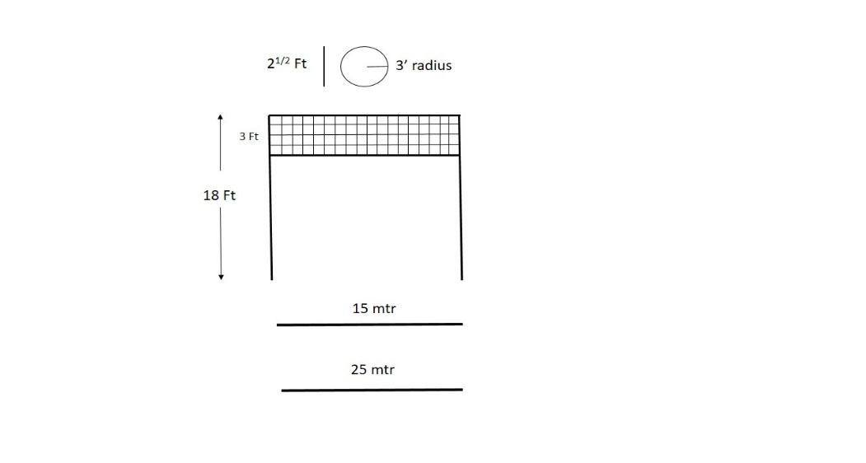(a)Grenade ko golai dekar phekne ka abhyas dene ke liye high wire ka istemal kiya jata hai. Yeh zamin se 18 feet unchi honi chahiye. Ismen 3 feet tak ki chaurai (jali) shamil hai. Jali ka niche wala hissa zamin se 15 feet hota hain. High wire ke age 10 mtr par ek morcha hota hain jiska chaurai 3 feet charon taraf aur 21/2 feet gahrai hoti hain. Highwire ke pichhe 15 mtr aur 25 mtr par throwing line banana chahiye. Ek jawan grenade ko 25 mtr se 35 mtr tak fank sakta hain.

**HIGH WIRE**

(c) **Namuna.** Ustad ek bar high wire ke upar se grenade phenkne ka namuna de aur class dekhe.

(d) **Abhyas.** Ustad ke niche high wire par grenade phankne ka groupon mein abhyas kare. Ek gp high wire ka istemal karen aur dusra bagair high wire ke abhyas karen.

3. **Lobbying karna**.

(a) **Bayan.** Gali kuchon ya jangal ki ilaqe men yeh jaruri hoga ki teji se grenade ko makan, khirki ya darwaje se dala jae ya ghani jharidar jagah men chhora jae.

(b) **Namuna.** Jawanon ko alag alag kai halaton men grenade chhodne ka namuna de.

(c) **Abhyas.** Sqd se grenade lobbying ka mila jula abhyas ho.

**LESSON PLAN**

1. **Shuru Shuru Ka Kam**. Class ki ginti groupon mein bant, Hathiyar saman ka nirikshan bandobast ki karwai.
2. **Dohrai.** Pichle sabaq se.
3. **Pahunch.** Pahunch chhota saf aur sabak se sambandhit ho.
4. **Uddesh.** No 36 Hand grenade ko throwing aur lobbying karne ka tarika sikhana hai (Dohraya jaega).
5. **Saman.** No 36 hand grenade, fig 11 tgt, sand bag, tar ki jali aur do pole 18’ ke.
6. **Bhagon Mein Bant.**
   1. **Bhag I.** Ready aur Throw karna.
   2. **Bhag II.**  High Wire ka Istemal.
   3. **Bhag III.** Lobbying Karna.
7. **Bhag I : Ready aur Throw Karna.** Namuna bayan ke sath diya jaega aur class sath nakal karegi. Class ka abhyas karaya jaega.
8. **Bhag II : High Wire ka istemal.** Namuna bayan ke sath diya jaega aur class sath nakal karegi. Class ka abhyas karaya jaega.
9. **Bhag III : Lobbying Karna.** Lobbying karne ke tarike ka namuna bayan ke sath diya jayega aur class sath nakal karegi. Class ka abhyas karaya jayega.
10. **Sankshep.** Sawal aur jawab se kiya jaye.

**LESSON-3**

**RIF GRENADE KI PEHCHAN, VISHESHTAEN AUR ISTEMAL**

**Ref- (Infantry Training Volume-I Infantry Platoon Weapons Pamphlet No 7 Grenade All Arms 2006)**

1. **Pehchan**. Rif grenade ka body ka rang gahra bhura hota hai aur iske gird hare rang ki dhari aur lal rang ke cross hote hai. Raat ke samay grenade ko iski body par bani hui dhariyon ki sahayta se pehchana ja sakta hai.
2. **Visheshtayen.**
   1. Yeh grenade janse mar dalne wala grenade hai. Phatne ki jagah se 8 mtr charon taraf mar dalta hai aur 274.3 mtr charo taraf jakhmi kar dene ki shakti rakta hai. Is grenade ko us jagah istemal kiya jata hai jahan chapti trajectory wale hathiyar kargar nahi hote hai, jaise morchon, makan aur tuti futi zamin mein.
   2. Is ki body dhale lohe ki bani hai aur iski body par jhiriyan kati hoti hai, joki grenade ko puri tarah tukre-tukre hone mein madad deti hai. Grenade mein HE yani dhamake se phatne wala barud bhara hota hai. Is ke andar do naliyan hoti hai. Bich wali striker aur spring ke lie, aur dusri detonators ke lie hoti hai. Striker aur spring ko lever apni jagah kayam rakhta hai, jo ki striker ki kati hui jhiri mein laga hota hai.
   3. **Tech Data.**
      1. Grenade - 700gms
      2. Arming Ring - 33gms
      3. Tube Launching Mk-I ka wazan - 127gms
      4. Tube Launching Mk-I ki lambai - 15 cm
   4. INSAS Rif grenade ke fire karne ke lie tube launching Mk-I ki jarurat parti hai. Grenade fire karne ke lie ek special ballisitic cartridge ki zarurat hoti hai.
3. **Tube Launching Mk-I se waqfiat.** Tube launching Mk-I ek khokhli nali ki shakal ka hai jo ek taraf se khula aur dusri taraf se band hain. Band wale sire par stud lagaya gaya hai, jismen churiyan bani hain. Stud ke jariye yeh tube grenade ke base plug ke surakh mein kas di jati hain. Khule sire ke jariye tube ko flash eliminator ke upar charaya jata hain. Is tube ka rang OG aur iski lambai 15 cm aur wazan 127 gm hain.Tube par kuch surakh hain jismen range control pin lagae gae hain. Rif grenade ko fire karne ke lie grenade mein ek arming ring charaya jata hain jo lever ko apni jagah se hilne se rokta hain.
4. **Tube Launching Mk-I ki visheshtaen.** Is tube se ham Rif grenade ko 50, 100 aur 150 mtr tak fire kar sakte hain. Jab donon rang ke control pin lage hue grenade fire karen toh range 50 mtr milta hain. Yeh kam se kam range hain. 100 mtr ka range hasil karne ke lye niche wali pin ko nikalna jaruri hain. 150 mtr ka range hasil karne ke lie donon pinon ka nikalna jaruri hain.

1. **Grenade ko fire ke lie taiyar karna.** Grenade ko taiyar karne ke hukam par sikhe hue tarike se saaf karen. Grenade ko saaf karne ke baad bayen hath mein pakar arming ring ko grenade ke niche wale sire se lever ke upar hath rakhte hue grenade par dakhil karen. Donon hath ki madad se arming ring ko itna upar khiche ki ring grenade ke bich wale katav mein jam jae. Dekhne ki bat arming ring ka katav lever ke barkhilaf ho. Ab grenade mein 7 sec wala fuze lagakar prime karen aur base plug ko kas den. Akhir mein tube ko lagaen. Ab grenade fire ke liye taiyar hai.
2. **Rif ko fire ke lie taiyar karna.** Rif ka nirikshan karein. Mag ko utaren, grenade site 90 degree par khara karein. Rif ko cock karein, HOD lagaein, HD cartridge chamber mein dakhil karen. Chal wale purje age jane dein aur change lever ki posn ‘S’ par karein.
3. **Grenade bharne ka hukam.** Taiyar kiye hue grenade ka nirikshan karein. Tube ko flash eliminator par dakhil karein, yakin karein ki thik lag gaya hai. Range milne par sikhe hue tarike se range lagayein aur tube ko eliminator par fit karein. Safety pin ko nikalein aur firing posn ikhtiyar karein. Change lever ko ‘R‘ par karein, trigger ko ek jhatke se dabaen. Agar cartridge misfire ho jaye to sikhe hue tarike se cartridge ki badli karein.
4. **Chal** Trigger ko dabane se cartridge fire hota hain jisse gas paida hoti hain. Gas tube ko flash eliminator se alag kar deti hain. Uran ke dauran chand second baad arming ring set back ke dhakke se gir jata hain aur lever azad ho jata hain. Baki chal hand grenade ki tarah hain.
5. **Bina Fire Khali karna.** Agar grenade ko fire karne ki zarurat na ho to karwai is prakar ki jati hain :-
   1. Change lever ‘S‘ par.
   2. Safty Pin lagayein.
   3. Tube ko flash eliminator se alag karein.
   4. Range control pin ko lagayein.
   5. Rif ko khali karein aur HD cartridge ko saaf karke cartoon main band karen.
6. **Unprime Karna.** Jis prakar se hand grenade ko unprime kiya jata hain usi tarah Rif grenade ko unprime karein.

**Note.**

* 1. Base plug aur tube thik kasa hona chahiye.
  2. Arming ring lagaya hua ho.
  3. Agar grenade air burst karna hai to 4 sec wala fuze istemal karen.

## LESSON-4

**NO 77, 80, 83, 90 GRENADE AUR BICAT STRIP**

**Ref- (Infantry Training Volume-I Infantry Platoon Weapons Pamphlet No 7 Grenade All Arms 2006)**

1. **Aam Bayan.** Sabhi prakar ke grenade ka istemal larai ke maidan mein hone wale shor-gul ke anukaran karne tatha dhuna paida karne ke liye kiya jata hai. Aam taur par ise sikhlai ke dauran istemal karte hain. Parantu jarurat parne par larai ke maidan me bhi iska prayog kar sakte hain. Sabhi prakar ke grenade ki visheshtaen tatha istemal karne ka tarika niche diya gaya hai.

**Grenade No 77**

1. **Visheshtayen.** Yeh grenade dhuwen ka parda banane ke alawa aag lagane ke kam men prayog hota hai. Is ke andar safed phosphorus bhara hota hai. Kisi bhi chiz se takrane par yeh phatta hai aur 30 sec tak dhuwan deta hai. Is ka rang hara aur wajan ¾ pound hota hai. Ismein No 62 detonator hota hai. Ek box mein 34 grenade pack hokar ate hai.
2. **Prime Karna.** 
   1. Dhakkan ko kholein (dhyan rahe safety cap alag na ho).
   2. Detonator ka khali bhag upar ki taraf karke, detonator sleeve men dalein.
   3. Ab dhakkan ko kas dein.
3. **Unprime Karna.** Prime ke ulat rup mein karwai karo.
4. **Chal.** Safety cap ko nikal kar grenade ko phek diya jata hai to wajan ke karan feeta khul jata hai. Safety bolt striker ke chhed se nikal jata hai. Striker .22 cap par thokar marta hain jisse shola paida hota hain jo detonator ko aag laga deta hain. Ab detonator phat kar grenade ki body ko faad deta hai aur ismen bhara phosphorus hawa ke sath mil kar dhuwan paida karta hai.
5. **Istemal (Phekna).** Safety cap ko nikalte samay feeta na niklane paye. Khud position lekar grenade ko golai mein phenkein. Dhyan rahe ki grenade ko najdik na phenkein. Iska khatarnak ilaqa fatne ki jagah se 15 mtr charon taraf hai.

**Grenade No 80**

1. **Visheshtayen.** Yeh grenade bhi dhuwa aur aag paida karta hai. Iske andar safed phosphorus bhara hota hai. Wajan 1¼ pound aur khatarnak ilaka 15 gaz charon aur hai. Iska dhuwan dene ka samay 30 se 40 sec hai. Ek box mein 24 band hokar ate hain.
2. **Prime karna.**
   1. Grenade ka mulahija karo.
   2. Mechanism holder ko kholo.
   3. Igniter set ko .22 cap upar ki taraf karke detonator sleeve mein dalo.
   4. Mechanism holder ko band karo.
3. **Unprime karna.** Prime ke ulat karwai karo.
4. **Chal.** Safety pin ko nikal kar grenade ko chhod diya jata hai to mechanism holder ajad ho jata hai. Spring ki madad se lever upar uth jata hai aur striker .22 cap par thokar marta hai. Jisse aag ki chingari paida hoti hai jo fuze ko jala deti hai. Detonator phat jata hai aur iska safed phosphorus hawa ke sath milkar dhuan dena shuru karta hai.
5. **Fenkna.** Lever par kabu pate hue safety pin nikalo. Posn lekar grenade ko golai mein phenko. Is ka khatarnak ilaka 15 gaz charon taraf hai.

**Grenade No 83**

1. **Visheshtayen.** Yeh dhuan dene ke alawa signal dene ke kam mein laya jata hai kyonki yeh char alag-alag rangon ka dhuan deta hai (lal, hara, peela aur neela). Iska wajan 1 pound aur yeh 25 se 45 sec tak dhuwa deta hai. Iski body par dhuwen ka rang likha rahta hai. Ek box mein 24 pack hokar ate hain.
2. **Chal.**  Jab pin ko nikal kar ise phenk diya jata hai to lever alag ho jata hai. Striker spring ki takat se .22 cap par chot marta hai. Jisse chingari paida hoti hai jo fuze ko jala kar malmal ki plate ko jala deta hai aur grenade dhuan dena shuru karta hai.
3. **Phekna.** Phekne ke liye karwai No 36 grenade ya No 80 grenade ki tarah hai.

**Grenade No 90**

1. **Visheshtayen.** Larai mein hone wale shor-gul ka anukaran karne ke liye is grenade ka istemal hota hai. Is ki awaj No 36 hand grenade ya 2” mor HE Bomb ke jaisi hoti hai. Is ka diameter 1¾”, lambai 8” aur ismen fuze No 11 istemal hota hai. Fuze ka ek sira sling compound se band hota hai dusra sira ignitor assembly mein hota hai jiske andar 12 gm cracker mixture barud bhar kar kagaj ki thaili mein band rahta hai aur ise sut ya tar se lapeta hota hai. Ek box men 16 grenade ate hain. Fuze ke jalne ke 9 se 15 sec bad fatta hai.
2. **Phekna.**
   1. Tej chaku ya blade se fuze ko compound (sealing) ke pas se tirchhe rukh kato.
   2. Kate hue kinare mein aag lagao aur fuze ke jalne ka shak hone par phenko.
3. **Suraksha.** 
   1. Safety fuze ko body se jitna ho sake door karo.
   2. Mitti ke tel ki bati ka prayog na karo.
   3. Fuze jalne ke turant bad phenko.
   4. Kharab fuze wale grenade ka istemal na karo.
   5. Grenade agar thik kam na kare aur fuze asli halat mein ho (jalne ke bad) to 5 min ke bad phir jalaya ja sakta hai.

**Bicat Strip**

1. **Visheshtayen.**
   1. Sikhlai ke dauran small arms fire ki awaz ka anukaran karne mein kaam aata hain.
   2. **Cracker.** Cracker mixture aur sukhi mitti ko ek kagaj ki thaili men dalkar banaya jata hain. Ismen 4 se 6 sec wala fuze fit hota hain. Cracker fuze ka dusra kinara safety fuze ke bich surakh banakar dala jata hain aur tar ya dhage se bandh diya jata hain. Fuze ke kinaro ko sealing compound dwara band kar diya jata hain. Cracker ko chipakne wale feete se lappet diya jata hain. Ek cracker ke andar 10 gm barud hota hain.
2. **Istemal.** 
   1. Tej chakoo se cracker ko tirche rukh kato.
   2. Kinare par safety matches se jalao, jalne par turant phenko.
3. **Hifajat.** Bache hue strip ko box men band karo aur chipakne wala feete se seal kar do.

**LESSON-5**

**TRIP FLARE SE WAQFIAT AUR ISTEMAL KAREN KA TARIQA**

**Ref - (Infantry Training Volume-I Infantry Platoon Weapons Pamphlet No 7 Grenade All Arms 2006)**

1. **Shuru Shuru ka Kam**

(a) Class ki ginti groupon mein bant

(b) Hathiyar aur saman ka nirikshan

(c) Bandobast ki karwai

2. **Dohrai**

Pichle lesson se kiya jaye.

3. **Pahunch**

Dushman raat ke waqt andhere ka faida uthakar hamare nazdik se nazdik aakar hamarai khabar hasil kar sakta hain. Isliye raat ke waqt dushman ke aane ki khabar malum karna aur uske upar aimed firekarne ke liye trip flaresabse accha sadhan hain jo ki dushman ke dwara chalwaya jata hain aur dushman ko iske bare main andesha na ho.

4. **Uddesh**

Trip flare se waqfiat aur istemal karne ka tariqa sikhana hain.

1. **Saman**

Trip flare, picket, wire spool, spring arm, ground sheet, Black board, chalk, duster.

1. **Bhagon Mein Bant**

Yeh sabaq char bhagon mein chalaya jayega:-

(a) **Bhag-I** - Trip flare ki vish aur tech data

(b) **Bhag-II** - Hisse ke naam, chal aur misfire per karwai

(c) **Bhag-III** - Trip flare ko lagana, arm, disarm aur udanae ka tariqa

(a) **Bhag-I - Trip flare ki vish aur tech data**

**Vish**

(i) Yeh ek acche silence sentry ka kaam karta hain.

(ii) Ek jawan isko assani se laga sakta hain.

(iii) Fatne ki jagah se 3 mtr ke ilaqe ko roshan karta hain.

(iv) Isko dushman ke dwara chalaya jata hain.

**Tech Data**

|  |  |  |  |
| --- | --- | --- | --- |
| (a) | Wazan | - | 255.1gms |
| (b) | Roshini dene ka samay | - | 30 sec se 40 sec |
| (c) | Roshini dene ka ilaqa | - | 3 mtr radius |
| (d) | Roshini dene ki power | - | 9000 candla |
| (e) | Explosive | - | 100gm WP Commercial) |
| (f) | Wire spool ke wire ki lambai | - | 60 feet |

(b) **Bhag-II - Hisson ke naam, chal aur misfire per karwai**

**Hisse purjon ke naam**

(i) **Picket** - Flare ke sath do picket ka hona zaruri hain. Picket ke hisse ke naam main post, side arm, side prong.

(ii) **Spring Arm** - Flare ko lagan eke liye ek spring arm ki zarurat padti hain. Hisson ke naam arm, link spring, link safety pin, clamping nut, links.

(iii) **Wire Spool** - Wire spool main 60 feet lamba wire aata hain, iske purjon ke naam trip wire, anchor ya hook, spilit pin.

(iv) **Flare Pot** - Iske hisson ke naam- Pot, wing nut, jaw, safety pin, control plate, way for side arm, way for main post.

**Chal** Yeh ek ignition hone wala flare hai jo ki spring se kaam karta hain.Jab trip wire per dabav ya khinchav parta hain to control plate hill jata hain. Jis se striker azad ho jata hain. Striker spring ki taqat se upper ki aur uth jata hain aur primer cap per thokar marta hain. Jisse chingari paida hoti hain aur flare pot ke flare main aag lag jata hain aur flare 30 sec to 40 sec tak roshini deta hain.

**Misfire per karwai**. Yadi flare misfire ho jaye toh muh ko niche ki taraf rakhte hue flare pot ko picket se alag karen aur blind ki tarah barbad karen.

(c) **Bhag-III - Trip flare ko lagana, arm, disarm aur udanae ka tariqa**.

**Trip flare ko lagana**. Flare ko lagane ke liye do picket ko dushman ke aane wale jagah ya approach par is parkar se lagayen ki donon picket ki side prong ander ki taraf ho aur side prong zamin ke sath mile hon taki picket ghum na jaye. Iske baad wire spool ko len, spilit pin ko nikalen, anchor ya hook ko us picket ke main post par lagayen jis par flare pot na lagana ho**,** ab spool ke wire ko kholte hue dusre picket tak len jayen. Dusre picket ke main post par spring arm ko is parkar se lagayen ki picket ke upar side arm spring apni taraf ho aur arm ghum nap aye. Flare pot ke main post aur side arm ke upar fit karen. Ab wire ko itna kinche ki spring ke upar pura tanav ho aur link pura khulen ho, wire ko clamping nut par lagakar nut ko kas den. Wing nut ko dhila karen aur wire ko jaw ke beech main lagayen aur wing nut ko tight karen. Trip flare ko camoflague kar den.

**Trip flare ko arm, disarm aur udana**. Arm karne ke liye sabdhani se link safety pin ko pahle link se nikalen aur phir safety pin ko flare pot se nkalen. Dhyan rahe safety pin ko nikalte waqt flare pot ke upar nahi jukna chaiya aur pin ko nikalne ki tartib nahin bhulna chaiya.

**Disarm karna**. Agar flare ko istemal na karna ho toh pahle flare pot ki safety pin ko lagayen aur uske baad link safety pin ko lagayen. Flare ko picket se alag karen aur wire ko spool ke sath lapate den.

**Udane ka tariqa**. Trip flare ko hum do tariqa se udate hain:-

(a) Taar ko katkar.

(b) Taar ko khinch kar.

7. **Sankshep.** Sawal aur jawab se.

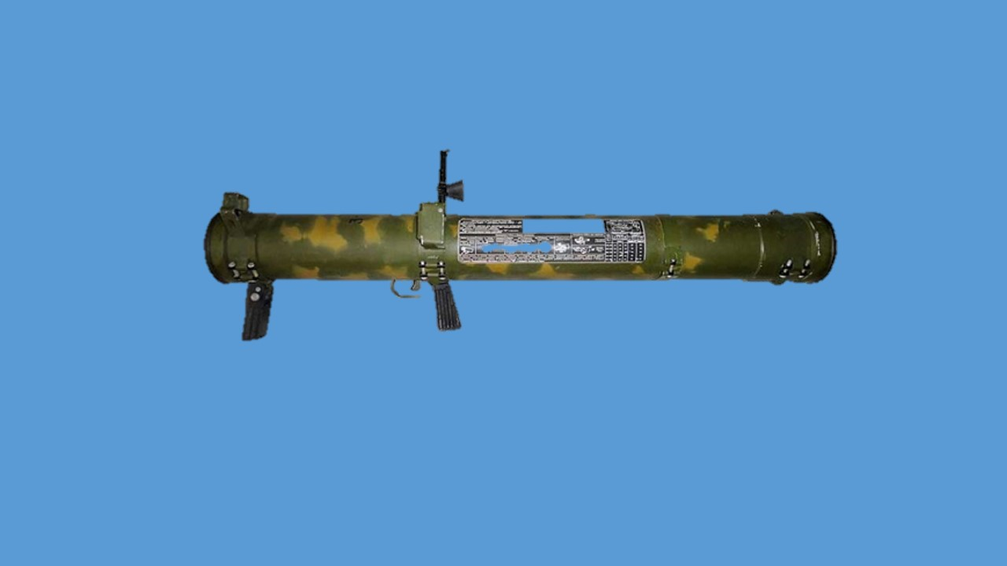

**RPO-A FLAME THROWER**

**(REACTIVINI PIKHOTNI OGNEMIYOT- TYPE-A)**

**LESSON-1**

**RPO-A FLAME THROWER**

**(REACTIVINI PIKHOTNI OGNEMIYOT- TYPE-A)**

1. **Introduction.** RPO-A- Flame thrower Russia desh dwara banaya gaya hai. Is hathiyar ki body majboot plastic aur dusre material se mila kar banai gai hai. Yeh hathiyar thermobaric ke sidhant par kaam karta hai jo patrol aur watawaran ki hawa ke sath milkar kaam karta hai aur tgt ko barbad karta hai. Is hathiyar mein thosh barood ka istemal kiya gaya hai aur sath hi finned stabilised rocket ka istemal kiya gaya hai.

1. Is hathiyar ka istemal dushman ke bunkers, pillboxes aur concrete ki building, bakhtarband gadiyon, B Vehicles aur troops ke khilap kiya jata hai.

1. **Visheshtaen**

|  |  |  |  |
| --- | --- | --- | --- |
|  | Made In | - | USSR/Russia |
|  | Kutar | - | 93mm |
|  | **Range**  (i) Maximum  (ii) Sight Range  (iii) Karger Range | -  -  - | 1000mtr  600mtr  25 se 350mtr |
|  | **Wazan**  (i) Flame Thrower  (ii) Explosive  (iii) 2 Flame Thrower  (iv) Projectile ka wazan | -  -  -  - | 12kg  2.1kg  24kg  4.5kg |
|  | Lambai | - | 920mm |
|  | Operating Temp | - | +50 degree se -50 degree C |
|  | Dply Time | - | 30 sec |
|  | Life | - | 9 years |
|  | Cost | - | 1.25 lakh |
|  | Back Blast | - | 47mtr lamba aur 14m chaura  110 degree ke angle mein |
|  | Pentration | - | 9mm |
|  | Sidhant | - | Thermo baric |
|  | MV | - | 125+ 5 mtr/sec |
|  | Killing area | - | 20mtr |
|  | Danger area | - | 50mtr |
|  | Version | - | 03 |
|  | RPO-A  RPO-Z  RPO-D | -  -  - | Thermo baric warhead  Incendiary warhead  Smoke warhead |

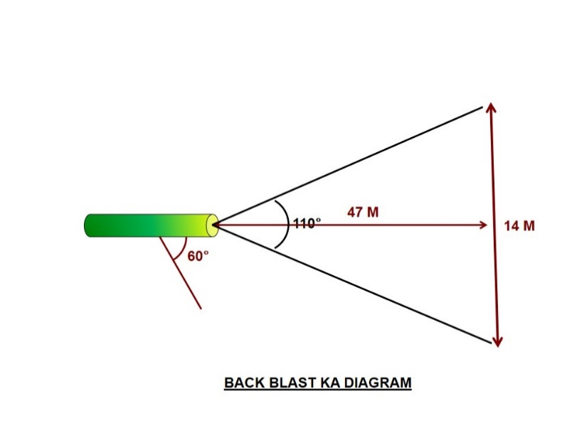

**Istemal**

1. RPO-A- Flame thrower ke istemal is prakar se hain:-

* + 1. Dushman ke strong firing points jaise pakke mitti aur lakadi ke bane pillboxes, fortification aur covered trenches aur zameen ke neeche bane concrete ke bunkers ke khilaf.

* + 1. Dushman ke halke armoured combat vehicles aur B vehicle ko barbad karne ke liye.

**Flame thrower aur iske mukhya hisson ka kaam karne ka tariqa**

1. Flame thrower disposable hathiyar ke adhar par banaya gaya hai.

1. **Flame thrower ke mukhya bhag**

* + 1. Container
    2. Rocket
    3. Ejection motor

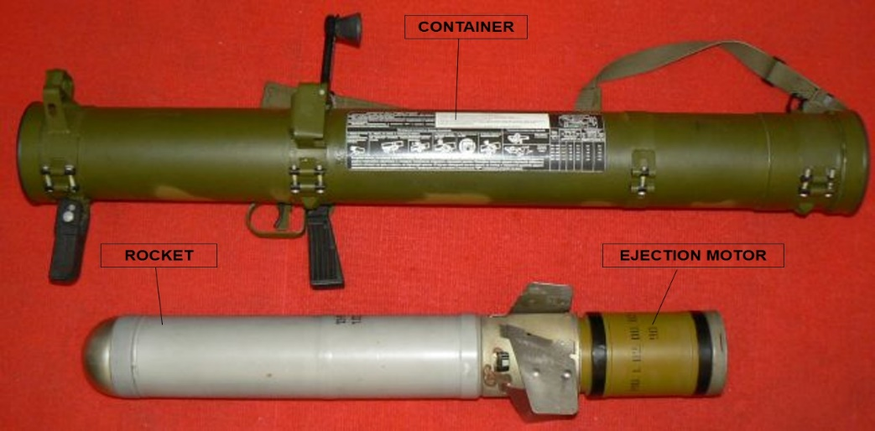

**Container**

1. Container ek tube ke aakar ka hai aur iske upar yeh hisse lagaye gaye hain:-

(a) **Firing aur trigger mechanism**. RPO-A- flame thrower ko cock aur fire karne ke liye.

(c) **Diopter Sight.** Sight ki visheshtaen is prakar se hain:-

* + - 1. Sight ko 180 degree tak ghumaya ja sakta hai.

* + - 1. Is ke upar 10,15,20,25,30,35,40.50.55 aur 60 ke ank khude hain jo ki zameen par 10 guna range ko jahir karte hain.

|  |
| --- |
| Diopter Sight |

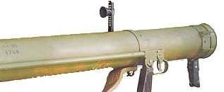

* + 1. **Sealing aur covers**. Flame thrower ko carry karne aur pack karne ke liye.
    2. **Sling aur anti noise plugs**. Sling flame thrower ko carry karne ke liye aur anti noise plugs firing ke dauran firer ke kaan ko suraksha pradan karte hain.

* + 1. **Assembly bracket.**Iska kaam do flame thrower ko pack karke carry karne mein madad karna hai.

**Ejection motor**

Iska kaam capsule/rocket ko muzzle velocity pradan karna hai. Isme solid propellant type barood ka istemal kiya gaya jo ki capsule mein alag se rakha jata hai. Firing ke dauran powder charge jalta hai aur capsule ko container se bahar eject karta hai.

**Capsule/Rocket**

1. Capsule/rocket container ko chhodne ke baad trajectory ke dauran halka spin karta hai aur isme thermobaric (air aur fuel) ka mixture hota hai jo ki tgt ko barbad karta hai. Iske mukhya bhag is prakar se hain:-

* + 1. **Fuze.** Yeh fuze pyrotechnical mechanism aur remote arming type ka hai aur iska kaam burst hone wale charge ko ignite karna hai aur ise capsule mein fit kiya gaya hai.

* + 1. **Igniting bursting charge.** Yeh fuze dwara activate hone ke baad explode hokar tgt ko barbad karta hai.

**Flame thrower ko fire karne ka tariqa.**

1. Flame thrower ko fire karne ka tariqa is prakar se hai:-

* + 1. Storage ki halat mein flame thrower ka firing grip tube/container ke sath fold hota hai aur trigger mechanism lock hota hai. Is dauran safety catch “Safe” position mein hota hai.

* + 1. Flame thrower ko firing mode mein lane ke liye dahine hath se firing grip ko dahine taraf karte huye lock ko tab tak ghumaye jab tak woh ruk na jaye. Iske baad safety catch ke arrow ko fire ki position par Karen.

* + 1. Trigger dabane se ejection motor ko mechanical impulse milti hai jisse capsule/rocket container se azad ho jata hai.

* + 1. Hawa mein capsule/rocket hawa ki wazah se ghumta hai.

* + 1. Rocket ke 8 se 25 m ki doori tay karne ke baad delay mechanism ki wazah se fuze combat mode mein shift ho jata hai.

* + 1. Jyonhi capsule tgt par takrata hai to fuze firing mechanism ki wajah se ignite ho jata hai aur bursting charge ko activate kar deta hai aur yeh thermobaric (air-fuel) ke sidahant par explode ho jata hai.

**Firing Positions**

1. Flame thrower ko 3 firing position se fire kiye ja sakta hai:-

* + 1. Lying position.
    2. Kneeling position.
    3. Standing position.

**Suraksha ke upay**

1. **Firing se pehle**.

* + 1. Kewal trained pers dwara hi handle kiya jaye.

* + 1. Fire se pehle back blast area clear ho.

(c ) Agar lying position se fire kiya ja raha ho to firer ka sharer firing pt se 600 ke angle se kam na ho.

* + 1. Shist lete samay firer ki ankh eye guard par lagi ho.

* + 1. Firing ke dauran kaan par ear plugs ka istemal Karen.

* + 1. Flame thrower se phaltu chher char na karen.

* + 1. Cock tabhi karen jab fire karna ho.

1. **Firing ke dauran**. Agar fire ke liye firing position tayar na ho to yeh aihtiyat barti jayen:-

* + 1. Lying position mein range 300 tak aur flame thrower ka elevation 60 se adhik na ho.

* + 1. Kneeling position mein range 600 m tak aur flame thower ka elevation 130 se adhik na ho.

(c) Standing position mein elevation 450 se adhik na ho.

1. **Suraksha ke liye hidayaten.**

* + 1. Flame thrower ko goli ya splinter se bachayen.

* + 1. Back blast area clear ho.

* + 1. Tgt dikhai dene par hi firing mechanism ka istemal karen.

* + 1. 25 m range se kam par fire na karen.

(d) Flame thrower ko girne se bachayen.

1. **Transportation, loading, unloading aur storage**.

* + 1. Agar flame thrower kisi kara. 5 m unchai se gir jaye to ise istemal kiya ja sakta hai parantu is dauran ismein koi damage nahi hona chahiye.

* + 1. Agar flame thrower .5 m se 3 m tak unchain se gir jata hai phir bhi yeh hathiyar safe hai parantu iski kargarta prabhavit ho sakti hai.

* + 1. Agar flame thrower 3 m se adhik unchain se gir jata hai to ise barbad kar diya jaye.

* + 1. Agar kisi karan iska fuze goli ya splinter se hit ho jaye to yeh chal kar sakta hai.

* + 1. Flame thrower par agar bullet ya splinter lag jaye to ise turant door pit ya trench mein rakh dena chahiye.

1. **Flame thrower ko barbad karna.**

* + 1. Destruction area abadi wale ilaqe se 1.5 Km se door hona chahiye.

* + 1. Flame thrower ko charge lagakar hi barbad karna chahiye.

* + 1. Jab barbad kiya ja raha ho to 100 m ke area mein koi nahi hona chahiye.

* + 1. Flame thrower ko bijli ya aag se barbad kiya jaye.

* + 1. Flame thrower ko double charge se barbad kiya jaye aur 1 kg barood ka istemal kiya jaye.

* + 1. Detonation ke 5 min ke baad hi trench se bahar aaya jaye agar misfire ho to 15 min ka intejar kiya jaye.

**IMPROVISED EXPLOSIVE DEVICES**

**BASIC CIRCUIT DIAGRAMS**

**POWER**

**SOURCE**

**EXPLOSIVE**

**IED**

**TIMER**

**AMPLIFIER**

**EXPL**

**RADIOSET**

**(**

**RX**

**)**

**9**

**V BATTERY**

**RCIE**

**LAGANE KI SAMBHAVIT JAGAH**

* 1. Kachche roads / Tuta futa road.
  2. Bridges / culverts.
  3. Roads / Sankara raasta/ Pass.
  4. Fauj dwara niyamit taur par istemal ki jaane waali roads.
  5. Khari charai ya road bend.
  6. Naala / Badi pipeline / Khali drums / Thela.
  7. Convoy rukne ki jagah.
  8. Road crossing / junctions.
  9. Rest karne waali jagah.
  10. Kritrim rukawaten jaise ki gire hue ped .

**IED KO KHOJNE / FATNE PAR / NISHKRIYA KARNE KI KARWAI**

* 1. IED hone ki sambhaavit jagah ko pehchane.
  2. Sthaniya abadi ki madad lein.
  3. Sandigdha ilakon ki tafseel mein jaanch karein.
  4. Tell tale signs ko khojne ke liye ilake ki jaanch karein.
  5. Khoj wale ilake ko fanning out ke tariqe ko apnakar cordon karein.
  6. Lawaris vastu ko sambhaavit IED samjhein.
  7. IED ko nishkriya karte samay road ke charon taraf 50m ke ilaaken ko dusri IED ya anya khatron se bachaav ke liye jaanchein.
  8. IED ko nishkriya karne ki karwai hamesha Engrs ya prashikshit jawanon ke dwara karwai jaye.

**IED : KARNE WAALI BAATEIN**

* 1. IED aur booby trap ke khilaf satark rahein.
  2. Accha intelligence network banayein.
  3. Operational ilake ki lagatar nigrani karein.
  4. Taaza khudi hui zamin, gobar aur road par gire hui cheejon ki jaanch karein.
  5. Saavdhan aur satark rahein.
  6. IED hone ki sambhaavit jagah par counter IED teams ka istemaal kiya jaye.
  7. Tafseel mein jaanch ki jaaye.
  8. Routine mein badlaav.
  9. Akarshak cheejein jo lawaris aur alag thalag pari ho unhe IED samjhein.
  10. Khuli dikhne waali taaron ka saavdhani se jaanch karein, woh trap ho sakta hai.
  11. IED milne par ilake ko mark karein aur report dein.
  12. IED milne par Engrs ko bulayen.

**IED : NA KARNE WAALI BAATEIN**

* 1. Yeh kabhi na soche ki ek hi IED lagayi gayi hai.
  2. IED milne par ghabraye nahi.
  3. IED fatne waale ilake ki taraf bhaag ke na jaayein, tactically harkat karein.
  4. Faaltu ka jokhim na uthaye.
  5. IED ke paas bheed na lagaye, khali ek aadmi IED ko handle karein aur baaki cover lekar baithe.
  6. IED ke saath chherkhani na karein.
  7. IED milne par koi taar na kaatein, koi tape na nikale aur packing na khole.
  8. Short cut ke taur par kacche raston ka istemaal na karein.

**IED HANDLING KE BUNIYAADI USOOL**

* 1. IED jahan milein wahin par barbaad kiya jaaye.
  2. Timer device / ALD ke liye IED ko jaanchon.
  3. Power source ko khoje aur usko sahi tariqe se barbaad karein.
  4. Koi raasta na bachne par hand entry technique ka istemaal kiya jaaye.

**HAMESHA YAAD RAKHEIN**

* 1. Aapko doosra mauka nahi milega.
  2. Shahid hone mein koi bahaduri nahi hai.
  3. IED’s ke bare mein jaankari haasil karein.
  4. Jab aap sochenge tabhi aap kar paayenge.
  5. The tragedy of ignorance is its complacency.
  6. Samajhdaar aadmi doosron ki galtiyon se sikhta hai.
  7. Nischit jaankari ke abhaav mein apne vivek ka istemaal karein.

**INTEGRATED WEAPON TRAINING**

**FIRE CONTROL ORDERS AUR TARGET KO KHOJNA**

**Saman**

1. Jhande, Fig 11 targets, Blank Rounds, Demo Troops, Rifle aur Magazine.

**Shuru Shuru ka kaam**

1. Shuru–shuru ke kaam mein nimn karwai ki jaati :-

* + 1. Ginti, groupon mein bant.
    2. Hathiyar ka mulahiza.
    3. Ladai ki haalaat ko madhya nazar rakhte huye demo troops camouflage kiye huye aurchupaye gaye hon.Fig 11 target ya ‘Pop up target’ rassi ya taar dwara khade kiye jayen.

**Uddeshya**

1. Fire control orders aur target ko khojne mein aur bhi abhyas deina hai.

**Bhag**

1. Yeh sabaq panch bhagon mein chalaya jayega :-

* + 1. **Bhag l.** Hidayatein.
    2. **Bhag II.** Zor deine wali batein.
    3. **Bhag III.** Ladai ki haalaat.
    4. **Bhag IV.** Yaad dilao.
    5. **Bhag V.** Abhyas.

**Bhag I - Hidayatein**

1. Sabaq ke anusar zaruri hidayatein do.

**Bhag II - Zor Deine Wali Batein**

1. **Zarur Jaanta ho.**

* + 1. Dushman ko khojna.
    2. Khojne ki tartib.
    3. Faasle ka anuman lagana.
    4. Fire control orders ki durust tartib.

1. **Jaanna Chahiye.**

* + 1. Chizen kyon nazar aati hain.
    2. Camouflage aur concealment mein farq.
    3. Aad ka sahi istemal.

**Bhag III - Ladai Ke Haalaat**

1. **Zarur Jaanta ho.** Dushman attack ki taiyari kar ke badh raha hai aur hum defence mein hain. Hamara task aur platoon ka task.

1. **Jaanna Chahiye.** Sath Wali unit ya sub unit ki zimmewari.

**Bhag IV - Yaad Dilao**

1. **Zarur Jaanta ho.**

* + 1. Fire units kya hoti hain.
    2. Fire control orders aur fire direction orders mein farq.
    3. Fire control orders dete samay dhyan mein rakhne wali batein.
    4. Fire control orders deine ki tartib.
    5. Aam rukh, dahine baen had aur arc of fire.

1. **Jaanna Chahiye.**

* + 1. Chizein kyon nazar aati hain.
    2. Target khojne ki tartib.
    3. Faasle ka anuman lagana.

**Bhag V - Abhyas**

1. **Zarur Jaanta Ho.**

* + 1. Target ko aiming rest par lagi rifle dwara dikha kar fire control order deina.
    2. Isse pehle usi target ko khojna hai aur phir dekh kar aiming rest par lage rifle se dikhana.
    3. Target ko students se check back karao.
    4. Chhupe huye demo troops ishara milne par blank round bhi fire karein jisse fasle ka anuman laga kar alag alag fire control orders diye jayen.

1. **Jaanna Chahiye.**

* + 1. Jhande chuni huyi ranges par rakh kar fasle ka anuman lagao.
    2. Camouflage aur concealment ke namune diye jayen aur ilaque ke anusar kis tarah badli karte hain bataya jaye.

1. **Jaan Sakta Hai.**

* + 1. Students section commander ki duties bari bari karein jisse sabhi fire control orders de sakein.
    2. Test ke taur par bhi yeh karwai ki jaye.

**Sankshep**

1. Fire control abhyas se hi aa sakta hai isliye ladai ki haalaat ko dhyan mein rakhte huye sabhi ko iski tartib aur qism aani chahiye.

**Nirikshan**

1. Hathiyar aur eqpt ka nirikshan karo.

**LESSON NO 2**

**5.56 MM INSAS RIFLE KI HANDLING**

**Saman**

1. 5.56 mm INSAS Rifle, Magazine, Targets, Blank Rounds aur Demo Troops.

**Shuru Shuru ka Kaam**

1. Shuru–shuru ke kaam mein nimn karwai ki jaati :-

* 1. Ginti, groupon mein baant.
  2. Hathiyar ka mulahiza (students se karwaya jaye).
  3. Camouflage aur concealment check.
  4. **Bandobast.** Training area taqriban 400m lamba aur kafi chaura hona chahiye taki jawan asani se harkat kar saken. Training area mein alag alag kism ke Adh maujud hone chahiye. Har ek 50 x ke fasle par demo troops ya figure 11 targets laga lena chahiye.

**Uddeshya**

1. 5.56 mm INSAS Rifle ki handling mein aur bhi abhyas deina hai.

**Bhag**

1. Sabaq panch bhagon mein chalaya jayega :-

* 1. **Bhag I.** Hidayatein.
  2. **Bhag II.** Zor deine wali batein.
  3. **Bhag III.** Ladai ki haalaat.
  4. **Bhag IV.** Yaad dilao.
  5. **Bhag V.** Abhyas.

**Bhag I – Hidayatein**

1. Sabaq ke anusar zaruri hidayatein batayein.

**Bhag II - Zor Deine Wali Batein**

1. **Zarur Jaanta Ho.**

* 1. Rokon ko dur karna.
  2. Dushman ko engage karna.
  3. Three round burst ka istemal.
  4. Sighton mein tabdili karna.

1. **Jaanna Chahiye.**

* 1. Adh ka durust istemal.
  2. Fasle ka sahi anuman lagana aur target ka sahi bayan.

**Bhag III - Ladai ki haalaat**

1. Ek ladai ki haalaat maujuda haalaat ke mutabik batao.

|  |  |
| --- | --- |
| 9. **Zarur Jaanta Ho.** | Dushman aur apni faujon ki khabar aur apne sec ka task. |
| 10. **Jaanna Chahiye.**    **Bhag IV - Yaad Dilao** | Baki sub units ke task. |
| 11. **Zarur Jaanta Ho.** | Hathiyar par sambandhit sawal. |
| 12. **Jaanna Chahiye.** | Field craft. |
| 13. **Jaan Sakta Hai.**    **Bhag V - Abhyas** | Minor tactics. |
| 14. **Zarur Jaanta Ho.** tabdili karna. | Rifle ki handling aur rokon ko dur karna aur sighton mein |
| 15. **Janna Chahiye.** | Adh ka istemal. |

**Sankshep**

1. Class ki achhi aur kharab batein batayein. Niche diye huye baton par zor dein :-

* 1. Adh ka sahi istemal.
  2. Durust dekhbhal aur handling.
  3. Fire position ka chunao.
  4. Zamini nishan ka bayan karna.

**Nirikshan**

1. Hathiyar aur saman.

**LESSON NO 3**

**ASSAULT MEIN 5.56 MM INSAS RIFLE KI HANDLING**

**Saman**

1. Rifle, Magazine, Blank Rounds, Bicart Strip, No 90 Grenade, Targets, Tube Launching, Drill Cartridges, Clearing Plug aur Cleaning Kit Box.

**Shuru Shuru ka Kaam**

1. Shuru–shuru ke kaam mein nimn karwai ki jaati :-

* + 1. Ginti, groupon mein bant.
    2. Hathiyar ka mulahiza (students se karwaya jaye).
    3. Camouflage aur concealment check.
    4. **Bandobast.** Training area taqriban 400m lamba aur kafi chaura hona chahiye. Har ek kism ki Adh aur cover maujud hona chahiye Dushman ko jahir karne ke liye targets, blank rounds aur No 90 grenade istemal kiya jaye.

**Uddeshya**

1. Assault ke dauran 5.56 mm INSAS Rifle ki handling mein aur bhi abhyas deina hai.

**Bhag**

1. Sabaq panch bhagon mein chalaya jayega :-

* + 1. **Bhag I.** Hidayatein.
    2. **Bhag II.** Zor deine wali batein.
    3. **Bhag III.** Ladai ki haalaat.
    4. **Bhag IV.** Yaad dilao.
    5. **Bhag V.** Abhyas.

**Bhag I – Hidayatein**

1. Sabaq ke anusar hidayatein batayein.

**Bhag II - Zor Deine Wali Batein**

1. **Zarur Jaanta Ho.**

* + 1. Ladai ke haalaat.
    2. Hathiyar ki handling.
    3. Three round burst ka istemal.
    4. Sighton mein tabdili karna.

(c) Adh ka istemal aur field craft.

1. **Jaanna Chahiye.**

* + 1. Harkat karna.
    2. Fire control orders.

**Bhag III - Ladai Ki Haalaat**

1. Ek ladai ki haalaat maujuda haalaat ke mutabik batao.

1. **Zarur Jaanta Ho.** Dushman aur apni faujon ki khabar aur apne sec ka task.

1. **Jaanna Chahiye.** Baki sub units ke task.

**Bhag IV - Yaad Dilao**

1. **Zarur Jaanta Ho.**

* + 1. Hathiyar par sambandhit sawal.
    2. Field craft.

1. **Janna Chahiye.** Minor tactics.

**Bhag V - Abhyas**

1. **Zarur Jaanta Ho.**

* + 1. Fire position ka chunao.
    2. Target ka bayan aur fire control orders.
    3. Rokon ko dur karna.
    4. Three round burst ka istemal.
    5. Sighton mein tabdili karna.

1. **Jaanna Chahiye.**

* + 1. Sniper / dushman ke ikka dukka nafri ke barkhilaf karwai.
    2. Hamle ke dauran formation mein hamla aur bayonet fighting.

**Sankshep**

1. Class ki achchhe aur kharab batein batayein. Niche diye huye baton par zor

dein :-

* + 1. Durust fire position ka chunao.
    2. Tgt ko khoj nikalna.
    3. Rokon ko dur karna.

**Nirikshan**

1. Hathiyar aur saman.

**LESSON NO 4**

**5.56 MM INSAS RIFLE KI DEFENCE MEIN HANDLING**

**Saman**

1. Rifle, Magazine, INSAS UBGL, Blank Rounds, Bicart Strip, No 90 Grenade, , Sand Bags, Targets, Drill Cartridges, Clearing Plug aur Cleaning Kit Box.

**Shuru Shuru ka Kaam**

1. Shuru–shuru ke kaam mein nimn karwai ki jaati :-

* 1. Ginti, groupon mein bant.
  2. Hathiyar ka mulahiza (students se karwaya jaye).
  3. Camouflage aur concealment check.
  4. **Bandobast.** Training area taqriban 400m lamba aur kafi chaura hona chahiye. Dushman ko zahir karne ke liye targets, blank rounds, bicat strip aur No 90 grenade istemal karna chahiye.

**Uddeshya**

1. Defence ke dauran 5.56 mm INSAS Rifle ki handling mein aur bhi abhyas deina.

**Bhag**

1. Sabaq panch bhagon mein chalaya jayega :-

* 1. **Bhag I.** Hidayatein.
  2. **Bhag II.** Zor deine wali batein.
  3. **Bhag III.** Ladai ke haalaat.
  4. **Bhag IV.** Yaad dilao.
  5. **Bhag V.** Abhyas.

**Bhag I – Hidayatein**

1. Sabaq ke anusar hidayatein batayein.

**Bhag II - Zor Deine Wali Batein**

1. **Zarur Jaanta Ho.**

* 1. Ladai ki haalaat.
  2. Hathiyar ki handling.
  3. Rokon ko dur karna.
  4. Three round burst ka istemal. (e) Sighton mein tabdili karna.

1. **Janna Chahiye.**

* 1. Tgt ko khojna.
  2. Aad ka istemal.

**Bhag III - Ladai Ke Haalaat**

1. Ek ladai ke haalaat maujuda haalaat ke mutabik batao.

1. **Zarur Jaanta Ho.** Dushman aur apni faujon ki khabar aur apne sec ka task.

1. **Jaanna Chahiye.** Baki sub units ke task.

**Bhag IV - Yad Dilao**

1. **Zarur Jaanta Ho.**

* 1. Hatyhiyar par sambandhit sawal.

1. **Janna Chahiye.** Field craft.

1. **Jaan Sakta Hai.** Minor tactics.

**Bhag V - Abhyas**

1. **Zarur Jaanta Ho.**

* 1. Target ka bayan aur fire control orders.
  2. Rokon ko dur karna.
  3. Three round burst ka istemal.
  4. Sighton mein tabdili karna.

1. **Jaanna Chahiye.**

* 1. Fire position ka chunao karna.
  2. Dushman 150m par ane par rifle grenade fire karne ki karwai. (c) Dushman 50m par ane par hamla karne ki karwai.

**Sankshep**

1. Class ki achchhe aur kharab batein batayein. Niche diye huye baton par zor

dein :-

* 1. Durust dekhbhal karna.
  2. Tgt ki khoj karna.
  3. Rokon ko dur karna.
  4. Durust fire position ka chunao.

**Nirikshan**

1. Hathiyar aur saman.

**LESSON NO 5**

**PRACTICAL ROKEIN 5.56 MM INSAS RIFLE**

**Saman**

1. Rifle, Magazine, Figure11 Targets, Genti, Belcha, Camouflage karne wala saman, Blank Rounds, Jhanda 4’X4’ (2).

**Shuru Shuru ka Kaam**

1. Shuru–shuru ke kaam mein nimn karwai ki jaati :-

* 1. Ginti, groupon mein bant.
  2. Hathiyar ka mulahiza (students se karwaya jaye).
  3. Camouflage aur concealment check.
  4. **Bandobast.** Training area aisa hona chahiye jahan alag alag qism ki zamin aur adh maujud ho. 300x aur 400x par fig 11 tgt ya demo troops hone chahiye aur inke liye koi bhi karwai karne ke liye ishara muqarrar hona chahiye.

**Uddeshya**

1. Ladai ke dauran rifle ki rokon ka sabab malum karna , unhein dur karna aur unke bachao ke bare mein aur bhi abhyas deina.

**Bhag**

1. Sabaq panch bhagon mein chalaya jayega :-

* 1. **Bhag I.** Hidayatein.
  2. **Bhag II.** Zor deine wali batein.
  3. **Bhag III.** Ladai ki haalaat.
  4. **Bhag IV.** Yaad dilao.
  5. **Bhag V.** Abhyas.

**Bhag I – Hidayatein**

1. Sabaq ke anusar hidayatein batayein.

**Bhag II - Zor Deine Wali Batein**

1. **Zarur Jaanta Ho.**

* 1. Ladai ke haalaat.
  2. Rokon ko dur karna aur hathiyar ki handling.

1. **Jaanna Chahiye.** Fire position ka chunao.

**Bhag III - Ladai Ke Haalaat**

1. Ek ladai ki haalaat maujuda haalaat ke mutabik batao.

1. **Zarur Jaanta Ho.** Dushman aur apni faujon ki khabar aur apne sec ka task.

1. **Jaanna Chahiye.** Baqi sub units ke task.

**Bhag IV - Yaad Dilao**

1. **Zarur Jaanta Ho.** Hathiyar par sambandhit sawal.

1. **Jaanna Chahiye.** Field craft.

1. **Jaan Sakta Hai.** Minor tactics.

**Bhag V - Abhyas**

1. **Zarur Jaanta Ho.**

* 1. Tactical haalaat ko madhya nazar rakhte huye advance karna.
  2. Dushman ka bhari tadad mein fire aane par karwai aur fire position ko ikhtiar karna.
  3. Rokon ko pehchanna aur dur karna.
  4. Chhote purzon ki badli.

1. **Jaanna Chahiye.**

* 1. Fire orders.
  2. Dushman advance karne par karwai.

**Sankshep**

1. Class ki achchhi aur kharab batein batayein. Niche diye huye baton par zor dein:-

* 1. Rokon ko pehchanna aur dur karna.
  2. Durust fire position ka chunao.

(b) Advance ke dauran durust dekhbhal karna.

**Nirikshan**

1. Hathiyar aur saman.

**LESSON NO 6**

**RIFLE KE SATH FIRE AND MOVE**

**Saman**

1. Rifle, Magazine, Blank Ammunition, Binoculars, Jhande (alag alag rangon ke).

**Shuru Shuru ka Kaam**

1. Shuru–shuru ke kaam mein nimn karwai ki jaati :-

* 1. Ginti, groupon mein bant.
  2. Hathiyar ka mulahiza (students se karwaya jaye).
  3. Camouflage aur concealment check.
  4. **Bandobast.** Training area mein tuti-phuti zamin aur jharian hon. Suraksha ke liye jhande aur sentries ka istemal kiya jaye.

**Uddeshya**

1. Rifle ke sath fire aur move mein abhyas deina.

**Bhag**

1. Sabaq panch bhagon mein chalaya jayega :-

* 1. **Bhag I.** Hidayatein.
  2. **Bhag II.** Zor deine wali batein.
  3. **Bhag III.** Ladai ki haalaat.
  4. **Bhag IV.** Yaad dilao.
  5. **Bhag V.** Abhyas.

**Bhag I – Hidayatein**

1. Sabaq ke anusar hidayatein batayein.

**Bhag II - Zor Deine Wali Batein**

1. **Zarur Jaanta Ho.**

* 1. Adh pakarne ka durust tariqa.
  2. Rifle ke sath harkat.

1. **Jaanna Chahiye.** Dushman ko engage karna.

**Bhag III - Ladai Ki Haalaat**

1. Ek ladai ki haalaat maujuda haalaat ke mutabik batao.

1. **Zarur Jaanta Ho.**

* 1. Fire and move ke buniyadi usul.
  2. Steady advance aur advance by bound .
  3. Alag alag qism ki adh (cover) ka istemal.
  4. Target ko khojna aur barbad karna.
  5. Fire position ka durust chunao.

|  |  |
| --- | --- |
| 10. **Jaanna Chahiye.**    **Bhag IV - Yaad Dilao** | Baqi sub units ke task. |
| 11. **Zarur Jaanta Ho.** | Hathiyar par sambandhit sawal. |
| 12. **Jaanna Chahiye.** | Field craft. |
| 13. **Jaan Sakta Hai.** | Minor tactics. |

**Bhag V - Abhyas**

1. **Zarur Jaanta Ho.**

* + 1. Ek bound se dusre bound ko advance karna.
    2. Fire position ka chunao.
    3. Dushman par kargar fire daalna.

**Sankshep**

1. Class ki achchhi aur kharab batein batayein. Niche diye huye baton par zor dein :-

* + 1. Adh ka durust istemal.
    2. Hathiyar ki handling.
    3. Ek group ka position pakarna aur fire karna dusre group ke liye harkat ka ishara mukarrar hona chahiye.

**Nirikshan**

1. Hathiyar aur saman.

**LESSON NO 7**

**5.56 MM INSAS RIFLE SE ANYA POSITIONON SE FIRE**

**Saman**

1. 5.56 mm INSAS Rifle, Magazine, Targets, Blank Rounds, Demo Troops, Jhande aur Radio Set.

**Shuru Shuru ka Kaam**

1. Shuru–shuru ke kaam mein nimn karwai ki jaati :-

* 1. Ginti, groupon mein bant.
  2. Hathiyar ka mulahiza (students se karwaya jaye).
  3. Camouflage aur concealment check.
  4. **Bandobast.** Training area mein alag alag adh maujud ho. Ilaqa takriban 400x lamba ho. Jawanon ko camouflage kar lena chahiye. Targets aur demo alag alag ranges par pahle hi lagaye jayein.

**Uddeshya**

1. 5.56 mm INSAS Rifle ke sath bhinn bhinn prakar ki firing position se alag alag ranges par targets ko engage karne ke tariqon mein aur bhi abhyas deina.

**Bhag**

1. Sabaq panch bhagon mein chalaya jayega :-

* 1. **Bhag I.** Hidayatein.
  2. **Bhag II.** Zor deine wali batein.
  3. **Bhag III.** Ladai ke haalaat.
  4. **Bhag IV.** Yaad dilao.
  5. **Bhag V.** Abhyas.

**Bhag I – Hidayatein**

1. Sabaq ke anusar hidayatein batayein.

**Bhag II - Zor Deine Wali Batein**

1. **Zarur Jaanta Ho.**

* 1. Ladai ke haalaat.
  2. Adh aur cover ka durust istemal.

1. **Jaanna Chahiye.** Dushman ko engage karna.

**Bhag III - Ladai Ki Haalaat**

1. Ek ladai ki haalaat maujuda haalaat ke mutabik batao.

|  |  |
| --- | --- |
| 9. **Zarur Jaanta Ho.** | Dushman aur apni faujon ki khabar aur apne sec ka task. |
| 10. **Jaanna Chahiye.**    **Bhag IV - Yaad Dilao** | Baqi sub units ke task. |
| 11. **Zarur Jaanta Ho.** | Hatyhiyar se sambandhit sawal. |
| 12. **Jaanna Chahiye.** | Alag alag fire position se rokon ko dur karna. |
| 13. **Jaan Sakta Hai.**    **Bhag V - Abhyas** | Minor tactics. |
| 14. **Zarur Jaanta Ho.** | Tactical advance karna aur jab dushman aae toh durust |

cover lekar aur fire position banate huye use engage karna. Alag alag fire position mein sthirta hasil karte huye fire karna.

**Sankshep**

1. Class ki achchhi aur kharab batein batayein. Niche diye huye baton par zor

dein:-

* 1. Cover ka durust istemal.
  2. Durust firing position chunna.
  3. Hathiyar ki handling.

**Nirikshan**

1. Hathiyar aur saman.

## LESSON NO 8

**CQB ROLE MEIN 5.56 MM INSAS RIFLE KI HANDLING**

**Saman**

1. 5.56 mm INSAS Rifle, Magazine, Bayonet, Fig 11Target aur Blank Ammunition.

**Shuru Shuru ka Kaam**

1. Shuru–shuru ke kaam mein nimn karwai ki jaati :-

* 1. Ginti, groupon mein bant.
  2. Hathiyar ka mulahiza (students se karwaya jaye).
  3. Camouflage aur concealment check.
  4. **Bandobast.** Training area mein alag qism ke adh maujod ho. Fig 11 targets aur demo troops hone chahiye. Training area takriban 300x lamba aur kafi chauda ho.

**Uddeshya**

1. Muthbhed ki ladai mein 5.56 mm INSAS Rifle ki handling mein aur bhi abhyas deina.

**Bhag**

1. Sabaq panch bhagon mein chalaya jayega :-

* 1. **Bhag I.** Hidayatein.
  2. **Bhag II.** Zor deine wali batein.
  3. **Bhag III.** Ladai ki haalaat.
  4. **Bhag IV.** Yaad dilao.
  5. **Bhag V.** Abhyas.

**Bhag I – Hidayatein**

1. Sabaq ke anusar hidayatein batayein.

**Bhag II- Zor Deine Wali Batein**

1. **Zarur Jaanta Ho.**

* 1. Ladai ki haalaat.
  2. Hathiyar ki handling, muthbhed ki ladai mein. (c) Three round burst ka istemal.

1. **Jaanna Chahiye.**

* 1. Zamin ka durust istemal aur field craft
  2. Ilaqe ki durust dekhbhal.

**Bhag III - Ladai Ki Haalaat**

1. Ek ladai ki haalaat maujuda haalaat ke mutabik batao.

|  |  |
| --- | --- |
| 9. **Zarur Jaanta Ho.** | Dushman aur apni faujon ki khabar aur apne det ka task. |
| 10. **Jaanna Chahiye.**    **Bhag IV - Yaad Dilao** | Baqi sub units ke task. |
| 11. **Zarur Jaanta Ho.** | Hathiyar se sambandhit sawal. |
| 12. **Jaanna Chahiye.** | Field craft. |
| 13. **Jaan Sakta Hai.** | Minor tactics. |

**Bhag V - Abhyas**

1. **Zarur Jaanta Ho.**

* 1. Dushman ka awaz se pata lagana aur qudrati sidhai hasil karte huye fire karna.
  2. Muthbhed ki ladai mein awaz aur harkat se dushman ka pata lagana aur qudrati sidhai hasil karte huye fire karna.

1. **Jaanna Chahiye.** Adh ka istemal aur sahi firing position apnana.

**Sankshep**

1. Class ki achchhe aur kharab batein batayein. Niche diye huye baton par zor

dein :-

* 1. Hathiyar ki durust handling.
  2. Adh ka durust istemal.
  3. Ilaqe ki dekhbhal karna.

**Nirikshan**

1. Hathiyar aur saman.

**LESSON NO 9**

**CQB ROLE MEIN SMG MP 9**

**Saman**

1. SMG MP 9, Magazine, Bayonet, Slings, 5.56 mm INSAS Rifle, Blank Rounds, Fig 11 Targets, No 90 Grenade aur Bi-cart strips.

**Shuru Shuru ka Kaam**

1. Shuru–shuru ke kaam mein nimn karwai ki jaati :-

* 1. Ginti, groupon mein bant.
  2. Hathiyar ka mulahiza (students se karwaya jaye).
  3. Camouflage aur concealment check.
  4. **Bandobast.** Ilaqa aisa ho jahan 100 se 200 metre tak asani se harkat ki ja sake. Jungle ya jhadi kafi matra mein hon. Jawan ilaqe ke mutabik camouflage karein. Class ko do bhagon mein banta jaye, ek group dushman ka kaam karne ke liye jo ki chhupao mein ho, aur dusra group patrol ka kaam karne ke liye.

**Uddeshya**

1. CQB ki ladai mein SMG MP 9 ki handling mein aur bhi abhyas deina.

**Bhag**

1. Sabaq panch bhagon mein chalaya jayega :-

* 1. **Bhag I.** Hidayatein.
  2. **Bhag II.** Zor deine wali batein.
  3. **Bhag III.** Ladai ki haalaat.
  4. **Bhag IV.** Yaad dilao.
  5. **Bhag V.** Abhyas.

**Bhag I – Hidayatein**

1. Sabaq ke anusar hidayatein batayein.

**Bhag II - Zor Deine Wali Batein**

1. **Zarur Jaanta Ho**.

* 1. Ladai ki haalaat.
  2. Hathiyar ki handling.

1. **Jaanna Chahiye.**

* 1. Field craft
  2. Target ko khoj nikalna.

**Bhag III - Ladai ki haalaat**

1. Ek ladai ki haalaat maujuda haalaat ke mutabik batao.

|  |  |
| --- | --- |
| 9. **Zarur Jaanta Ho.** | Dushman aur apni faujon ki khabar aur apne sec ka task. |
| 10. **Jaanna Chahiye.**    **Bhag IV - Yaad Dilao** | Baqi sub units ke task. |
| 11. **Zarur Jaanta Ho.** | Hathiyar par sambandhit sawal. |
| 12. **Jaanna Chahiye.** | Field craft. |
| 13. **Jaan Sakta Hai.** | Minor tactics. |

**Bhag V - Abhyas**

1. **Zarur Jaanta Ho.**

* 1. Nazdik dushman nikalne par achanak fire kholna. (b) Fire karte karte rok parne par karwai.

1. **Jaanna Chahiye.**

* 1. Bhari huyi carbine ke sath harkat karna.
  2. Agar fire karne ka samay na ho to bayonet ka istemal kaise kiya jata hai.

**Sankshep**

1. Class ki achchhi aur kharab batein batayein. Niche diye huye baton par zor dein

:-

* 1. Adh ka durust istemal.
  2. Hathiyar ke sath durust harkat.
  3. Ladaku ‘josh’ ki ahmiyat.

**Nirikshan**

1. Hathiyar aur saaman.

**LESSON NO 10**

**CQB ROLE MEIN PISTOL**

**Saman**

1. 9 mm Pistol, Magazine, Targets, Bicart strip, No 90 Grenade, Demo Troops.

**Shuru Shuru ka Kaam**

1. Shuru–shuru ke kaam mein nimn karwai ki jaati :-

* 1. Ginti, groupon mein bant.
  2. Hathiyar ka mulahiza (students se karwaya jaye).
  3. Camouflage aur concealment check.
  4. **Bandobast.** Sabaq us jagah achhi tarah chalaya ja sakta hai, jahan tute makan aur barracks hon. Iske alawa jhadidar ilaqe ko bhi istemal kiya ja sakta hai.

**Uddeshya**

1. CQB ki ladai mein 9 mm Pistol ki handling mein aur bhi abhyas deina.

**Bhag**

1. Sabaq panch bhagon mein chalaya jayega :-

* 1. **Bhag I.** Hidayatein.
  2. **Bhag II.** Zor deine wali batein.
  3. **Bhag III.** Ladai ki haalaat.
  4. **Bhag IV.** Yaad dilao.
  5. **Bhag V.** Abhyas.

**Bhag I – Hidayatein**

1. Sabaq ke anusar hidayatein batayein.

**Bhag II - Zor Deine Wali Batein**

1. **Zarur Jaanta Ho.**

* 1. Ladai ki haalaat.
  2. Hathiyar ki handling, muthbhed ki ladai mein.

1. **Jaanna Chahiye.**

* 1. Adh ka istemal.
  2. Ladai ke lie taiyari.

**Bhag III - Ladai Ki Haalaat**

1. Ek ladai ki haalaat maujuda haalaat ke mutabik batao.

|  |  |
| --- | --- |
| 9. **Zarur Jaanta Ho.** | Dushman aur apni faujon ki khabar aur apne det ka task. |
| 10. **Jaanna Chahiye.**    **Bhag IV - Yaad Dilao** | Baqi sub units ke task. |
| 11. **Zarur Jaanta Ho.** | Hathiyar par sambandhit sawal. |
| 12. **Jaanna Chahiye.** | Field craft. |
| 13. **Jaan Sakta Hai.** | Minor tactics. |

**Bhag V - Abhyas**

1. **Zarur Jaanta Ho.**

* 1. Dushman ko CQB mein engage karna.
  2. Rokon ko dur karna.

1. **Jaanna Chahiye.** Adh ka istemal.

**Sankshep**

1. Class ki achchhi aur kharab batein batayein. Niche diye huye baton par zor dena chahiye :-

* 1. Hathiyar ki handling.
  2. Durust fire position ka chunao aur istemal.
  3. Rokon ko jaldi se jaldi dur karna.

**Nirikshan**

1. Hathiyar aur saman.

**LESSON NO 11**

**ADVANCE AUR ATTACK MEIN LMG KI HANDLING**

**Saman**

1. LMGs, Magazines, Spare Part Wallets, Holdalls, Utility Pouches, Demo Troops, Blank Ammunition, Bicart Strip, No 90 Grenade aur Sand Bags.

**Shuru Shuru ka Kaam**

1. Shuru–shuru ke kaam mein nimn karwai ki jaati :-

* 1. Ginti, groupon mein bant.
  2. Hathiyar ka mulahiza (students se karwaya jaye).
  3. Camouflage aur concealment check.
  4. **Bandobast.** Demo troops dushman ka kaam karne ke liye maujod hone chahiye. Fire ko zahir karne ke liye demo troops ko 90 No grenade aur bicart strip ka istemal karna chahiye.

**Uddeshya**

1. Advance aur attack mein LMG ki handling mein aur bhi abhyas deina.

**Bhag**

1. Sabaq panch bhagon mein chalaya jayega :-

* 1. **Bhag I.** Hidayatein.
  2. **Bhag II.** Zor deine wali batein.
  3. **Bhag III.** Ladai ki haalaat.
  4. **Bhag IV.** Yaad dilao.
  5. **Bhag V.** Abhyas.

**Bhag I – Hidayatein**

1. Sabaq ke anusar hidayatein batayein.

**Bhag II - Zor Deine Wali Batein**

1. **Zarur Jaanta Ho.**

* 1. Ladai ki haalaat.
  2. Zamini nishan ka bayan.
  3. LMG ki handling.

1. **Jaanna Chahiye.**

* 1. Fire control orders.
  2. Ilaqe ki dekhbhal aur fire position ka chunao.
  3. LMG ke sath harkat.

**Bhag III - Ladai ki haalaat**

1. Ek ladai ki haalaat maujuda haalaat ke mutabik batao.

1. **Zarur Jaanta Ho.** Dushman aur apni faujon ki khabar aur apne det ka task.

1. **Jaanna Chahiye.** Baqi sub units ke task.

**Bhag IV - Yaad Dilao**

1. **Zarur Jaanta Ho.** Hatyhiyar par sambandhit sawal.

1. **Jaanna Chahiye.** Field craft.

1. **Jaan Sakta Hai.** Minor tactics.

**Bhag V - Abhyas**

1. **Zarur Jaanta Ho.**

* 1. Tactical haalaat mein advance karna.
  2. Durust battle drill.
  3. Hathiyar ki handling.

1. **Jaanna Chahiye.**

* 1. Fire control orders.
  2. LMG ke sath harkat karna.

1. **Jaan sakta hai.** LMG det aur Rifle group ko verbal orders deina.

**Sankshep**

1. Class ki achchhi aur kharab batein batayein. Niche diye huye baton par zor dein

:-

* 1. LMG ke sath harkat karna.
  2. Battle drill.
  3. Hathiyar ki durust handling.

**Nirikshan**

1. Hathiyar aur saman.

**LESSON NO 12**

**DEFENCE MEIN LMG**

**Saman**

1. LMGs, Magazines, Spare Part Wallets, Holdalls, Utility Pouches, Demo Troops, Blank Ammunition, Bicart Strip, No 90 Grenade aur Sand Bags.

**Shuru Shuru ka Kaam**

1. Shuru–shuru ke kaam mein nimn karwai ki jaati :-

* 1. Ginti, groupon mein bant.
  2. Hathiyar ka mulahiza (students se karwaya jaye).
  3. Camouflage aur concealment check.
  4. **Bandobast.** Yakin kiya jaye ki alag alag tarah ki Adh maujod ho aur dekhbhal ke liye kafi ilaqa khula ho.

**Uddeshya**

1. Defence mein LMG ki handling mein aur bhi abhyas deina.

**Bhag**

1. Sabaq panch bhagon mein chalaya jayega :-

* 1. **Bhag I.** Hidayatein.
  2. **Bhag II.** Zor deine wali batein.
  3. **Bhag III.** Ladai ki haalaat.
  4. **Bhag IV.** Yaad dilao.
  5. **Bhag V.** Abhyas.

**Bhag I – Hidayatein**

1. Sabaq ke anusar hidayatein batayein.

**Bhag II - Zor Deine Wali Batein**

1. **Zarur Jaanta Ho.**

* 1. Ladai ki haalaat.
  2. Zamini nishan aur fire control orders.

1. **Jaanna Chahiye.**

* 1. Cover ka istemal.
  2. Camouflage aur concealment.

**Bhag III - Ladai Ki Haalaat**

1. Ek ladai ki haalaat maujuda haalaat ke mutabik batao.

1. **Zarur Jaanta Ho.** Dushman aur apni faujon ki khabar aur apne det ka task.

1. **Jaanna Chahiye.** Baqi sub units ke task.

**Bhag IV - Yaad Dilao**

1. **Zarur Jaanta Ho.** Hatyhiyar se sambandhit sawal.

1. **Jaanna Chahiye.** Field craft.

1. **Jaan Sakta Hai.** Minor tactics.

**Bhag V - Abhyas**

1. **Zarur Jaanta Ho.**

* 1. Defence mein ilaqe ki zimmewari ke liye bant aur fixed line.
  2. Target ka bayan.
  3. Tracking aur trapping ka tarika (d) LMG se enfilade fire karne ka tariqa.

(e) Rokon ko pehchanna aur dur karna.

1. **Janna Chahiye.** 
   1. Camouflage aur concealment.
   2. Alternative position mein badli karna.

**Sankshep**

1. Class ki achchhi aur kharab batein batayein. Niche diye huye baton par zor do

:-

* 1. Cover ka durust istemal.
  2. Fasle ka anuman lagana.
  3. Hathiyar ki durust handling.

**Nirikshan**

1. Hathiyar aur saman.

**LESSON NO 13**

**ANTI-AIRCRAFT ROLE MEIN LMG KA ISTEMAL**

**Saman**

1. LMGs, Magazines, Spare Part Wallets, Holdalls, Utility Pouches, Drill Carts, Hydrogen Toy Balloons, 3 ton ya 1 ton AA Mounting ke sath, Hawai Zahaj ki pehchan ke Charts.

**Shuru Shuru ka Kaam**

1. Shuru–shuru ke kaam mein nimn karwai ki jaati :-

* 1. Ginti, groupon mein bant.
  2. Hathiyar ka mulahiza (students se karwaya jaye).
  3. Bandobast mein Anti-Aircraft range mili ho.
  4. Camouflage aur concealment ilaqe ke mutabik.

**Uddeshya**

1. Defence ke dauran Anti-Aircraft role mein LMG ke istemal mein aur bhi abhyas dena.

**Bhag**

1. Sabaq panch bhagon mein chalaya jayega :-

|  |  |  |  |
| --- | --- | --- | --- |
|  | (a) | **Bhag I.** | Hidayatein. |
|  | (b) | **Bhag II.** | Zor deine wali batein. |
|  | (c) | **Bhag III.** | Ladai ki haalaat. |
|  | (d) | **Bhag IV.** | Yaad dilao. |
|  | (e) | **Bhag V.** | Abhyas. |

**Bhag I – Hidayatein**

1. Sabaq ke anusar zaruri hidayatein batao.

**Bhag II - Zor Deine Wali Batein**

1. **Zarur Jaanta Ho.**

* 1. Tezi aur durusti se target pehchanna.
  2. Fasle ka sahi anuman lagana.
  3. Sahi lead hasil karna.
  4. Fire Control.
  5. Hathiyar ko Anti-Aircraft role ke liye taiyar karna.

1. **Jaanna Chahiye.**

* 1. Dushman ke jahazon ki gati.
  2. Chart dwara jahazon ko pehchanna.

**Bhag III- Ladai Ki Haalaat**

1. **Zarur Jaanta ho.** Apne platoon, company ke ilaqe mein dushman ki hawai karwai se sambandhit ladai ki haalaat.

1. **Jaanna Chahiye.** Apne neighbouring ya flanking units.

**Bhag IV - Yaad Dilao**

1. **Zarur Jaanta Ho.**

* 1. LMG ko Anti-Aircraft role mein istemal ka tariqa.
  2. Tracer bharne ka tariqa.
  3. Jahajon ke liye leads.

1. **Jaanna Chahiye.**

* 1. Apne jahazon ki pehchan aur gati.
  2. Gadion par mount lagana.

1. **Jaan Sakta Hai.**

* 1. Dushman ke jahazon ki pehchan.
  2. Anti-Aircraft role mein LMG ke alawa hathiyar.

**Bhag V - Abhyas**

1. **Zarur Jaanta Ho.**

* 1. Anti-Aircraft role mein camouflage aur concealment ko barkarar rakhte huye LMG ka istemal.
  2. Tracer bharne ka tariqa.
  3. Range par tracer dwara practise.
  4. Rokon ko dur karna.

1. **Jaanna Chahiye.**

* 1. Mount ko gadion ke sath istemal karna.
  2. Lead lagana.

1. **Jaan Sakta Hai.** Model dwara jahazon ki pehchan.

**Sankshep**

1. Galtion ko batao mote taur par, aur durust handling dekhbhal aur fire control par zor do.

**Nirikshan**

1. Hathiyar ka nirikshan aur ammunition ka hisab.

**LESSON NO 14**

**YANTRIK (MECHANICAL) ROKEIN**

**Saman**

1. LMGs, Magazines, Spare Part Wallets, Holdalls, Utility Pouches, Demo Troops ya pop up Targets, Blank Ammunition, No 90 Grenade, Bicart Strips.

**Shuru Shuru ka Kaam**

1. Shuru–shuru ke kaam mein nimn karwai ki jaati :-

* 1. Ginti, groupon mein bant.
  2. Hathiyar ka mulahiza.
  3. Yeh sabaq us ilaqe mein chalaya jaye jahan kafi Adh aur cover mil saken. (d) 300 se 500x tak alag alag ranges par pop up target ya demo troops hone chahiye.

**Uddeshya**

1. LMG ki rokon ko dur karne mein aur bhi abhyas deina.

**Bhag**

1. Sabaq panch bhagon mein chalaya jayega :-

* 1. **Bhag I.** Hidayatein.
  2. **Bhag II.** Zor deine wali batein.
  3. **Bhag III.** Ladai ki haalaat.
  4. **Bhag IV.** Yaad dilao.
  5. **Bhag V.** Abhyas.

**Bhag I – Hidayatein**

1. Sabaq ke anusar zaruri hidayatein batao.

**Bhag II - Zor Deine Wali Batein**

1. **Zarur Jaanta Ho.**

* 1. Adh ka sahi istemal karna.
  2. Fire posn ka durust chunao karna aur hathiyar ka sahi istemal.
  3. Ladai mein durust handling ki zarurat, rokon ko tezi se dur karna.

1. **Jaanna Chahiye.**  Alag alag adh tak pahunchhe se pahle LMG ke sath sikhai hui crawling / chal.

**Bhag III - Ladai Ki Haalaat**

1. Ek choti si ladai ki haalaat, jis bhi ops of war ke andar abhyas karna hai batao.

**Bhag IV - Yaad Dilao**

1. **Zarur Jaanta Ho.**

* 1. LMG mein aam roken kaun si hai.
  2. Fauri ilaj se dur hone wali roken.
  3. Body chamber ki rok.

1. **Jaanna Chahiye.**

* 1. Alag alag aar tak pahunchne ke tariqe.
  2. Action mein ane par handling.

**Bhag V - Abhyas**

1. **Zarur Jaanta Ho.**

* 1. Zahir kiye dushman ka bayan karte huye LMG ki handling.
  2. Sabhi kism ki rokon ko dur karne ka abhyas.
  3. LMG No 1 aur 2 mein badli.
  4. Body aur chamber ki rokon ko dur karna.
  5. Chhote purzon ki badli.

1. **Jaanna Chahiye.**

* 1. Cover ka istemal karte huye rokon ko dur karna. (b) Cover tak jane ke liye handling .

(c) Chupe huye dushman ko khoj kar barbad karna.

**Sankshep**

1. Mote taur par galtion ko batao, ladai mein kis tarah tezi se rok dur karni chahiye, is par zor dein.

**Nirikshan**

1. Hathiyar aur saman ka nirikshan karo.

**LESSON NO 15**

**DEFENCE MEIN 84 MM ROCKET LAUNCHER KI HANDLING**

**Saman**

1. 84 mm Rocket Launcher, 84 mm Drill Rounds, 5.56 mm INSAS Rifle, Camo Nets, Range Cards, Tank Targets, 5.56 mm Blank Rounds.

**Shuru Shuru ka Kaam**

1. Shuru–shuru ke kaam mein nimn karwai ki jaati :-

* 1. Ginti, groupon mein bant.
  2. Students dwara hathiyar ka mulahiza.
  3. Bandobast mein alag alag kism ke Adh hon, numbers ya demo troops tank ki harkat karne ke liye, targeton dwara.

**Uddeshya**

1. Defence mein 84 mm RL ki handling mein aur bhi abhyas deina.

**Bhag**

1. Sabaq panch bhagon mein chalaya jayega :-

* 1. **Bhag I.** Hidayatein.
  2. **Bhag II.** Zor deine wali batein.
  3. **Bhag III.** Ladai ki haalaat.
  4. **Bhag IV.** Yaad dilao.
  5. **Bhag V.** Abhyas.

**Bhag I – Hidayatein**

1. Sabaq ke anusar zaruri hidayatein, ilaqe ke liye aur hathiyar ke liye batao.

**Bhag II - Zor Deine Wali Batein**

1. **Zarur Jaanta Ho.**

* 1. Fire position ka durust chunao.
  2. Fasle ka sahi anuman lagana.
  3. Dushman ke tanks, inf ko barbad karna.
  4. Rokon ko tezi se dur karna.
  5. Fire control orders.

1. **Jaanna Chahiye.**

* 1. 84 mm RL ko site karne ke sidhant.
  2. 84 mm RL ke pit ka nap.

1. **Jaan Sakta Hai.** Tank runs ka chunao.

**Bhag III - Ladai Ki Haalaat**

1. **Zarur Jaanta Ho.** Apni coy aur pl ki ladai ki haalaat.

1. **Jaanna Chahiye.** Apne Battalion ki anti tank tazveez aur flanking units ya company.

1. **Jaan Sakta Hai.** Upar wale cdrs ka anti tank plan, tanks aur dusre anti tank hathiyar.

**Bhag IV - Yaad Dilao**

1. **Zarur Jaanta Ho.**

* 1. 84 mm RL site karne ke usul.
  2. Harkati target barbad karne ke kaide.
  3. HE round ke liye range lagane ka tariqa.
  4. Raat ko rok dur karne ka tariqa.

1. **Jaanna Chahiye.**

* 1. Cam aur concealment 84 mm RL ke back blast ke liye.
  2. Alternative posn ka chunao.

**Bhag V - Abhyas**

1. **Zarur Jaanta Ho.**

* 1. Cam aur concealment.
  2. Target ko engage karna,harkati aur stationary.
  3. HE round ka alag alag tariqon se fire ke liye istemal.
  4. Targets ko bayan karne ka tariqa aur fire control.
  5. Rokon ko dur karna.

1. **Jaanna Chahiye.**

* 1. Ill round ka istemal, pendulum sight ka istemal.
  2. Dushman ki shelling ka asar aur alternativ posn par jana.

.16. **Jaan Sakta Hai.** Air Defence role mein helicopter ke khilaf HE ka istemal.

**Sankshep**

1. Aam galtion ko batao aur zor do ki kis tarah 84 mm RL ki alag alag khasusiaton ka istemal kiya ja sakta hai.

**Nirikshan**

1. Hathiyar aur saman ka nirikshan karein.

**LESSON NO 16**

**AMBUSH MEIN 84 MM ROCKET LAUNCHER KA ISTEMAL**

**Saman**

1. 84 mm Rocket Launcher, 84 mm Drill Rounds, 5.56 mm INSAS Rifle, Camouflage ka Saman, Tank Targets ya Gadian, 5.56 mm Blank Rounds.

**Shuru Shuru ka Kaam**

1. Shuru–shuru ke kaam mein nimn karwai ki jaati :-

* 1. Ginti, groupon mein bant.
  2. Hathiyar ka mulahiza.
  3. Bandobast mein actual ya asli ambush site ka ilaqa ho jismein gadian harkat kar saken ya tank target harkat kar saken.

**Uddeshya**

1. Ambush mein 84 mm RL ki handling mein aur bhi abhyas deina.

**Bhag**

1. Sabaq panch bhagon mein chalaya jayega :-

* 1. **Bhag I.** Hidayatein.
  2. **Bhag II.** Zor deine wali batein.
  3. **Bhag III.** Ladai ki haalaat.
  4. **Bhag IV.** Yaad dilao.
  5. **Bhag V.** Abhyas.

**Bhag I – Hidayatein**

1. Sabaq ke anusar zaruri hidayatein batao.

**Bhag II - Zor Deine Wali Batein**

1. **Zarur Jaanta Ho.**

* 1. Ambush site ka durust chunao.
  2. Hathiyar ki durust handling. (c) Ambush ki karwai.

(d) 84 mm RL ka khas istemal.

1. **Jaanna Chahiye.** 
   1. Cam aur concealment.
   2. Alag alag amn ka istemal ambush mein.

1. **Jaan Sakta Hai.** Ambush site mein aate aur jate waqt harkat.

**Bhag III - Ladai Ki Haalaat**

1. Ek ambush se sambandh rakhne wali ladai ki haalaat.

1. **Zarur Jaanta Ho.**

* 1. Dushman ke tank hain ya gadian.
  2. Dushman kihabits aur counter ambush drill.
  3. Apni ladai ki haalaat aur task.

1. **Jaanna Chahiye.**

* 1. Kya apni koi patrol us ilaqe mein harkat kar rahi hai. (b) Ishare aur fire kholne ka tariqa.

**Bhag IV - Yaad Dilao**

1. **Zarur Jaanta Ho.**

* 1. Ambush site mein dhyan rakhne wali batein.
  2. Ambush ki parties mein 84 mm RL ki jagah.
  3. Ambush mein tank barbad karne ka tariqa.

1. **Jaanna Chahiye.**

* 1. Ambush site pakarne aur chorne ka tariqa.
  2. Ishare aur RV.

**Bhag V - Abhyas**

1. **Zarur Jaanta Ho.**

* 1. Ambush site pakarna.
  2. Ambush mein tanks ya gadion ka intezar.
  3. Fire kholne ka tariqa aur tank barbad karna.
  4. Ambush site chodna.

1. **Jaanna Chahiye.** Alternative ambush site pakarna. RV ke liye main site chorna.

**Sankshep**

1. Surprise ambush ka sabse bada bhag hai. Is par zor deina aur kaise 84 mm RL ko site karte samay ise hasil karna Chahiye.

**Nirikshan**

1. Hathiyar aur saman ka nirikshan karein.

**LESSON NO 17**

**ADVANCE ATTACK AUR DEFENCE MEIN 51 mm MORTAR KA ISTEMAL**

**Saman**

1. 51 mm Mortar, Zati Equipment, Sand Filled aur Smoke Bombs, Fig 11 Tgts, Exercise Area ka Sketch.

**Shuru Shuru ka Kaam**

1. Shuru–shuru ke kaam mein nimn karwai ki jaati :-

* 1. Ginti, groupon mein bant.
  2. Hathiyar ka mulahiza.
  3. Ek ilaqa kafi khula hua ho jismein 51 mm Mortar ki range ka faida uthaya ja sake.
  4. Agar ho sake to bandobast mein 51 mm Mortar sling ka bhi istemal kiya jaye.

**Uddeshya**

1. Aadvance, attack aur defence ke dauran 51 mm Mortar ke istemal mein aur bhi abhyas deina.

**Bhag**

1. Sabaq 6 bhagon mein chalaya jayega :-

* 1. **Bhag I.** Hidayatein.
  2. **Bhag II.** Zor deine wali batein.
  3. **Bhag III.** Ladai ki haalaat.
  4. **Bhag IV.** Yaad dilao.
  5. **Bhag V.** Advance aur attack mein abhyas.
  6. **Bhag VI.** Defence mein abhyas.

**Bhag I – Hidayatein**

1. Sabaq ke anusar zaruri hidayatein batao.

**Bhag II - Zor deine wali batein**

1. **Zarur Jaanta Ho.**

* 1. Fasle ka sahi anuman lagana.
  2. Fire posn ka sahi chunao.
  3. Range card banana.
  4. Target ko durust tariqe se engage karna.
  5. Raat ke waqt firing aids ka istemal.
  6. Dial sight ka istemal.

1. **Jaanna Chahiye.**

* 1. Dhuyen ka parda banana.
  2. Fire control orders.

**Bhag III - Ladai Ki Haalaat**

1. Advance aur attack ke pahle ladai ki haalaat batao aur baad mein defence ki ladai ki haalaat.

1. **Zarur Jaanta Ho.** Apna task aur baqi imdadi daste.

1. **Jaanna Chahiye.** Neighbouring units aur 81 mm Mortar ke task jo ilaqe mein hon.

**Bhag IV - Yaad Dilao**

1. **Zarur Jaanta Ho.**

* 1. Advance aur attack mein 51 mm Mortar ka task.
  2. Defence mein 51 mm Mortar ka task.
  3. 51 mm Mortar ka kargar range aur safety limit.
  4. HE bomb ka maar dalne ka ilaqa aur khatarnak ilaqa.

1. **Jaanna Chahiye.**

* 1. Dhuyen ka parda banane ka tariqa, HE bombs ke sath sath.
  2. 51 mm Mortar posn ka chunao alag alag ilaqon mein.
  3. DF task chunna.

1. **Jaan Sakta Hai.** Raat ke samay aiming mark lagana.

**Bhag V - Advance aur Attack Mein Abhyas**

1. **Zarur Jaanta Ho.**

* 1. Axis of advance mein kahan kahan 51 mm Mortar istemal karna hai aur kaise pl mein madad di jayegi.
  2. Attack ke dauran safety limit ka dhyan.
  3. Det ko rokon ko dur karne mein abhyas.
  4. Direct aur indirect fire.
  5. Dial sight ka istemal.
  6. Auxilliary aur subsidiary aiming mark.

1. **Jaanna Chahiye.**

* 1. Success signal milne par action.
  2. Amn ke khatam hone par action.

**Bhag VI - Defence Mein Abhyas**

1. **Zarur Jaanta Ho.**

* 1. 51 mm Mortar posn ka chunao.
  2. DF task chunna.
  3. Aiming mark lagana.
  4. Illuminating plan mein shamil hokar fire karna.
  5. Dial sight ka istemal.

1. **Jaanna Chahiye.**

* 1. 51 mm Mortar ke HE bomb ke ranges aur khatarnak ilaqa. (b) Alternative posn par harkat.

**Sankshep**

1. Is baat par zor dein ki 51 mm Mortar Pl cdr ka topkhana hai , iska pura faida uthane ke liye achchhi siting aur fire control zaruri hai.

**Nirikshan**

1. Hathiyar aur saman ka nirikshan karein.

**LESSON NO 18**

**LADAI KI TAMAM HAALAATON MEIN 51 MM MORTAR SE SMOKE AUR**

**ILLUMINATING BOMB KA ISTEMAL**

**Saman**

1. 51 mm Mortar Smoke, Para ill bombs, sand bags, digging tools, laal jhande.

**Shuru Shuru ka Kaam**

1. Shuru–shuru ke kaam mein nimn karwai ki jaati :-

* 1. Ginti, groupon mein bant.
  2. Hathiyar ka mulahiza.
  3. Bandobast mein ex trg ya field firing ilaqe mein chalaya jaye. Suraksha sambandhi baton par zor diya jaye.
  4. Defence ke liye pit khode jayen.
  5. Laal jhandon dwara danger zone jahir karo.

**Uddeshya**

1. Ladai ki alag alag haalaaton mein 51 mm Mortar se smoke aur ill bombs fire karne mein aur bhi abhyas deina.

**Bhag**

1. Sabaq panch bhagon mein chalaya jayega :-

* 1. **Bhag I.** Hidayatein.
  2. **Bhag II.** Zor deine wali batein.
  3. **Bhag III.** Ladai ki haalaat.
  4. **Bhag IV.** Yaad dilao.
  5. **Bhag V.** Abhyas.

**Bhag I – Hidayatein**

1. Suraksha sambandhi hidayatein batao, control ke jariye aur lal jhandon dwara zahir hadon ke bare mein batao.

**Bhag II - Zor Deine Wali Batein**

1. **Zarur Jaanta Ho.**

* 1. Fire posn ka durust chunao.
  2. Cam aur concealment aur field craft ka durust istemal.
  3. Fire control orders aur dhuyen ka parda banana.

1. **Jaanna Chahiye.**

* 1. Raat ke samay pehchan.
  2. Dhuyen ka parda banana alag alag ilaqon mein.

**Bhag III - Ladai Ki Haalaat**

1. **Zarur Jaanta Ho.** Apna task aur smoke ya ill plan.

1. **Jaanna Chahiye.** Padosi pl ya coy ka task.

1. **Jaan Sakta Hai.** 81 mm Mortar aur 84 mm RL ke ill plan.

**Bhag IV - Yaad Dilao**

1. **Zarur Jaanta Ho.**

* 1. 51 mm Mortar se dhuyen ka parda banate samay dhyan mein rakhane ki batein.
  2. Hawa ka asar rakhte huye point of burst chunna.
  3. Ill ka samay.
  4. Ill bombon par range lagana.

1. **Jaanna Chahiye.**

* 1. Alag alag ops of war mein ill aur smoke bombs ki zarurat. (b) Scale of ammunition.

**Bhag V - Abhyas**

1. **Zarur Jaanta Ho.**

* 1. Advance karte samay quick attack ke liye smoke bomb ka istemal. (b) Defence mein ill bomb ka istemal aur ill plan mein kaise shamil hona, chahiye

(c) Attack mein smoke ka istemal.

1. **Jaanna Chahiye.** Alag alag zamini haalaat aur adh ka istemal aur rokon ko dur karna.

1. **Jaan Sakta Hai.** Fasle ka sahi anuman lagana.

**Sankshep**

1. Class ko jaldi se, durust zamin aur adh ka istemal karte huye dhuyen ka parda banane par zor do aur galtian batao.

**Nirikshan**

19. Hathiyar aur saman ka nirikshan karo.

**LESSON NO 19**

**ADVANCE ATTACK AUR DEFENCE MEIN**

**NO 36 HAND GRENADE KA ISTEMAL**

**Saman**

1. Briefing Board, Drill Hand Grenades, Zati Hathiyar, Fig 12 Tgts aur Jhande.

**Shuru Shuru ka Kaam**

1. Shuru–shuru ke kaam mein nimn karwai ki jaati :-

* 1. Ginti, groupon mein bant.
  2. Hathiyar ka mulahiza.
  3. Hand grenade ka golf course mein ya alag ilaqe mein trench khod kar sabaq chalaya ja sakta hai.
  4. Student ilaqe ke mutabik cam karein.
  5. Students ke beech 30 sec se 1 min ka waqfa rahe.
  6. Fire trenches par fig 12 tgt khara kiya jaye, ya pull up type ‘pop up’ tgts bhi ho sakte hain.

**Uddeshya**

1. Aadvance, Attack aur Defence mein NO 36 hand grenade ke istemal mein aur bhi abhyas deina.

**Bhag**

1. Sabaq panch bhagon mein chalaya jayega :-

* 1. **Bhag I.** Hidayatein.
  2. **Bhag II.** Zor deine wali batein.
  3. **Bhag III.** Ladai ki haalaat.
  4. **Bhag IV.** Yaad dilao.
  5. **Bhag V.** Abhyas.

**Bhag I – Hidayatein**

1. Sabaq ke anusar zaruri hidayatein batao.

**Bhag II - Zor Deine Wali Batein**

1. **Zarur Jaanta Ho.**

* 1. Zamin ki banawat dekhte huye zati camouflage.

* 1. Sahi lobbying ka tariqa.
  2. Stalking aur zamin ka istemal.
  3. Achchhi dekhbhal aur harkat.

1. **Jaanna Chahiye.** Priming ka tariqa aur grenade rakhne ka tariqa.

**Bhag III - Ladai Ki Haalaat**

1. Ladai ki chhoti si haalaat batao, jo ki grenade golf course ke liye bhi lagu ho.

**Bhag IV - Yaad Dilao**

1. **Zarur Jaanta Ho.**

* 1. No 36 hand grenade ka wazan.
  2. Aam jawan kitni dur phaink sakta hai.
  3. Bunker mein kis tarah phainka jata hai.
  4. No 36 hand grenade ke ignitor set ki pehchan.

1. **Jaanna Chahiye.**

* 1. Advance, Attack aur Defence mein kab kab hand grenade istemal hoga.
  2. Tanks/ICV mein agar ja rahen hon to kaise istemal hoga.
  3. Stalking ke tariqe kya hain.
  4. Special mission mein istemal.

**Bhag V - Abhyas**

1. **Zarur Jaanta Ho.**

* 1. Stalking aur adh ka istemal karna aur grenade phainkna.
  2. Trenches mein lage fig 12 tgts barbad karna.
  3. Bunkers mein grenade lob karna.
  4. Raat ke samay grenade ka ignitor pehchanna aur prime karna. (e) Studeints ko har trench ya tgt par grenade ka asar batao.

**Sankshep**

1. Class ko galtian batao aur No. 36 hand grenade ke khas asar batar aur ambush aur raid par bhi zor do.

**Nirikshan**

19. Hathiyar aur saman ka nirikshan karein.

**LESSON NO 20**

**ADVANCE, ATTACK AUR DEFENCE MEIN**

**INSAS UBGL KA ISTEMAL**

**Saman**

1. Rifle, Magzine, INSAS UBGL, Drill Grenades, Fig 12 & Fig 11 Tgts, Jhande aur Drill Carts.

**Shuru Shuru ka Kaam**

1. Shuru–shuru ke kaam mein nimn karwai ki jaati :-

* 1. Ginti, groupon mein bant.
  2. Hathiyar ka mulahiza.
  3. Bandobast mein LMG farziya taur par bataya ja sakta hai.
  4. DF task bataye jayenge.
  5. Section ke adhe jawan Rfn No 3 ka kaam kareinge aur baqi coach ka.

**Uddeshya**

1. Advance, Attack aur Defence mein INSAS UBGL ke istemal mein aur bhi abhyas deina.

**Bhag**

1. Sabaq panch bhagon mein chalaya jayega :-

* 1. **Bhag I.** Hidayatein.
  2. **Bhag II.** Zor deine wali batein.
  3. **Bhag III.** Ladai ki haalaat.
  4. **Bhag IV.** Yaad dilao.
  5. **Bhag V.** Abhyas.

**Bhag I – Hidayatein**

1. Sabaq ke anusar zaruri hidayatein batao.

**Bhag II - Zor deine wali batein**

1. **Zarur Jaanta Ho.**

* 1. Fire posn ka durust chunao.
  2. Fasle ka sahi anuman lagana.
  3. Gren fire karte samay 5.56 mm INSAS Rif ki handling.

1. **Jaanna Chahiye.**

* 1. INSAS UBGL ka istemnal.
  2. Rokon ko dur karna.

**Bhag III - Ladai ki haalaat**

1. Ladai ki haalaat batao jinmen, apna task saaf saaf batao.

**Bhag IV - Yaad Dilao**

1. **Zarur Jaanta Ho.**

* 1. INSAS UBGL grenade ka nap tol.
  2. INSAS UBGL grenade ka maar dalne ka ilaqa. (c) INSAS UBGL se ranges kaise hasil karte hain.

(d) Direct aur Indirect fire karne ka tariqa.

1. **Jaanna Chahiye.** 5.56 mm INSAS Rif ki rokon ko dur karna.

**Bhag V - Abhyas**

1. **Zarur Jaanta Ho.**

* 1. Sec Cdr ke niche sec advance karta hai.
  2. 400 m par sec cdr sakth fire ka hukam deta hai.
  3. Pop up tgt upar ate hain aur tuti-phuti zamin mein chup jate hain, jab ki No 3 INSAS UBGL ka istemal karta hai.
  4. Sec ke Nos ko apas mein badli karte hain.

1. **Jaanna Chahiye.** Success signal milne par reorg ki karwai.

1. **Jaan Sakta Hai.** Special mission mein abhyas.

**Sankshep**

1. Class ko galtian batao aur chhote rgs ke liye INSAS UBGL ke istemal par zor do.

**Nirikshan**

1. Hathiyar aur saman ka nirikshan karein.